**LAB 3: EMOTIONS**

**Núria Codina Serra (U186655) & Maria Guasch Torres (U188325)**

*Universitat Pompeu Fabra - February 2024*

1. **INTRODUCTION**

The aim of this project is to empirically explore the structure of subjective emotional perception derived from facial expressions.

1. **LITERATURE REVIEW**

The Circumplex Model of Affect, as presented in the *"The Circumplex Model of Affect: An Integrative Approach to Affective Neuroscience, Cognitive Development, and Psychopathology" (Posner, Jonathan & Russell, James & Peterson, Bradley, 2005),* serves as a framework for understanding emotions. This model categorises emotions based on their location within a two-dimensional space defined by *valence* and *arousal*. By placing emotions along these axes, the Circumplex Model provides a comprehensive approach to studying affective experiences across various areas, including affective neuroscience, cognitive development, and psychopathology. It offers researchers a versatile tool for exploring the complexities of emotional states and their implications for human behavior and mental health.

In a more focused application of the Circumplex Model, the study *"Using the Circumplex Model of Affect to Study Valence and Arousal Ratings of Emotional Faces by Children and Adults with Autism Spectrum Disorders" (Tseng, A., Bansal, R., et al. 2014)* investigates emotional responses in individuals with Autism Spectrum Disorders (ASD). By employing the Circumplex Model, researchers analyze valence and arousal ratings of emotional faces among children and adults with ASD, revealing a restricted emotional range, particularly in valence. This study shows the utility of the Circumplex Model in understanding emotional processing variations in populations with mental disorders, highlighting potential implications for social cognition and reward processing in ASD.

1. **IMAGE ANNOTATION**

The dataset contains 3 images for each of the 8 emotions: angry, boredom, disgust, friendly, happiness, laughter, sadness and surprise. So, a total of 24 images.

The first part of this lab consisted in assessing the similarity of the portrayed emotion in pairs of images (0 meaning not similar at all, and 9 extremely similar).

That would add up to a total of 276 comparisons. However, we had to compare again some pairs of images, to check the consistency of our evaluation, which added up to 300 comparisons.

1. **SIMILARITY, CONSISTENCY AND DISSIMILARITY MATRICES**

From the 300 pairs of images we obtained a similarity matrix (the first 276 assessments) and a consistency matrix (the remaining ones).

As we mentioned in the previous section, the consistency matrix contains annotations of some pairs of images that were already seen for the similarity matrix. The purpose of this is to check whether the person(s) doing the assessment of similarity (in this case, ourselves) is consistent with their scores.

Lastly, we have computed a *dissimilarity* matrix. As the name suggests, rather than taking into consideration how similar two emotions are, we take the dissimilarity. This measure will be later used as a form of distance to perform multidimensional scaling.

To create it, we have used the following formula, provided to us in the instructions of this project: $d_{ij} = {\sqrt{c_{ii} - 2c_{ij}+c_{jj}}}_{}$, where $c_{ij}$ is the similarity between images $i$ and $j$.

| **Similarity** | **Dissimilarity** |
| --- | --- |
|  |  |
|  |  |

In the table above we display both the similarity and dissimilarity matrices, as well as a coloured representation of them. Note that the origins (0,0) are located differently due to limitations of the implementation.

Looking at the coloured version, we can see how the two matrices are opposite: dark blue represents a high value, and light color represents a low value. This is why in the similarity matrix the diagonal is dark and in the dissimilarity matrix, it’s light.

Moreover, we can take a look at the clusters of 3 by 3 that are formed in the diagonal (see image to the left). In the similarity matrix, they are clearly darker than the points just around them. This makes sense, as these darker points correspond to the pairwise comparison of 3 images representing the same emotion. In the matrix of numbers, this can be seen at the bottom left, with a 3 by 3 submatrix of ‘9s’ and ‘8s’ (meaning that these 3 images are extremely similar to each other).

On the other hand, there are some areas where the opposite happens (see image to the right). For example, when we compare images of “Angry” with “Happiness” or “Laughter” the similarity matrix has very light colors (and equivalently, the dissimilarity matrix is very dark), meaning that these two emotions are labeled as very different.

1. **MEAN ABSOLUTE ERROR**

We have computed the *mean absolute error* (MAE) between the non-infinite entries in the consistency matrix, with their corresponding entries in the similarity matrix. We have obtained a MAE of 0.5769.

With this value alone, we cannot assess if our annotations are consistent enough, so we have created other consistency matrices, with random values (between 0 and 9) in the same positions as in our original one.

Then, we computed the MAE for each of them. As it is notable in the plot to the right, our value of MAE (red line) is much smaller than the obtained error by doing random annotations.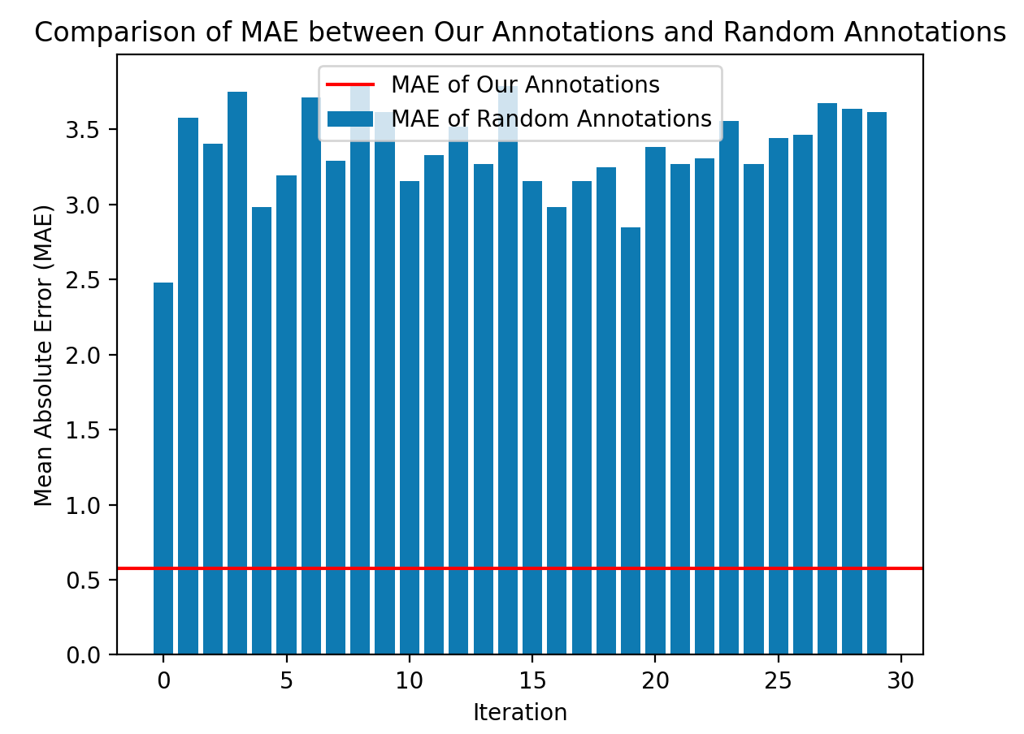

So taking this into account, we can deduce that our annotations are consistent enough.

We need to consider that it’s much more difficult to obtain a 0 value for the MAE, due to the fact that emotion interpretation is subjective, and after assessing many pairs, we were tired and it was difficult to distinguish different emotions, as similar facial expressions resulted in higher punctuation even if the emotions were different.

1. **MULTIDIMENSIONAL SCALING (MDS)**

In order to recover the original points (emotions) from the dissimilarity matrix, we have performed multidimensional scaling. With this process, we are able to convert the pairwise comparisons into 2D points in a plane, in which emotions should be grouped and separated based on their similarities and differences.

To achieve so, we have followed the following steps. We have first calculated the matrix A = (aij) where aij = -0.5·dij2 , and dij are the entries of the dissimilarity matrix. Then, we have formed the “doubly centered” symmetric matrix B = HAH, where H = In-n-1Jn and Jn = 1n1nT. Lastly, we have computed the eigenvectors and eigenvalues of this matrix B, and have taken the first two, to obtain the first two bases and reconstruct the points in a 2D scatter plot.

1. **RESULTS AND INTERPRETATION**

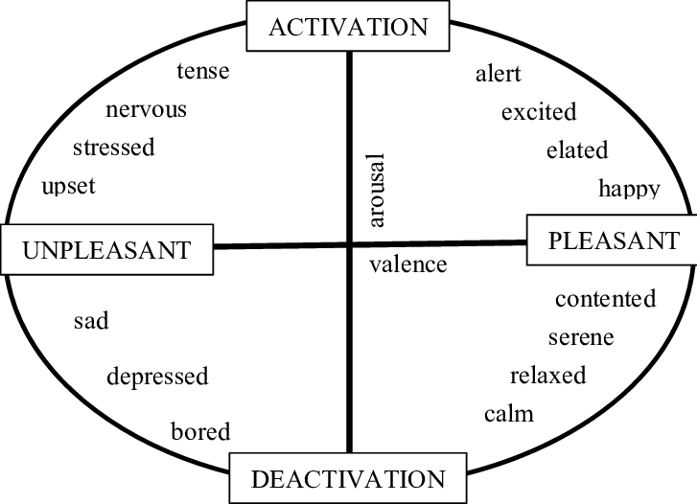After applying multidimensional scaling to our dissimilarity matrix, we are able to reconstruct a “map” in which samples with similar emotions should be clustered together.

And that is exactly what we obtained. We have assigned a different color to each emotion, and it is very clear in the plot (left one in the table below) that small clusters of 3 data points are created. Moreover, they are positioned in a circular shape, which follows the circumplex model of affect (Russell, J. A., 2005) seen in theory class.

By examining the plot and comparing it to the circumplex model of affect, it's evident that negative emotions are less distinct from each other compared to the other emotions. Notably, positive emotions, along with boredom and surprise form well-defined clusters. This observation might be due to the complexity of arousal compared to valence when it comes to discerning facial expressions. The subtle variations in arousal levels, especially within the spectrum of negative emotions, could contribute to the less pronounced separation observed in the plot. Moreover, the complex interaction among facial features associated with different negative emotions can make it challenging to draw clear distinctions. For instance, if we consider the subtle differences in facial expressions between sadness and fear, both may involve downturned mouth corners and furrowed brows, making it harder to distinguish features for categorization. This complexity in facial dynamics contributes to the observed difficulty in achieving clear separations among negative emotions on the plot.

We utilized a pre-existing MDS function from the *sklearn* library to validate our results. The outcomes (see image below) closely align with our own, but with minor variations in scale and rotation. It is worth noting that such differences are typical, due to slight differences in initialization, convergence criteria, etc.

| **Our MDS** | **Sklearn MDS** |
| --- | --- |
|  |  |

1. **CONCLUSIONS**

In summary, even though sorting through pairs of emotions was a bit of a puzzle, our results surprised us by showing that the 2D points mostly grouped together based on different emotions. It turns out we did a better job than we expected. Also, we noticed that figuring out emotions by their energy levels (arousal) is trickier compared to judging their positivity or negativity (valence). This just goes to show how emotions can be a bit of a rollercoaster, and our study opens the door for more cool discoveries about how we perceive and understand them.

1. **REFERENCES**

Tseng, A., Bansal, R., Liu, J., Gerber, A. J., Goh, S., Posner, J., ... & Peterson, B. S. (2014). Using the circumplex model of affect to study valence and arousal ratings of emotional faces by children and adults with autism spectrum disorders. Journal of autism and developmental disorders, 44, 1332-1346.

POSNER, J., RUSSELL, J. A., & PETERSON, B. S. (2005). The circumplex model of affect: An integrative approach to affective neuroscience, cognitive development, and psychopathology. Development and Psychopathology, 17(3), 715–734. doi:10.1017/S0954579405050340

1. **OTHERS**

Note: we have modified the *Matlab* file with the matrices to remove infinite values.

Link to our GitHub repository: <https://github.com/mariaguasch/ACG_2024_Nuria_Maria>