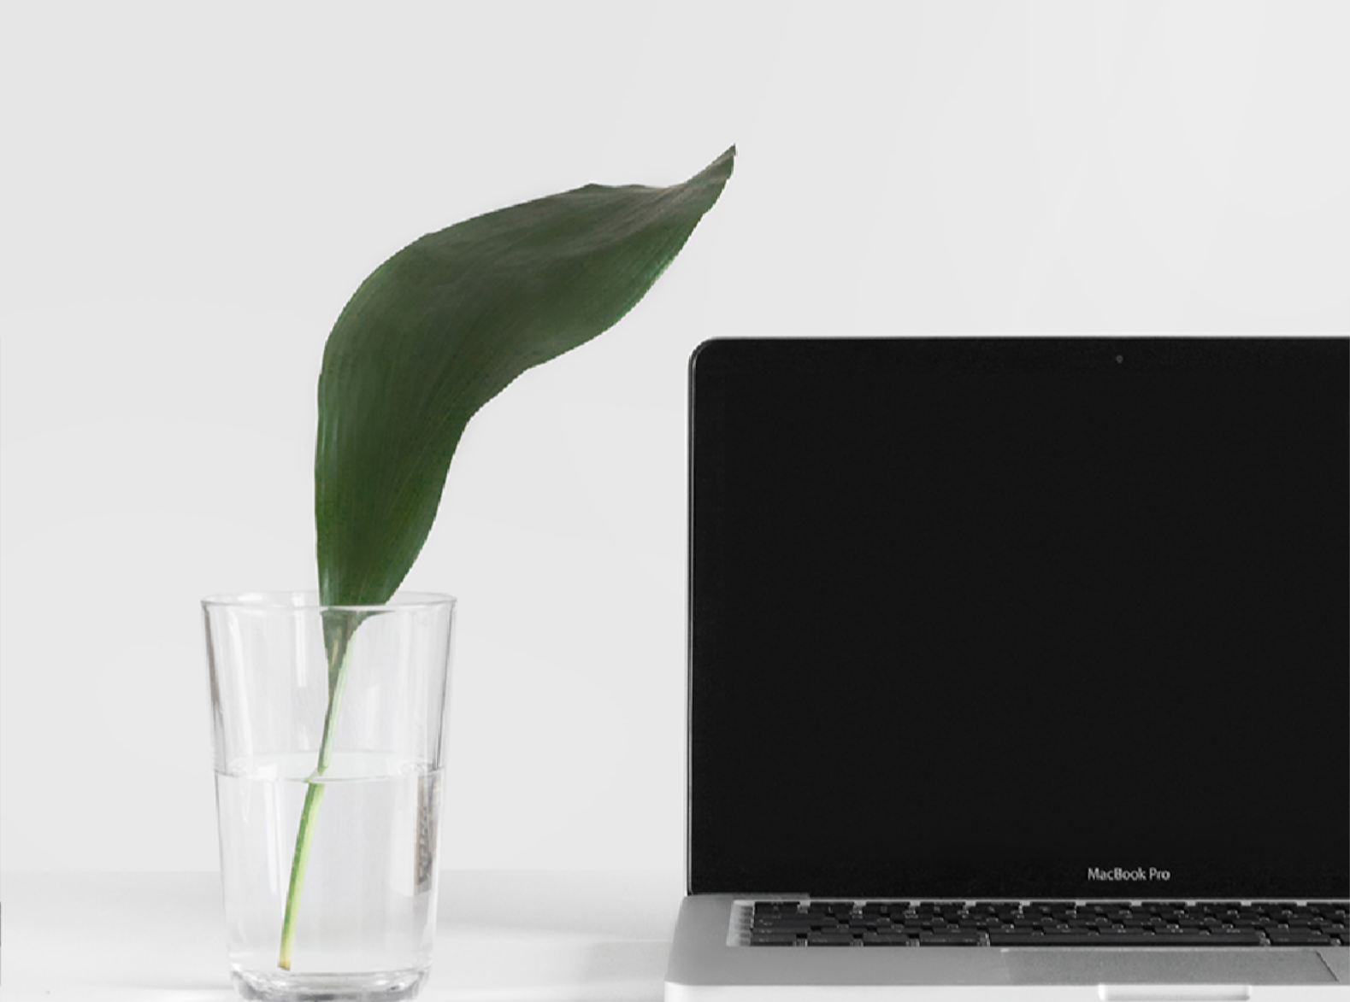

Hello! My Name is

**Maria Gul**

Electronics Engineer

**WELCOME TO MY**

PORTFOLIO 2023

1