**VRRP**

* 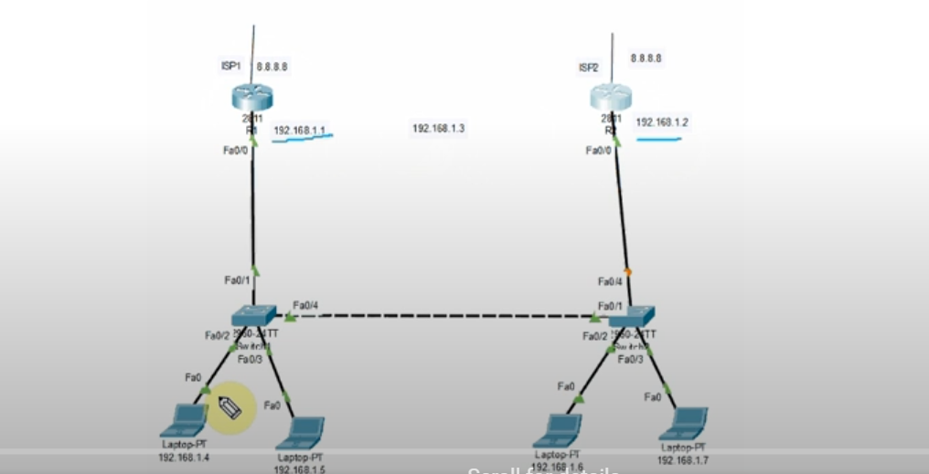Virtual router redundancy protocol, necessary for redundancy. If one service like ISP down then we can use another backup ISP
* Can be used to create virtual gateways
* We pick a default gateway which contains an IP other than the one shown for the above routers (192.168.1.1 and 192.168.1.2). This new gateway will have an IP which will be part of the same network, shown as 192.168.1.3, so that if one link is down, the other router’s interface will be used
* Auto Idle Pc done to minimize CPU utilization
* 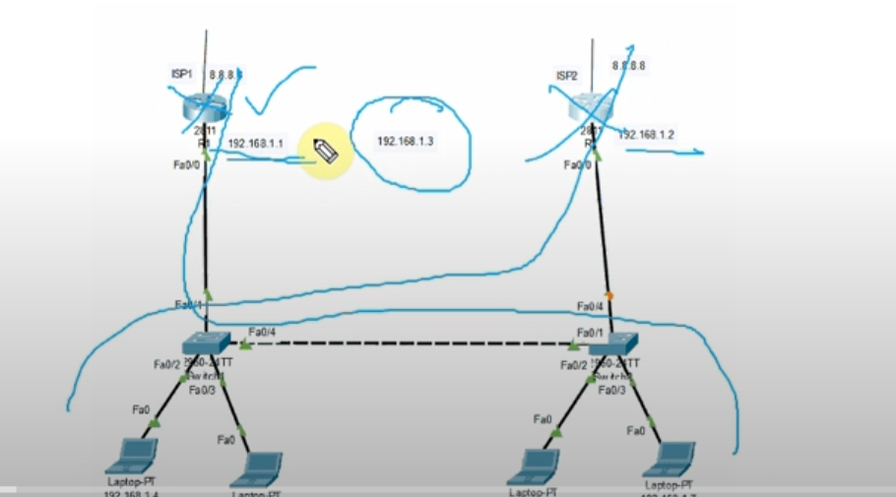HSRP(hot standby router protocol) is same as VRRP except that HSRP is a protocol only use by Cisco devices while VRRP can be used device from any vendor
* VRRP is faster than HSRP. In VRRP the hello timer is 1 second and the hold time is 3 seconds while in HSRP the hello timer is 3 seconds and the hold timer is 10 seconds
* VRRP is an open standard
* Loopback are virtual interfaces on a router or switch which are always on. They simulate an interface without needing a physical cable or hardware. We can assign an IP address t them like a real interface
* VRRP (Virtual Router Redundancy Protocol) creates a virtual IP that a group of routers share.
* Normally, if the router's physical interface goes down, the router can't participate in VRRP anymore — even if the router is still "alive."
* A loopback interface doesn't depend on physical cables or ports — it always stays up as long as the router is powered on.
* So, using a loopback IP means that even if physical interfaces go down temporarily, VRRP can still operate properly, or the router can smoothly handle failovers.

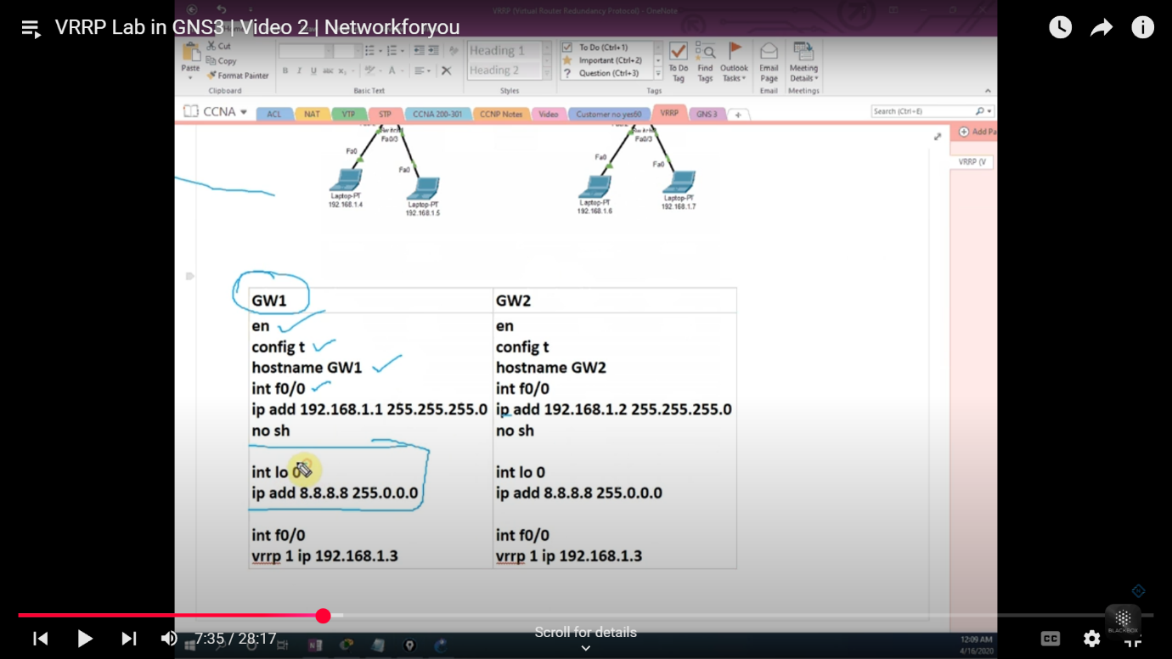

* When we assign an IP to loopback we don’t need to write “no shutdown” command after it since it it’s a logical interface which will never be down
* The **Master router** periodically sends VRRP "hello" packets.
* These packets are used to **prove it’s still alive**.
* You set this timer (default is 1 second).
* If no If no hello messages are received in that time (3.609 seconds times), the Backup Router takes over and becomes Master.
* Ping 8.8.8.8 -t (pc1) means continuously access the internet
* The router with the higher priority is considered as the master, however if they have the same priorities (As is in our case) the router with the higher IP will be considered master. In our case the router 2 is master router
* When we shutdown the link, then gateway of router 1 took over. Once we got timeout but then all the packets were successfully sent from PC1.
* We can run show vrrp to confirm status of master router. It’ll be init when it is down and master when it is up.