**Capturing Telnet Password with Wireshark**

**Telnet**

**TELNET** stands forTeletype Network. It is a **client/server application protocol** that provides access to virtual terminals of remote systems on local area networks or the Internet. The local computer uses a telnet client program and the remote computers use a telnet server program.

Telnet is less secure than SSH as sends unencrypted plaintext.

**Topology:**  
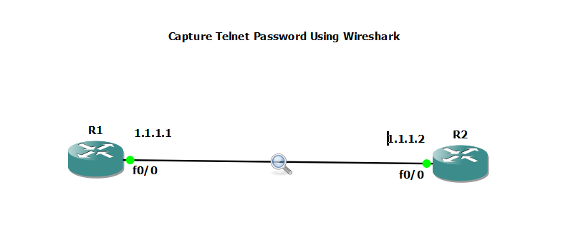

**Steps:**

1. Create following Topology. And enable Auto-idle PC for both routers to make PC efficient.

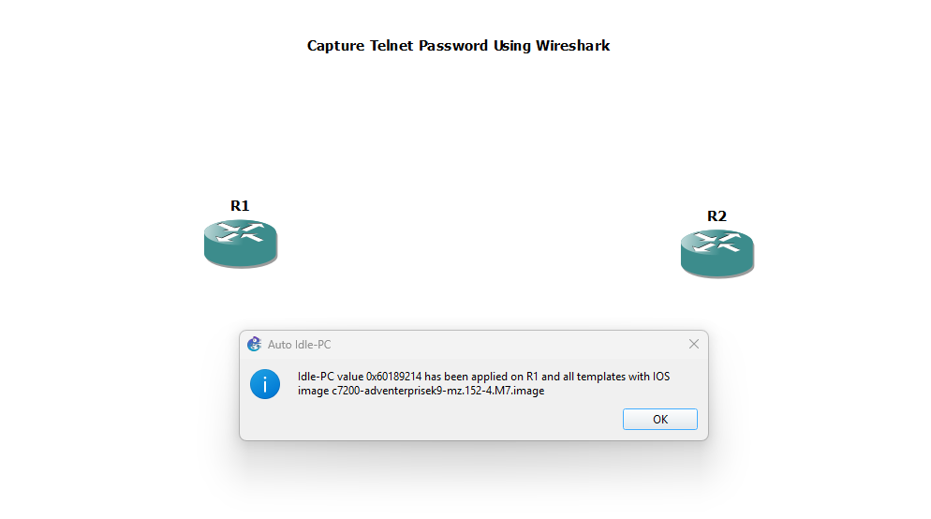

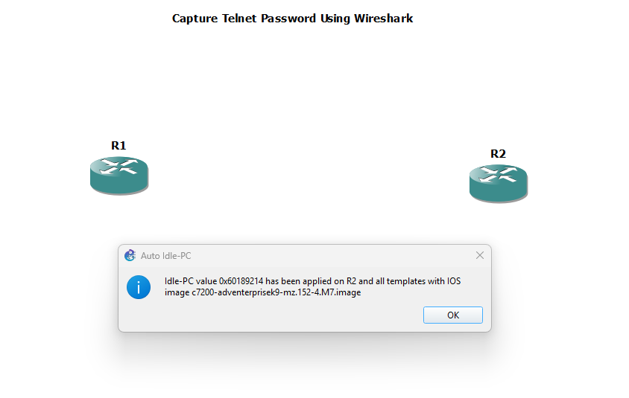

1. Start the routers and enter into the router console.

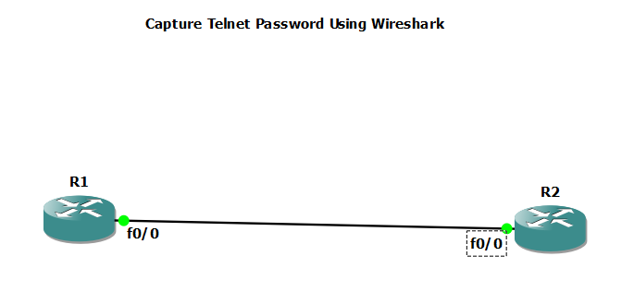

1. Press the 3 dots on the menu bar on the console. Go to settings then general. Select Launch Putty and then Appearance (left side menu). On the right side, press Change button and select the desired font. Then select session on the eft panel (the same place where appearance setting was located), select the Default session and hit save -> cancel and the pop window will close. You’ll b back to the general settings, just press save and restart the console to see the font size has changed.

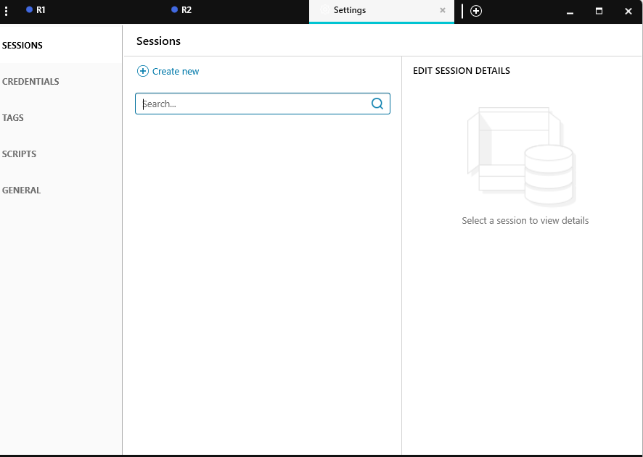

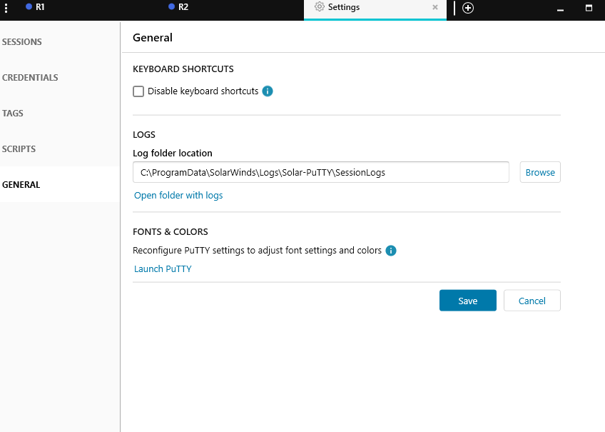

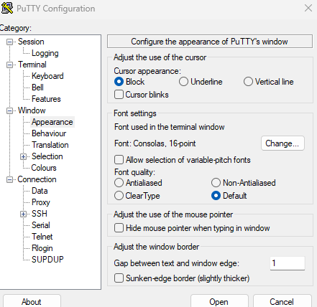

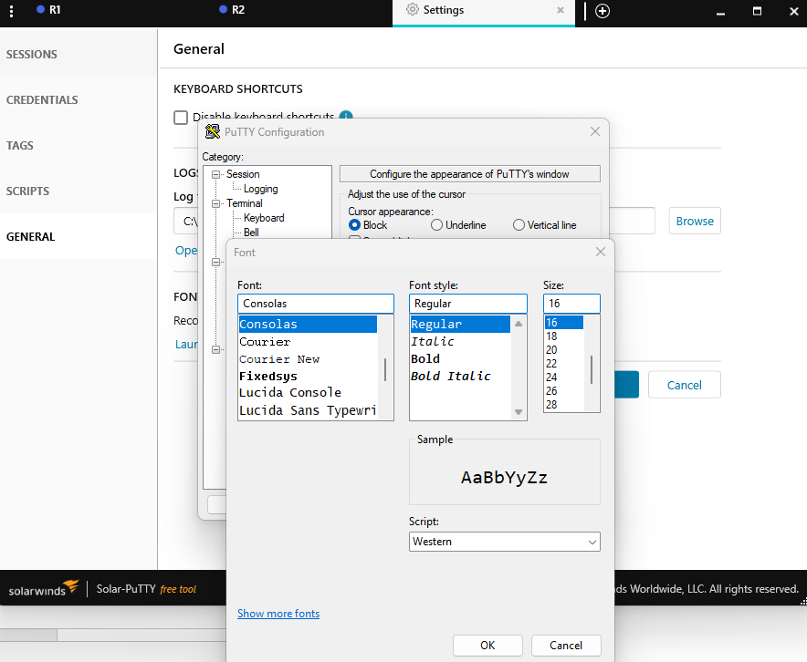

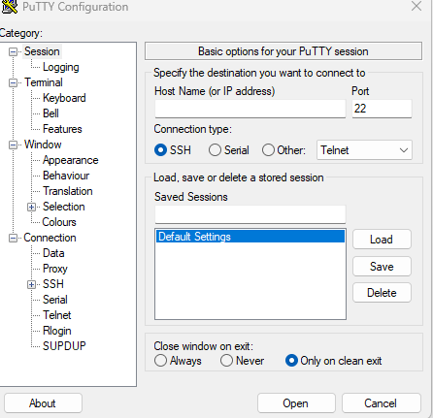

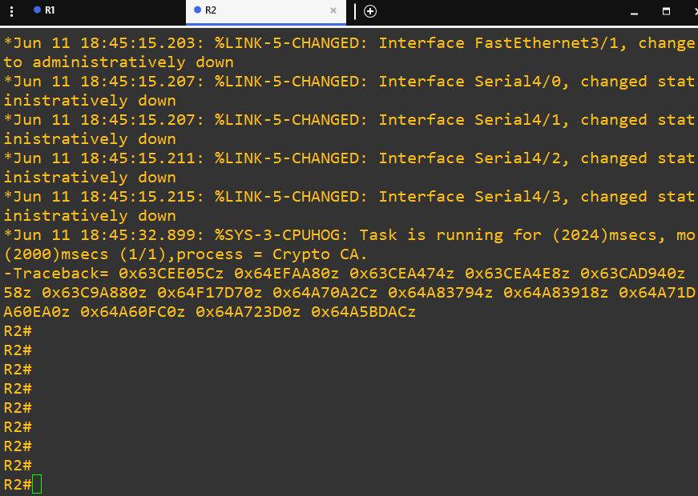

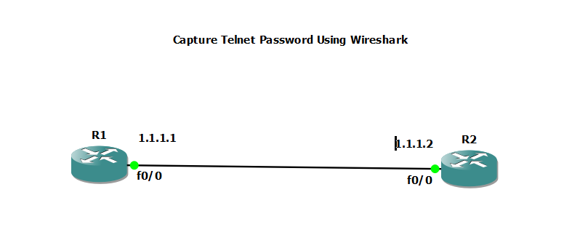

1. Configure the ip address in routers 1 and 2

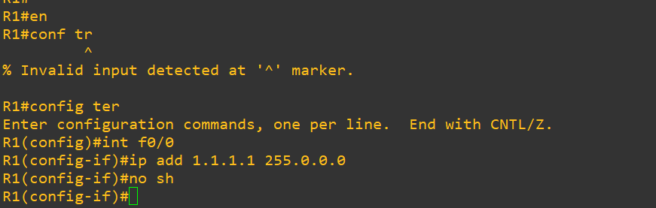

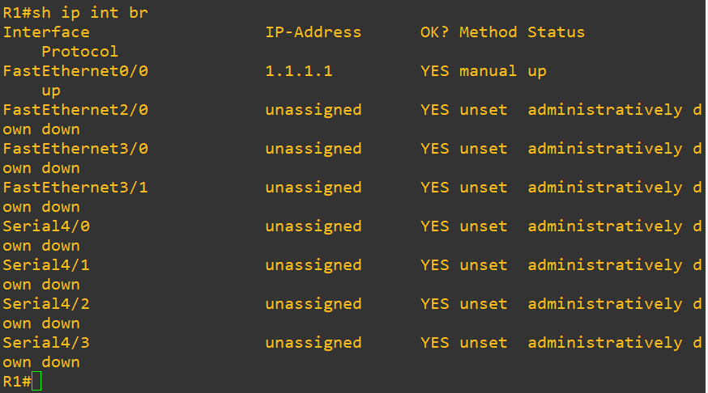

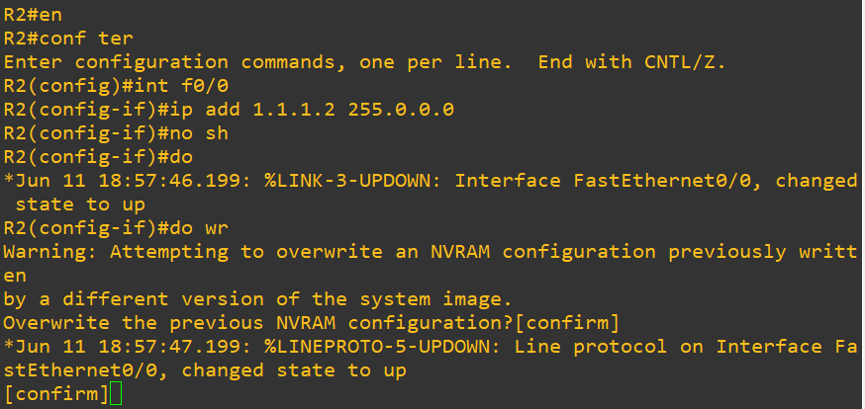

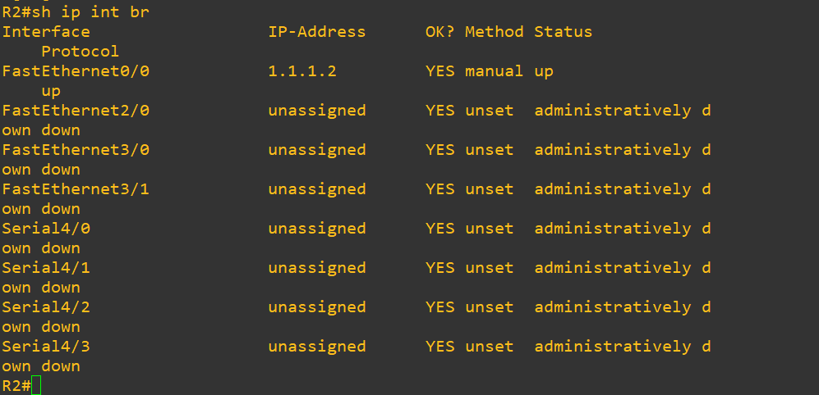

1. Configure telnet in router 2. Assign basic password for Router 2 to configure telnet. Anyone can login into router 2 if they know the password. Password is “cisco.”

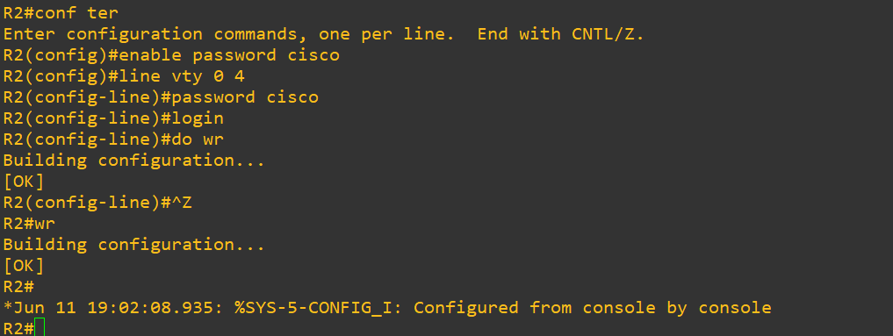

1. To capture the packets from R1 to R2, right click on the direct link between the routers and select “Start capture” Option, Press enter on the pop window and then it will open Wireshark.

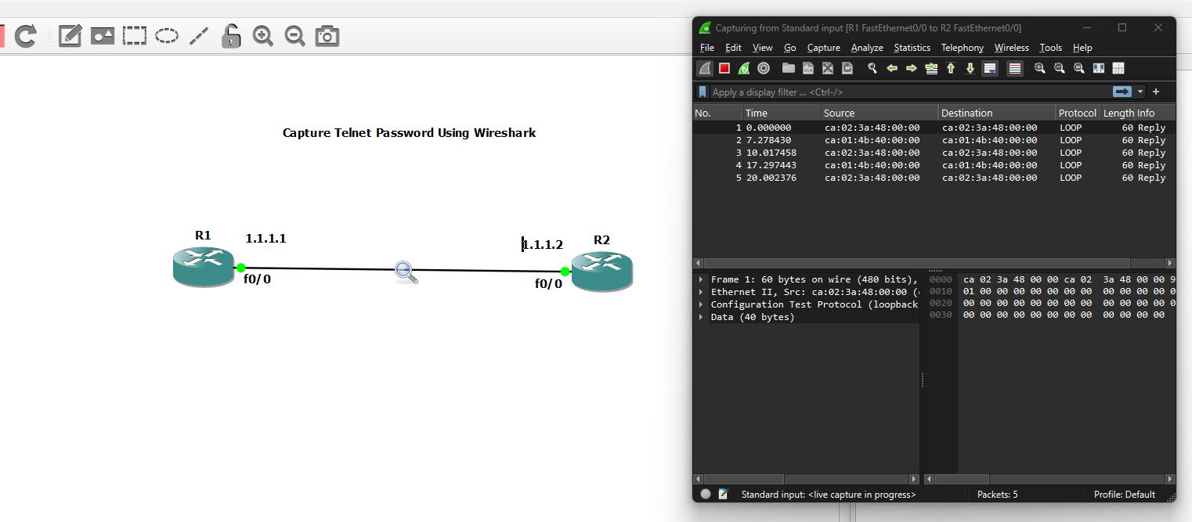

1. Will analyze the packet analyzer tool, Wireshark, to capture packets that R1 sends to R2 using telnet. Run the following command to send telnet packets from R1 to R2. Enter the password when prompted. We have successfully entered into router 2 from router 1

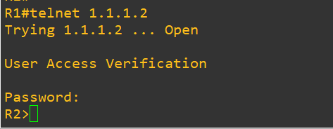

1. Wireshark will show the packets exchanged between the two routers. Right click on the 2nd last telnet packet and got to Follow -> TCP stream. You an see the console commands entered on router 1 to access router 2. It will also show the password as plaintext. If we had configured SSH instead of Telnet then the password wouldn’t be captured as plaintext

