**Enhanced Interior Gateway Routing Protocol**

* First worked on cisco routers
* Now works on any router
* Classless routing protocol
* A classless routing protocol is a routing protocol that includes subnet mask information (also called the prefix length) in its routing updates.
* Administrative distance is 90
* Metrics include bandwidth, load and reliability used
* RIP uses hop count but inefficient as does check bandwidth and maximum of 216 protocols can be used
* EIGRP and OSPF both check the bandwidth
* Default metric is bandwidth and delay
* Conversion rate is very fast
* Supports VLSM and Subnetting : **VLSM** allows you to **divide an IP network into subnets of different sizes**, based on actual need. This helps avoid wasting IP addresses and is a core concept in **classless** IP addressing.
* Uses DUAL algorithm
* Summarization can be done in any router

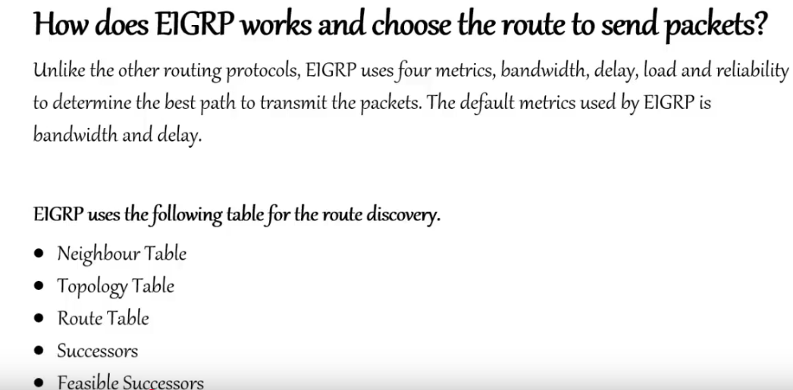

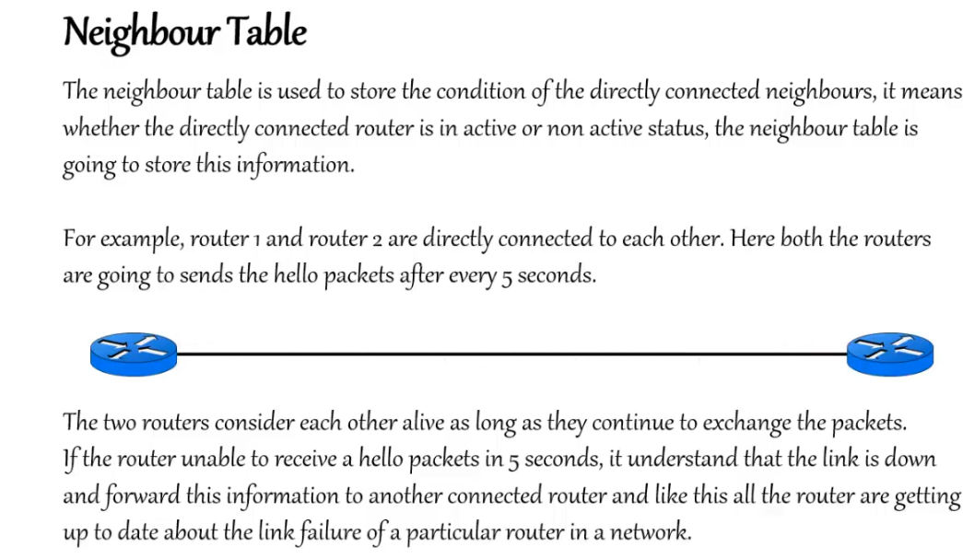

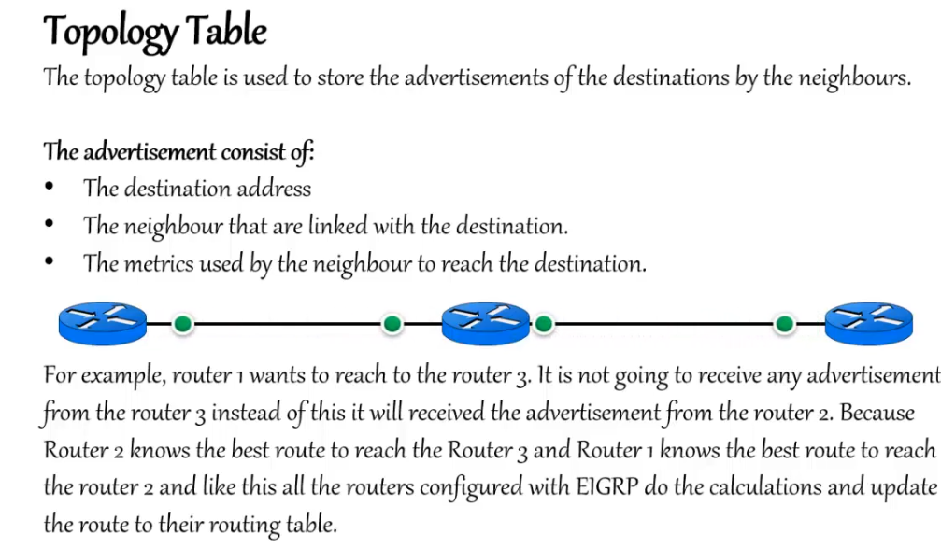

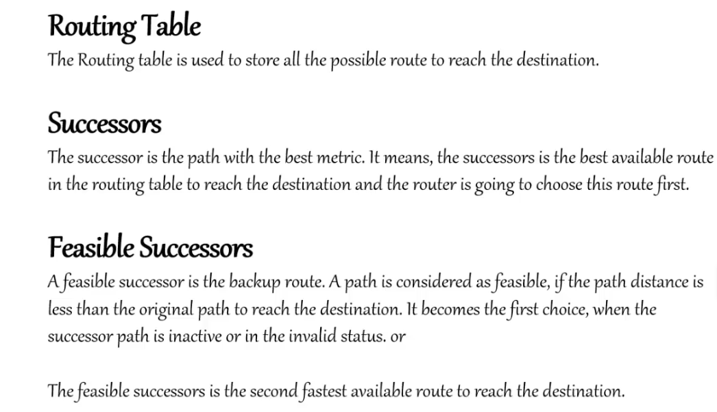

Configure the IP addresses of all inetrfaces on all 4 routers as usual using the following

enable

configure terminal

interface fastethernet 0/0

ip address 192.168.12.1 255.255.255.0

no sh

exit

do wr

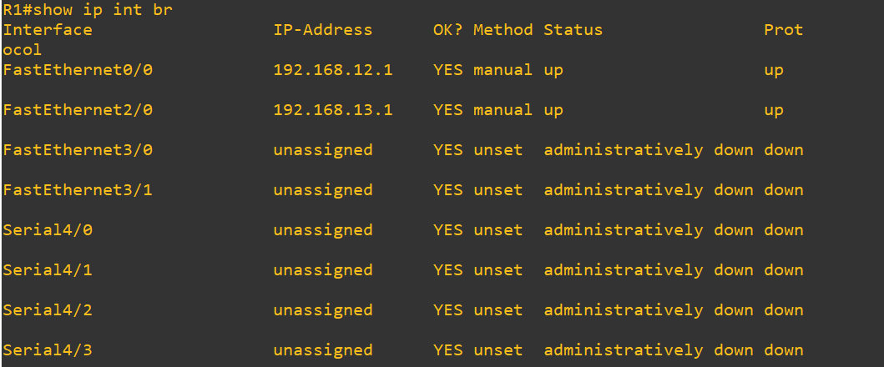

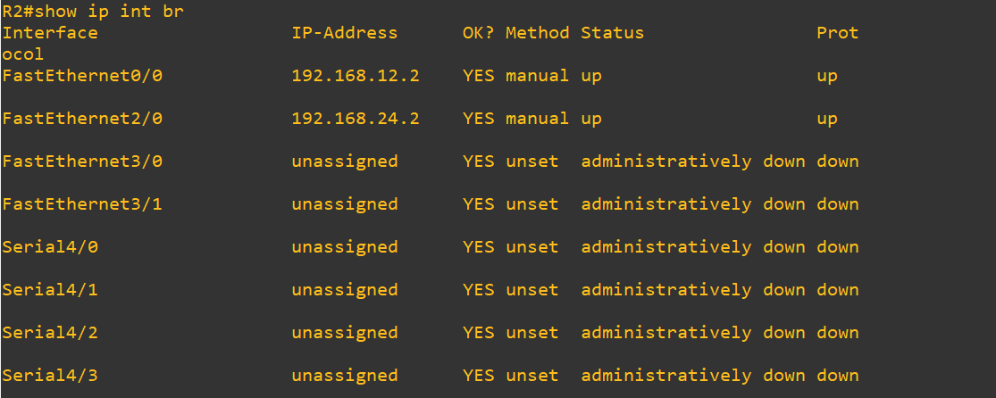

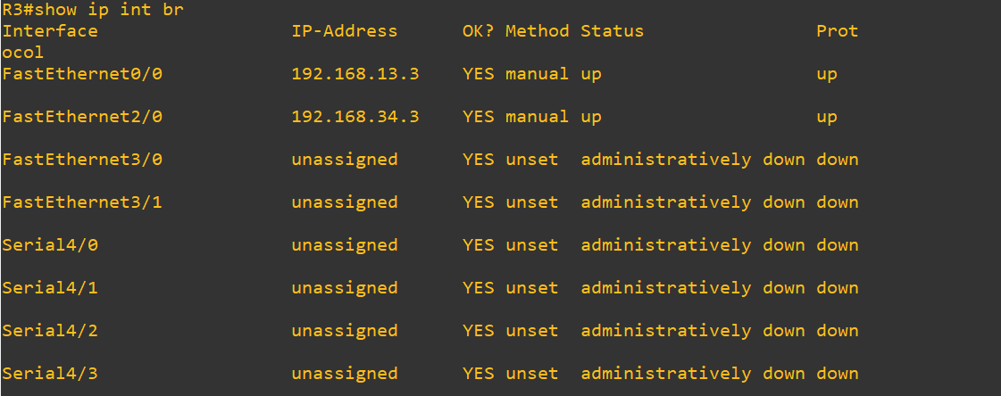

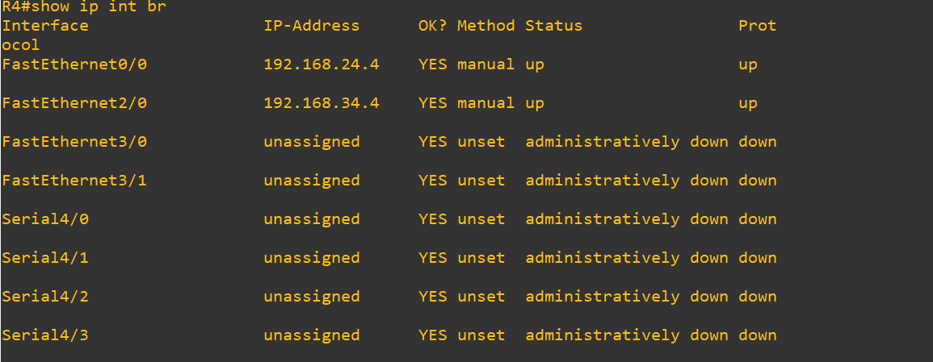

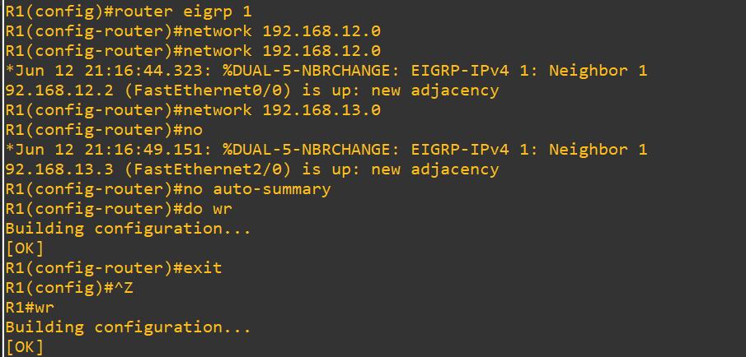

Do the same for all other routers

router eigrp 1

network (network-address of directly connected networks) 🡪 repeat command for as many directly connected networks to router

no auto-summary

