Measuring the baseline performance of Australia’s aquatic animal health system under AQUAPLAN 2022–2027

K. Scutt, I. Ernst, O. Liu | AQUAPLAN Executive Office.  Aquatic Pest and Health Policy section, Australian Government Department of Agriculture, Fisheries and Forestry.

Contents
Summary ii
Introduction 1
Method 2
Results 3
Question 1. Aquatic animal health in context 3
Question 2. Opportunities and challenges for aquatic animal production in Australia 5
Question 3. Aquatic animal health management system performance and AQUAPLAN objectives 7
Question 4. Communication preferences 7
Conclusion 9

Summary
AQUAPLAN is Australia’s national strategic plan for aquatic animal health.
It sets out national priorities, collaboratively developed by industry and governments, for shared action to strengthen Australia’s aquatic animal health management system (system). This system is critical to improve the productivity and profitability of aquatic animal industries (including aquaculture, fisheries, and ornamental fish sectors) and to protect our unique aquatic environments from the threat of disease.
This project aimed to establish a baseline measure for how stakeholders evaluate progress towards achieving AQUAPLAN’s vision and objectives.
The objectives of AQUAPLAN 2022–2027 align with the key components of Australia’s aquatic animal health management system, and the vision aligns with the outcomes we expect from it. This survey can therefore be used to inform how stakeholders perceive the performance of the system and changes over time.
A survey was developed to evaluate stakeholder experience and perceptions of the aquatic animal health management system and related factors, such as risks and opportunities. 107 aquatic animal industry, government, research, and private sector respondents participated in a short survey between December 2022 and April 2023.
This first survey was used to establish the baseline performance of the system. AQUAPLAN’s vision and objectives were each scored out of 100. This survey will be used as a baseline reference for future surveys to measure the impact of AQUAPLAN 2022–2027 and guide investment. The scores for each objective are provided in Figure 1 below.
Figure 1. Aquatic animal health system baseline scores 2023
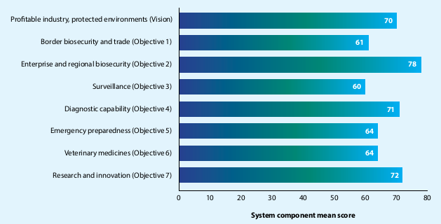
Note. N = 107. System outcome and components shown with corresponding AQUAPLAN vision and objectives in brackets.

Introduction

AQUAPLAN, Australia’s national strategic plan for aquatic animal health
For more than two decades, Australia’s aquatic animal industries (including aquaculture, fisheries, and ornamental fish sectors) and Commonwealth, state and territory governments have identified common priorities for investing in the national aquatic animal health management system through a series of national strategic plans, AQUAPLAN.
The objectives of AQUAPLAN closely mirror the components of Australia’s aquatic animal health (AAH) management system (Figure 2) meaning investment in AQUAPLAN has built much of the system that we know today.
Figure 2. AQUAPLAN 2022–2027 vision and objectives
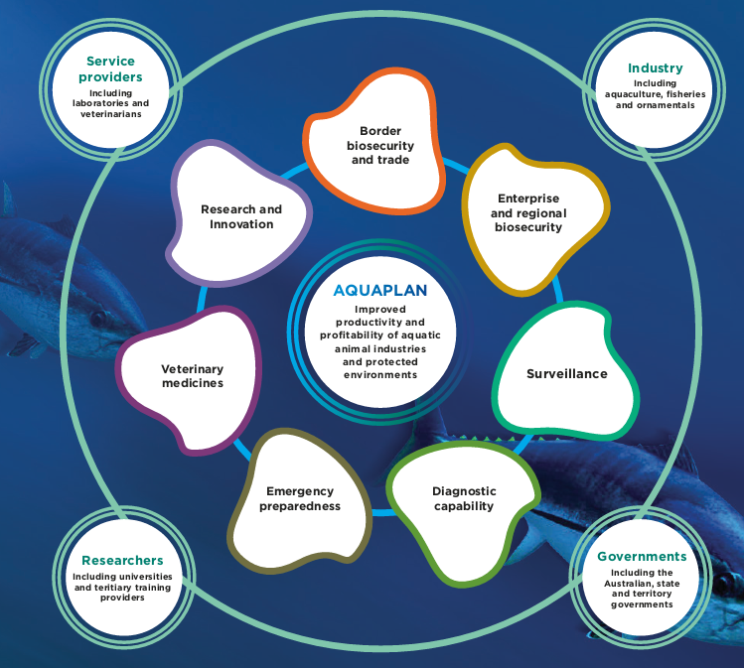
Australia’s fourth national strategic plan for aquatic animal health, AQUAPLAN 2022–2027, includes objectives and actions to invest in all major areas of the national AAH management system, including border biosecurity and trade, enterprise and regional biosecurity, surveillance, diagnostic capability, emergency preparedness, veterinary medicines, and research and innovation (Figure 2). These objectives draw on industries’ priorities and trends for the next 5 to 10 years and aim to provide lasting benefit. Industry and government collaboration is the pathway to achieving each objective.
Implementation of AQUAPLAN 2022–2027 is guided by four pillars (refer to page 48 of AQUAPLAN 2022–2027), of which pillar 4 is realising and demonstrating benefit. Pillar 4 aims to evaluate how well AQUAPLAN is contributing to national aquatic animal health improvements, at the activity, objective, and overall plan levels. Evaluation of the plan and its activities is essential to guide implementation and identify ways to continuously improve. Evaluation will also help demonstrate the degree of return provided through investment in AQUAPLAN, which will inform ongoing investment decisions.

AQUAPLAN 2022–2027 Impact Survey
This project aims to evaluate changes in the performance of Australia’s aquatic animal health management system over time and the impact of AQUAPLAN 2022–2027.
A longitudinal survey was developed to evaluate changes in stakeholder experience and perceptions of the aquatic animal health management system and related factors, such as risks and opportunities.
Four overarching questions were identified:
- How important is aquatic animal health in the context of overall business confidence?
- What are the major opportunities and challenges for aquatic animal health in Australia in the next 5 to 10 years?
- How well are AQUAPLAN’s vision and objectives being fulfilled?
- What are the communication and engagement needs and preferences of stakeholders?

Method

Ethics
No formal institutional ethical approval was required. However, the survey was designed to be consistent with the National Health and Medical Research Council’s National Statement on Ethical Conduct in Human Research (2007).

Participants
Participants were invited to participate in the survey either directly through email or by snowball sampling through relevant aquatic animal industry peak bodies. The survey was also promoted through the Fisheries Research and Development Corporation’s communication channels. The survey was open from December 2022 to April 2023.
Participants completed an online questionnaire through Survey Monkey, which took on average 15 minutes to complete.
107 Australian aquatic animal industry, Commonwealth, state and territory government staff and aquatic animal health service providers and researchers responded (Table 1).

Table 1 Participants breakdown by sector
Sector | N | Percentage (%)
Aquaculture industry ª | 29 | 27.10
Government ^{b} | 50 | 46.73
Service providers & researchers ^{c} | 28 | 26.17
Note: Further breakdown of participants is unavailable to protect anonymity. a Fisheries sectors were invited, but only one response was received which has been included within the aquaculture analysis. b Government includes government research, laboratory, and diagnostic services. c Service providers & researchers includes research institutions and the private sector service industry such as consultants, veterinarians, and private laboratories.

Measures
A bespoke questionnaire was developed to answer the four research questions.
The survey questions were designed to measure stakeholder perceptions of key components of Australia’s aquatic animal health management system, mirroring the AQUAPLAN 2022–2027 objectives.
To do this, several questions were asked per system component/AQUAPLAN objective. Composite scores were then created for each system component to provide an overall score out of 100. Additional questions were developed to understand participants’ communication preferences and views about biosecurity, aquatic animal health, and prospects for the future.
The survey was developed by the project team (Scutt, Ernst and Liu) who invited comment on the survey design from the Sub-Committee on Aquatic Animal Health and Seafood Industry Australia’s Aquaculture Advisory Committee.
All participants completed the core questions (N = 107). Industry (n = 29) and governments (n = 50) were asked some additional sector specific questions.

Results

Question 1. Aquatic animal health in context
This section describes the results of the industry and government specific questions.
Government participants (n = 50) were asked about their expectations for growth of aquatic animal production in the next 5 to 10 years. Results found:
- 93% of government participants anticipate an increase in aquaculture production in their jurisdiction
- 43% of government participants anticipate an increase in government investment in aquatic animal health.
Industry participants (n = 29) were asked about the importance of aquatic animal health to achieving their overall business and sector goals. Results showed that 100% of industry participants thought aquatic animal health is important to achieving overall business and sector goals and that:
- 31% rate this as the most important priority
- 69% rate this as important, but not the top priority.
Industry participants (n = 29) were also asked about the top benefits and challenges of effective aquatic animal health management on-farm (Figure 3). Results showed industry considered the top benefits to be increased production/yield (73%) and preventing disease outbreaks (50%). Accessing lines of disease resistant animals (23%) and accessing tools to support aquatic animal health management (23%) were rated the top challenges.
Figure 3. Industry rated top benefits of aquatic animal health management
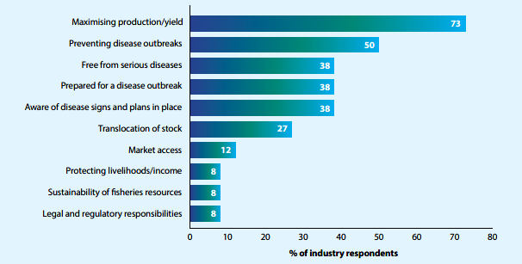
Note. n = 29 (industry only). Participants selected the top three benefits therefore percentages do not sum to 100.

Question 2. Opportunities and challenges for aquatic animal production in Australia
All participants (N = 107) were asked about the top opportunities and challenges for aquatic animal production in Australia in the next 5 to 10 years (Figure 4). Results found that:
- outbreaks of exotic or emerging diseases are seen as the top threat
- selective breeding is seen as the top opportunity, closely followed by new production methods or technologies.
Figure 4. Top three opportunities and threats to the growth of aquatic animal production in the next 5 to 10 years
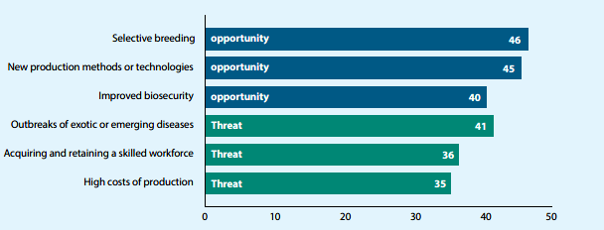
Note. N = 107 (all participants). Participants selected the top three benefits therefore percentages do not sum to 100.
When asked about the likelihood of a major aquatic animal disease outbreak (affecting any sector) in Australia in the next 12 months, most participants thought a major aquatic disease outbreak was likely to varying degrees (35% somewhat likely; 28% likely; 15% very likely).
A range of possible new introduction sources were hypothesised, including through imported product (including diversion of products for non-intended uses), environmental factors, shipping, ornamental fish, and changes in endemic diseases to become more pathogenic or changing to new host species.
A minority of industry participants reported having mechanisms in place to support recovery after an emergency disease outbreak (11%; e.g., financial, business plans). Industry and government participants had varying degrees of confidence in their sector’s/organisation’s ability to respond to a disease outbreak (Figure 5).

Figure 5. Combined industry and government confidence in their sector/organisations’ ability to respond to a disease outbreak
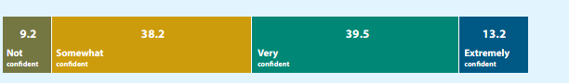
Note. n = 79 (industry and government only). Service providers were not asked this question.

Question 3. Aquatic animal health management system performance and AQUAPLAN objectives
The items answering this question established a baseline of how stakeholders perceive and score components of the aquatic animal health system. In doing so, this also provides a baseline measure for each AQUAPLAN objective.
This was achieved by participants answering multiple questions that align with components of the system and AQUAPLAN’s objectives and vision. The questions for each system component were then combined and transformed to create a score out of 100 to allow comparison across components and time points. The average across all system components was a score of 67. The scores for each component are shown in Figure 6.
Sector specific differences among industry, government, and service providers and researchers were examined. Overall, sector specific differences were minimal, suggesting that using the mean scores of all participants was appropriate.
Figure 6 Aquatic animal health system baseline scores 2023

Note. N = 107.

Question 4. Communication preferences
Participants were asked to identify:
- their three most preferred sources of information about aquatic animal health (Table 2)
- how they prefer to receive this information (Table 3)
- the extent that social media is used for professional purposes (Table 4)
- areas where participants would like to increase their skills and knowledge in aquatic animal health (Table 5).
Note that because participants selected their top three responses, the totals are not expected to sum to 100%. There were some differences in responses among participant groups and to account for this, industry specific responses and whole sample responses are provided.

Table 2. Top three sources of aquatic animal health information
Priority | Industry (n = 29) | Whole Sample (N = 107)
1 | State or Territory Department of primary industries (52%) | Peer reviewed journals (46%)
2 | Fisheries Research and Development Corporation (52%) | Colleagues/peers (44%)
3 | Aquatic veterinarian or aquatic health specialist (48%) | State or Territory Department of primary industries (39%)

Table 3. Top three preferred ways to receive information on aquatic animal health
Priority | Industry (n = 29) | Whole Sample (N = 107)
1 | Conferences and industry meetings (71%) | Targeted information session/webinars on specific topics (62%)
2 | Email (62%) | Email (53%)
3 | Targeted information session/webinars on specific topics (52%) | Conferences and industry meetings (47%)

Table 4. Top three social media platforms for professional purposes
Priority | Industry (n = 29) | Whole Sample (N = 107)
1 | Facebook (57%) | Not a social media user for professional purposes (43%)
2 | LinkedIn (48%) | LinkedIn (38%)
3 | Not a social media user for professional purposes (19%) | Facebook (33%)

Table 5. Top three areas where participants would like to increase their skills and knowledge in aquatic animal health
Priority | Industry (n = 29) | Whole Sample (N = 107)
1 | New research in aquatic animal health and biosecurity that could be relevant to me (57%) | New research in aquatic animal health and biosecurity that could be relevant to me (52%)
2 | How you can best prepare for, and respond to, an emergency disease outbreak (48%) | Surveillance approaches for aquatic animal disease (e.g., on-farm, regionally, nationally (45%)
3 | Surveillance approaches for aquatic animal disease (e.g., on-farm, regionally, nationally) (43%) | How you can best prepare for, and respond to, an emergency disease outbreak (30%)

Conclusion
This project developed a novel survey method to evaluate stakeholders’ experience and perceptions of Australia’s aquatic animal health management system. The survey operationalised components of Australia’s aquatic animal health management system, aligning with the vision and objectives of AQUAPLAN 2022–2027.
On average stakeholders scored all objectives of AQUAPLAN 2022-2027 67 out of 100, setting the baseline from which future impact surveys can be compared and changes in stakeholder perceptions of the performance of Australia’s aquatic animal health management system can be evaluated.
Insights were gathered into the benefits and challenges confronting aquatic animal industries and governments to manage aquatic animal health and maximise productivity and profitability. These insights will inform AQUAPLAN’s implementation and identify potential changes in industry-government priorities. The survey also gathered information about stakeholder communication preferences, which is an essential aspect to implementation, extension, and adoption of AQUAPLAN activities.
The AQUAPLAN Impact Survey will be conducted twice more as part of AQUAPLAN 2022-2027’s evaluation, in 2025 as part of the mid-plan review and in 2027 as part of the end of plan evaluation. This will provide an understanding of stakeholder experience and perceptions of how the aquatic animal health management system is changing over the duration of AQUAPLAN 2022-2027.

https://www.agriculture.gov.au/agriculture-land/animal/aquatic/committees
https://seafoodindustryaustralia.com.au/aquaculture/

