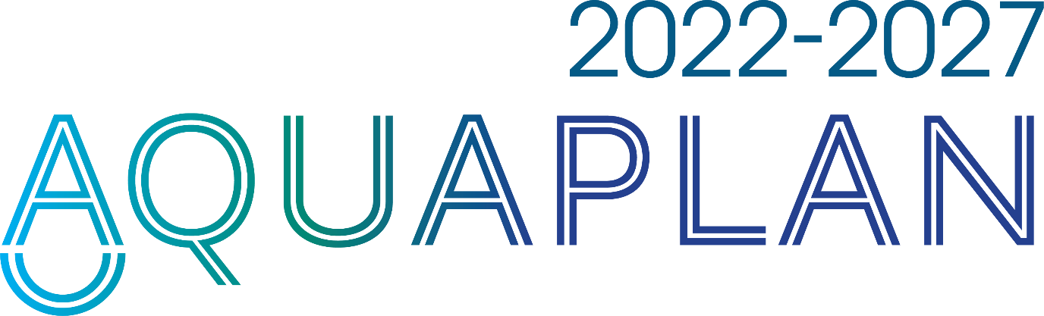

Australia's National Strategic Plan for Aquatic Animal Health

Mid-term review
December 2025

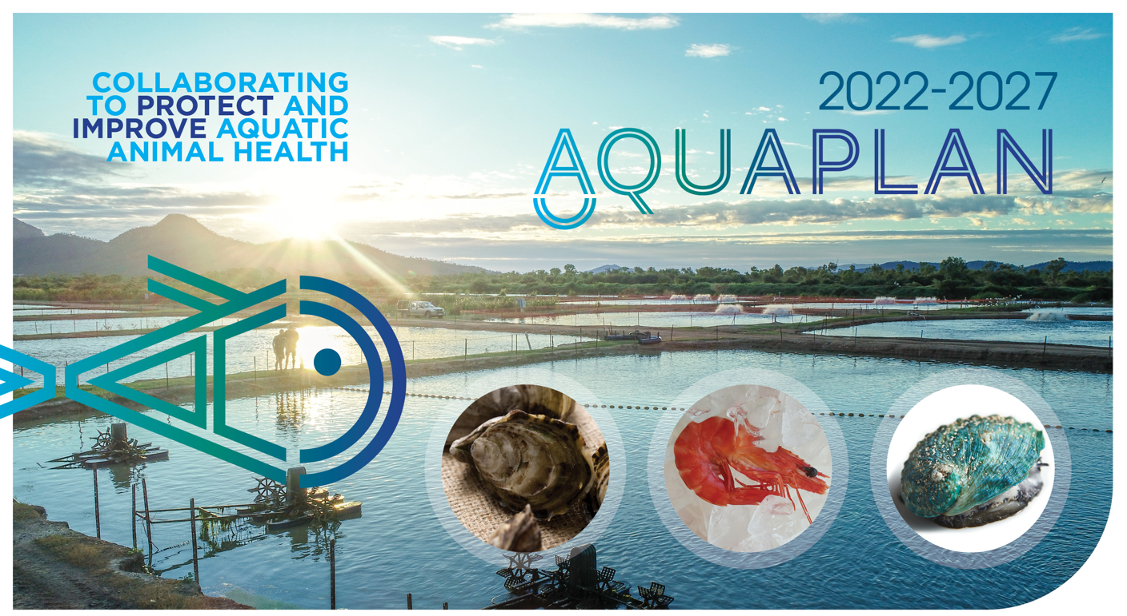

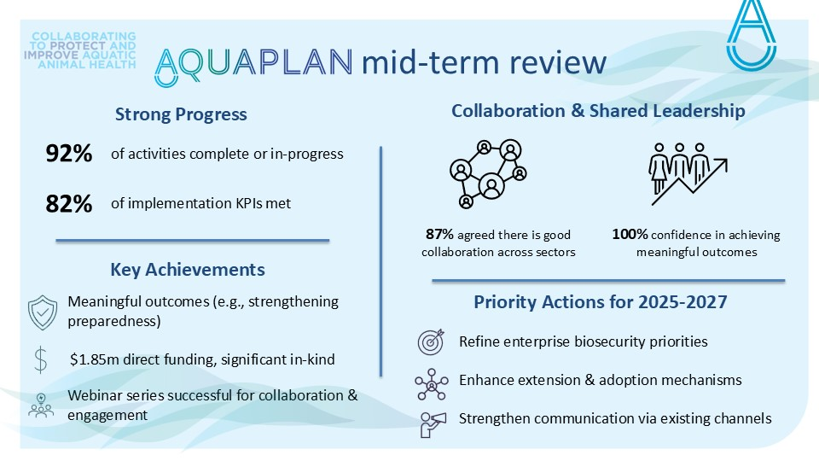

Executive summary
Purpose: A mid-term review of AQUAPLAN 2022-2027 has been completed by aquatic animal industries and governments. Implementation progress was reviewed and clear recommendations for the remainder of the plan agreed.
Overall Progress: Seven of 28 projects have been completed and a further 19 activities are in progress. Eight of nine key performance indicators (KPI) for the Implementation Plan are being met, eight of nine KPIs of the Monitoring and Evaluation Plan are being met, and seven of ten KPIs of the Communication and Engagement Plan are being met. AQUAPLAN owners (i.e., aquatic animal industries and governments) are confident in AQUAPLAN’s ability to achieve meaningful outcomes and in the cross-sectoral collaboration required to achieve this.
Key Achievements:
- Collaboration and shared leadership – AQUAPLAN activities demonstrate strong co-design and ownership between industry and government, contributing to successful delivery. Of the 30 industry and government stakeholders who participated in the mid-term review workshop, 87% agreed/strongly agreed that there is willingness for collaboration across sectors to implement AQUAPLAN effectively.
- Implementation success – Most activities are progressing well, with completed and ongoing projects collectively driving progress toward AQUAPLAN’s strategic objectives. Of the 30 industry and government stakeholders who participated in the mid-term review workshop, 100% agreed/strongly agreed that they are confident in AQUAPLAN achieving meaningful outcomes.
- Communication led by webinar series – The webinar series has become a central mechanism for engagement, extension, and adoption, supporting implementation and stakeholder connection.
Priority Actions for 2025-2027:
- Leverage and strengthen communication and engagement – Build on the success of the webinar series as a central platform for engagement, extension, and adoption. Broaden AQUAPLAN’s reach by utilising existing communication channels through Fisheries Research and Development Corporation (FRDC), Seafood Industry Australia (SIA), and industry newsletters, and assess whether any gaps remain in current communication and engagement efforts to ensure all stakeholder groups are effectively reached. Develop AQUAPLAN communication templates that can be used by activity leads.
- Reconsider enterprise and regional biosecurity priorities – Engage with end-users on Objective 2 activities (2.1–2.3) to ensure alignment with current sector needs and available resources, and determine approaches for targeted implementation. Prioritise continuous improvement (activity 2.3) and defer activities 2.1–2.2 until lead sectors can be identified.
- Enhance extension and adoption mechanisms – Strengthen approaches to ensure AQUAPLAN outcomes are well understood and applied by end-users (including at the operational level), particularly through Activity 7.2 and broader communication and engagement efforts.

Introduction
This is the fourth of Australia’s national strategic plans for aquatic animal health, and the first to incorporate a mid-term review. The inclusion of this review reflects AQUAPLAN’s strong emphasis on shared ownership, measurable impact, and demonstrating return on investment.
The mid-term review is designed to be efficient and purposeful, providing a timely opportunity to reflect on progress and ensure AQUAPLAN remains responsive and effective for the remainder of its implementation period.

Purpose and objectives
The mid-term review brings together aquatic animal industries and governments to:
- Assess implementation progress of AQUAPLAN 2022-2027, and
- Agree on clear, actionable recommendations for the remainder of the plan.

Objectives
- Evaluate progress across AQUAPLAN activities and identify areas requiring further attention.
- Review implementation of supporting plans, including:
  - The Implementation Plan,
  - The Monitoring and Evaluation Plan, and
  - The Communication Plan.
- Based on findings from Objectives 1 and 2, develop practical recommendations to guide implementation through to 2027.
- Reinforce shared ownership and build momentum for the remainder of the plan.

Review method
- Desktop review of AQUAPLAN implementation progress.
- Stakeholder workshop (11 November 2025) to discuss findings and agree on recommendations. The workshop included:
  - Current industry and government context
  - Updates on AQUAPLAN activity progress
  - Mid-term review initial findings & recommendations (discussion and Mentimeter feedback)
Of stakeholders who participated in Mentimeter (10 government, 15 industry, 5 other), 69% agreed/strongly agreed that workshop objectives were met, 100% agreed/strongly agreed that they are confident in AQUAPLAN achieving meaningful outcomes and 87% agreed/strongly agreed that there is strong willingness for collaboration across sectors to implement AQUAPLAN effectively (13% neutral).
- Mid-term review report (this report) to document progress and capture agreed recommendations. The report has been informed by the desktop review and stakeholder workshop and was prepared by the AQUAPLAN executive office at DAFF (Katie Scutt, Ingo Ernst, Ben Crowe). A draft of the report was reviewed by the stakeholder workshop facilitators, Tracey Bradley (DEECA) and Julie Petty (Seafood Industry Australia). The report has been revised based on stakeholder comments prior to finalisation.

Progress against objectives
Objective | Status | Mid-term review considerations
1. Border Biosecurity & Trade | 1.3  1.1  1.2 | On track.
2. Enterprise & Regional Biosecurity | 2.5  2.2  2.1  2.4  2.6  2.3 | Activities 2.1–2.3 – activities have either not commenced or progressed slowly. Industry consultation indicates that needs may have changed for some sectors. The mid-term review workshop indicated that the priority of activities 2.2 and 2.3 are at or above the average priority of all activities.  Activity 2.6 – consider activity approach given development of national freshwater pest plan/strategy.
3. Surveillance | 3.2  3.1  3.3 | On track.
4. Diagnostic Capability | 4.4  4.5  4.3  4.2  4.1 | On track.
5. Emergency Preparedness | 5.4  5.3  5.2  5.5  5.1 | On track.
6. Veterinary Medicines | 6.3  6.1  6.2 | Activity 6.3 – consider priority in context of activities 6.1 and 6.2. Consider participating sectors and developing projects that provide sound return on investment.
7. Research & Innovation | 7.2  7.3  7.1 | Activity 7.2 – high priority as outcomes from this activity can be foundational for extension and adoption of all AQUAPLAN activities and aquatic animal health and biosecurity research generally.
Legend: Complete | In-progress | Yet to commence

Implementation performance
1. Implementation plan
Pillar 1: Shared Ownership and Collaboration
AQUAPLAN represents shared priorities among investors in aquatic animal health to achieve a common vision. This pillar aims to cultivate shared ownership of the plan to achieve its vision and outcomes
KPIs |  | Outcome
1.1 AQUAPLAN webinar series. |  | Sixteen webinars of the regular series (Activity 7.3) have been held with an average attendance of 46 attendees and 15 unique presenters. Webinars have covered subjects relevant to all AQUAPLAN objectives. Of six webinars that have been evaluated an average of 94% of respondents agreed that their knowledge on the subject matter was increased, 78% agreed that they will apply new knowledge to their day-to-day work, and 96% agreed that the webinar had met their expectations. A forward program of webinars has been established to facilitate regular information sharing, broader coverage of activities and encourage participation, with six webinars held in 2025. Six webinars (additional to the 16 of the regular series) have been held as part of Activity 1.1. and will be evaluated separately as part of that activity.
1.2 Annual AQUAPLAN workshop. |  | Workshops have been held in February 2023 (AQUAPLAN launch), April 2024 (AQUAPLAN annual workshop) and November 2025 (mid-term review workshop).
1.3 Activities jointly led by industry and governments, in collaboration with experts. |  | There is a high degree of joint leadership, collaboration or consultation as appropriate for the nature of different activities. Twelve activities of a strategic nature (e.g., activities 2.4 Translocation, 3.1 National Surveillance Strategy) have joint leadership arrangements through industry-government steering groups or working groups. Seven activities of a technical nature (e.g., 3.3 Passive surveillance sensitivity, 5.1 Priority disease list) have been led by experts with collaboration/consultation arrangements suited to the activity. The remaining nine activities have either not commenced or are early in development.
Pillar 2: Sustainable resourcing
AQUAPLAN is designed to attract funding for specific activities and in some cases in-kind resources from the aquatic animal health community. This pillar aims to secure resources over the life of the plan and match available resources to priorities.
KPIs |  | Outcome
- Direct funding is secured. |  | Direct contributions to aquatic animal health and biosecurity initiatives total $1,853,727 across nine directly funded projects, supporting key AQUAPLAN activities including enterprise and regional biosecurity planning, diagnostics, surveillance, simulation exercises, and access to veterinary medicines. The majority of direct funding has been provided by the FRDC.
- In-kind resources are secured and applied in a sustainable manner. |  | Substantial in-kind contributions have been made to support project activities, reflecting strong engagement across government, industry, and other stakeholder groups in planning and implementation of activities. Few estimates of in-kind contributions have been provided by activity leads. However, for 14 activities where estimates were provided, in-kind contributions total approximately 1,486 person-days.
Pillar 3: Strong and efficient coordination
AQUAPLAN 2022-2027 has seven objectives, each with supporting activities that will be progressed over five years. This pillar aims to support strong and efficient coordination to monitor and evaluate each activity and overall progress towards achieving AQUAPLAN’s vision.
KPIs |  | Outcome
- Biannual activity reporting. | Not met | Four AQUAPLAN activity progress reports have been published with targets met in 2023 (launch year, 1 published) and 2024 (two published). Only one progress report will be published in 2025.
- Project plans for each activity that include monitoring, evaluation, and communication. |  | An AQUAPLAN activity project plan has been developed to support project planning, including monitoring, evaluation and communication. Where funding has been sought from the FRDC, the FRDC project plan templates have been used. Twenty activities have project plans developed, either through the AQUAPLAN template or via FRDC processes. The remaining eight activities have either not commenced or are within the planning phase.
Pillar 4: Demonstrating and realising benefit
To create lasting change and improvements in the aquatic animal health system outputs of AQUAPLAN need to be extended and adopted by their end-users. Demonstrating return on investment and sound evaluation of outcomes will be essential to secure ongoing investment. This pillar aims to realise and demonstrate benefit.
KPIs |  | Outcome
- Activities are not considered complete until they have been evaluated and efforts have been made to extend and encourage adoption by end-users. |  | Several completed projects (e.g., 3.1 national surveillance strategy; 5.1 priority disease list; 5.5 disease investigation guide) have been extended extensively through websites, webinars, conferences, newsletters and social media. Evaluation is occurring in context appropriate ways. Routine evaluation is occurring for ongoing activities (e.g., 7.3 webinar series) and rigorous evaluation is occurring for activities where it is integral to the activity (e.g., 5.3 sector specific exercises).
- Mid-term and end of plan reviews. |  | The mid-term review is underway (this document).

2. Monitoring and Evaluation plan
Monitor and prioritise
The AQUAPLAN executive office will monitor progress of AQUAPLAN together with stakeholders. The aim is to ensure AQUAPLAN produces meaningful outcomes to improve aquatic animal health.
KPI |  |  | Outcome
- Each calendar year, annual priorities for AQUAPLAN activities will be set. |  |  | Prioritisation has generally occurred based on appropriate sequencing of activities to consider dependencies and competing priorities for available resources (e.g., in-kind and direct funding). For example, Activity 3.1 National Aquatic Animal Disease Surveillance Strategy was completed prior to activity 3.2. sector specific surveillance plans. The mid-term review will consider priorities for the remainder of the plan’s implementation.
- A mid-term review will examine progress and confirm priorities for the second half of the plan’s term. |  |  | The mid-term review is underway. Key components of the review: desktop review of progress, stakeholder workshop for priority setting, report with agreed recommendations.
Resource
AQUAPLAN has been designed to attract resources, both direct and in-kind, by establishing agreed national priorities for industry and governments.
KPI |  |  | Outcome
- Activity leads will be responsible for seeking resources for their activities. |  |  | Activity leads have successfully sought the required resources with several activities provided direct funding through the FRDC. For example, activities 5.3 (exercises), 4.1 (future diagnostics), 2.4 (translocation), and 5.5 (outbreak investigation guidelines).
- The AQUAPLAN executive office can assist activity leads to identify funding sources. |  |  | Assistance has generally not been required. However, the AQUAPLAN executive office has provided advice on funding application development for several projects.
- Progress towards attracting funding towards priority activities will also be monitored to ensure difficulties are identified and resolved early. |  |  | As part of the biannual progress reports, activity leads provide information on direct and in-kind resources and indicate any challenges in resourcing where assistance may be required.
Report
Reporting and engaging with all stakeholders about AQUAPLAN implementation will be conducted as per the AQUAPLAN Communication and Engagement Plan.
KPI |  |  | Outcome
- Activity leads will provide biannual progress reports which will inform AQUAPLAN updates to all stakeholders. AQUAPLAN executive office will coordinate this process. |  |  | Activity leads have provided activity progress reports as requested.
- The AQUAPLAN executive office will provide annual AQUAPLAN implementation progress reports to all stakeholders. |  |  | Annual updates on AQUAPLAN implementation are shared at annual stakeholder workshops (March 2023, April 2024, November 2025) and published on the DAFF website.
Evaluate
The impact of AQUAPLAN will be evaluated
KPI |  |  | Outcome
- Longitudinal impact surveys, a mid-term review, and end of plan review. These will involve all stakeholders and will be led the AQUAPLAN executive office. |  |  | Impact surveys: Survey 1 complete and published. Survey 2 pending (early 2026).  Mid-term review: In-progress.  End of plan review: Pending.
- Activity leads will develop evaluation plans for each AQUAPLAN activity. Activities will not be considered complete until this has occurred. | Partially met |  | Evaluation plans are included as part of activity planning. To-date, activity level evaluation has not been closely monitored by the AQUAPLAN executive office; however, evaluation is occurring in context appropriate ways. Broad AQUAPLAN impact is being measured through the longitudinal impact survey project.

3. Communication and engagement plan
Objectives
The Communication and Engagement Plan aims to: increase awareness and understanding of AQUAPLAN, encourage involvement in and support of AQUAPLAN activities, provide progress updates on activities, communicate and encourage uptake of outcomes.

KPI |  | Outcome
- Activity project plans (Start of each activity) |  | As mentioned above under KPI 1.7.
- Activity progress reports (biannual) | Partially met | As mentioned above under KPI 1.6.
- AQUAPLAN workshop (annual) |  | As mentioned above under KPI 1.2.
- AQUAPLAN webinar series (at least 4 times each year) |  | As mentioned above under KPI 1.1.
- AQUAPLAN newsletter (bi-annual) | Not  met | This communication mechanism was intended to advise stakeholders of progress and outcomes of specific AQUAPLAN activities. Participants of the mid-term review workshop did not highlight an AQUAPLAN newsletter as a priority mechanism.
- AQUAPLAN website (biannual/more often as required) | Not  met | As mentioned above under KPI 1.6.
- Committee reports (as required) |  | Numerous reports have been provided to both industry (e.g., industry association R&D or biosecurity subcommittees, SIA Aquaculture Committee) and government committees (e.g., SCAAH, Aquaculture Committee, Australian Fisheries Managers Forum, Animal Health Committee) on the progress of specific activities or on AQUAPLAN more broadly.
- Conference and industry meeting presentations (Ad hoc) |  | The 2025 FRDC Aquatic Animal Health and Biosecurity conference featured 10 presentations with linkages to AQUAPLAN. Presentations have been provided to other industry meetings on specific activities (e.g., APFA conference – activities 3.3, 5.3)
- Other newsletters or articles (ad hoc) |  | These are infrequent, however, some articles have been published in newsletters as appropriate such as the FRDC stakeholder newsletter, health highlights newsletter.
- Media releases (ad hoc) |  | At launch and some activity specific promotion. Note: this is not expected to be a primary communication mechanism.

Key Findings of the review

What’s working well
- Collaboration and shared leadership: AQUAPLAN activities that are complete or underway demonstrate strong co-design and shared ownership between industry and government partners.
Mid-term review workshop participants emphasised collaboration and partnership between industry and government as the primary strength of AQUAPLAN implementation, including co-design and shared responsibility to lead activities. Several participants noted that engagement and shared responsibility has led to genuine needs being addressed. Progress on translocation, emergency simulation exercises and the actions arising from simulation exercises were noted as important outcomes.
- Webinar series: The webinar series has emerged as a central mechanism for communication, engagement, extension, and adoption of AQUAPLAN activities. It covers a broad range of topics directly linked to AQUAPLAN activities and objectives, and plays a key role in supporting implementation. The series provides a consistent and accessible platform for sharing activity outcomes with end-users, enabling routine extension and adoption. It also fosters ongoing dialogue between stakeholders, helping to build awareness, understanding, and momentum across the aquatic animal health sector.
Mid-term review workshop participants noted that webinars were an effective communication strategy for sharing information and engaging stakeholders.
- Impact survey: The stakeholder impact survey provides valuable insights into how AQUAPLAN is perceived and the outcomes it is delivering. It serves as a key tool for measuring overall success from the perspective of those involved in or affected by AQUAPLAN activities. As surveys are conducted over time, the ability to compare results will offer a meaningful view of progress, trends, and areas for improvement, helping to inform future planning and decision-making.
- Implementation plan KPIs: Most key performance indicators across the implementation plans are being met, contributing to the successful delivery of AQUAPLAN. This is the first time in-kind funding contributions have been estimated. It is recommended to continue refining this approach to more accurately estimate the true co-investment in AQUAPLAN.
- Activity delivery: Of the 28 AQUAPLAN activities, seven have been completed and a further 19 are currently underway, leaving two yet to commence. While each activity is delivering outcomes at the individual level, their collective contribution is what drives progress toward AQUAPLAN’s broader objectives.
Mid-term review workshop participants noted progress on translocation and actions arising from simulation exercises as important outcomes.

Case study: Objective-level outcomes – Objective 5: Emergency Preparedness
Objective 5 of AQUAPLAN focuses on strengthening the capacity and capability of industries and governments to respond rapidly, appropriately, and collaboratively to aquatic animal disease emergencies. The activities under this objective work together to strengthen national preparedness.
A key achievement is the development of the National Priority Disease List (activity 5.1), a jointly agreed framework that directs preparedness efforts and investment toward the most critical diseases. Action Plans (activity 5.2) are being developed for each priority disease to support a systematic and collaborative approach to preparedness, guiding resource allocation and response strategies. To test and refine preparedness arrangements, Simulation Exercises have been conducted (activity 5.3) – two technical exercises have already identified response gaps and informed improvements, with planning underway for a third exercise.
Efforts to modernise Contingency Planning are also progressing (activity 5.4), with updates to AQUAVETPLAN manuals aimed at improving usability – essential for rapid decision-making during disease emergencies. New Disease Investigation Guidelines have been developed (activity 5.5) to support early detection, diagnosis, and response to emerging or unknown diseases, further strengthening national biosecurity.
Together, these activities have driven improvements in Australia’s aquatic animal health emergency response capability.

Challenges and opportunities
- Communication plan: While some activities (e.g., webinar series) are performing well, three of the 10 KPIs are not being met. There may be scope to optimise communication and engagement efforts to better meet the plan’s objectives.
Mid-term review workshop participants indicated that they actively promote webinars, share AQUAPLAN information, and present updates at conferences and meetings. The key ways mid-term review participants report supporting AQUAPLAN are through communication pathways—attending webinars and sharing updates to extend reach—demonstrating shared ownership of communication and extension of AQUAPLAN activities.
There is potential to extend AQUAPLAN’s reach by using established communication channels (e.g., FRDC, SIA, and industry newsletters). Workshop suggestions to leverage communication efforts and extend reach emphasised the need for targeted and accessible communication materials such as one-page infographics and social media posts. Other suggestions include podcasts or short videos however these would require use of existing communications capability and channels as they would be more resource intensive. An AQUAPLAN newsletter was not identified as a priority and it is recommended that this not be pursued.
- Objective 2: Enterprise & Regional Biosecurity: Activities under Objective 2.1–2.3 have either not commenced or progressed slowly. Industry consultation indicates that needs may have changed for some sectors. The relative priority of these activities were rated as average, or slightly above average when compared to the priority of other AQUAPLAN activities (3 equals average priority). Training for continual improvement (activity 2.3) was the highest relative priority based on current industry sector needs (e.g., with many sectors already having developed sector-specific biosecurity plans).
Activity 2.1: Sector-specific biosecurity plan writing workshops = 2.9 / 5
Activity 2.2: On-farm biosecurity support program = 3.0 / 5
Activity 2.3: Continual improvement training program = 3.4 / 5
Participants noted that continual training is the foundation of effective biosecurity, on-farm support turns training into tangible outcomes and higher-quality plans, and plan-writing workshops must produce auditable outputs that deliver a clear advantage. It was noted that there are differences in the level of sector advancement in adoption of biosecurity, so sector needs will differ. There is a need for management buy-in through a strong value proposition, and ongoing engagement and updates to sustain adoption.
- Enhancing extension and adoption: Activity 7.2 presents an opportunity to strengthen approaches to extension and adoption, ensuring AQUAPLAN outcomes are well understood and applied across sectors.
Workshop participants identified the key ingredients to ensure AQUAPLAN activities have impact. Relevance to stakeholder needs was the primary response, with related factors including practical implementation, buy-in, collaboration and communication of outcomes.

Recommended strategic priorities for 2025-2027 (mid-term review objective 3)
- Reconsider enterprise and regional biosecurity priorities (mid-term review objective 1)
Review the relevance and priority of Objective 2 activities (2.1–2.3) to ensure alignment with current sector needs and available resources and determine whether adjustments are needed to support progress.
Action 1. Activity leads (peak industry bodies) and collaborators (state, territory and Commonwealth governments) to tailor all enterprise biosecurity activities by sector needs to develop meaningful projects for activities 2.1–2.3.

Action 2. Explore commencing with Activity 2.3 (continuous improvement) as a higher priority, acknowledging this can provide a foundation for other activities, underpinned by industry management buy-in.

Action 3. Defer activities 2.1 and 2.2 until an activity lead (peak industry body) can be identified.
- Leverage and strengthen communication and engagement (mid-term review objective 2)
Optimise communication and engagement efforts to ensure all stakeholder groups are effectively reached, noting a particular pathway of communication won’t be suitable for all engagements. Build on the success of the webinar series as a central platform for engagement, extension, and adoption. Broaden AQUAPLAN’s reach by utilising existing communication channels through FRDC, SIA, and industry newsletters.
Action 4. Activity leads to prepare concise communications materials that can be used to leverage existing communication channels (e.g., FRDC and SIA newsletters, social media channels) and increase engagement in AQUAPLAN webinars. Consider innovative communication formats such as short videos and including images of people. AQUAPLAN Executive Office to provide support.

Action 5. AQUAPLAN Executive Office to continue to refine systems for efficient and meaningful implementation of the communication, engagement, and implementation and monitoring and evaluation plans. For example, biannual activity updates, in-kind contribution estimation.

- Enhance extension and adoption mechanisms (mid-term review objective 1 & 2)
Strengthen approaches to ensure AQUAPLAN outcomes are well understood and applied by end-users, particularly through Activity 7.2 and broader communication and engagement efforts. Communication with end-users from project inception to completion with a foundation of addressing a true need is a core element of success.
Action 6. Activity leads and collaborators to embed within projects extension and adoption strategies identified as part of AQUAPLAN activity 7.2 (pending), ensuring opportunities for output adoption and maximising return on investment.

Conclusion
AQUAPLAN is making strong progress toward its 2027 targets, with most activities either underway or completed. Twenty three of 28 key performance indicators within the implementation, monitoring and evaluation and communication and engagement plans are being met. Continued success will depend on refining enterprise and regional biosecurity priorities, optimising communication and engagement strategies, and strengthening extension and adoption mechanisms to ensure all stakeholder groups are effectively reached and outcomes are broadly adopted. With these targeted adjustments, AQUAPLAN owners report confidence in cross-sectoral collaboration and 100% confidence that AQUAPLAN 2022-2027 is on track to achieving its objectives by 2027 (mid-term review objective 4).

Next Steps:
- Review and endorsement of this mid-term review document by AQUAPLAN owners.
- Finalise mid-term review document and publish on the DAFF website.
- Circulate a mid-term review summary that can be shared more broadly.

Contact: aquaplan@aff.gov.au
_____________________
This report includes information drafted using generative Microsoft 365 Copilot to streamline content creation. All outputs have been critically reviewed to ensure accuracy and relevance during 2025.

Note: Underestimation of in-kind investment

