Abalone viral ganglioneuritis (AVG)

Also known as infection with abalone herpesvirus (AbHV), infection with haliotid herpesvirus 1 (HaHV-1) and abalone viral mortality

From Aquatic animal diseases significant to Australia: identification field guide, 5th edition
Figure 1 Greenlip abalone (Haliotis laevigata) with AVG
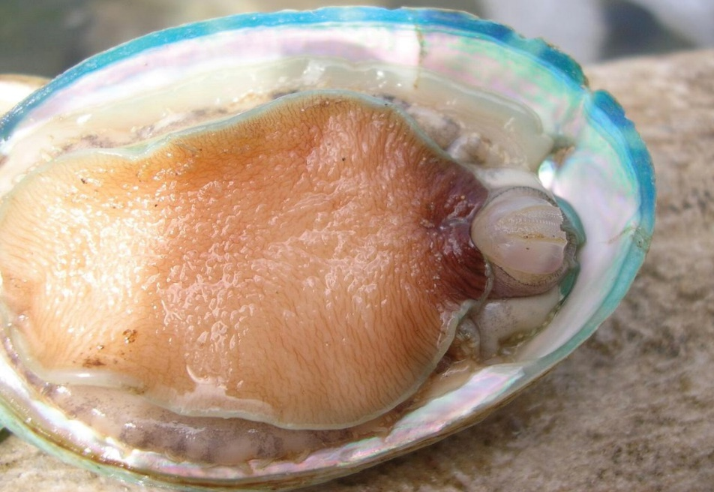
Note: Swollen and protruding mouth parts, particularly the prominent radula (toothed chitinous ribbon). The retracted (curled) foot margins expose bare shell beneath.
Source: Victorian Department of Primary Industries
Figure 2 Healthy greenlip abalone (Haliotis laevigata)
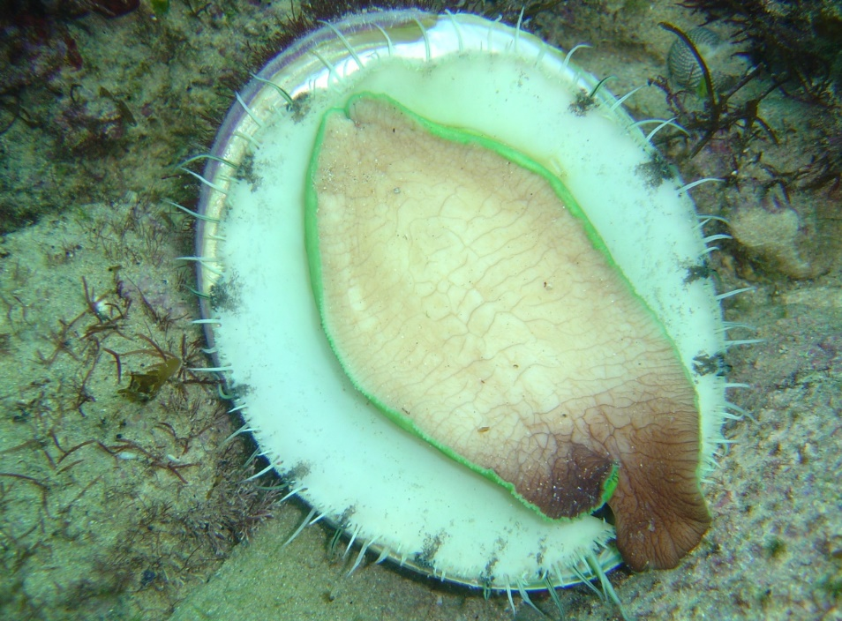
Note: No evidence of any protruding mouth parts or foot curl.
Source: Victorian Department of Primary Industries
Figure 3 Foot of tiger hybrid greenlip × blacklip abalone (Haliotis rubra × H. laevigata) with AVG
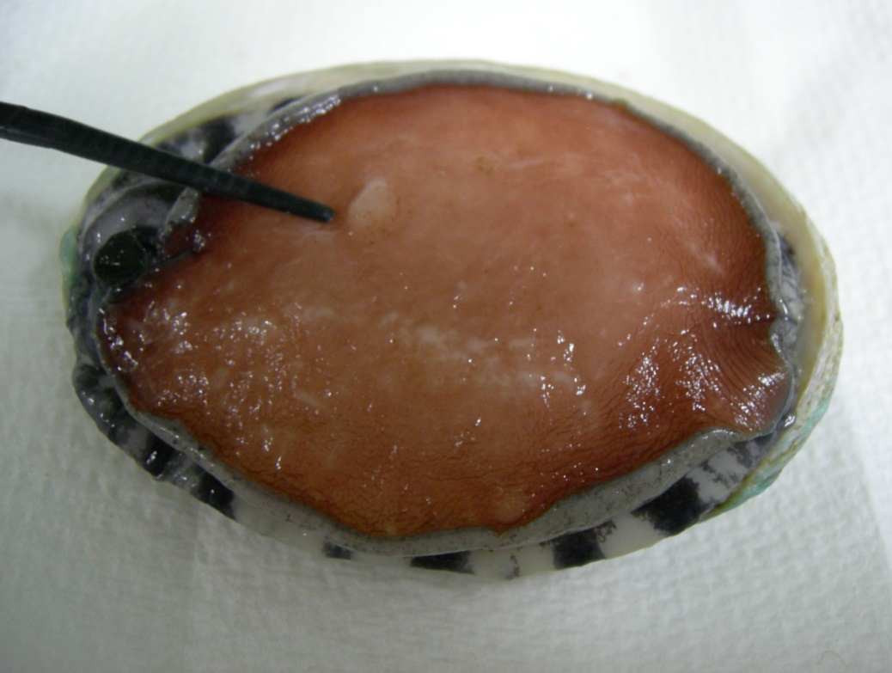
Note: Blistering of foot (lesion near forceps).
Source: L Williams, CSIRO Australian Animal Health Laboratory

Signs of disease
Important: Animals with this disease may show one or more of these signs, but the pathogen may still be present in the absence of any signs.
Disease signs at the farm, tank or pond level are:
- rapid and high cumulative mortality of up to 90%
- inability to adhere to the substrate
- inability of individuals to right themselves when upside down.
Gross pathological signs are:
- swollen and protruding mouth parts
- reduced activity of the pedal muscle
- edges of the foot curled inwards, leading to exposure of clean, shiny shell
- tetany or 'hard foot', sometimes with blistering
- excessive mucous production
- abnormal spawning and bloating.
Microscopic pathological signs are:
- inflammation and necrosis of neural tissue.

Disease agent
AVG is caused by infection with abalone herpesvirus (AbHV), also known as haliotid herpesvirus 1 or HaHV-1. The virus is a member of the Haliotivirus genus in the family Malacoherpesviridae.

Host range
Several species of abalone are known to be susceptible to infection with AbHV. However, the New Zealand paua (Haliotis iris) appears highly resistant to infection.
Table 1 Species known to be naturally susceptible to infection with AbHV
Common name | Scientific name
Blacklip abaloneª | Haliotis rubra
Brownlip abalone | Haliotis conicopora
Disc abaloneª | Haliotis discus hannai
Diversicolor or jiukong abaloneª | Haliotis diversicolor
Greenlip abaloneª | Haliotis laevigata
Pink abalone | Haliotis corrugata
Tiger abaloneª | Haliotis rubra × H. laevigata
a Naturally susceptible. Note: Other species have been shown to be experimentally susceptible.

Presence in Australia
Victoria and Tasmania have officially reported the presence of AVG. In Victoria, AVG has been observed in farmed and wild abalone.
In Tasmania, the disease has not been observed in wild abalone populations. However, AbHV has been detected in wild abalone and the disease has been observed in abalone held in holding facilities and aquaculture facilities.
Map 1 Presence of AbHV, by jurisdiction
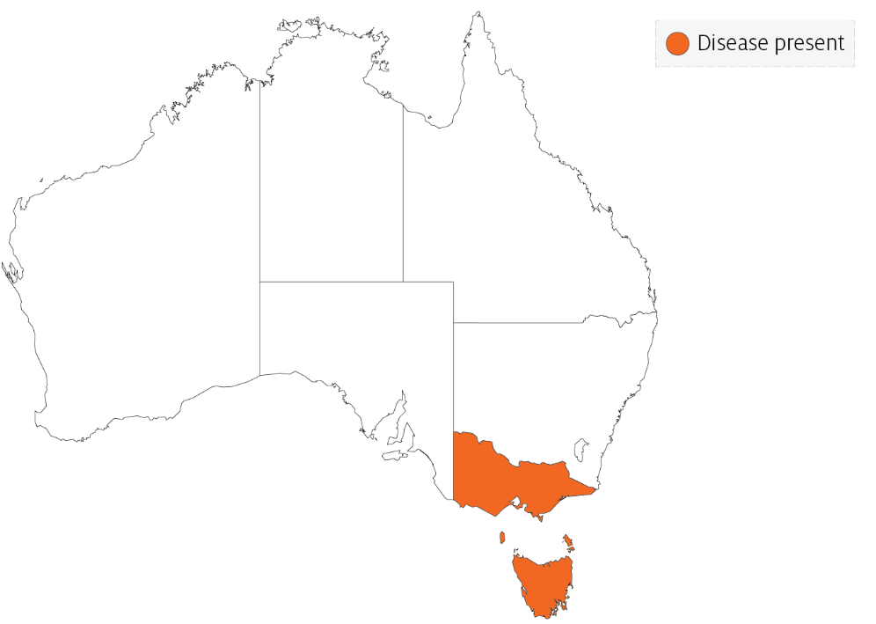

Epidemiology
- AVG affects the nervous system of abalone.
- AVG affects abalone of all ages.
- Horizontal transmission has been demonstrated by:
  - exposing healthy abalone to water containing diseased abalone in the same tank, but without direct contact between the diseased and healthy abalone
  - placing healthy abalone in water that was previously inhabited by diseased abalone
  - intramuscular injection of healthy abalone with a filtered tissue homogenate from diseased abalone.
- Mortality can occur within 4 days of infection and within 1 to 2 days following the onset of clinical signs.
- Apparently healthy wild-caught abalone subjected to sensitive molecular diagnostic tests have tested positive for the virus.
- At least 5 variants of AbHV have been identified: Vic1, Tas1, Tas2, Tas3 and Tas4. All virus variants cause disease and mortality in all Australian native abalone stocks tested to date.

Differential diagnosis
The list of similar diseases in the next section refers only to the diseases covered by this field guide. Gross pathological signs may also be representative of diseases not included in this guide. Do not rely on gross signs to provide a definitive diagnosis. Use them as a tool to help identify the listed diseases that most closely account for the observed signs.

Similar diseases
No diseases in this field guide are similar to Abalone viral ganglioneuritis.

Sample collection
Only trained personnel should collect samples. Using only gross pathological signs to differentiate between diseases is not reliable, and some aquatic animal disease agents pose a risk to humans. If you are not appropriately trained, phone your state or territory hotline number and report your observations. If you have to collect samples, the agency taking your call will advise you on the appropriate course of action. Local or district fisheries or veterinary authorities may also advise on sampling.

Emergency disease hotline
See something you think is this disease? Report it. Even if you’re not sure.
Call the Emergency Animal Disease Watch Hotline on 1800 675 888. They will refer you to the right state or territory agency.

Microscope images
Figure 4 Electron micrograph of AbHV responsible for causing AVG
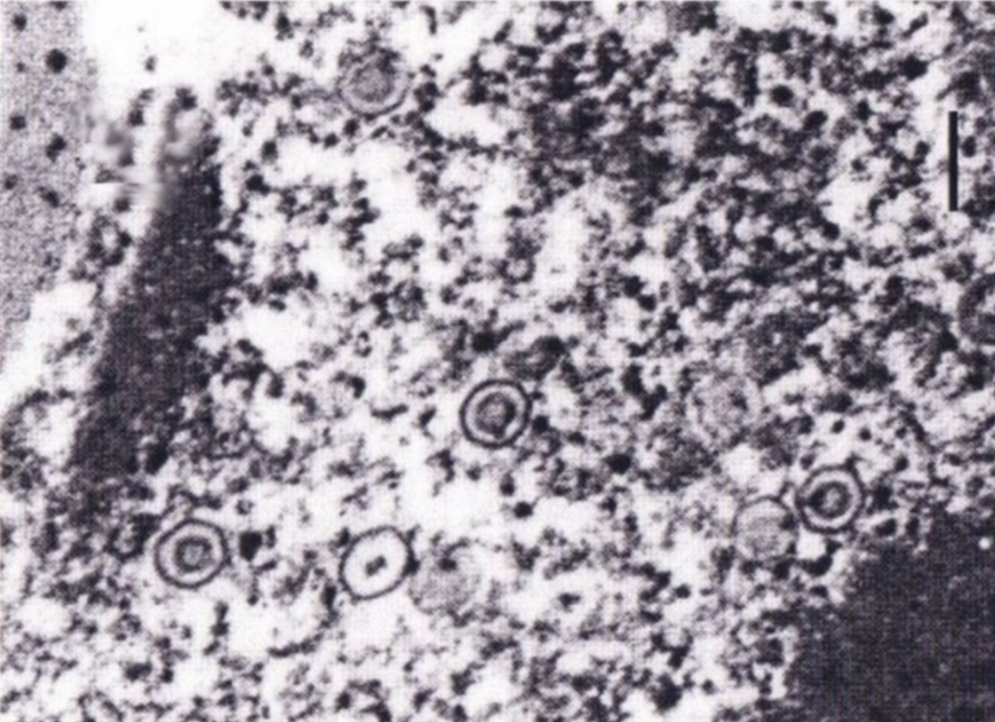
Note: Several enveloped herpesvirus particles are visible.
Source: CSIRO Australian Animal Health Laboratory
Figure 5 Histological section of foot of abalone with clinical AVG
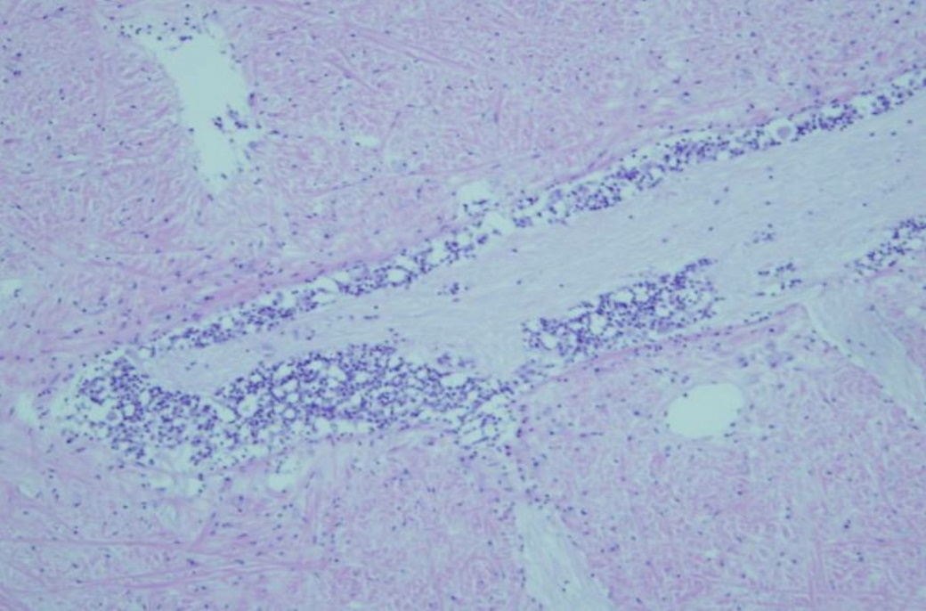
Note: Florid inflammatory response (darker spots) around the nerve ganglia is typical of clinical AVG.
Source: Victorian Department of Primary Industries
Figure 6 Higher magnification histological section of foot of abalone with clinical AVG
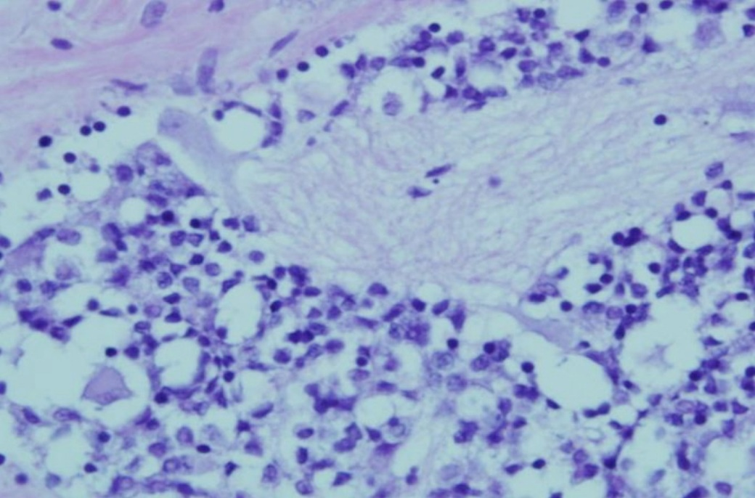
Note: Higher magnification of bottom left quadrant of Figure 5. Shows numerous inflammatory cells surrounding the affected nerve ganglion.
Source: Victorian Department of Primary Industries

Further reading
CEFAS International Database on Aquatic Animal Diseases Infection with abalone herpesvirus
Department of Agriculture, Water and the Environment AQUAVETPLAN disease strategy manual: Abalone viral ganglioneuritis
World Organisation for Animal Health Manual of diagnostic tests for aquatic animals
These hyperlinks were correct at the time of publication.

Contact details
Emergency Animal Disease Watch Hotline 1800 675 888
Email AAH@agriculture.gov.au
Website agriculture.gov.au/pests-diseases-weeds/aquatic
© Commonwealth of Australia 2020
This work is copyright. It may be reproduced in whole or in part subject to the inclusion of an acknowledgement of the source and no commercial usage or sale.

