Acute hepatopancreatic necrosis disease (AHPND)

Also known as early mortality syndrome (EMS)

From Aquatic animal diseases significant to Australia: identification field guide, 5th edition
Figure 1 Pacific white shrimp (Penaeus (Litopenaeus) vannamei) with AHPND
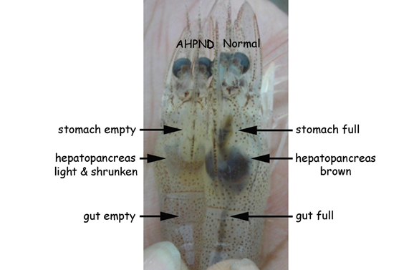
Note: Infected shrimp shows empty stomach and gut and a paler and shrunken hepatopancreas. Healthy shrimp shows a full stomach and gut and brown hepatopancreas.
Source: DV Lightner
Figure 2 Black tiger prawn (Penaeus monodon) with AHPND
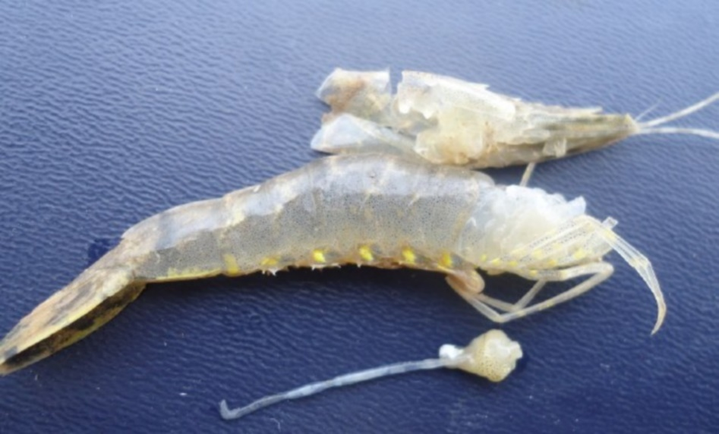
Note: Pale colour and small size of excised, atrophied hepatopancreas.
Source: DV Lightner

Signs of disease
Important: Animals with this disease may show one or more of these signs, but the pathogen may still be present in the absence of any signs.
Disease signs at the farm, tank or pond level are:
- pale to white hepatopancreas due to pigment loss in the connective tissue capsule
- moribund prawns sink to bottom
- onset of clinical signs and mass mortality up to 100% starting as early as 10 days post stocking and usually within 30 to 35 days.
Gross pathological signs are:
- soft shell
- guts with discontinuous contents or no contents
- black (melanised) spots or streaks visible within the hepatopancreas
- atrophy (shrinkage) of the hepatopancreas
- hepatopancreas does not squash easily between thumb and forefinger.
Microscopic pathological signs are:
- acute phase
  - massive and progressive degeneration of the hepatopancreas tubules from proximal to distal
  - significant rounding and sloughing of hepatopancreas tubule epithelial cells into the tubule lumens, collecting ducts and posterior stomach
- terminal phase
  - massive secondary bacterial infection (Vibrio spp.) in the sloughed cells
  - complete destruction of the hepatopancreas.
The only definitive histopathology is in the acute stage with the massive sloughing of hepatopancreas tubule epithelial cells in the absence of bacteria.

Disease agent
AHPND is also known as early mortality syndrome (EMS), and is caused by infection with Vibrio parahaemolyticus (Vp_{AHPND}). Vp_{AHPND} contains a plasmid (pVA1) of an approximately 70-kbp with genes that encode homologues of the Photorhabdus insect-related (Pir) toxins PirA and PirB. There are reports of the isolation of other Vibrio species from clinical cases of AHPND. However, only Vp_{AHPND} has been demonstrated to cause AHPND.

Host range
This disease affects mainly Penaeus (Litopenaeus) vannamei and Penaeus monodon. It may also be problematic in Penaeus (Fenneropenaeus) chinensis. Kuruma prawns are unaffected but may act as carriers. Live polychaete worms may also act as vectors for specific virulent strains of Vibrio parahaemolyticus when used to feed broodstock prawns.
Table 1 Species known to be susceptible to AHPND
Common name | Scientific name
Black tiger prawnª | Penaeus monodon
Chinese white shrimpª | Penaeus (Fenneropenaeus) chinensis
Kuruma prawn | Penaeus (Marsupenaeus) japonicus
Pacific white shrimpª | Penaeus (Litopenaeus) vannamei
a Naturally susceptible.
Table 2 Non-crustacean carriers of AHPND
Common name | Scientific name
Polychaetesª | Various genera and species
a Naturally susceptible.

Presence in Australia
Exotic disease—not recorded in Australia.
Vibrio parahaemolyticus is known to occur in Australia. However, specific strains containing the plasmid (pVA1) of approximately 70-kbpwith genes that encode homologues of the Photorhabdus insect-related (Pir) toxins, PirA and PirB have not been recorded.
Map 1 Presence of AHPND, by jurisdiction
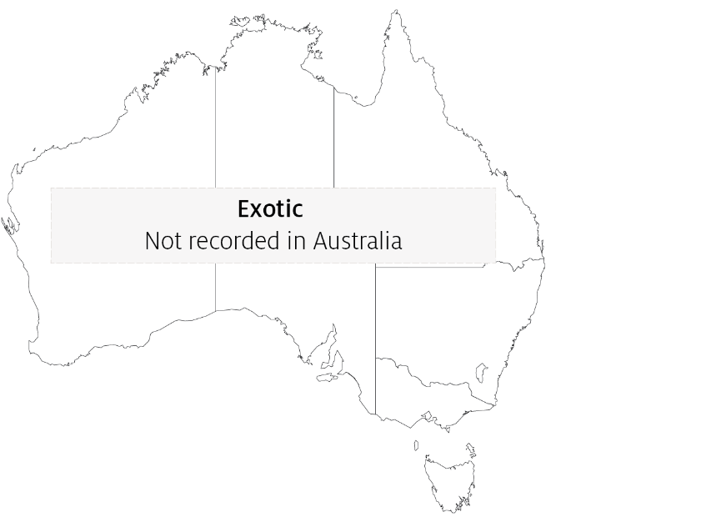

Epidemiology
- AHPND was first reported in 2009 as a novel disease of unknown aetiology in cultured prawns and was initially named early mortality syndrome (EMS). A more descriptive term for the syndrome, acute hepatopancreatic necrosis syndrome (AHPNS), was later adopted.
- With the aetiological agents now identified, the current disease name is AHPND.
- AHPND is transmitted horizontally by the oral route and cohabitation.
- Water sources with low salinity (less than 20ppt) seem to reduce the incidence of the disease.
- Other factors that may lead to AHPND in areas where these specific bacterial strains are present include overfeeding, poor seed quality, poor water quality, poor feed quality, algal blooms or algal crashes.
- The hatchery practice of feeding live polychaete worms to broodstock to increase nauplii production presents a significant biosecurity risk and is a possible source of AHPND.
- It may be possible to reduce AHPND outbreaks by changing the design of rearing ponds, and through changes in husbandry practices.

Differential diagnosis
The list of similar diseases in the next section refers only to the diseases covered by this field guide. Gross pathological signs may also be representative of diseases not included in this guide. Do not rely on gross signs to provide a definitive diagnosis. Use them as a tool to help identify the listed diseases that most closely account for the observed signs.

Similar diseases
Infection with Enterocytozoon hepatopenaei (EHP), infection with Hepatobacter penaei (NHP) and infection with shrimp haemocyte iridescent virus (SHIV).

Sample collection
Only trained personnel should collect samples. Using only gross pathological signs to differentiate between diseases is not reliable, and some aquatic animal disease agents pose a risk to humans. If you are not appropriately trained, phone your state or territory hotline number and report your observations. If you have to collect samples, the agency taking your call will advise you on the appropriate course of action. Local or district fisheries or veterinary authorities may also advise on sampling.

Emergency disease hotline
See something you think is this disease? Report it. Even if you’re not sure.
Call the Emergency Animal Disease Watch Hotline on 1800 675 888. They will refer you to the right state or territory agency.

Mocroscope images
Figure 3 Low-magnification photomicrograph of the hepatopancreas of a juvenile Pacific white shrimp (Penaeus (Litopenaeus) vannamei) with acute AHPND
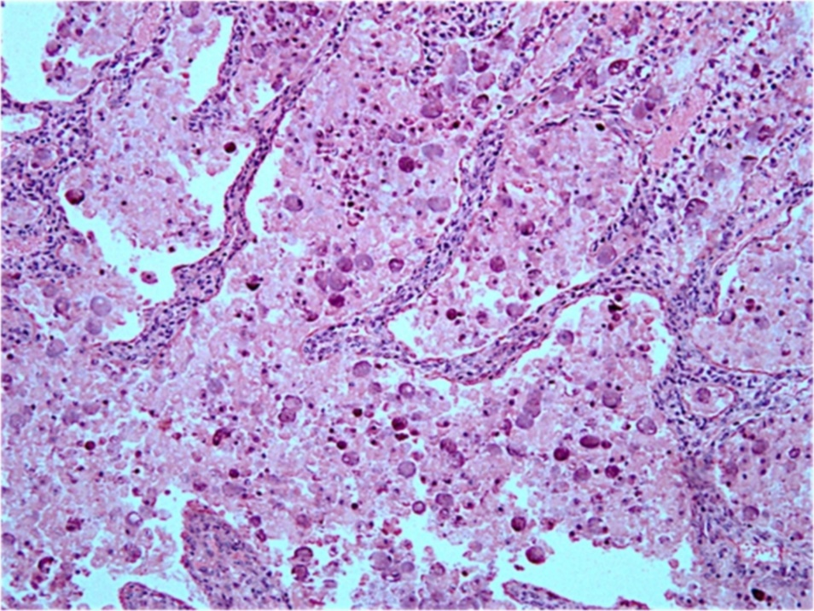
Note: Massive necrosis and sloughing of the tubule epithelial cells into the tubule lumen.
Source: J Brock
Figure 4 High magnification photomicrograph of the hepatopancreas of a juvenile Pacific white shrimp (Penaeus (Litopenaeus) vannamei) with acute AHPND
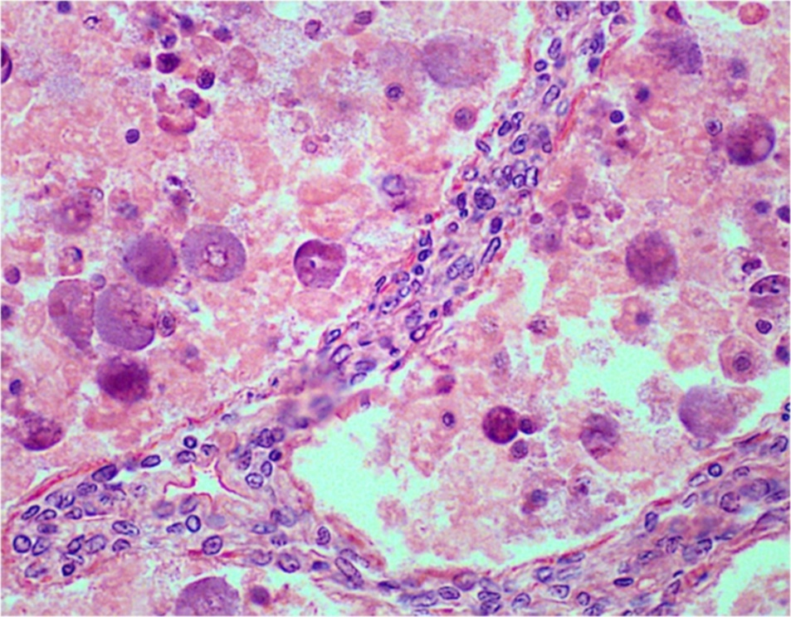
Note: Massive necrosis, sloughing and rounding up of tubule epithelial cells as they disintegrate into the tubule lumen in the absence of obvious bacterial infection.
Source: J Brock
Figure 5 Low magnification photomicrograph of hepatopancreas of a juvenile Pacific white shrimp (Penaeus (Litopenaeus) vannamei) with terminal AHPND
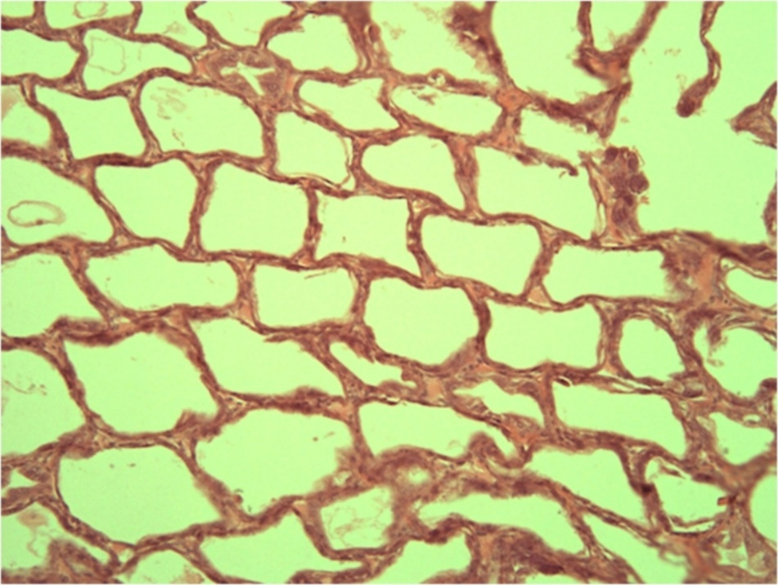
Note: Severe atrophy of the hepatopancreas tubules with almost complete loss of epithelium.
Source: J Brock

Further reading
CABI Invasive Species Compendium Acute hepatopancreatic necrosis disease
Network of Aquaculture Centres in Asia-Pacific Acute hepatopancreatic necrosis: disease card
World Organisation for Animal Health Manual of diagnostic tests for aquatic animals
These hyperlinks were correct at the time of publication.

Contact details
Emergency Animal Disease Watch Hotline 1800 675 888
Email AAH@agriculture.gov.au
Website agriculture.gov.au/pests-diseases-weeds/aquatic
© Commonwealth of Australia 2020
This work is copyright. It may be reproduced in whole or in part subject to the inclusion of an acknowledgement of the source and no commercial usage or sale.

