Bacterial kidney disease (BKD)

Also known as infection with Renibacterium salmoninarum

From Aquatic animal diseases significant to Australia: identification field guide, 5th edition
Figure 1 Ventral view of adult chinook salmon (Oncorhynchus tshawytscha) infected with Renibacterium salmoninarum
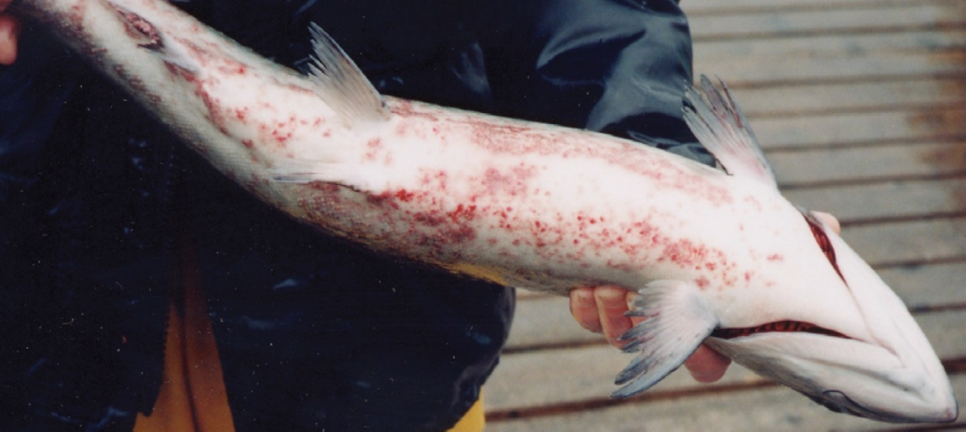
Note: Dermatitis (spawning rash) typical of BKD on bottom of fish.
Source: R Pascho and D Elliott
Figure 2 Kidneys of Juvenile chinook salmon (Oncorhynchus tshawytscha) affected by BKD
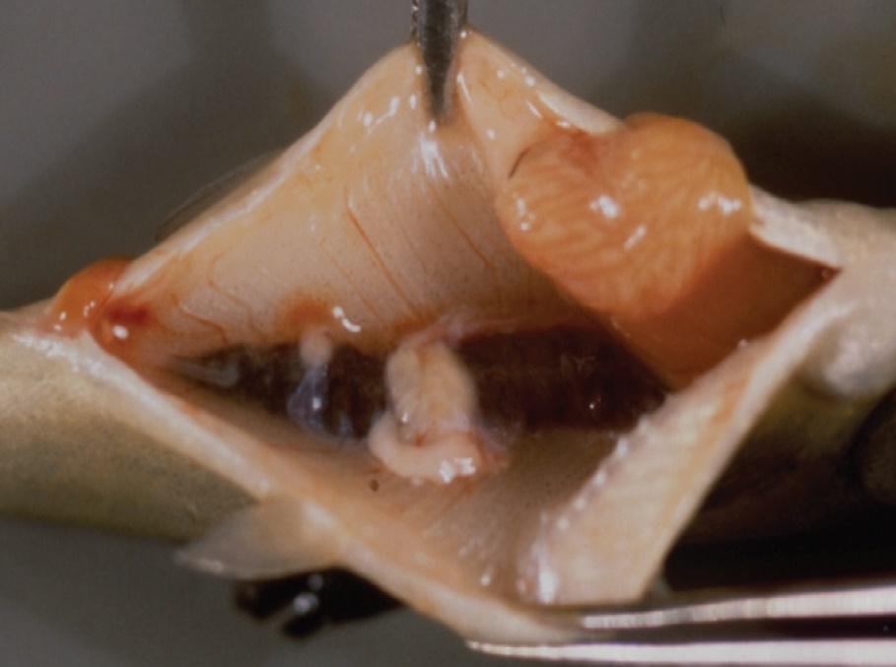
Note: Multiple kidney lesions.
Source: R Pascho and C O’Farrell

Signs of disease
Important: Animals with this disease may show one or more of these signs, but the pathogen may still be present in the absence of any signs.
Disease signs at the farm, tank or pond level are:
- lethargy
- Increasing mortality.
Gross pathological signs are:
- exophthalmos (popeye)
- swollen abdomen and skin blisters (spawning rash) or shallow ulcers (remnants of ruptured blisters)
- darkening of skin and pale gills
- haemorrhages at the base of the fins or at the vent
- creamy-white, granulomatous, nodular lesions in the kidney and sometimes in the liver and spleen, which may be encapsulated
- ascites (fluid in the abdominal cavity)
- haemorrhages on the abdominal wall and in the viscera
- diffuse, white membranous layer on one or more internal organs
- enlarged spleen
- cystic cavities in skeletal muscle.
Microscopic pathological signs are:
- focal or diffuse granulomatous reaction in the kidneys, liver and spleen
- small, rod-shaped bacteria (Renibacterium salmoninarum) in histological sections of skin lesions.

Disease agent
BKD is caused by infection with R. salmoninarum, a member of the family Micrococcaceae. BKD is a slow, progressive and frequently fatal infection of cultured and wild salmonids in both fresh and marine waters.

Host range
Table 1 Species of salmonid fish known to be susceptible to BKD
Common name | Scientific name
Arctic char | Salvelinus alpinus
Atlantic salmonª | Salmo salar
Black sea salmon | Salmo labrax
Brook troutª | Salvelinus fontinalis
Brown troutª | Salmo trutta
Chinook salmonª | Oncorhynchus tshawytscha
Chum salmon | Oncorhynchus keta
Coho salmonª | Oncorhynchus kisutch
Cutthroat troutª | Oncorhynchus clarkii
Danube salmonª | Hucho hucho
Masu salmonª | Oncorhynchus masou
Pink salmonª | Oncorhynchus gorbuscha
Rainbow troutª | Oncorhynchus mykiss
a Naturally susceptible. Note: Other species have been shown to be experimentally susceptible.
Table 2 Species of non-salmonid fish known to be susceptible to BKD
Common name | Scientific name
Ayu | Plecoglossus altivelis
Burbot | Lota lota
Common shiner | Luxilus cornutus
Fathead minnow | Pimephales promelas
Grayling | Thymallus thymallus
Pacific herring | Clupea pallasii
Sablefish | Anoplopoma fimbria
Sea lamprey | Petromyzon marinus
Shiner perch | Cymatogaster aggregata
Table 3 Non-salmonid carriers
Common name | Scientific name
Bartail flathead | Platycephalus indicus
Greenling | Hexagrammos otakii
Japanese scallop | Patinopecten yessoensis

Presence in Australia
Exotic disease—not recorded in Australia.
Map 1 Presence BKD, by jurisdiction
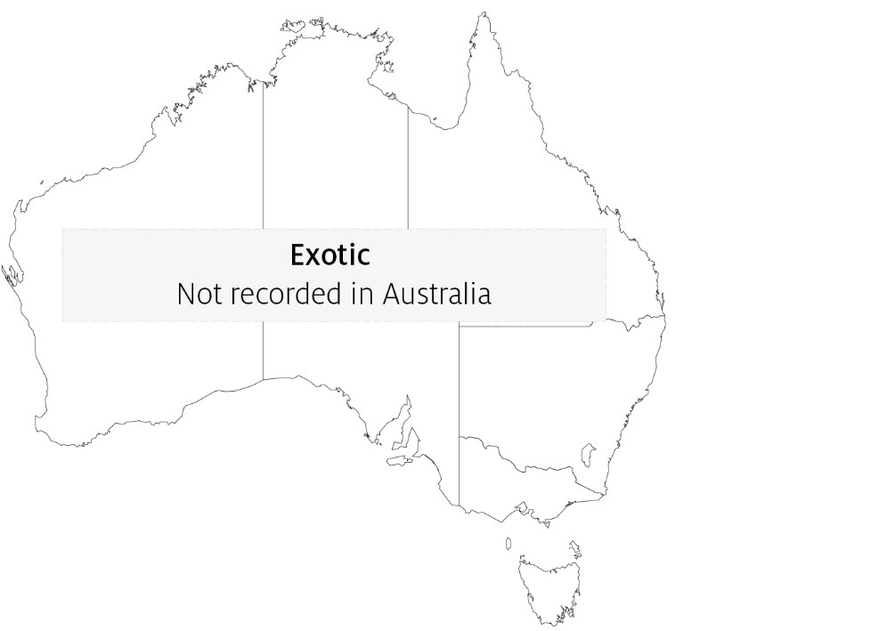

Epidemiology
- The causative bacterium is likely to persist only within salmonids and not in the environment. However, as R. salmoninarum is often endemic in wild salmon populations, hatcheries can be constantly exposed to bacteria shed into the water by wild fish upstream.
- Other non-salmonid species have been demonstrated susceptible to infection with R. salmoninarum, but only when raised in proximity to highly infected salmonids.
- The bacterium is transmitted both horizontally (between fish via the water) and vertically (parent to offspring via eggs). Surface disinfection of eggs does not prevent vertical transmission.
- Advanced infection becomes apparent only after the first year of the fish's life.
- Coho (Oncorhynchus kisutch) and chinook (O. tshawytscha) salmon are the most important worldwide sources of infection.

Differential diagnosis
The list of similar diseases in the next section refers only to the diseases covered by this field guide. Gross pathological signs may also be representative of diseases not included in this guide. Do not rely on gross signs to provide a definitive diagnosis. Use them as a tool to help identify the listed diseases that most closely account for the observed signs.

Similar diseases
Piscirickettsiosis and viral haemorrhagic septicaemia (VHS).

Sample collection
Only trained personnel should collect samples. Using only gross pathological signs to differentiate between diseases is not reliable, and some aquatic animal disease agents pose a risk to humans. If you are not appropriately trained, phone your state or territory hotline number and report your observations. If you have to collect samples, the agency taking your call will advise you on the appropriate course of action. Local or district fisheries or veterinary authorities may also advise on sampling.

Emergency disease hotline
See something you think is this disease? Report it. Even if you’re not sure.
Call the Emergency Animal Disease Watch Hotline on 1800 675 888. They will refer you to the right state or territory agency.

Microscope images
Figure 3 Histological section of skin lesion of juvenile chinook salmon (Oncorhynchus tshawytscha) infected with Renibacterium salmoninarum
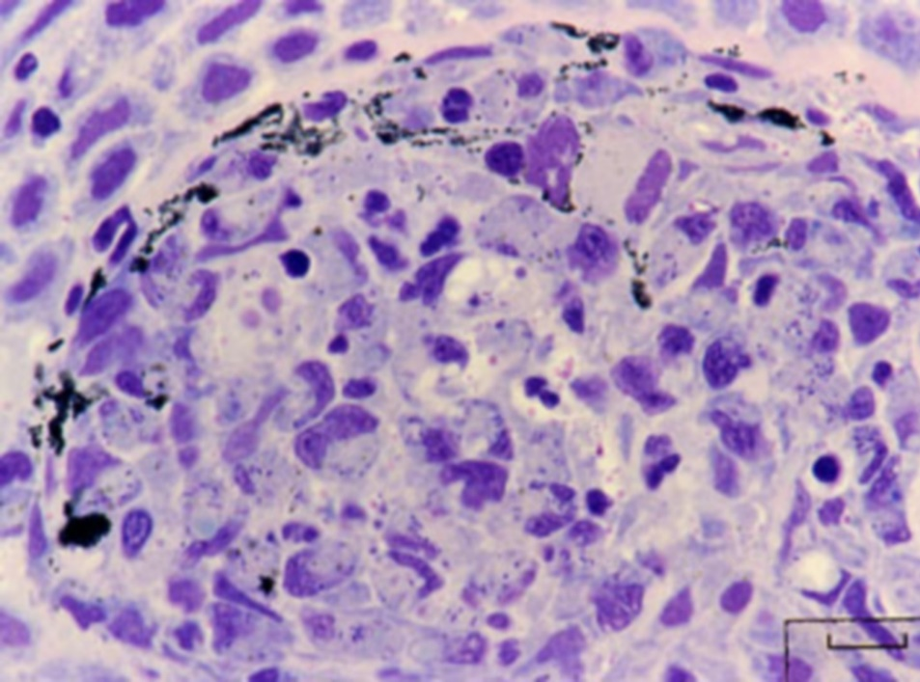
Note: Most of the small, rod-shaped R. salmoninarum are visible within the cytoplasm of macrophages. In this Giemsa-stained preparation, bacteria are purple–blue and melanin granules are black.
Source: R Pascho
Figure 4 Histological section of granulomas of juvenile chinook salmon (Oncorhynchus tshawytscha) affected by BKD
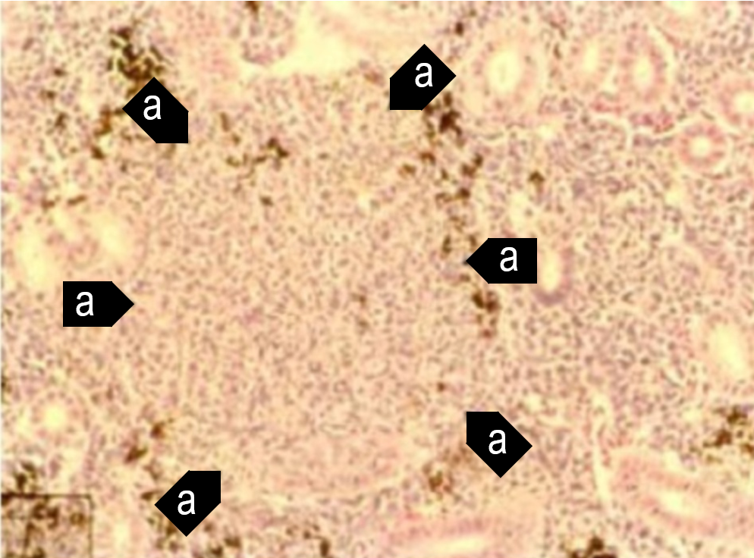
Note: Focal granulomatous inflammation (a).
Source: R Pascho and C O’Farrell
Figure 5 Histological section of granulomas of juvenile chinook salmon (Oncorhynchus tshawytscha) affected by BKD
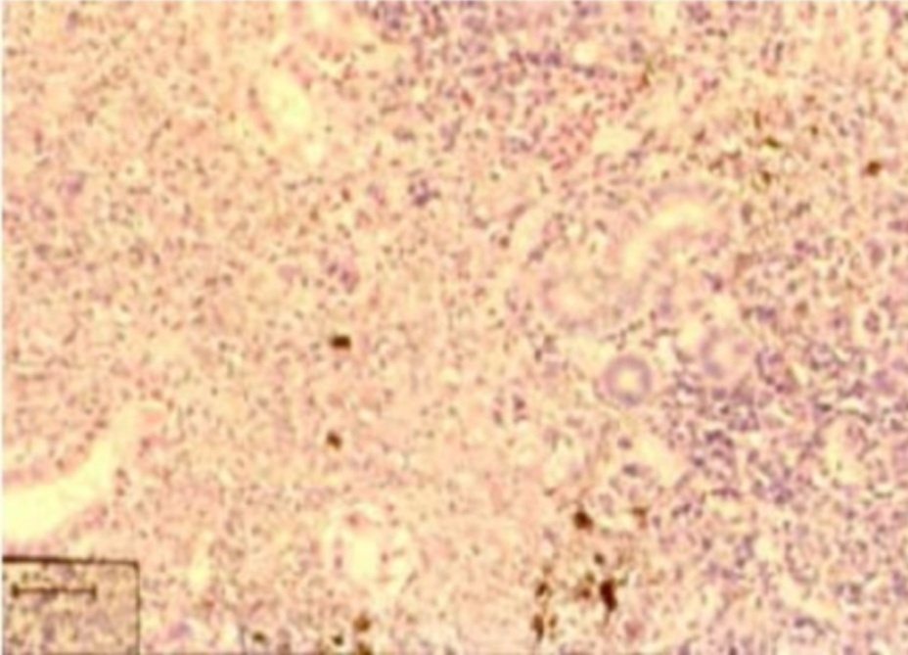
Note: Diffuse granulomatous inflammation.
Source: R Pascho and C O’Farrell
Figure 6 Gram-stained histological section of pancreatic tissue of juvenile chinook salmon (Oncorhynchus tshawytscha) with systemic BKD
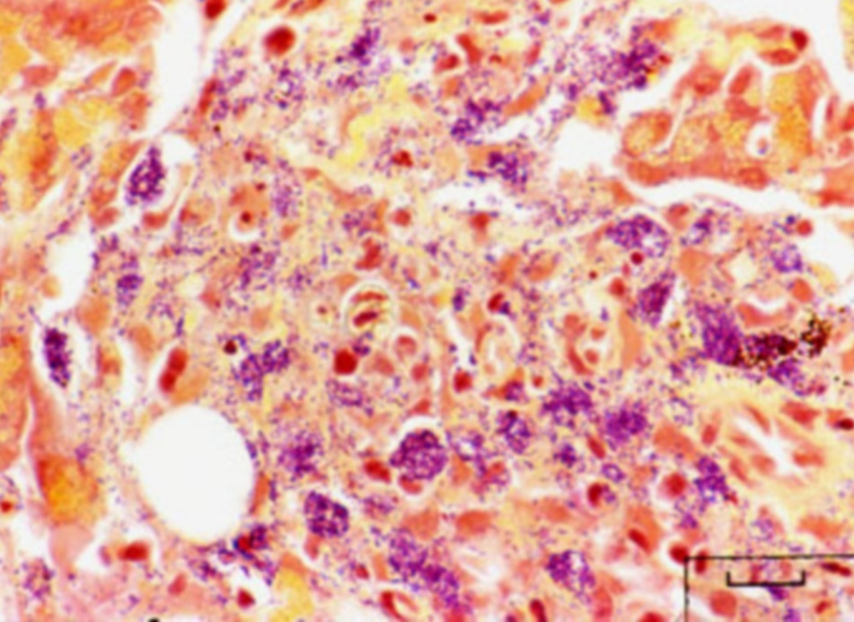
Note: Gram-positive (purple–blue) cells of R. salmoninarum are present extracellularly and intracellularly within macrophages, in contrast to brown–black melanin granules.
Source: R Pascho

Further reading
CABI Invasive Species Compendium ‘Renibacterium salmoninarum’
CEFAS International Database on Aquatic Animal Diseases Bacterial Kidney Disease (‘Renibacterium salmoninarum’)
World Organisation for Animal Health Manual of diagnostic tests for aquatic animals
These hyperlinks were correct at the time of publication.

Contact details
Emergency Animal Disease Watch Hotline 1800 675 888
Email AAH@agriculture.gov.au
Website agriculture.gov.au/pests-diseases-weeds/aquatic
© Commonwealth of Australia 2020
This work is copyright. It may be reproduced in whole or in part subject to the inclusion of an acknowledgement of the source and no commercial usage or sale.

