Channel catfish virus disease (CCVD)

Also known as infection with Ictalurid herpesvirus 1

From Aquatic animal diseases significant to Australia: identification field guide, 5th edition
Figure 1 Channel catfish (Ictalurus punctatus) fingerling showing signs of CCVD
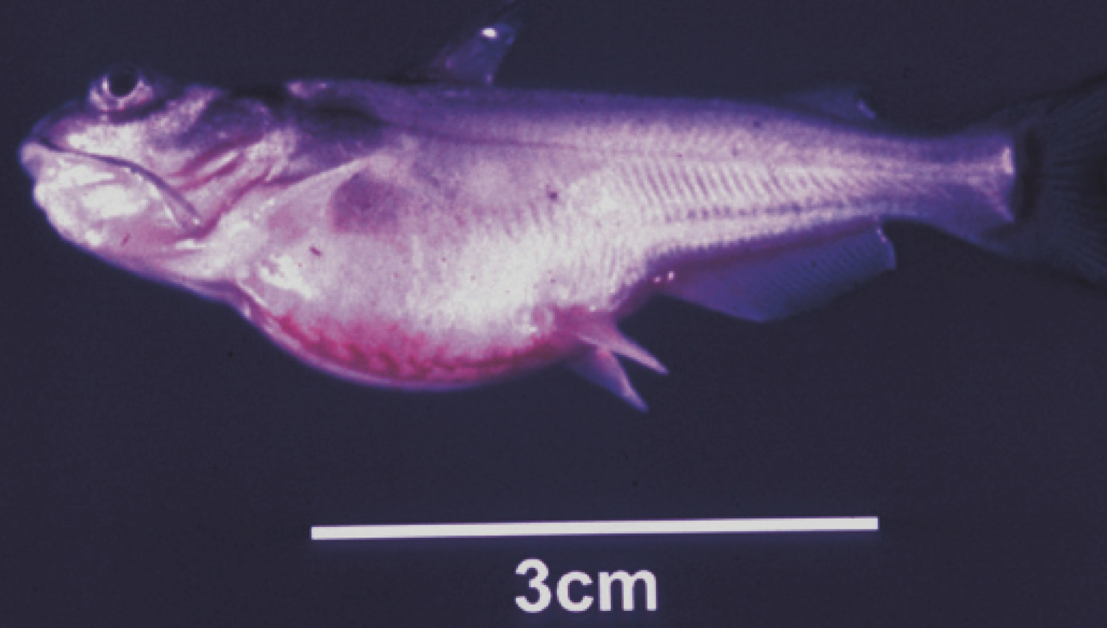
Note: Swollen abdomen and popeye.
Source: LA Hanson
Figure 2 Channel catfish (Ictalurus punctatus) with CCVD
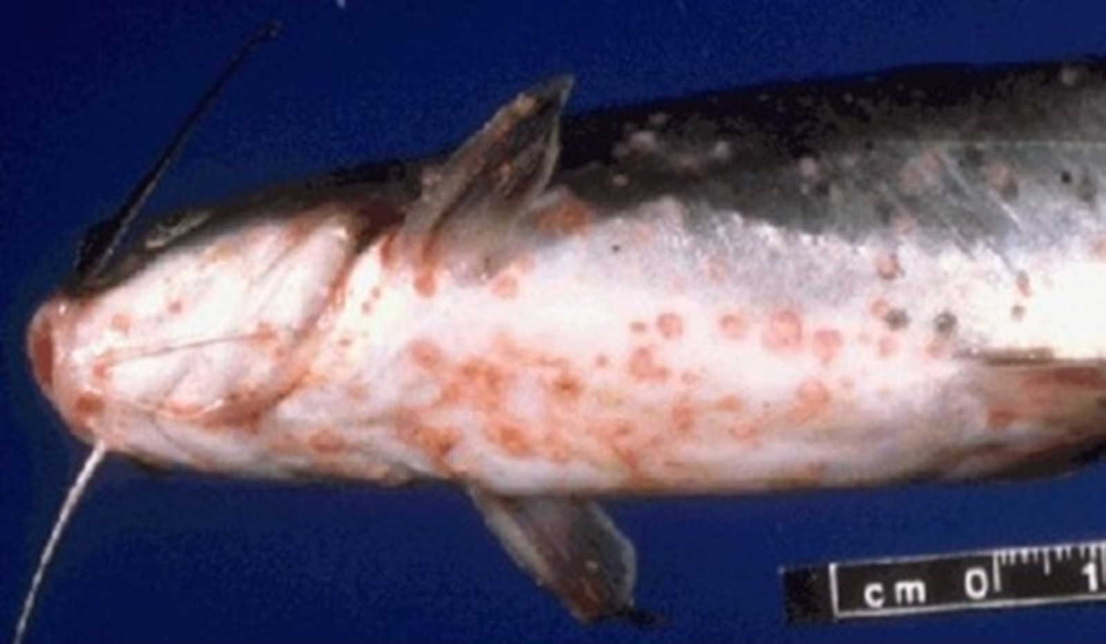
Note: Haemorrhages present on the base of the body, gills and fins.
Source: United States Department of Agriculture, Water and the Environment

Signs of disease
Important: Animals with this disease may show one or more of these signs, but the pathogen may still be present in the absence of any signs.
Disease signs at the farm, tank or pond level are:
- decreased feeding activity (usually the first sign of disease)
- high mortality in fry and juvenile catfish
- erratic swimming
- brief episodes of hyperactivity when fish are disturbed, followed by extended periods of lethargy
- large congregations of fish at the sides of hatching troughs or ponds, motionless in a head-up tail-down position.
Gross pathological signs are:
- swollen abdomen
- exophthalmos (popeye)
- haemorrhaging of fins and ventral abdomen
- haemorrhaging of the musculature, liver and kidneys
- dark and enlarged spleen
- fluid in the abdominal cavity
- pale, enlarged kidneys, which may be the only internal indication of disease in infected fish.
Microscopic pathological signs are:
- extensive necrosis of renal tubules and interstitial tissues of the kidney.

Disease agent
CCVD is caused by infection with Ictalurid herpesvirus 1, a double stranded DNA herpes virus classified within the genus Ictalurivirus, from the family Alloherpesviridae.

Host range
CCVD has been reported from blue catfish, channel catfish and channel catfish hybrids cultured in the USA, as well as Pangasius (Basa) catfish cultured in Asia. Ictalurid herpesvirus 1 has also been isolated from crucian carp (Carassius carassius) and common carp (Cyprinus carpio) not exhibiting disease signs. It is currently unknown if they act as reservoirs for the virus.
Table 1 Species known to be susceptible to CCVD
Common name | Scientific name
Blue catfishª | Ictalurus furcatus
Channel catfishª | Ictalurus punctatus
Common carp and koi carp | Cyprinus carpio
Crucian carp | Carassius carassius
Striped catfish or Traª | Pangasianodon hypophthalmus
a Naturally susceptible. Note: Other species have been shown to be experimentally susceptible.

Presence in Australia
Exotic disease—not recorded in Australia.
Map 1 Presence of CCVD, by jurisdiction
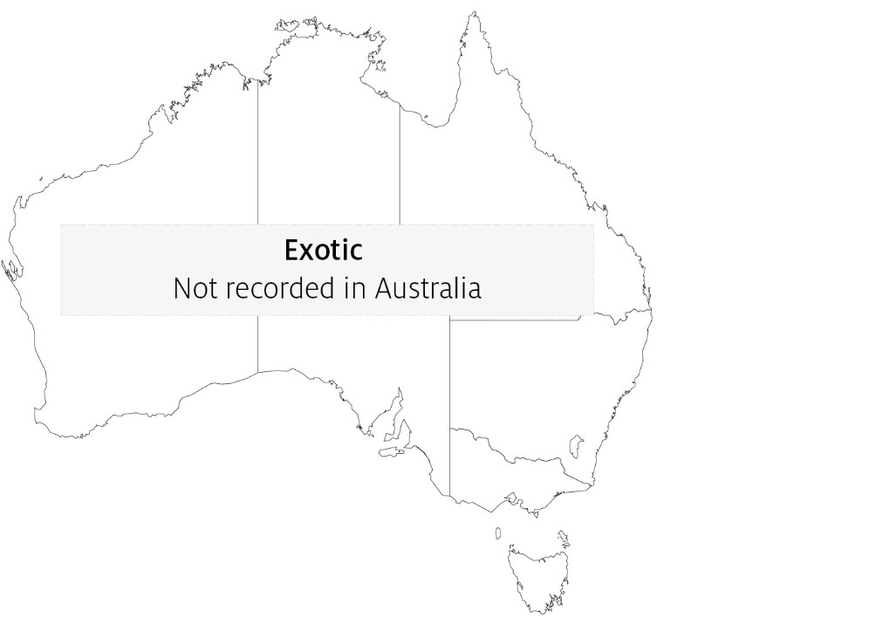

Epidemiology
- Horizontal transmission occurs directly from virus shed in water, and from virus carried by animal vectors and on fomites.
- Vertical transmission (from parent to offspring via eggs) is believed to be common.
- Mortality rates in exposed fish can exceed 95%. Survivors of CCVD may experience short-term reductions in feed conversion (reduced weight gain). Generally, these fish appear normal but become carriers of the virus.
- Susceptibility appears to vary according to the strain of the virus.
- The disease occurs almost exclusively in fish that are less than 1 year old (fry and fingerlings) or smaller than 15cm in length. The majority of occurrences are in fish less than 4 months old.
- Mortality rates are highest where water temperature exceeds 27°C and declines with a reduction in temperature. Mortality rates are negligible at water temperatures lower than 18°C.

Differential diagnosis
The list of similar diseases in the next section refers only to the diseases covered by this field guide. Gross pathological signs may also be representative of diseases not included in this guide. Do not rely on gross signs to provide a definitive diagnosis. Use them as a tool to help identify the listed diseases that most closely account for the observed signs.

Similar diseases
Enteric septicaemia of catfish, European catfish virus (ECV) and European sheatfish virus (ESV), and infection with Aeromonas salmonicida—atypical strains.

Sample collection
Only trained personnel should collect samples. Using only gross pathological signs to differentiate between diseases is not reliable, and some aquatic animal disease agents pose a risk to humans. If you are not appropriately trained, phone your state or territory hotline number and report your observations. If you have to collect samples, the agency taking your call will advise you on the appropriate course of action. Local or district fisheries or veterinary authorities may also advise on sampling.

Emergency disease hotline
See something you think is this disease? Report it. Even if you’re not sure.
Call the Emergency Animal Disease Watch Hotline on 1800 675 888. They will refer you to the right state or territory agency.

Further reading
CABI Invasive Species Compendium Channel catfish virus disease
Camus, AC 2004, Channel catfish virus disease, Southern Regional Aquaculture Centre
CEFAS International Database on Aquatic Animal Diseases Channel catfish virus disease
These hyperlinks were correct at the time of publication.

Contact details
Emergency Animal Disease Watch Hotline 1800 675 888
Email AAH@agriculture.gov.au
Website agriculture.gov.au/pests-diseases-weeds/aquatic
© Commonwealth of Australia 2020
This work is copyright. It may be reproduced in whole or in part subject to the inclusion of an acknowledgement of the source and no commercial usage or sale.

