Anatomy

Crustaceans

Prawns
The common names ‘prawn’ and ‘shrimp’ are often used synonymously for the same crustaceans in different parts of the world. This field guide uses the terms most commonly used in Australia. Where Australian species of crustaceans are primarily involved in the disease, they are referred to as prawns. However, where the species of crustacean involved in the disease are exotic to Australia, they are referred to as shrimp.
Figure 1 External anatomy of prawn 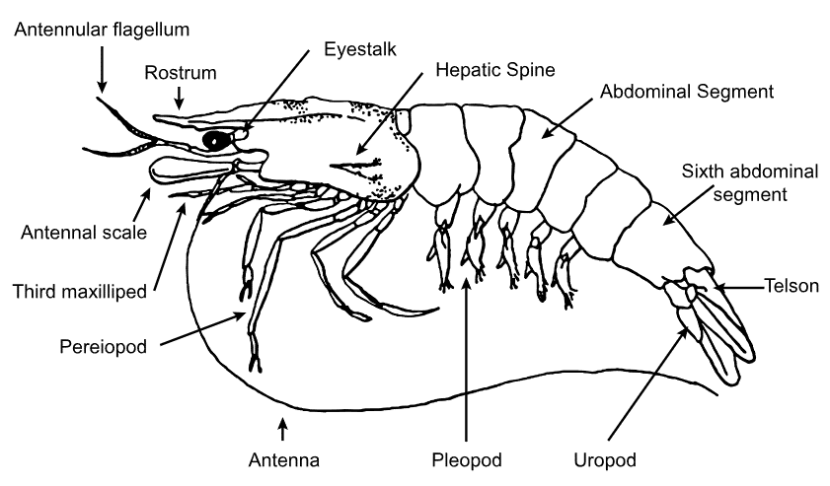
Source: R Bowater, Queensland Department of Primary Industries and Fisheries
Figure 2 Black tiger prawn (Penaeus monodon)
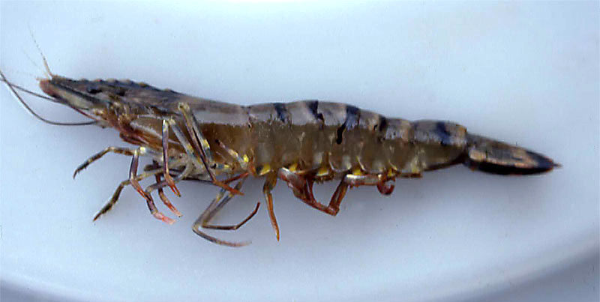
Source: Australian Government Department of Agriculture, Water and the Environment

Crabs
Figure 3 External anatomy of crab
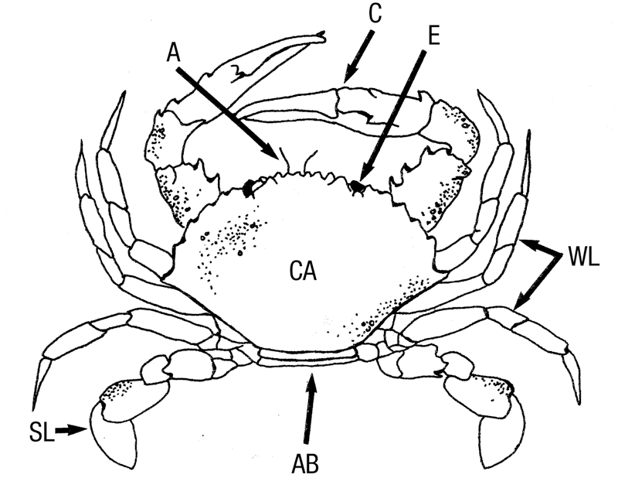
A antenna. AB abdomen (underneath). C claw. CA carapace. E eye. SL swimming leg. WL walking leg.
Source: R Bowater, Queensland, Department of Primary Industries and Fisheries
Figure 4 Internal anatomy of crab—saggital section
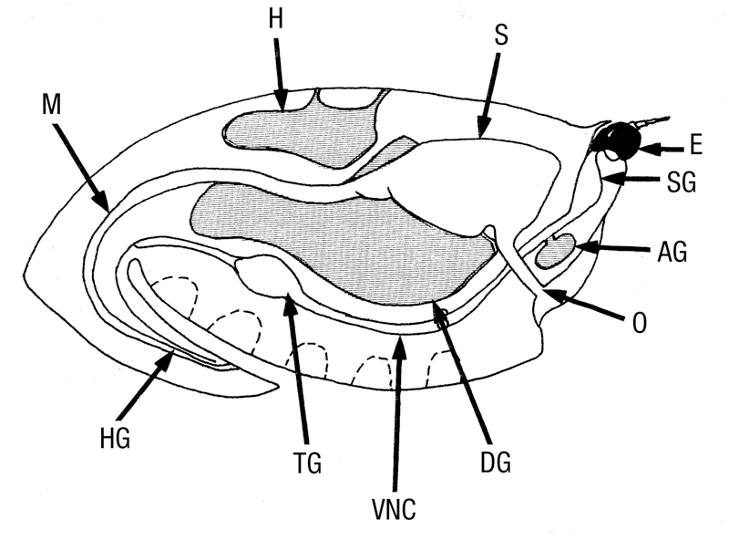
AG antennal gland. DG digestive gland (hepatopancreas). E eye. H heart. HG hindgut. M midgut. O oesophagus. S stomach. SG supraoesophageal ganglion. TG thoracic ganglion. VNC ventral nerve cord.
Source: R Bowater, Queensland Department of Primary Industries and Fisheries
Figure 5 Internal anatomy of blue swimmer crab (Callinectes sapidus)
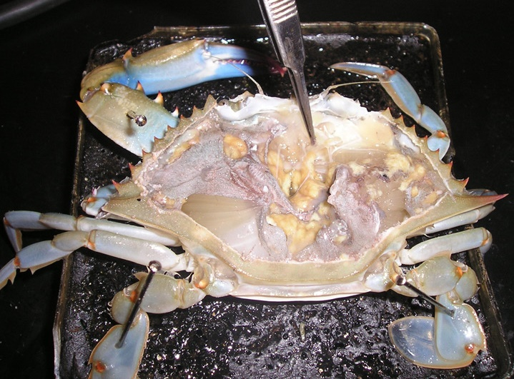
Source: O Zmora

Crayfish
Figure 6 External anatomy of freshwater crayfish
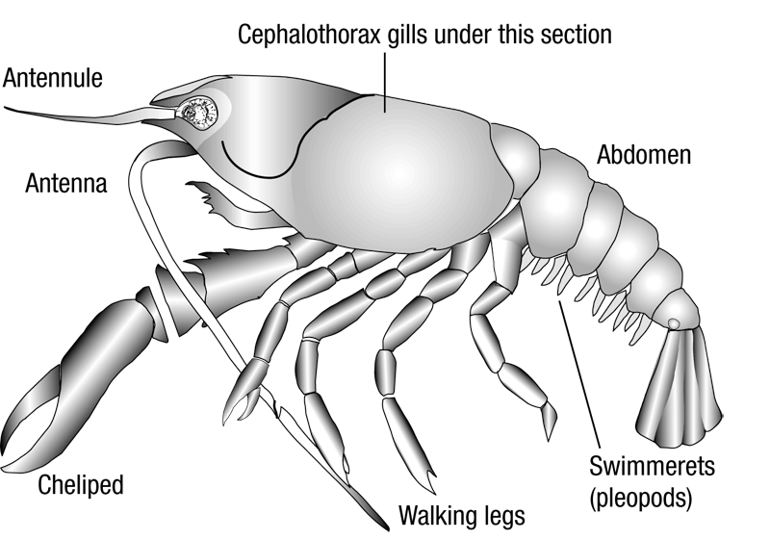
Source: Australian Government Department of Agriculture, Water and the Environment
Figure 7 Internal anatomy of freshwater crayfish—sagittal section
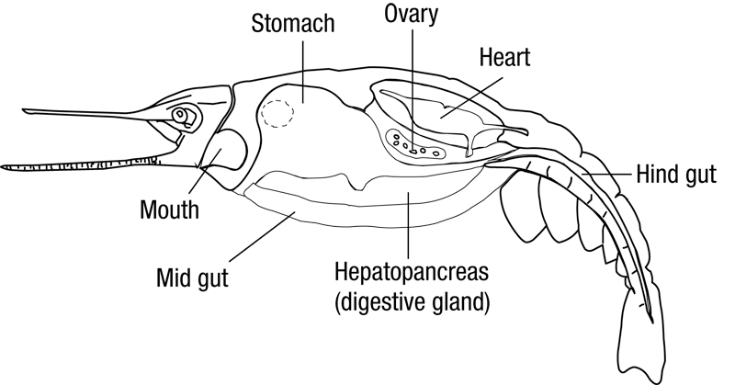
Source: Australian Government Department of Agriculture, Water and the Environment
Figure 8 Redclaw crayfish (Cherax quadricarinatus)
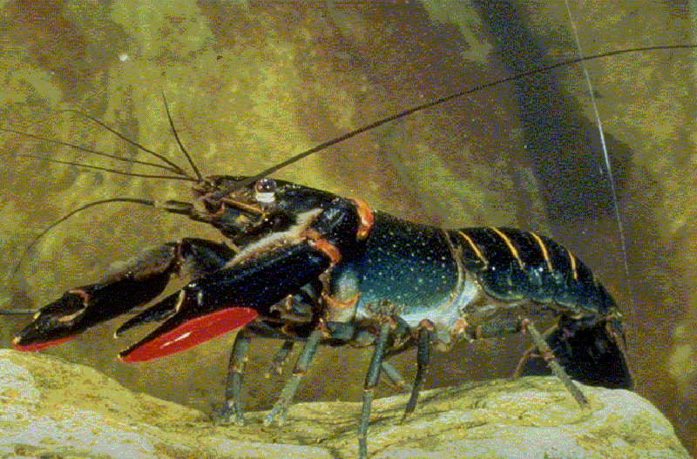
Source: C Jones
Figure 9 Gills of redclaw crayfish (Cherax quadricarinatus)
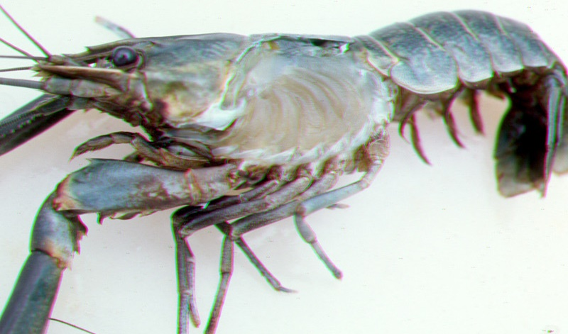
Source: C Jones

