Enteric red mouth disease (ERMD)

Also known as infection with Yersinia ruckeri

From Aquatic animal diseases significant to Australia: identification field guide, 5th edition
Figure 1 Characteristic red mouth from ERMD in rainbow trout (Oncorhynchus mykiss)
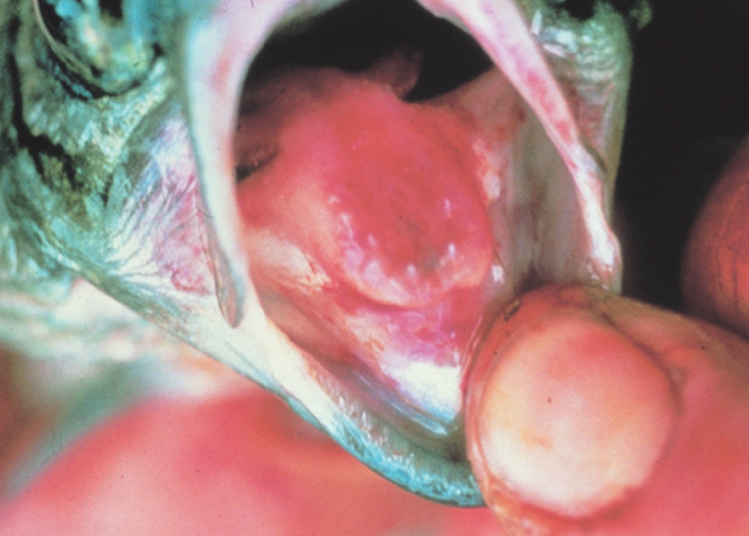
Note: Reddened mouth and tongue.
Source: HJ Schlotfeldt
Figure 2 ERMD in rainbow trout (Oncorhynchus mykiss)
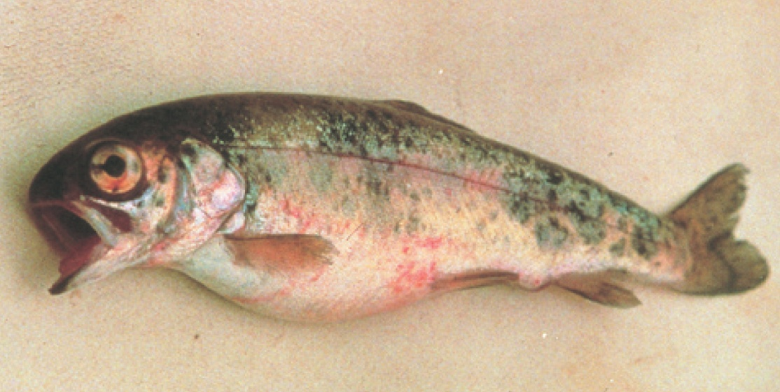
Note: Skin and eye haemorrhages, and swollen abdomen.
Source: HJ Schlotfeldt

Signs of disease
Important: Animals with this disease may show one or more of these signs, but the pathogen may still be present in the absence of any signs.
Disease signs at the farm, tank or pond level are:
- separation from other fish
- occasional nervous signs
- acute infections in fingerlings (fish of all ages may be affected, usually with sustained low-level mortalities).
Gross pathological signs are:
- dark body colour (seen in atypical infections)
- haemorrhages at base of paired fins and vent
- reddening (subcutaneous haemorrhages) of gill cover, corners of mouth, gums, palate and tongue
- exophthalmos (popeye) and orbital haemorrhages
- loss of appetite
- swollen abdomen
- ascites (fluid in the abdominal cavity)
- petechial (pinpoint) haemorrhages may occur on the surfaces of the liver, pancreas, pyloric caeca, swim bladder and in the lateral musculature
- enlarged, friable spleen is often almost black in colour
- inflamed lower intestine containing thick yellow fluid.
Microscopic pathological signs are:
- generalised haemorrhagic septicaemic inflammatory response of all tissues
- bacterial colonisation of well-vascularised tissue (spleen, liver, heart, gills, kidney)
- necrosis of haematopoietic tissue in the kidney and spleen.

Disease agent
ERMD is caused by infection with Yersinia ruckeri (Hagerman strain), a member of the family Enterobacteriaceae. There are several serotypes of the bacterium, and classification systems can be based upon whole-cell typing as well as individual cell-wall antigen groupings. The serotype responsible for ERMD is the Hagerman strain, serotype O1a, is considered to be the most virulent.
The enteric red mouth strain of Y. ruckeri (serotype O1a) is exotic to Australia. However, a virulent form of Y. ruckeri (serotype O1b) is endemic in Australia. Serotype O1b produces a septicaemic condition in Atlantic salmon (Salmo salar) known as yersiniosis. A characteristic of this form of the disease is exophthalmia (popeye) and the formation of pronounced haemorrhages in the eye that give rise to the description of blood spot disease. Signs typical of classical ERMD—prominent reddening of the corners of the mouth, gums and palate—do not normally occur in yersiniosis.

Host range
Table 1 Species found in Australia known to be naturally susceptible to ERMD
Common name | Scientific name
Atlantic salmon | Salmo salar
Brown trout | Salmo trutta
Brook trout | Salvelinus fontinalis
Common carp and koi carp | Cyprinus carpio
Goldfish | Carassius auratus
Rainbow trout | Oncorhynchus mykiss
Table 2 Species not commonly found in Australia known to be naturally susceptible to ERMD
Common name | Scientific name
Salmonids
Arctic char | Salvelinus alpinus
Chinook salmon | Oncorhynchus tshawytscha
Coho salmon | Oncorhynchus kisutch
Cutthroat trout | Oncorhynchus clarkii
Sockeye salmon | Oncorhynchus nerka
Whitefish | Coregonus spp.
Whitefish (Muksun) | Coregonus muksun
Whitefish (Peled) | Coregonus peled
Non-salmonids
Bighead carp | Aristichthys nobilis
Burbot | Lota lota
Channel catfish | Ictalurus punctatus
Cisco | Coregonus artedi
Common sole | Solea solea
Emerald shiner | Notropis atherinoides
European eel | Anguilla anguilla
Fathead minnow | Pimephales promelas
Pike | Esox lucius
Siberian sturgeon | Acipenser baerii
Silver carp | Hypophthalmichthys molitrix
Turbot | Scophthalmus maximus
Table 3 Non-fish carriers
Common name | Scientific name
Freshwater crayfish | Various genera and species

Presence in Australia
Exotic disease—not recorded in Australia.
A related disease known as yersiniosis or blood spot disease occurs in Australia.
Map 1 Presence of ERMD, by jurisdiction
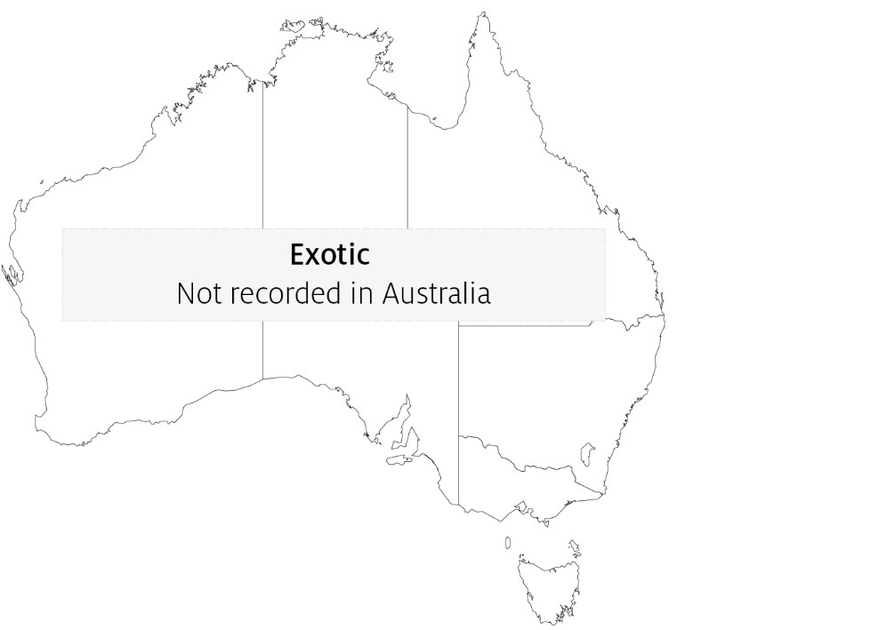

Epidemiology
- Many other aquatic species are potential carriers but show no signs (some crustaceans, including freshwater crayfish).
- Transmission can be horizontal, via direct contact with infected fish or carriers. Carriers are particularly important sources of infection under stressful situations (such as increasing water temperature).
- Yersinia ruckeri can survive in the environment, with some strains able to form biofilms.
- Vertical transmission (fish to egg) is suggested by the presence of Y. ruckeri DNA in ovarian fluids and unfertilized eggs.
- ERMD causes septicaemia (bacteria are spread through the body via the blood).
- Fish of all ages are affected, and outbreaks usually begin with low mortalities that slowly escalate. The severity of the outbreak depends on the strain and presence of stressors.

Differential diagnosis
The list of similar diseases in the next section refers only to the diseases covered by this field guide. Gross pathological signs may also be representative of diseases not included in this guide. Do not rely on gross signs to provide a definitive diagnosis. Use them as a tool to help identify the listed diseases that most closely account for the observed signs.

Similar diseases
Infection with HPR-deleted or HPR0 infectious salmon anaemia virus, infectious haematopoietic necrosis (IHN), spring viraemia of carp (SVC), viral haemorrhagic septicaemia (VHS) and whirling disease.

Sample collection
Only trained personnel should collect samples. Using only gross pathological signs to differentiate between diseases is not reliable, and some aquatic animal disease agents pose a risk to humans. If you are not appropriately trained, phone your state or territory hotline number and report your observations. If you have to collect samples, the agency taking your call will advise you on the appropriate course of action. Local or district fisheries or veterinary authorities may also advise on sampling.

Emergency disease hotline
See something you think is this disease? Report it. Even if you’re not sure.
Call the Emergency Animal Disease Watch Hotline on 1800 675 888. They will refer you to the right state or territory agency.

Microscope images
Figure 3 Skeletal muscle of rainbow trout (Oncorhynchus mykiss) naturally infected with Yersinia ruckeri
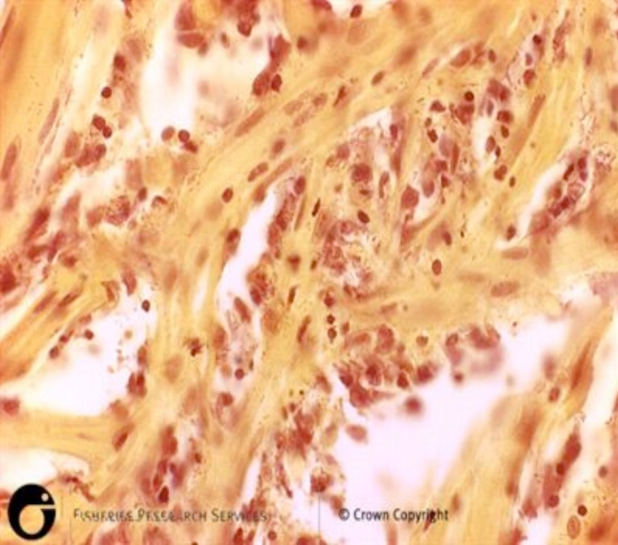
Note: Diffuse haemorrhage evident in sections of skeletal muscle.
Source: Scottish Government
Figure 4 Kidney of rainbow trout (Oncorhynchus mykiss) naturally infected with Yersinia ruckeri
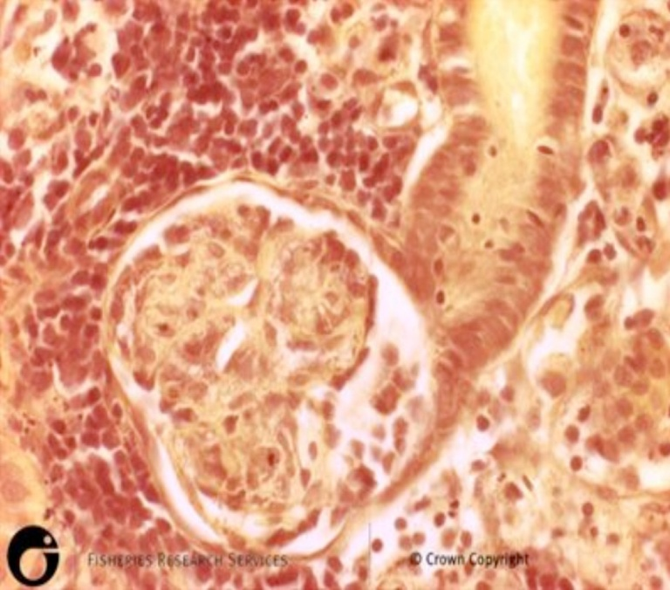
Note: Diffuse haemorrhage evident in sections of kidney.
Source: Scottish Government

Further reading
CEFAS International Database on Aquatic Animal Diseases Entric Redmouth
Glenn RA, Taylor PW, Pelton EH, Gutenberger SK, Ahrens MA, Marchant LM, Hanson KC 2015, Genetic evidence of vertical transmission and cycling of ‘Yersinia ruckeri’ in hatchery-origin fall chinook salmon ‘Oncorhynchus tshawytscha’, Journal of Fish and Wildlife Management.
Kumar G, Menanteau-Ledouble S, Saleh M, El-Matbouli M 2015, ‘Yersinia ruckeri’, the causative agent of enteric red mouth disease in fish, Veterinary Research.
These hyperlinks were correct at the time of publication.

Contact details
Emergency Animal Disease Watch Hotline 1800 675 888
Email AAH@agriculture.gov.au
Website agriculture.gov.au/pests-diseases-weeds/aquatic
© Commonwealth of Australia 2020
This work is copyright. It may be reproduced in whole or in part subject to the inclusion of an acknowledgement of the source and no commercial usage or sale.

