Enteric septicaemia of catfish

Also known as infection with Edwardsiella ictaluri, edwardsiellosis and hole-in-the-head disease

From Aquatic animal diseases significant to Australia: identification field guide, 5th edition
Figure 1 Ulcer in channel catfish (Ictalurus punctatus) with chronic enteric septicaemia of catfish
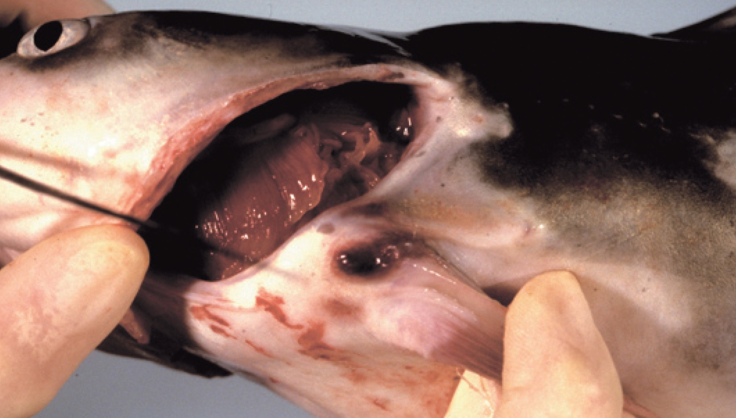
Note: Ulcerative lesions in the joints of the pectoral or dorsal spines.
Source: L A Hanson
Figure 2 Cranial ulcer in channel catfish (Ictalurus punctatus) with enteric septicaemia of catfish
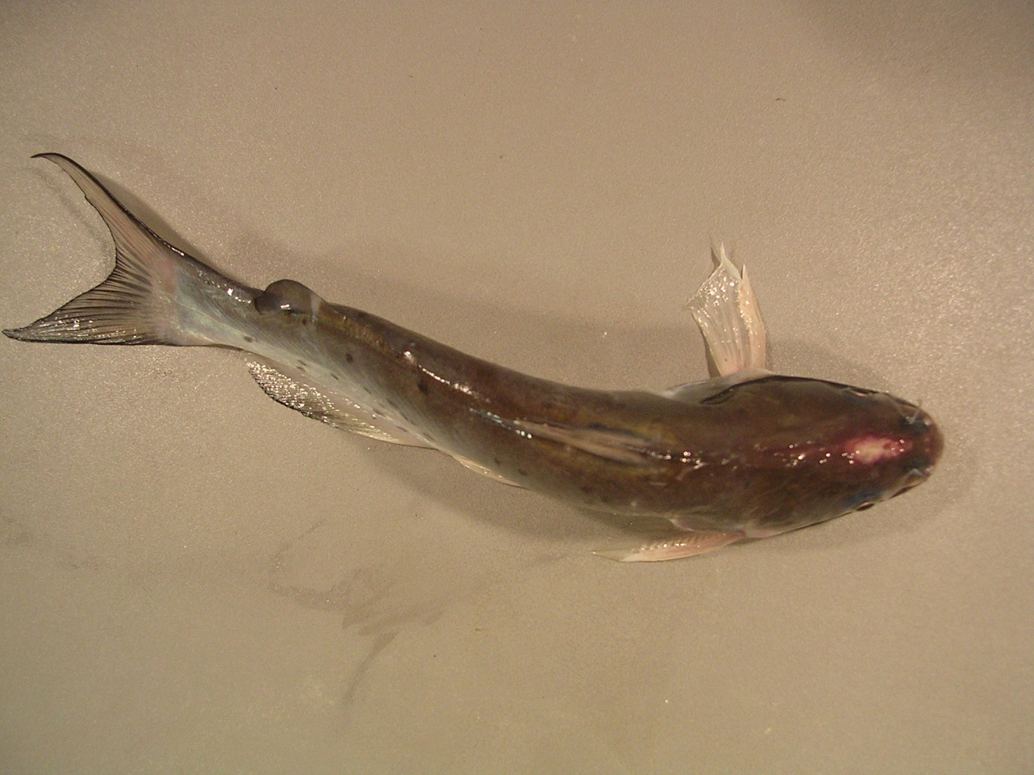
Note: Cranial ulcer, also known as a hole-in-the-head lesion.
Source: L Khoo
Figure 3 Internal organs of channel catfish (Ictalurus punctatus) with enteric septicaemia of catfish
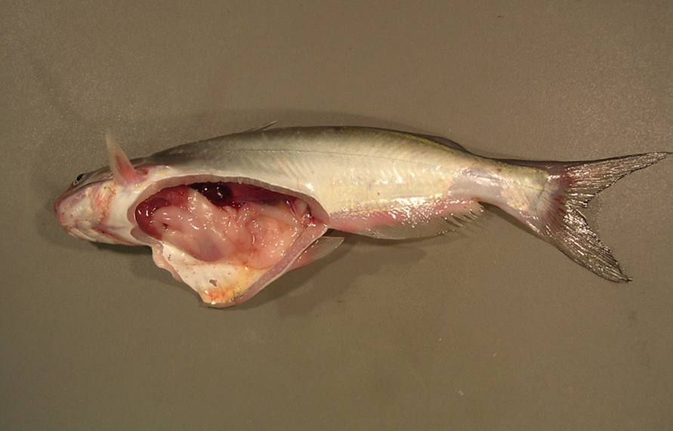
Note: Signs of infection with Edwardsiella ictaluri include swollen posterior kidney, enlarged spleen, gastro-intestinal haemorrhage and ascites fluid.
Source: L Khoo

Signs of disease
Important: Animals with this disease may show one or more of these signs, but the pathogen may still be present in the absence of any signs.
Disease signs at the farm, tank or pond level are:
- lethargic swimming
- abnormal behaviour (alternating listlessness and chaotic swimming)
- disorientation and swimming in spirals
- loss of appetite
- surfing, with head protruding from water.
Gross pathological signs are:
- chronic encephalitic form
  - swelling on top of the head, occasionally progressing to the erosion of connective tissue and exposure of the brain (a hole-in-the-head lesion)
  - granulomatous inflammation of the brain
- acute septicaemic form
  - pale gills
  - darkening of the skin (observed in species other than channel catfish)
  - multiple small white spots on the skin
  - raised skin patches progressing to shallow ulcers on the flanks and head
  - haemorrhage at the base of the fins, around the mouth, and on the throat, operculum (gill cover) and abdomen
  - exophthalmos (popeye)
  - swollen abdomen (pot-belly)
  - ascites (fluid in the abdominal cavity)
  - lesions on the liver and other internal organs
  - intestines frequently bloody, but may be transparent or clear yellow
  - red, swollen anal region with trailing faecal casts (observed in infected barramundi)
  - soft and pale spleen, anterior kidney or posterior kidney, with petechial (pinpoint) haemorrhages.
Microscopic pathological signs are:
- gram-negative rods in histological sections (muscle, kidney)
- locally extensive cellulitis in the head region
- necrotising myositis.

Disease agent
Enteric septicaemia of catfish (or edwardsiellosis) is caused by infection with the bacterium Edwardsiella ictaluri, belonging to the family Enterobacteriaceae.

Host range
Enteric septicaemia of catfish is a highly infectious bacterial disease of the catfish families Ictaluridae, Plotosidae, Clariidae, Siluridae, Pangasiidae and Ariidae. Ictalurids are particularly susceptible. Several non-catfish species are also susceptible, including salmonids.
Table 1 Species known to be susceptible to Edwardsiella ictaluri
Common name | Scientific name
Ayuª | Plecoglossus altivelis
Barramundi | Lates calcarifer
Berney’s catfish | Neoarius berneyi
Black bullheadª | Ameiurus melas
Black catfish | Neosilurus ater
Blue catfishª | Ictalurus furcatus
Brown bullheadª | Ameiurus nebulosus
Channel catfishª | Ictalurus punctatus
Chinook salmon | Oncorhynchus tshawytscha
Glass knifefishª | Eigenmannia virescens
Rainbow trout | Oncorhynchus mykiss
Rosy barbª | Puntius conchonius
Sind danioª | Danio devario
Sutchi catfishª | Pangasius hypophthalmus
Tadpole madtomª | Noturus gyrinus
Toothless catfish | Anodontiglanis dahlia
Walking catfishª | Clarias batrachus
Wet tropics tandanª | Tandanus tropicanus
White catfishª | Ameiurus catus
Yellow bullheadª | Ameiurus natalis
Yellow catfishª | Pelteobagrus fulvidraco
Zebrafishª | Danio rerio
a Naturally susceptible. Note: All other species have been shown to be experimentally susceptible.

Presence in Australia
Edwardsiella ictaluri has been isolated from healthy wild wet-tropics tandan catfish, from the Tully River valley in north Queensland, at a prevalence of 40%.
Enteric septicaemia of catfish has also been officially reported in Australia from imported aquarium fish (danios, rosy barbs) held in contained facilities in the Northern Territory and Tasmania. In 2010 and 2011, native black catfish, toothless catfish and Berney’s catfish held near imported aquarium fish in a facility in the Northern Territory became infected, resulting in mortalities. There have been no detections of the disease in the wild in the Northern Territory or Tasmania.
Map 1 Presence of Edwardsiella ictaluri, by jurisdiction
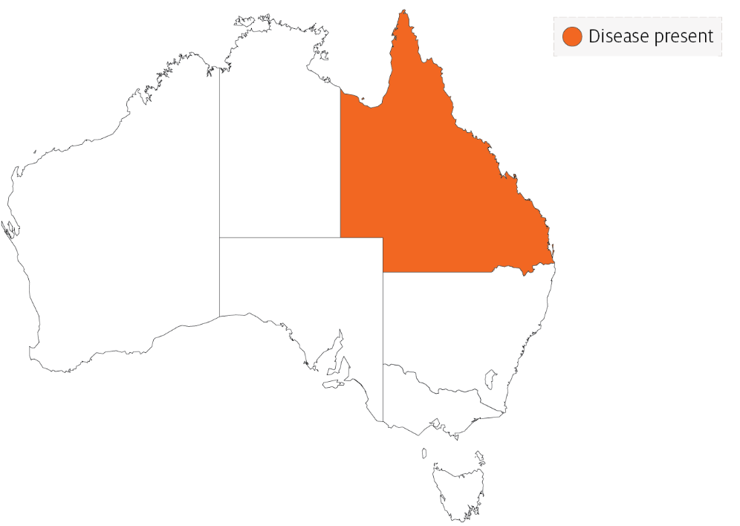

Epidemiology
- Edwardsiella ictaluri has been linked to disease outbreaks in barramundi (also known as Asian seabass) and Pangasius (basa catfish).
- Enteric septicaemia of catfish was originally considered primarily a disease of channel catfish. However, the bacterium has since been reported to cause disease in other catfish and non-catfish species. Most of the epidemiological knowledge about the disease is based on its occurrence in channel catfish.
- Horizontal transmission is via the faecal-oral route, cannibalism, and contact with contaminated water and materials used in handling infected fish.
- Faeces are the main source of shedding and dissemination. The disease may also be spread via dead fish and contaminated equipment such as fishing nets and sorting devices.
- The intestinal tract is the primary site of infection for the acute septicaemic form. The chronic encephalitic form is thought to establish after entering fish via the olfactory epithelium.
- Surviving catfish carry the bacterium, which also seems to be able to survive in the intestinal tracts of other fish species.
- Disease occurs primarily at water temperatures between 18°C and 28°C, making spring and autumn the most common times for outbreaks. Stress is often a predisposing factor.
- The bacterium can survive 3 to 4 months in pond water, mud and vegetation.
- Environmental stressors can influence the expression of clinical signs and extend the incubation period.
- Morbidity and mortality can be high in heavily stocked ponds.

Differential diagnosis
The list of similar diseases in the next section refers only to the diseases covered by this field guide. Gross pathological signs may also be representative of diseases not included in this guide. Do not rely on gross signs to provide a definitive diagnosis. Use them as a tool to help identify the listed diseases that most closely account for the observed signs.

Similar diseases
Channel catfish virus disease, European catfish virus and European sheatfish virus, infection with Aphanomyces invadans and spring viraemia of carp.

Sample collection
Only trained personnel should collect samples. Using only gross pathological signs to differentiate between diseases is not reliable, and some aquatic animal disease agents pose a risk to humans. If you are not appropriately trained, phone your state or territory hotline number and report your observations. If you have to collect samples, the agency taking your call will advise you on the appropriate course of action. Local or district fisheries or veterinary authorities may also advise on sampling.

Emergency disease hotline
See something you think is this disease? Report it. Even if you’re not sure.
Call the Emergency Animal Disease Watch Hotline on 1800 675 888. They will refer you to the right state or territory agency.

Microscope images
Figure 4 Histopathological section of skeletal muscle of channel catfish (Ictalurus punctatus) with enteric septicaemia of catfish
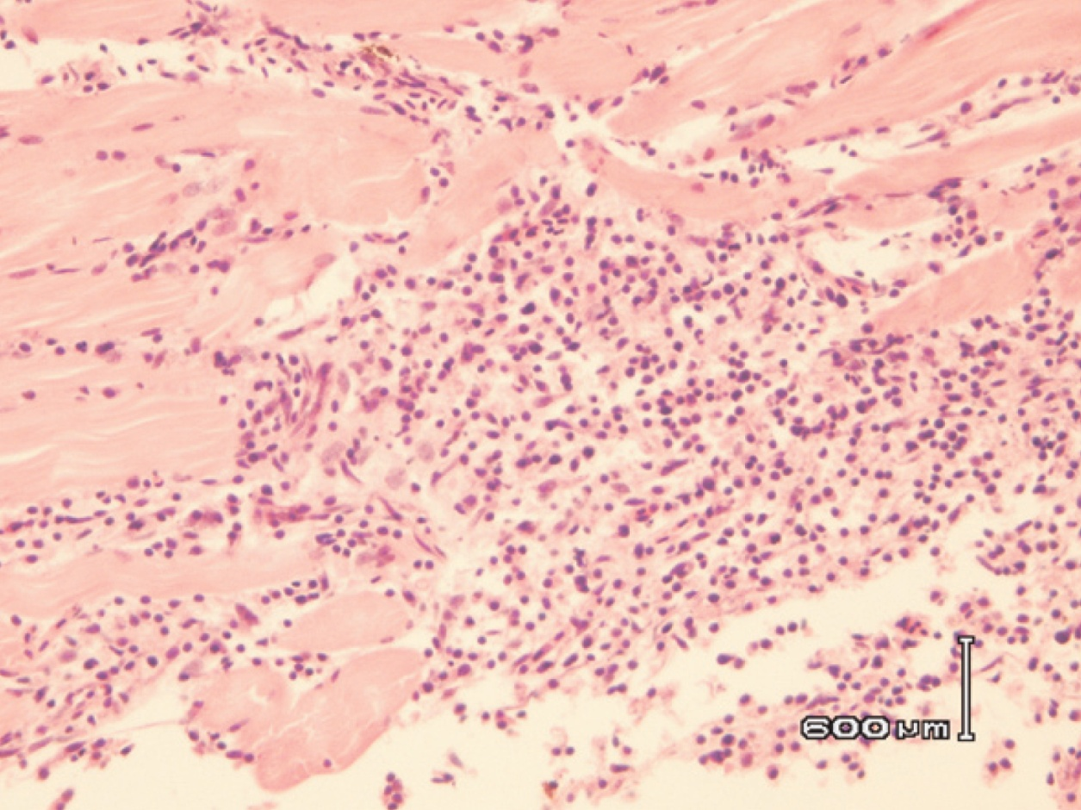
Note: Necrotising myositis in the skeletal muscle. Scale bar = 600µm.
Source: G Storie and H Prior
Figure 5 Histopathological section of head of channel catfish (Ictalurus punctatus) with enteric septicaemia of catfish
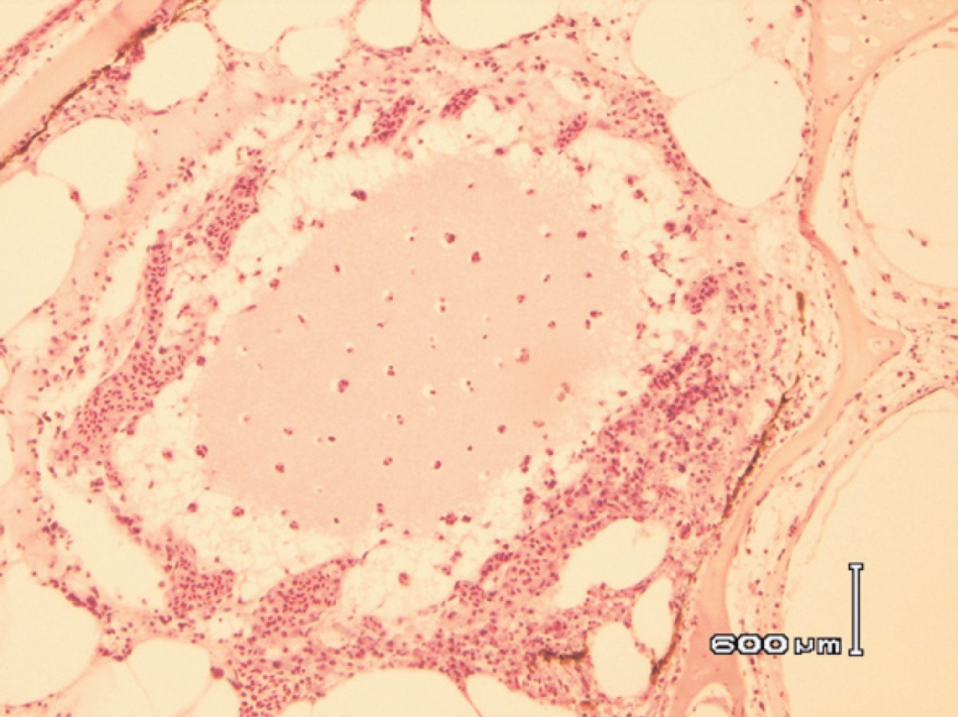
Note: Locally extensive cellulitis involving connective tissue surrounding cranial bones and cartilage. Scale bar = 600µm.
Source: G Storie and H Prior
Figure 6 Gram staining of histopathological section from kidney of channel catfish (Ictalurus punctatus) with enteric septicaemia of catfish
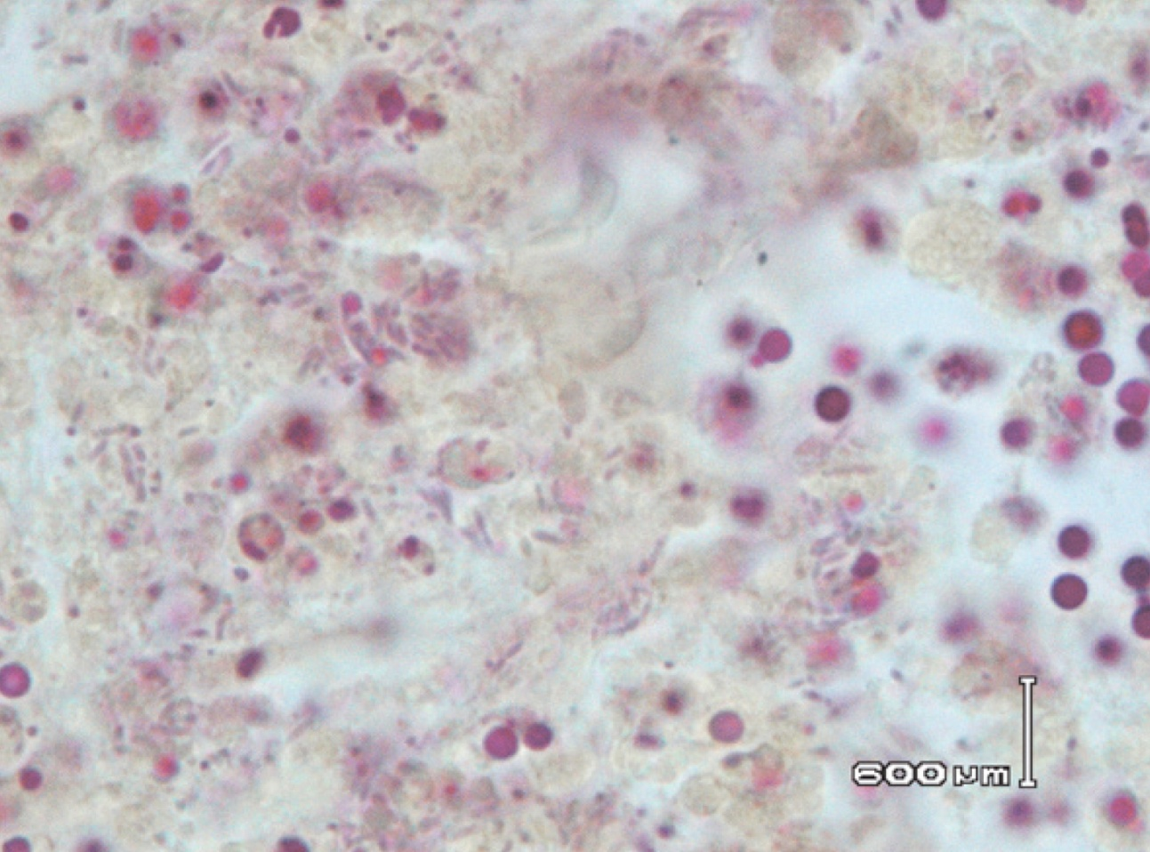
Note: Gram-negative rods are Edwardsiella ictaluri. Scale bar = 600µm.
Source: G Storie and H Prior
Figure 7 Gram staining of histopathological section from skeletal muscle of channel catfish (Ictalurus punctatus) with enteric septicaemia of catfish
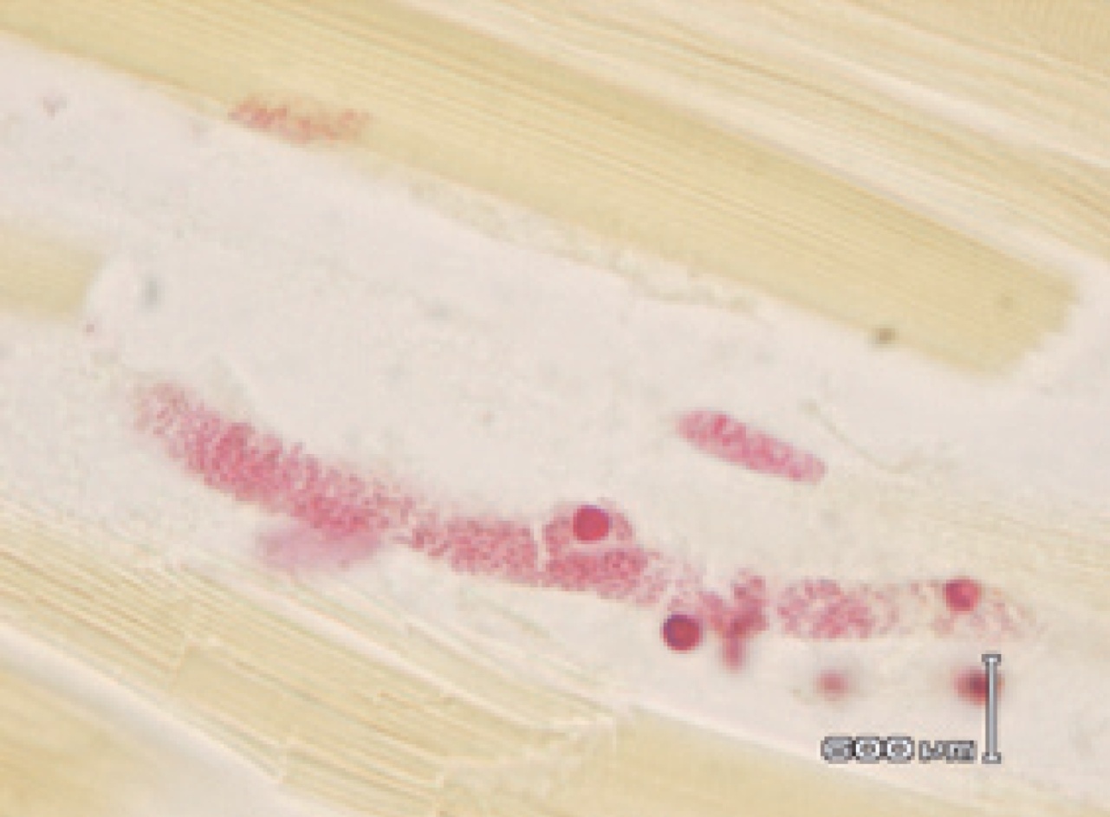
Note: Gram-negative rods of Edwardsiella ictaluri. Scale bar = 600µm.
Source: G Storie and H Prior

Further reading
CABI Invasive Species Compendium Enteric septicaemia of catfish
CEFAS International Database on Aquatic Animal Diseases Enteric Septicaemia of Catfish (Edwardsiellosis)
These hyperlinks were correct at the time of publication.

Contact details
Emergency Animal Disease Watch Hotline 1800 675 888
Email AAH@agriculture.gov.au
Website agriculture.gov.au/pests-diseases-weeds/aquatic
© Commonwealth of Australia 2020
This work is copyright. It may be reproduced in whole or in part subject to the inclusion of an acknowledgement of the source and no commercial usage or sale.

