European catfish virus (ECV) and European sheatfish virus (ESV)

From Aquatic animal diseases significant to Australia: identification field guide, 5th edition
Figure 1 Skin lesions on brown bullhead (Ameiurus nebulosus) with ECV infection
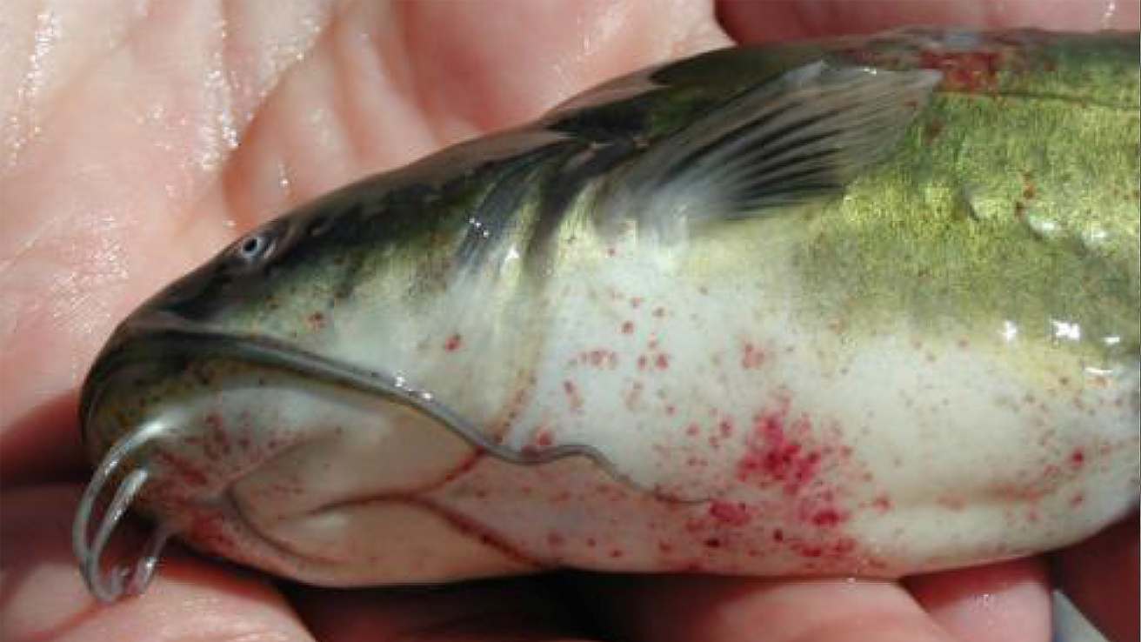
Note: Haemorrhagic skin lesions on the abdomen.
Source: J Tamás
Figure 2 Fin lesion on brown bullhead (Ameiurus nebulosus) with ECV infection
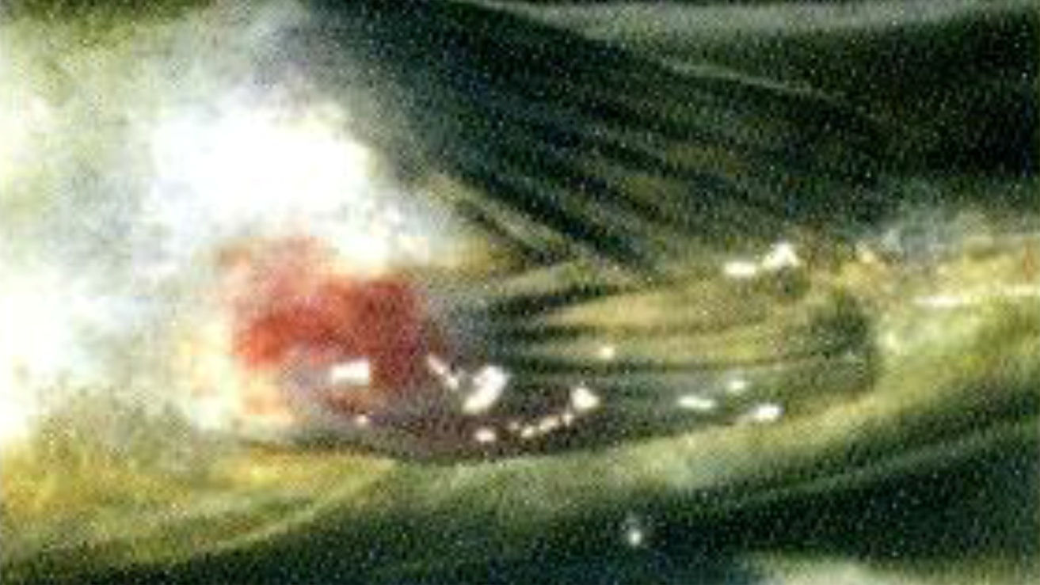
Note: Haemorrhagic skin lesions on the pelvic fin.
Source: J Tamás

Signs of disease
Important: Animals with this disease may show one or more of these signs, but the pathogen may still be present in the absence of any signs.
Disease signs at the farm, tank or pond level are:
- sudden high mortality rates (up to 100%) in juvenile fish in aquaculture or in the wild
- losses of up to 30% of adult sheatfish
- loss of appetite 1 to 2 days before mortalities occur
- erratic spiral swimming at the water surface
- lethargy.
Gross pathological signs are:
- swollen abdomen (ascites)
- darkened skin colour
- petechial (pinpoint) haemorrhages around the base of paired fins and in the viscera
- haemorrhagic areas on the skin
- pale gills
- many dead fish.
Microscopic pathological signs are:
- coagulative or liquefactive necrosis of the liver, spleen and especially the kidney
- destruction of haematopoietic tissues
- necrotic lesions in the heart, pancreas, gastrointestinal tract and gills.

Disease agent
ECV and ESV are classified as members of the genus Ranavirus within the family Iridoviridae. Other closely related ranaviruses such as epizootic haematopoietic necrosis virus (EHNV), grouper iridovirus (GIV) or Ranavirus maxima from European turbot cause similar systemic necrotising iridovirus syndromes in a range of fish species (EHNV and GIV are also in this guide).

Host range
ECV and ESV have been detected only in Europe. The pathogen has triggered epizootics in cultivated sheatfish in Germany and wild black bullheads in France, Italy and Hungary. Experimental ESV infection causes high mortality in pike, but black bullhead and rainbow trout appear to be unaffected, although viral replication has been detected. Juvenile pike perch may be susceptible to infection under certain conditions. These viruses may also be carried via the gut, feathers, feet and bill of piscivorous birds.
Table 1 Species known to be susceptible to ECV and ESV
Common name | Scientific name
Black bullhead or European catfishª | Ameiurus melas
Brown bullheadª | Ameiurus nebulosus
Pike | Esox lucius
Pike perch | Sander lucioperca
Rainbow trout | Oncorhynchus mykiss
Wels catfish or sheatfishª | Silurus glanis
Piscivorous birds | Various genera and species
a Naturally susceptible. Note: Other species have been shown to be experimentally susceptible.

Presence in Australia
Exotic disease—not recorded in Australia.
Map 1 Presence of ECV and ESV, by jurisdiction
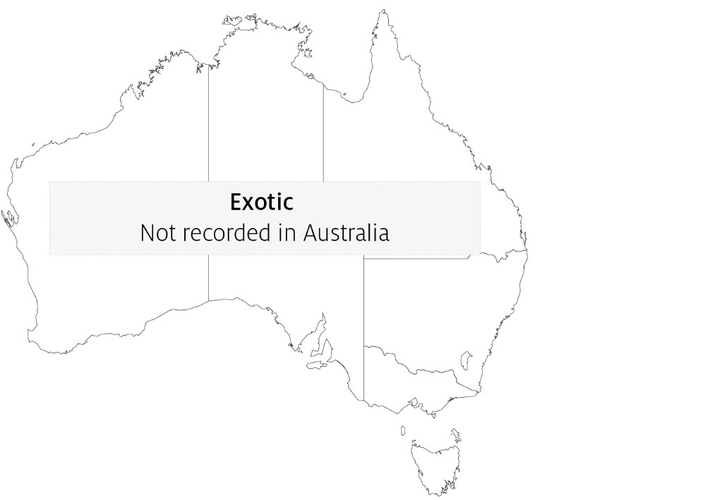

Epidemiology
- ESV was the first fish ranavirus to be isolated in Europe, when it was obtained from moribund sheatfish (Silurus glanis) fry experiencing 100% mortalities in Germany in 1989.
- Clinical outbreaks of sudden mass mortalities are typically seen in fingerlings and juvenile fish, though adult fish may also be affected.
- Transmission is horizontal and can occur by cohabitation resulting in up to 100% mortality within 11 days.
- Disease outbreaks may be associated with high summer water temperatures and/or poor water quality.
- Ranaviruses are resistant viruses, surviving for months in water, persisting in frozen fish tissues for more than two years and in fish carcasses for at least one year.
- Ranaviruses may be carried on equipment including nets and boats, in fish (live or dead) used for bait and via the gut, feathers, feet and bill of piscivorous birds.

Differential diagnosis
The list of similar diseases in the next section refers only to the diseases covered by this field guide. Gross pathological signs may also be representative of diseases not included in this guide. Do not rely on gross signs to provide a definitive diagnosis. Use them as a tool to help identify the listed diseases that most closely account for the observed signs.

Similar diseases
Channel catfish virus disease (CCVD), enteric septicaemia of catfish and epizootic haematopoietic necrosis (EHN).

Sample collection
Only trained personnel should collect samples. Using only gross pathological signs to differentiate between diseases is not reliable, and some aquatic animal disease agents pose a risk to humans. If you are not appropriately trained, phone your state or territory hotline number and report your observations. If you have to collect samples, the agency taking your call will advise you on the appropriate course of action. Local or district fisheries or veterinary authorities may also advise on sampling.

Emergency disease hotline
See something you think is this disease? Report it. Even if you’re not sure.
Call the Emergency Animal Disease Watch Hotline on 1800 675 888. They will refer you to the right state or territory agency.

Further reading
CABI Invasive Species Compendium Isolation of ranavirus causing mass mortality in brown bullheads (Ameiurus nebulosus) in Hungary
World Organisation for Animal Health Manual of diagnostic tests for aquatic animals
These hyperlinks were correct at the time of publication.

Contact details
Emergency Animal Disease Watch Hotline 1800 675 888
Email AAH@agriculture.gov.au
Website agriculture.gov.au/pests-diseases-weeds/aquatic
© Commonwealth of Australia 2020
This work is copyright. It may be reproduced in whole or in part subject to the inclusion of an acknowledgement of the source and no commercial usage or sale.

