Anatomy

Finfish
The external and internal anatomy of finfish varies considerably across species. Specific adaptations to predator–prey interactions, aquatic habitat variability and dietary preferences can explain these differences. One example is the short intestinal length of carnivorous fish compared with the relatively long intestine of herbivorous fish. Another, is the ventrally directed mouth of bottom-feeding species such as European carp (Cyprinus carpio) compared with the upward oriented mouth of the surface-feeding saratoga (Scleropages leichardti).
Figure 1 Mature male Atlantic salmon (Salmo salar)
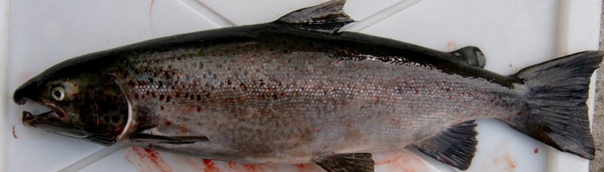
Note: Typical hooked mouth.
Source: M Porter
Figure 2 Gravid female Atlantic salmon (Salmo salar)
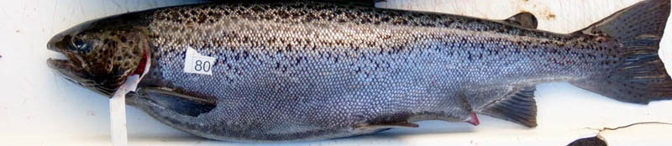
Note: Distended abdomen and protruding spawning vent.
Source: M Porter
Figure 3 Anatomy of female juvenile salmon
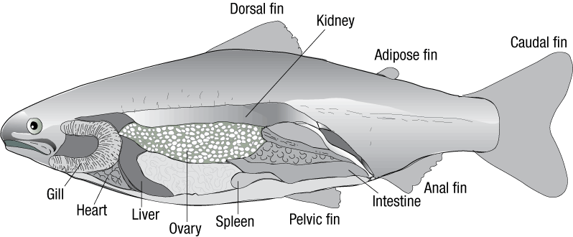
Source: Australian Government Department of Agriculture, Water and the Environment
Figure 4 Stomach cavity of gravid female Atlantic salmon (Salmo salar)
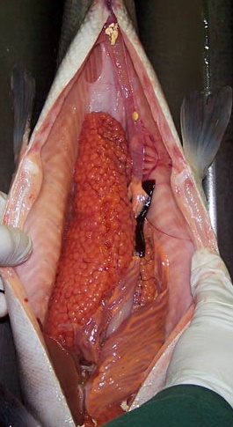
Note: Stomach cavity dominated by ovary. Compare the relative size of ovary with the rest of the internal organs.
Source: K Nelson
Figure 5 Internal organs of gravid female Atlantic salmon (Salmo salar)
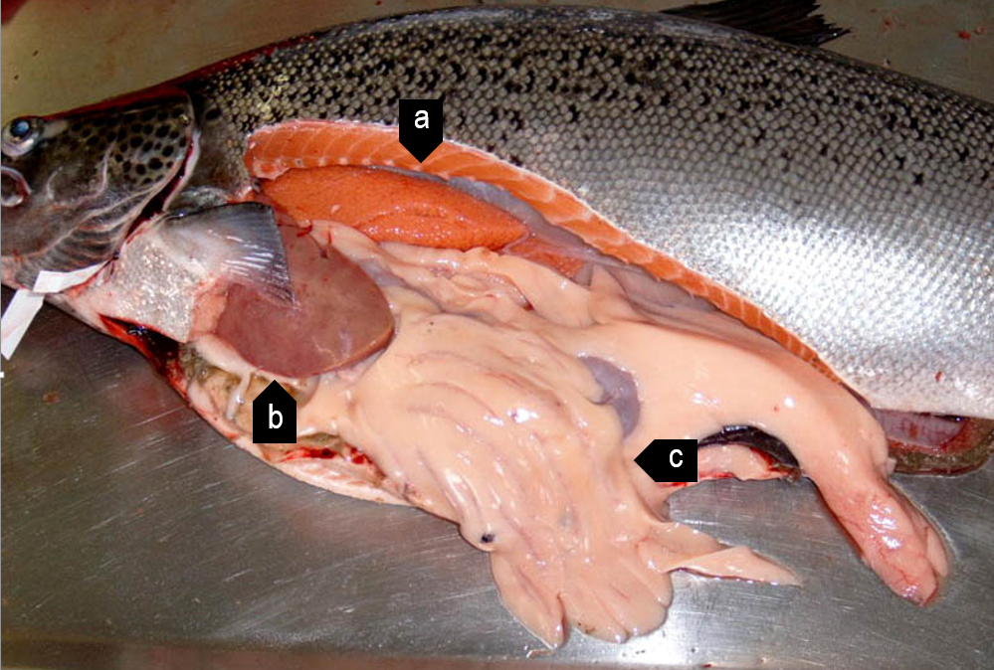
Note: Ovary (a) is positioned between the liver (b) and intestines (c) and the vertebrae.
Source: M Porter
Figure 6 Degenerative eggs in old female Atlantic salmon (Salmo salar)
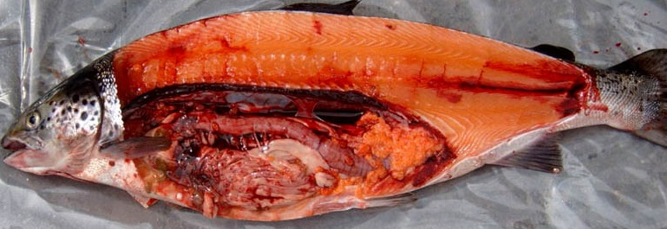
Source: M Porter
Figure 7 Golden perch (Macquaria ambigua)
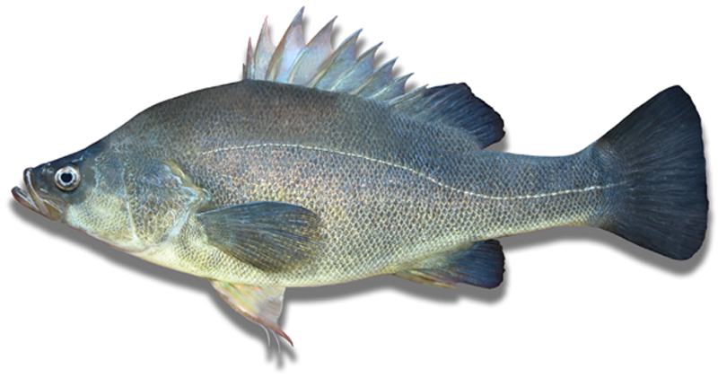
Note: Compare morphology to silver perch (Bidyanus bidyanus) in Figure 8
Source: New South Wales Department of Primary Industries
Figure 8 Silver perch (Bidyanus bidyanus)
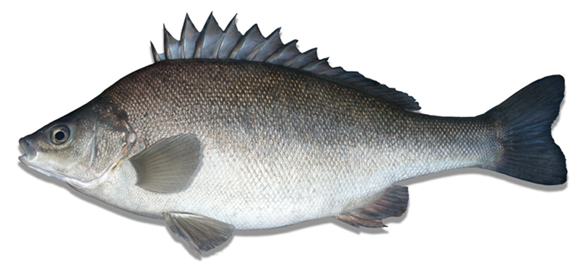
Note: Compare morphology to golden perch (Macquaria ambigua) in Figure 7.Figure 8
Source: New South Wales Department of Primary Industries
Figure 9 Internal anatomy of silver perch (Bidyanus bidyanus)
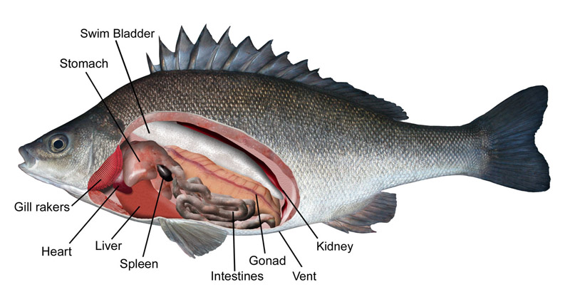
Source: New South Wales Department of Primary Industries

