Furunculosis

Also known as infection with Aeromonas salmonicida subsp. salmonicida

From Aquatic animal diseases significant to Australia: identification field guide, 5th edition
Figure 1 Furunculosis in Atlantic salmon (Salmo salar)
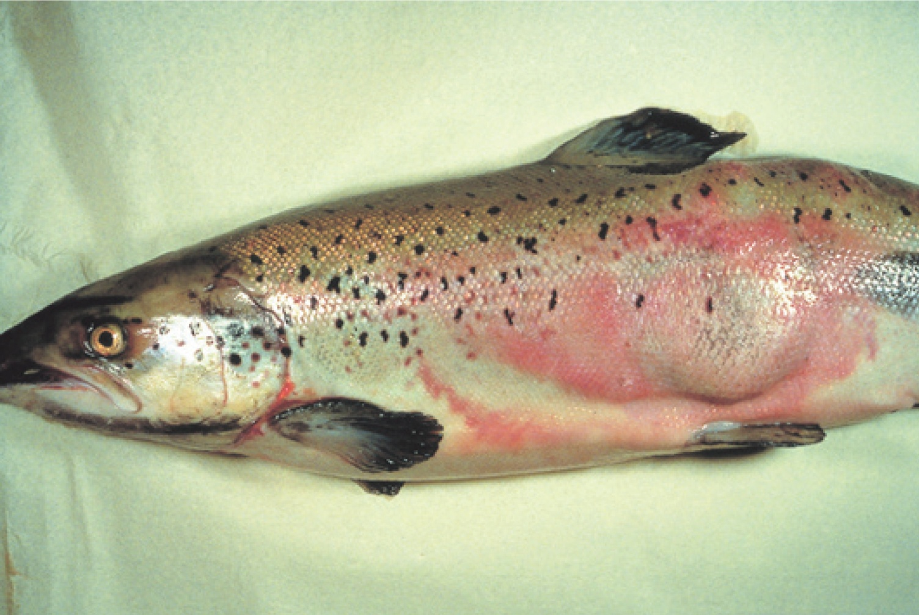
Note: Large furuncle (boil) on side of fish.
Source: T Håstein
Figure 2 Atlantic salmon (Salmo salar) with furunculosis boil exposed below the surface of the skin
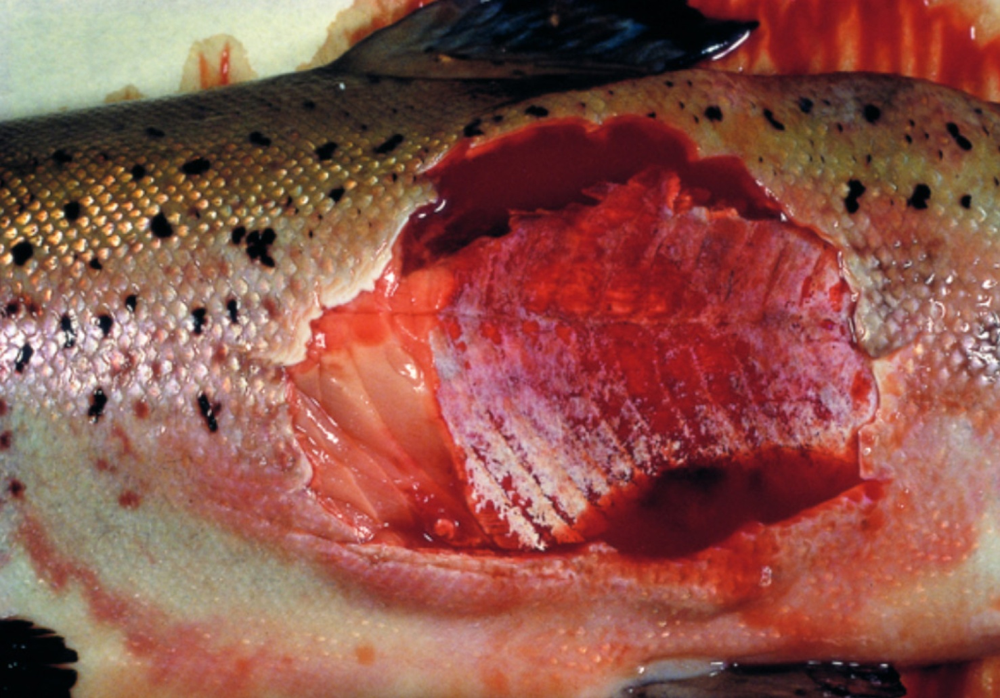
Note: Furuncle has been cut away to show underlying necrotic tissue.
Source: T Håstein

Signs of disease
Important: Animals with this disease may show one or more of these signs, but the pathogen may still be present in the absence of any signs.
Disease signs at the farm, tank or pond level are:
- sudden death, perhaps with slight exophthalmos (popeye)
- often no clinical signs in young fish with peracute form of the disease
- death within days of initial clinical signs of disease in growing fish with acute furunculosis
- high mortality
- lethargic swimming or swimming just below the surface
- loss of appetite
- respiratory distress and jumping from the water immediately before an outbreak.
Gross pathological signs are:
- furuncles (boils) involving skin and/or muscle, progressing to crater lesions (usually restricted to the subacute or chronic phase in adult salmon)
- haemorrhages on the skin, mouth and fin bases (mainly of paired fins)
- darkening of body colour and pale gills
- bloody discharge from nares and/or vent
- exophthalmos (popeye)
- haemorrhages in muscle and internal organs
- enlarged spleen and focal necrosis of the liver
- stomach filled with mucus, blood and sloughed epithelial cells
- congested intestine
- death without any clinical signs other than darkening of the skin (occurs only in peracute infections in juvenile salmon).
Microscopic pathological signs are:
- fusion of gill lamellae, with necrosis of the epithelium
- eosinophilic inflammatory changes in gills
- bacterial colonies in many tissues
- sloughing of renal tubular cells into the renal tubular lumen
- sloughing of intestinal epithelial cells into the intestinal lumen.

Disease agent
Furunculosisis caused by infection with the bacterium Aeromonas salmonicida subsp. salmonicida, a member of the family Enterobacteriaceae. The bacterium is intracellular and so may avoid some host immune defences after infection. During infection, the bacterium produces extracellular toxins that may play a significant role in the pathogenesis of the disease. There are four other subspecies of A. salmonicida; these ‘atypical’ strains are considered to cause a different disease syndrome, infection with Aeromonas salmonicida—atypical strains, which is also discussed in this guide.

Host range
All salmonids and eels are believed to be susceptible to A. salmonicida subsp. salmonicida. Species known to be susceptible are listed in Table 1. The bacterium has also been isolated from sea lice infecting lesions on fish and can be spread by piscivorous birds.
Table 1 Species known to be susceptible to Aeromonas salmonicida subsp. salmonicida
Common name | Scientific name
Amago salmonª | Oncorhynchus rhodurus
American eelª | Anguilla rostrata
Arctic char | Salvelinus alpinus
Atlantic codª | Gadus morhua
Atlantic salmonª | Salmo salar
Atlantic wolfishª | Anarhichas lupus
Ayu | Plecoglossus altivelis
Black sea salmon | Salmo labrax
Brook troutª | Salvelinus fontinalis
Brown troutª | Salmo trutta
Bull trout | Salvelinus confluentus
Bullhead | Cottus gobio
Chinook salmon | Oncorhynchus tshawytscha
Chum salmon | Oncorhynchus keta
Cisco | Coregonus artedi
Coho salmon | Oncorhynchus kisutch
Common shiner | Luxilus cornutus
Cutthroat trout | Oncorhynchus clarkii
Danube salmon | Hucho hucho
Eels | Anguillidae all species
European eel | Anguilla anguilla
Galaxiids | Galaxiidae all species
Gila trout | Oncorhynchus gilae
Gilt-head sea bream | Sparus aurata
Golden trout | Oncorhynchus aguabonita
Grayling | Thymallus thymallus
Hybrid (rainbow trout × coho salmon) | Oncorhynchus mykiss × O. kisutch
Japanese eel | Anguilla japonica
Lake trout | Salvelinus namaycush
Lake whitefish | Coregonus clupeaformis
Masu salmon | Oncorhynchus masou
Mountain whitefish | Prosopium williamsoni
Pacific halibutª | Hippoglossus stenolepis
Pacific salmonª | Oncorhynchus spp.
Pike | Esox lucius
Pike perch | Sander lucioperca
Pink salmonª | Oncorhynchus gorbuscha
Rainbow troutª | Oncorhynchus mykiss
Salmonids (all presumed susceptible)ª | Salmonidae all species
Sea lampreyª | Petromyzon marinus
Shortfin eel | Anguilla australis
Sockeye salmonª | Oncorhynchus nerka
Splake (lake trout × brook trout) | Salvelinus namaycush × S. fontinalis
Turbot | Scophthalmus maximus
Whitefish (Muksun) | Coregonus muksun
Whitefish (Peled) | Coregonus peled
Whitespotted char | Salvelinus leucomaenis
Wrasses | Labridae all species
a Naturally susceptible. Note: Other species likely to be susceptible or shown to be experimentally susceptible.
Table 2 Non-fish carriers
Common name | Scientific name
Salmon louse A (Lepeophtheirus spp.) | Lepeophtheirus salmonis
Salmon louse B (Caligus spp.) | Caligus elongatus
Piscivorous birds | Various genera and species

Presence in Australia
Exotic disease—not recorded in Australia.
The strain of Aeromonas causing furunculosis in salmonids overseas (typical strain) is not present in Australia. However, atypical strains are present (see Infection with Aeromonas salmonicida—atypical strains).
Map 1 Presence of furunculosis, by jurisdiction
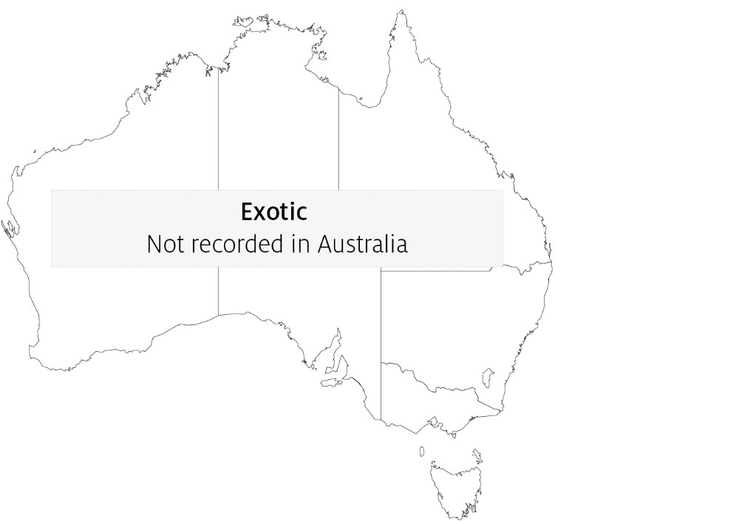

Epidemiology
- Furunculosis is highly contagious and affects fish of all ages.
- The disease is one of the most commercially significant salmonid diseases, occurring in freshwater and marine salmonid aquaculture in all countries except Australia and New Zealand.
- Overseas, this disease must be controlled on farms by medication or vaccination.
- Outbreaks typically occur at temperatures above 10°C. However outbreaks can occur in very young fish and at temperatures as low as 2 to 4°C. Disease may be precipitated by endogenous stressors (such as smoltification or spawning) and exogenous stressors (such as temperature fluctuations or poor water quality).
- Australia's relatively warm water temperatures may favour the establishment of A. salmonicida subsp. salmonicida.
- Rainbow trout are relatively resistant to the disease, but are still considered susceptible.
- Horizontal transmission occurs via the water column, but also through direct fish-to-fish contact and animal vectors (birds and invertebrates such as sea lice).
- Aeromonas salmonicida subsp. salmonicida has been detected on the surface of fertilised eggs. Surface decontamination using iodine is effective in preventing vertical transmission (passage of infection from parent to offspring).
- Aeromonas salmonicida subsp. salmonicida can survive for months in some environments.
- Non-salmonids may become infected by ingesting tissue of infected salmonids. Transmission to non-salmonids can occur where fish caught for feed are taken from waters near an outbreak.
- Susceptibility to the disease increases with damaged mucous and skin, such as occurs when fish are handled with nets.
- Fish surviving disease outbreaks are recognised as carriers of the disease. Carriers may continue to infect the remaining population without themselves showing any outward signs of infection. Stress may precipitate disease in subclinical carriers.

Differential diagnosis
The list of similar diseases in the next section refers only to the diseases covered by this field guide. Gross pathological signs may also be representative of diseases not included in this guide. Do not rely on gross signs to provide a definitive diagnosis. Use them as a tool to help identify the listed diseases that most closely account for the observed signs.

Similar diseases
Epizootic haematopoietic necrosis (EHN), infection with Aeromonas salmonicida—atypical strains and infectious haematopoietic necrosis (IHN).

Sample collection
Only trained personnel should collect samples. Using only gross pathological signs to differentiate between diseases is not reliable, and some aquatic animal disease agents pose a risk to humans. If you are not appropriately trained, phone your state or territory hotline number and report your observations. If you have to collect samples, the agency taking your call will advise you on the appropriate course of action. Local or district fisheries or veterinary authorities may also advise on sampling.

Emergency disease hotline
See something you think is this disease? Report it. Even if you’re not sure.
Call the Emergency Animal Disease Watch Hotline on 1800 675 888. They will refer you to the right state or territory agency.

Further reading
CEFAS International Database on Aquatic Animal Diseases Furunculosis
Department of Agriculture, Water and the Environment AQUAVETPLAN disease strategy manual: Furunculosis
These hyperlinks were correct at the time of publication.

Contact details
Emergency Animal Disease Watch Hotline 1800 675 888
Email AAH@agriculture.gov.au
Website agriculture.gov.au/pests-diseases-weeds/aquatic
© Commonwealth of Australia 2020
This work is copyright. It may be reproduced in whole or in part subject to the inclusion of an acknowledgement of the source and no commercial usage or sale.

