Infection with gill-associated virus (GAV)

Also known as mid-crop mortality syndrome and infection with yellowhead virus genotype 2 (YHV2)

From Aquatic animal diseases significant to Australia: identification field guide, 5th edition
Figure 1 Black tiger prawn (Penaeus monodon) infected with GAV
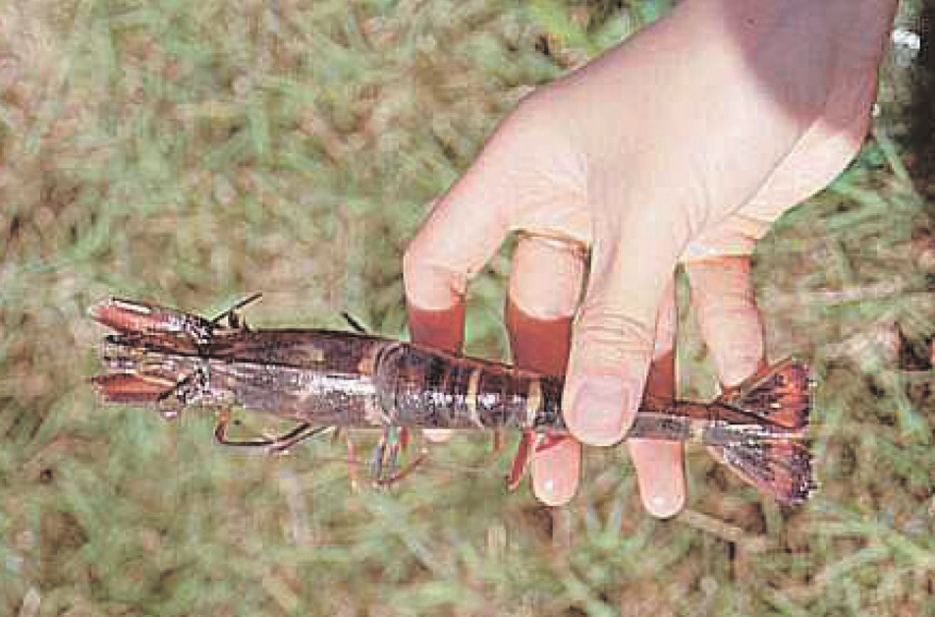
Note: Red colouration of prawn appendages and tail.
Source: D Callinan

Signs of disease
Important: Animals with this disease may show one or more of these signs, but the pathogen may still be present in the absence of any signs.
Disease signs at the farm, tank or pond level are:
- high mortality (up to 80%)
- moribund prawns aggregating near the surface at pond edges
- initial increase in feeding at an abnormally high rate, followed by a sudden decline.
Gross pathological signs are:
- reddening of body and appendages
- biofouling with exoparasites
- emaciation
- pink to yellow colouration of the gills.
Microscopic pathological signs are:
- lymphoid organ necrosis (hypertrophied nuclei, marginated chromatin and vacuolation).

Disease agent
GAV is also known as YHV2, which is genotype 2 of at least 10 genotypes in the yellowhead complex of viruses. GAV is the type species of the genus Okavirus, in the family Roniviridae and order Nidovirales.
Comparison of DNA sequences indicates that GAV and yellowhead virus genotype 1 (YHV1) are closely related but have distinctly different genotypes, sharing 85% of their genetic material. Natural genetic recombination between GAV and other genotypes in the yellowhead complex has been reported outside Australia.
Other known genotypes in the complex (genotypes 3 to 10) occur in Penaeus monodon in East Africa, Asia and Australia. Most are rarely or never associated with disease.

Host range
Table 1 Species known to be susceptible to infection with GAV
Common name | Scientific name
Black tiger prawnª | Penaeus monodon
Brown tiger prawn | Penaeus esculentus
Gulf banana prawn | Penaeus (Fenneropenaeus) merguiensis
Kuruma prawn | Penaeus (Marsupenaeus) japonicus
a Naturally susceptible. Note: Other species have been shown to be experimentally susceptible.

Presence in Australia
GAV has been officially reported from New South Wales, Queensland, the Northern Territory and Western Australia. Other genotypes within the yellowhead complex are known to occur in Australia, including YHV6 and YHV7.
Map 1 Presence of GAV, by jurisdiction
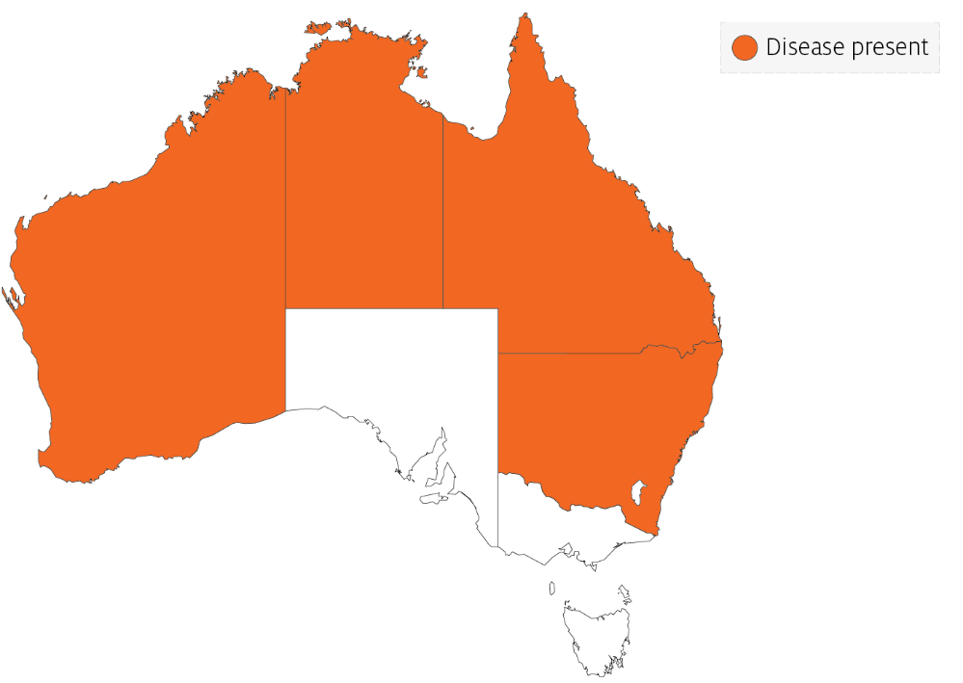

Epidemiology
The epidemiology of GAV is thought to be very similar to that of yellowhead virus:
- Transmission can be horizontal, directly from the water column and through ingestion of infected material.
- Vertical transmission can occur via surface contamination or infection of tissue surrounding the fertilised egg.
- Viral multiplication and disease appear to be induced by environmental stress.
- Mortality usually occurs among early to late juvenile stages in rearing ponds.
- Experimental infections with GAV indicate that larger (approximately 20g) Kuruma prawns are less susceptible to disease than smaller (approximately 6 to 13g) prawns of the same species.
- GAV has been associated with mortalities of up to 80% in black tiger prawn ponds in Australia.
GAV genotypes YHV2 and YHV7 occur commonly as a chronic infection in healthy broodstock and farmed black tiger prawns in eastern Australia. YHV2 has also been associated with acute infections and disease outbreaks in ponds, causing high mortality. However, it produces gross signs and patterns of tissue tropism that differ from those for yellowhead virus genotype 1.

Differential diagnosis
The list of similar diseases in the next section refers only to the diseases covered by this field guide. Gross pathological signs may also be representative of diseases not included in this guide. Do not rely on gross signs to provide a definitive diagnosis. Use them as a tool to help identify the listed diseases that most closely account for the observed signs.

Similar diseases
Infection with yellowhead virus genotype 1 (YHV1).
GAV and YHV1 are closely related viruses, so molecular testing is required to discriminate between the two disease agents and between other YHV genotypes that are endemic to Australia (YHV6 and YHV7).

Sample collection
Only trained personnel should collect samples. Using only gross pathological signs to differentiate between diseases is not reliable, and some aquatic animal disease agents pose a risk to humans. If you are not appropriately trained, phone your state or territory hotline number and report your observations. If you have to collect samples, the agency taking your call will advise you on the appropriate course of action. Local or district fisheries or veterinary authorities may also advise on sampling.

Emergency disease hotline
See something you think is this disease? Report it. Even if you’re not sure.
Call the Emergency Animal Disease Watch Hotline on 1800 675 888. They will refer you to the right state or territory agency.

Microscope images
Figure 2 Histopathology of lymphoid organ of black tiger prawn (Penaeus monodon) infected with GAV
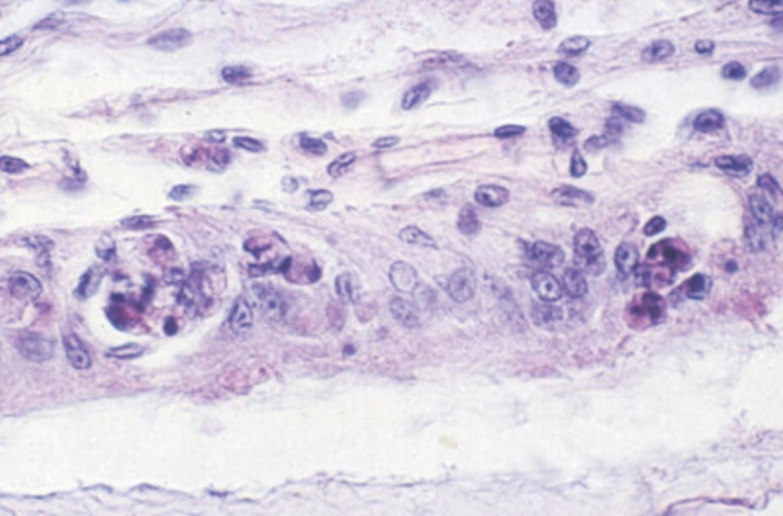
Note: Lymphoid necrosis includes signs such as hypertrophied nuclei, marginated chromatin and vacuolation.
Source: L Owens

Further reading
CABI Invasive Species Compendium Gill-associated virus
World Organisation for Animal Health Manual of diagnostic tests for aquatic animals
These hyperlinks were correct at the time of publication.

Contact details
Emergency Animal Disease Watch Hotline 1800 675 888
Email AAH@agriculture.gov.au
Website agriculture.gov.au/pests-diseases-weeds/aquatic
© Commonwealth of Australia 2020
This work is copyright. It may be reproduced in whole or in part subject to the inclusion of an acknowledgement of the source and no commercial usage or sale.

