Grouper iridoviral disease

Also known as sleepy grouper disease, grouper iridovirus of Taiwan (TGIV) and Singapore grouper iridovirus (SGIV)

From Aquatic animal diseases significant to Australia: identification field guide, 5th edition
Figure 1 Gross signs of secondary infection in estuary cod (Epinephelus tauvina) infected by grouper iridovirus
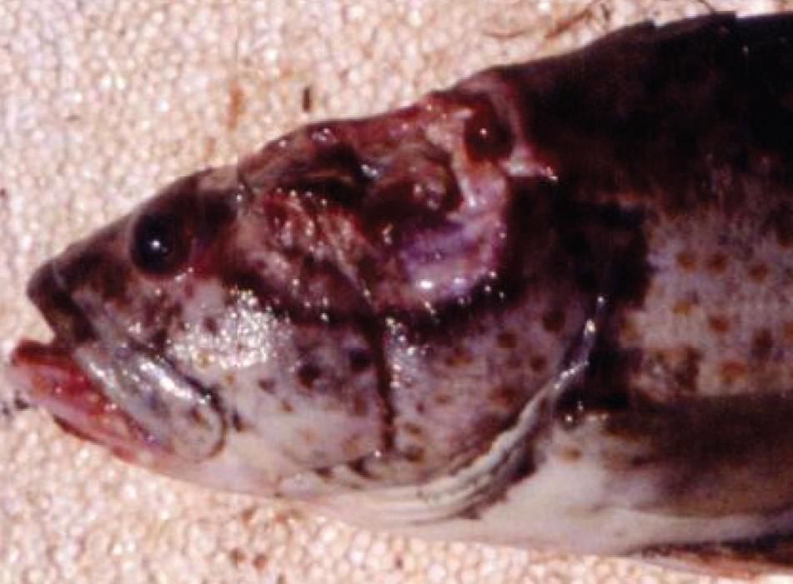
Note: Deep ulceration in muscular tissue of the head.
Source: S Kanchanakhan
Figure 2 Gross signs of secondary infection in estuary cod (Epinephelus tauvina) infected by grouper iridovirus
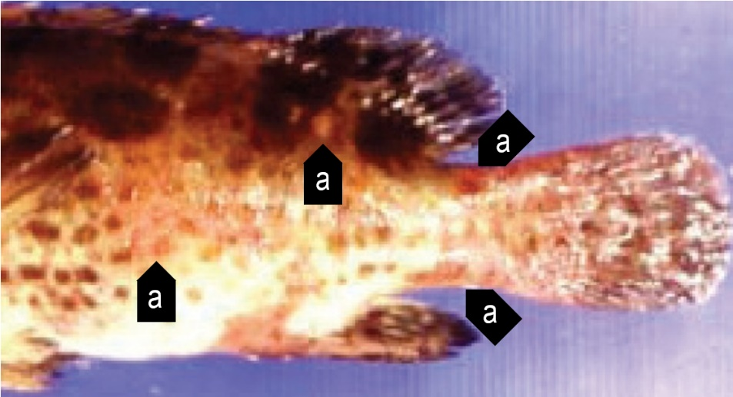
Note: Haemorrhagic red boils (a) on the body surface.
Source: S Kanchanakhan

Signs of disease
Important: Animals with this disease may show one or more of these signs, but the pathogen may still be present in the absence of any signs.
Disease signs at the farm, tank or pond level are:
- typically high mortalities, with many dead and moribund fish
- high mortality of young grouper
- loss of appetite
- lethargic swimming
- rapid opercular movements and dashing to the surface for air (in the terminal phase).
Gross pathological signs are:
- darkened body colour, pale gills and enlarged spleen
- signs of secondary infection such as deep ulceration or papular lesions.
Microscopic pathological signs are:
- necrosis of the splenic pulp, and myocardium
- necrosis and reduction of haematopoietic tissue of the kidney in the absence of marked cell hypertrophy.

Disease agent
Grouper iridovirus disease is caused by infection with grouper iridovirus (GIV), belonging to the genus Ranavirus within the family Iridoviridae. Synonyms include grouper iridovirus of Taiwan (TGIV) and Singapore grouper iridovirus (SGIV).

Host range
Table 1 Species known to be naturally susceptible to GIV
Common name | Scientific name
Brown marbled grouper | Epinephelus fuscoguttatus
Coral trout | Plectropomus leopardus
Estuary cod | Epinephelus tauvina
Giant grouper | Epinephelus lanceolatus
Grouper and estuary cod | Epinephelus spp.
Malabar grouper | Epinephelus malabaricus
Spotted coral grouper | Plectropomus maculatus
Tiger grouper hybrid | Epinephelus fuscoguttatus × E. lanceolatus
Yellow grouper | Epinephelus awoara
Note: All other species have been shown to be experimentally susceptible.

Presence in Australia
Exotic disease—not recorded in Australia.
Map 1 Presence of grouper iridoviral disease, by jurisdiction
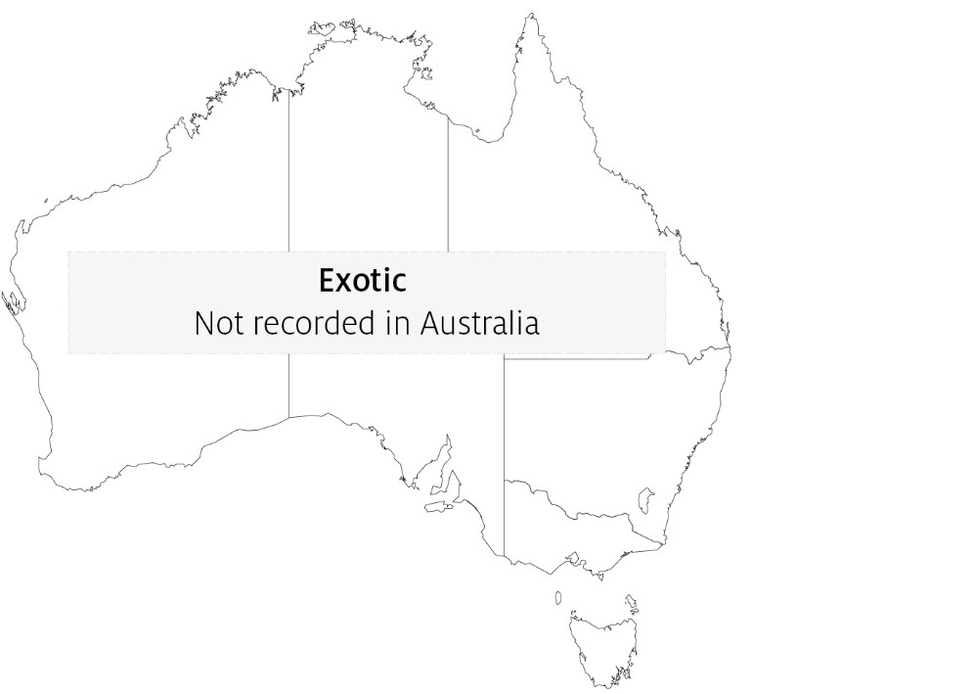

Epidemiology
- Grouper iridoviral disease causes losses in fry and juvenile grouper, and in 1 to 2-year-old market-sized grouper (a highly priced product in tropical mariculture).
- Clinical disease and highest mortalities are usually seen in 3 to 4-month-old fish after stocking into sea cages.
- Older diseased fish typically appear lethargic due to anaemia.
- Horizontal contact and waterborne transmission appear to be the principal mechanisms for virus spread.

Differential diagnosis
The list of similar diseases in the next section refers only to the diseases covered by this field guide. Gross pathological signs may also be representative of diseases not included in this guide. Do not rely on gross signs to provide a definitive diagnosis. Use them as a tool to help identify the listed diseases that most closely account for the observed signs.

Similar diseases
Infection with Aphanomyces invadans (EUS), infection with infectious spleen and kidney necrosis virus (ISKNV)-like viruses, red sea bream iridoviral disease (RSIVD) and viral encephalopathy and retinopathy (VER).

Sample collection
Only trained personnel should collect samples. Using only gross pathological signs to differentiate between diseases is not reliable, and some aquatic animal disease agents pose a risk to humans. If you are not appropriately trained, phone your state or territory hotline number and report your observations. If you have to collect samples, the agency taking your call will advise you on the appropriate course of action. Local or district fisheries or veterinary authorities may also advise on sampling.

Emergency disease hotline
See something you think is this disease? Report it. Even if you’re not sure.
Call the Emergency Animal Disease Watch Hotline on 1800 675 888. They will refer you to the right state or territory agency.

Further reading
Hazeri M, Hassan MD, Abba Y, Omar AR, Allaudin ZN, Soltani M, Hamdan RH, Mohamad NF 2017, Molecular characterisation of grouper iridovirus isolates from Peninsular Malaysia, Journal Veterinar Malaysia
Ma H, Peng C, Su Y, Feng J, Guo Z 2016, ‘Isolation of a Ranavirus-type grouper iridovirus in mainland China and comparison of its pathogenicity with that of a Megalocytivirus-type grouper iridovirus’, Aquaculture
Network of Aquaculture Centres in Asia–Pacific Grouper iridoviral disease: disease card
These hyperlinks were correct at the time of publication.

Contact details
Emergency Animal Disease Watch Hotline 1800 675 888
Email AAH@agriculture.gov.au
Website agriculture.gov.au/pests-diseases-weeds/aquatic
© Commonwealth of Australia 2020
This work is copyright. It may be reproduced in whole or in part subject to the inclusion of an acknowledgement of the source and no commercial usage or sale.

