Infection with Aeromonas salmonicida—atypical strains

Also known as infection with atypical strains of Aeromonas salmonicida, marine aeromonad disease of salmonids (MAS), goldfish ulcer disease, carp erythrodermatitis and ulcer disease of flounder, eel and salmon

From Aquatic animal diseases significant to Australia: identification field guide, 5th edition
Figure 1 Goldfish ulcer disease in goldfish (Carassius auratus)
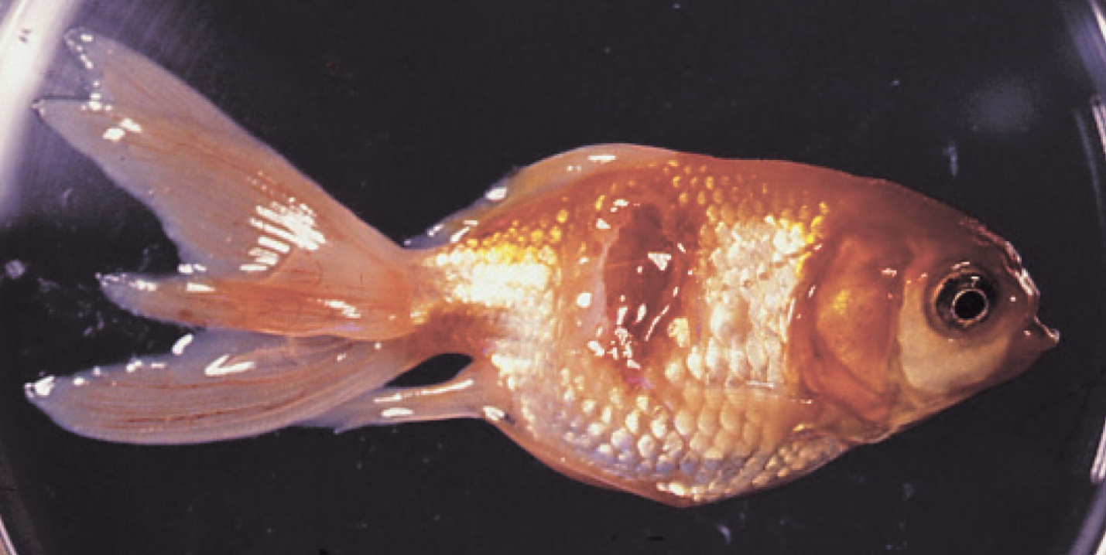
Note: Characteristic ulcers on the body.
Source: J Carson
Figure 2 Greenback flounder (Rhombosolea tapirina) infected with greenback flounder strain of Aeromonas salmonicida
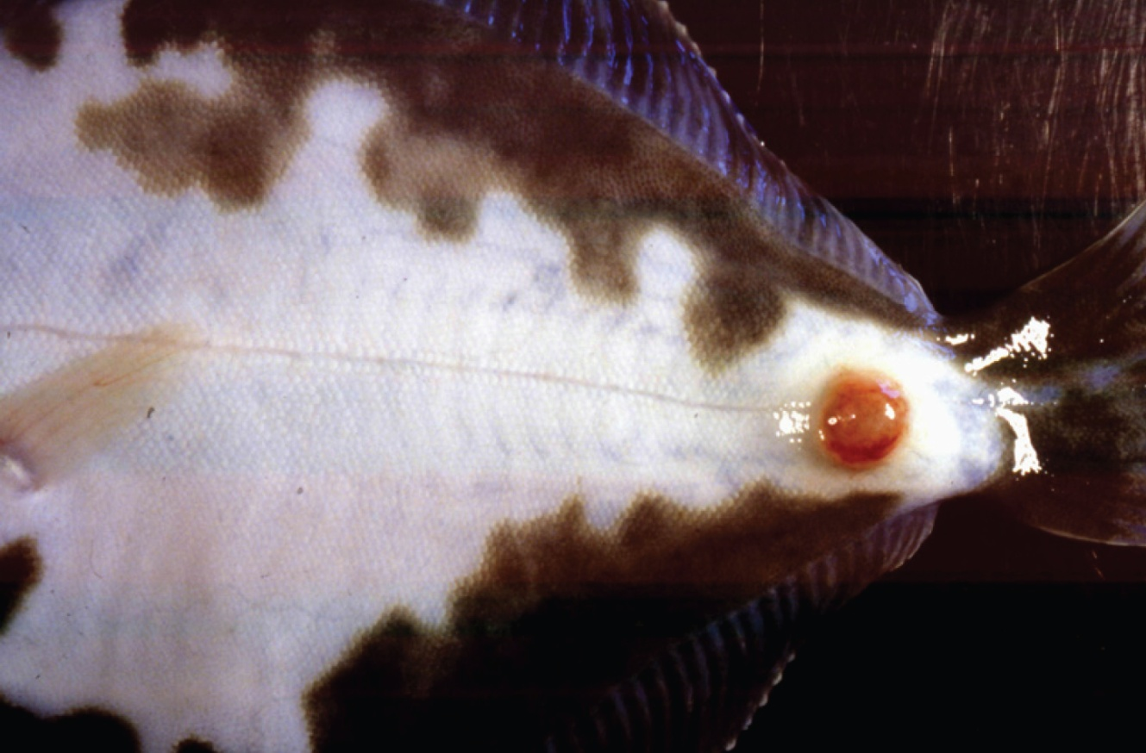
Note: Ulcer on ventral side of body.
Source: J Carson.
Figure 3 Infection with atypical Aeromonas salmonicida in silver perch (Bidyanus bidyanus)
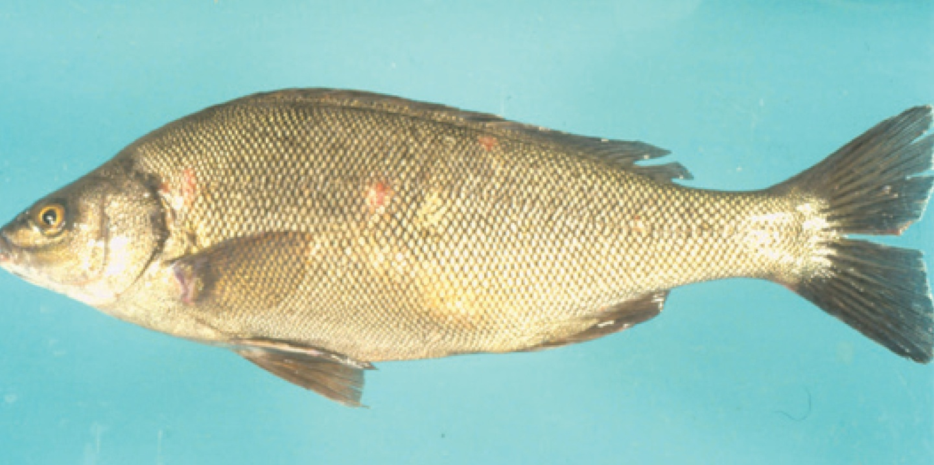
Note: Ulcers on body.
Source: M Landos
Figure 4 Infection with Aeromonas salmonicida biovar Acheron in Atlantic salmon (Salmo salar)
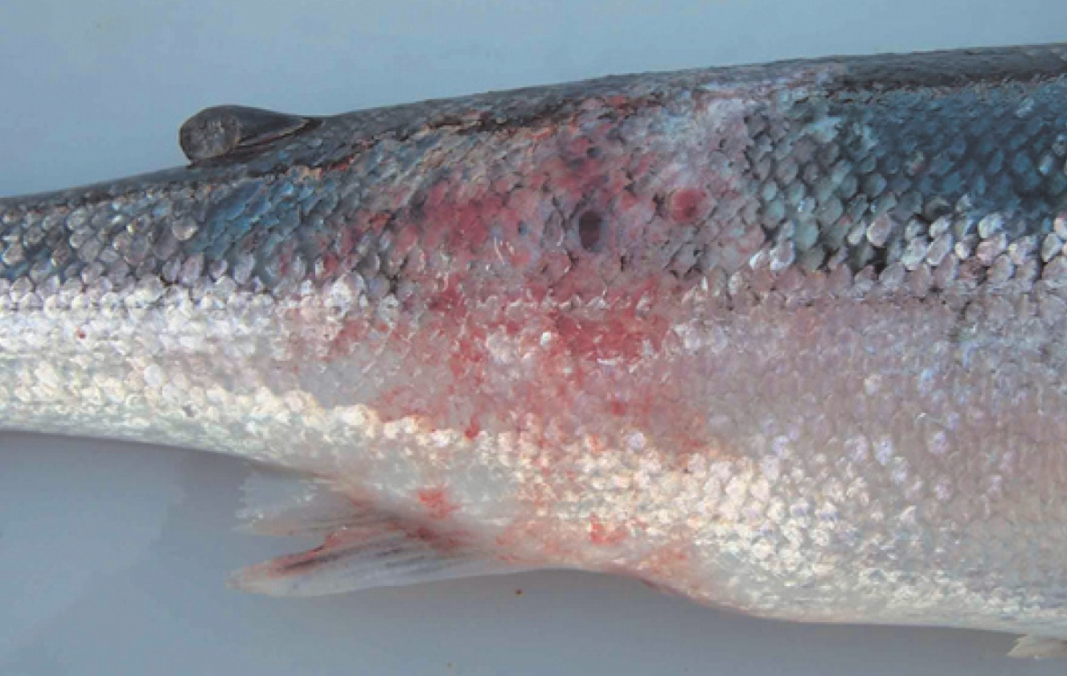
Note: Haemorrhagic lesion on the flank typical of MAS.
Source: K Ellard
Figure 5 Atlantic salmon (Salmo salar) with blood filled MAS ulcerations
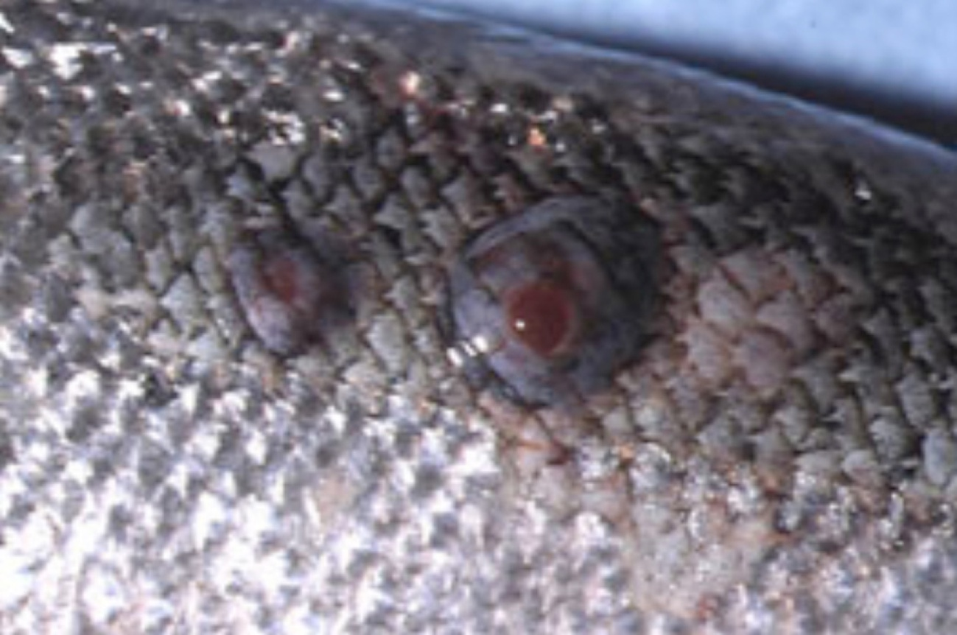
Note Blood-filled furuncles in MAS are rarely noted, because they rupture easily.
Source: K Ellard
Figure 6 Atlantic salmon (Salmo salar) with MAS ulcer exposed below the surface of the skin
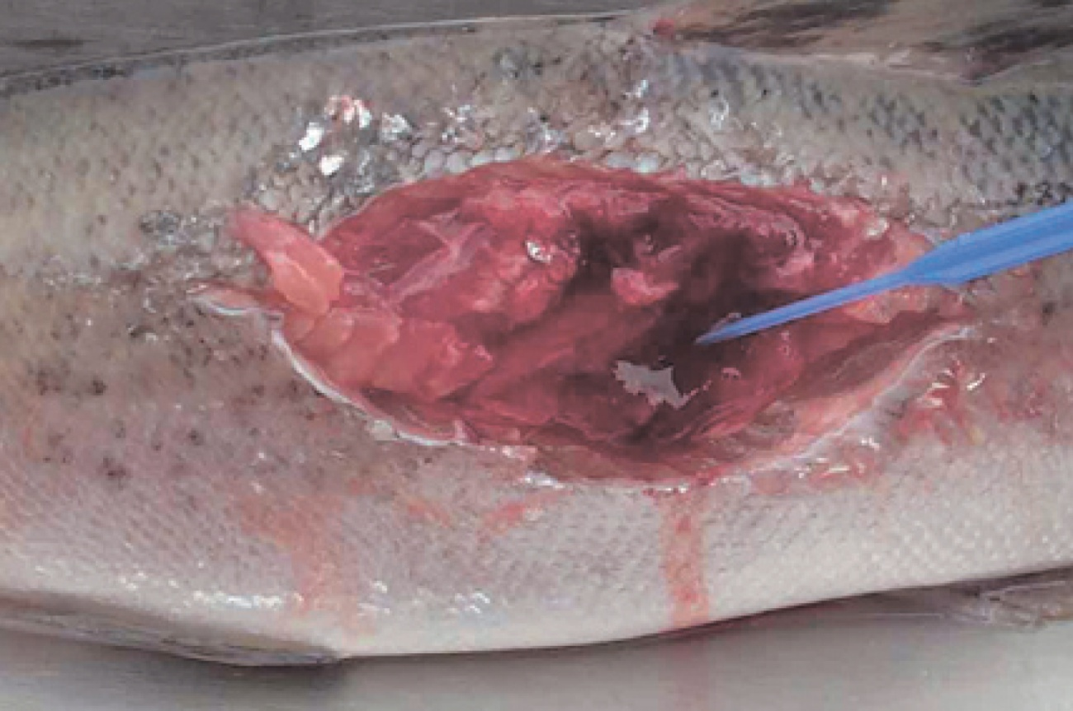
Note: The MAS lesion extends into the underlying muscle.
Source: K Ellard
Figure 7 Atlantic salmon (Salmo salar) infected with greenback flounder strain of atypical A. salmonicida after cohabitation with infected flounder
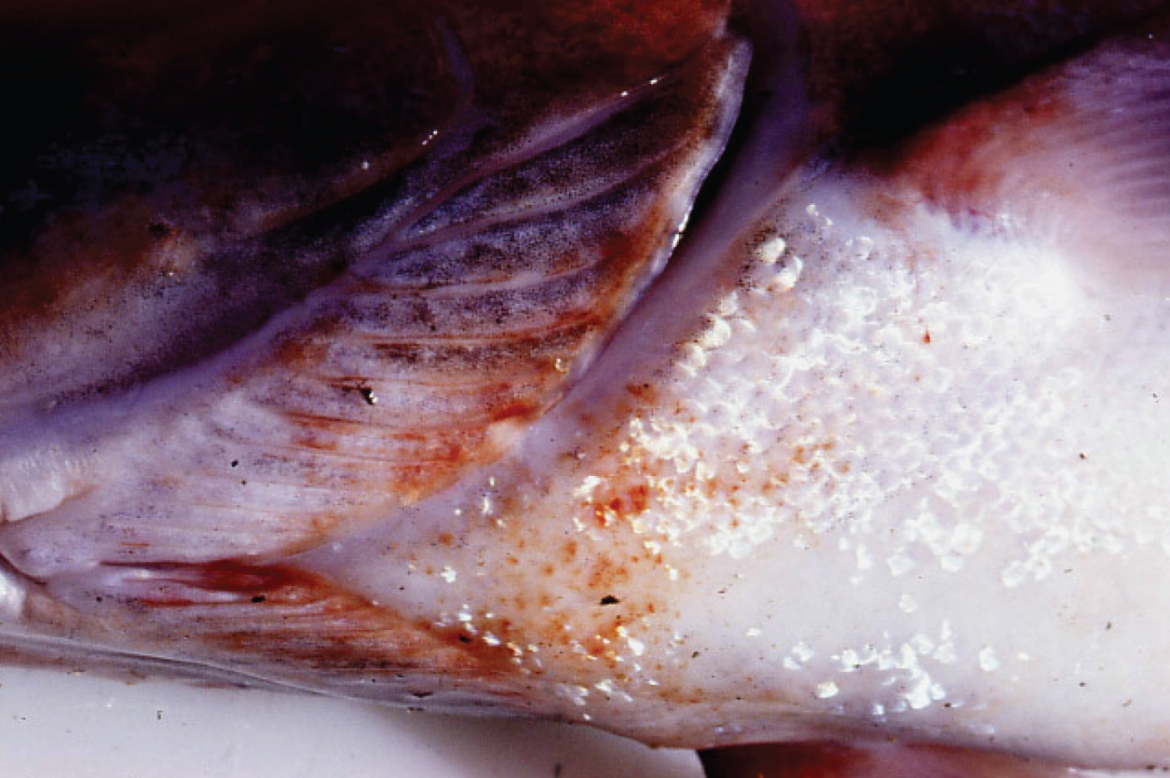
Note: Haemorrhagic lesions around the isthmus and branchiostegal membranes.
Source: J Carson

Signs of disease
Important: Animals with this disease may show one or more of these signs, but the pathogen may still be present in the absence of any signs.
Disease signs at the farm, tank or pond level are:
- lethargic swimming
- abnormal swimming and disorientation
- loss of appetite
- increased mortality.
Gross pathological signs are:
- white raised patches on the skin that progress to ragged-edged red ulcers
- haemorrhages on the skin and fin bases (usually the paired fins)
- fingernail-sized ulcers found anywhere on the fish, most often on the upper side of the lateral line behind the head or at the base of the tail fin
- pale gills with petechial (pinpoint) haemorrhages
- intestinal protrusion through the abdominal wall following severe ulceration
- haemorrhages in muscle and internal organs
- swollen kidneys and spleen.
Microscopic pathological signs are:
- hyperplasia of the gills, which may contain bacterial colonies
- ulcerated areas that show oedema, hyperaemia, leukocyte infiltration and considerable degenerative changes
- hyperaemia and haemorrhage in the spleen and kidneys
- fibroblast-like cells, which may produce granulomas in the dermis, spleen and kidney.

Disease agent
Atypical strains of the Aeromonas salmonicida bacterium within the family Enterobacteriaceae differ from the typical strain causing furunculosis in salmonids. Atypical strains affect mainly non-salmonids (wild and cultured, marine and freshwater). Infection with atypical A. salmonicida does not necessarily result in the acute mortality and septicaemia that are characteristic of the typical furunculosis strain, but manifests more as external lesions and ulceration, often involving secondary infection. An exception is MAS in Tasmania; in such cases, Atlantic salmon are most commonly affected, and clinical presentation is similar to furunculosis.
There are five subspecies of A. salmonicida. A. salmonicida salmonicida is known as the typical strain and is the only one to cause furunculosis (listed separately in this guide). The other four subspecies (achromogenes, masoucida, smithia and pectinolytica) are referred to as atypical A. salmonicida and are recognised worldwide. All except A. salmonicida pectinolytica cause disease in fish.
A. salmonicida biovar Acheron is a new atypical strain recently described in Australia (Tasmania), causing MAS in Atlantic salmon.

Host range
Laboratory experiments indicate that all trout and salmon species, as well as many non-salmonids, are potentially susceptible to atypical strains of A. salmonicida. For example, Atlantic salmon and striped trumpeter can be infected by cohabitation with infected flounder.
Rainbow trout are relatively resistant to atypical strains.
Table 1 Species known to be susceptible to atypical strains of Aeromonas salmonicida
Common name | Scientific name
Amago salmonª | Oncorhynchus rhodurus
American eelª | Anguilla rostrata
American plaice | Hippoglossoides platessoides
Arctic char | Salvelinus alpinus
Atlantic codª | Gadus morhua
Atlantic herringª | Clupea harengus
Atlantic salmonª | Salmo salar
Ayu | Plecoglossus altivelis
Black sea salmon | Salmo labrax
Black rockfishª | Sebastes schlegelii
Brook troutª | Salvelinus fontinalis
Brown troutª | Salmo trutta
Bull trout | Salvelinus confluentus
Chubª | Leuciscus cephalus
Chinook salmon | Oncorhynchus tshawytscha
Chum salmonª | Oncorhynchus keta
Coho salmon | Oncorhynchus kisutch
Common carp and koi carpª | Cyprinus carpio
Common roachª | Rutilus rutilus
Crucian carpª | Carassius carassius
Cutthroat trout | Oncorhynchus clarkii
Dabª | Limanda limanda
Daceª | Leuciscus leuciscus
Danube salmon | Hucho hucho
Eels | Anguillidae all species
European eel | Anguilla anguilla
Flounderª | Platichthys flesus
Fourbeard rocklingª | Enchelyopus cimbrius
Freshwater breamª | Abramis brama
Gila trout | Oncorhynchus gilae
Golden trout | Oncorhynchus aguabonita
Goldfishª | Carassius auratus
Goldsinnyª | Ctenolabrus rupestris
Graylingª | Thymallus thymallus
Great sandeelª | Hyperoplus lanceolatus
Greenback flounderª | Rhombosolea tapirina
Haddockª | Melanogrammus aeglefinus
Hybrid (rainbow trout × coho salmon) | Oncorhynchus mykiss × O. kisutch
Japanese eel | Anguilla japonica
Japanese flounderª | Paralichthys olivaceus
Lake trout | Salvelinus namaycush
Lake whitefish | Coregonus clupeaformis
Lesser sand eel | Ammodytes tobianus
Masu salmonª | Oncorhynchus masou
Minnowª | Phoxinus phoxinus
Pacific halibutª | Hippoglossus stenolepis
Pacific salmonª | Oncorhynchus spp.
Pike | Esox lucius
Pink salmon | Oncorhynchus gorbuscha
Plaiceª | Pleuronectes platessa
Rainbow troutª | Oncorhynchus mykiss
Redfin or European perch | Perca fluviatilis
Ruddª | Scardinius erythrophthalmus
Sablefish | Anoplopoma fimbria
Salmonids (all presumed susceptible)ª | Salmonidae all species
Shortfin eel | Anguilla australis
Shotted halibutª | Eopsetta grigorjewi
Shubunkinª | Carassius sp.
Silver breamª | Blicca bjoerkna
Silver perchª | Bidyanus bidyanus
Smallmouth bassª | Micropterus dolomieu
Sockeye salmonª | Oncorhynchus nerka
Splake (lake trout × brook trout) | Salvelinus namaycush × S. fontinalis
Spotted wolfishª | Anarhichas minor
Striped trumpeterª | Latris lineata
Tomcodª | Gadus microgadus
Turbotª | Scophthalmus maximus
Viviparous blennyª | Zoarces viviparus
Whitefish (Muksun) | Coregonus muksun
Whitefish (Peled) | Coregonus peled
Whitefish | Coregonus spp.
Whitespotted char | Salvelinus leucomaenis
Whitingª | Merlangius merlangus
Wrasseª | Labrus bergylta
Wrasses | Labridae all species
Yellow bassª | Morone mississippiensis
a Naturally susceptible. Note: Other species likely to be susceptible.

Presence in Australia
Atypical A. salmonicida has been officially reported from New South Wales, Queensland, South Australia, Victoria (goldfish ulcer disease only) and Tasmania (greenback flounder biovar and Acheron biovar only). Movement controls are in place to prevent the spread of goldfish ulcer disease to Western Australia and Tasmania. The Acheron biovar has been reported only from Tasmania and is limited to an isolated production area.
Map 1 Presence of atypical strains of Aeromonas salmonicida, by jurisdiction
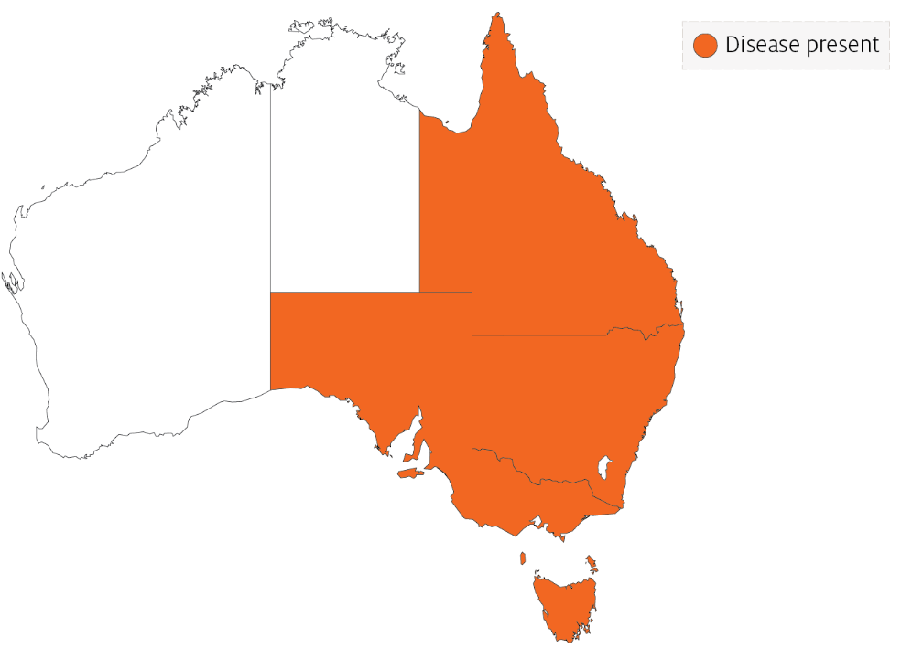

Epidemiology
- Transmission occurs horizontally (between fish via the water).
- Susceptibility to the disease increases with damaged mucus and skin, which occurs when fish are handled with nets.
- Outbreaks are expected to occur at water temperatures above 10°C (summer months in southern waters of Australia) and may be precipitated by stress (such as handling, overpopulation and rapid temperature fluctuations).
- Secondary infection with other bacteria often occurs.
- Fish that survive disease outbreaks are recognised as carriers of the disease. Carriers may continue to infect the remaining population without themselves exhibiting signs of infection.
- Diagnosis based on clinical or external signs of disease is difficult because clinical signs vary and skin ulcers are often infected with opportunistic bacteria and fungi. A definitive diagnosis requires laboratory examination.

Differential diagnosis
The list of similar diseases in the next section refers only to the diseases covered by this field guide. Gross pathological signs may also be representative of diseases not included in this guide. Do not rely on gross signs to provide a definitive diagnosis. Use them as a tool to help identify the listed diseases that most closely account for the observed signs.

Similar diseases
Channel catfish virus disease (CCVD), furunculosis, infection with Aphanomyces invadans (EUS), koi herpesvirus disease (KHV) and spring viraemia of carp (SVC).

Sample collection
Only trained personnel should collect samples. Using only gross pathological signs to differentiate between diseases is not reliable, and some aquatic animal disease agents pose a risk to humans. If you are not appropriately trained, phone your state or territory hotline number and report your observations. If you have to collect samples, the agency taking your call will advise you on the appropriate course of action. Local or district fisheries or veterinary authorities may also advise on sampling.

Emergency disease hotline
See something you think is this disease? Report it. Even if you’re not sure.
Call the Emergency Animal Disease Watch Hotline on 1800 675 888. They will refer you to the right state or territory agency.

Further reading
Menanteau-Ledouble S, Kumar G, Saleh M, El-Matbouli M 2016, ‘Aeromonas salmonicida’: updates on an old acquaintance, Diseases of Aquatic Organisms
Whittington RJ, Djordjevic SP, Carson J, Callinan RB 1995, Restriction endonuclease analysis of atypical ‘Aeromonas salmonicida’ isolates from goldfish ‘Carassius auratus’, silver perch ‘Bidyanus bidyanus’, and greenback flounder ‘Rhombosolea tapirina’ in Australia, Diseases of Aquatic Organisms
These hyperlinks were correct at the time of publication.

Contact details
Emergency Animal Disease Watch Hotline 1800 675 888
Email AAH@agriculture.gov.au
Website agriculture.gov.au/pests-diseases-weeds/aquatic
© Commonwealth of Australia 2020
This work is copyright. It may be reproduced in whole or in part subject to the inclusion of an acknowledgement of the source and no commercial usage or sale.

