Infection with Aphanomyces astaci

Also known as crayfish plague

From Aquatic animal diseases significant to Australia: identification field guide, 5th edition
Figure 1 Dorsal surface of signal crayfish (Pacifastacus leniusculus) resistant to crayfish plague
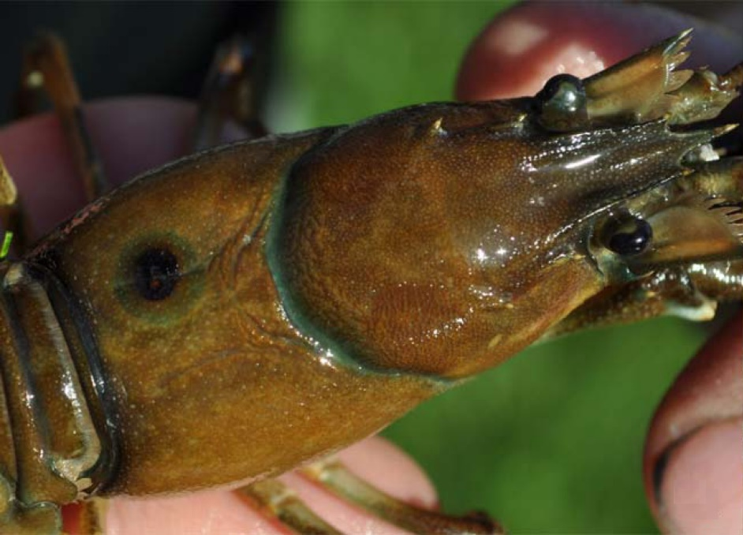
Note: Focal melanised spot on upper carapace due to infection by Aphanomyces astaci.
Source: T Vrålstad
Figure 2 Ventral surface of signal crayfish (Pacifastacus leniusculus) resistant to crayfish plague
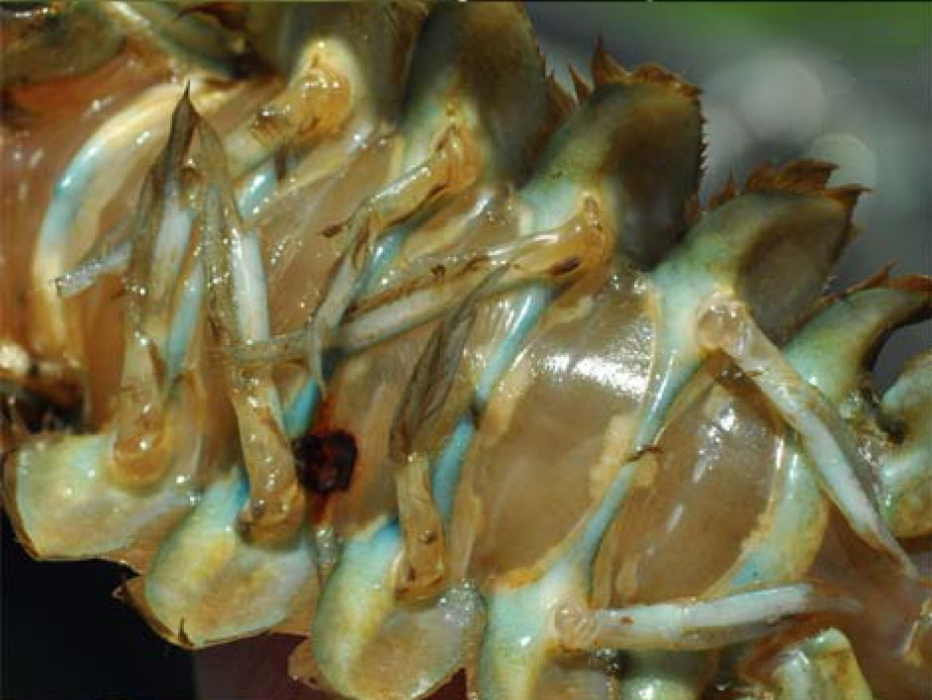
Note: Focal melanised spot on abdominal segment due to infection by Aphanomyces astaci.
Source: T Vrålstad
Figure 3 Signs of crayfish plague in body of susceptible stone crayfish (Austropotamobius torrentium)
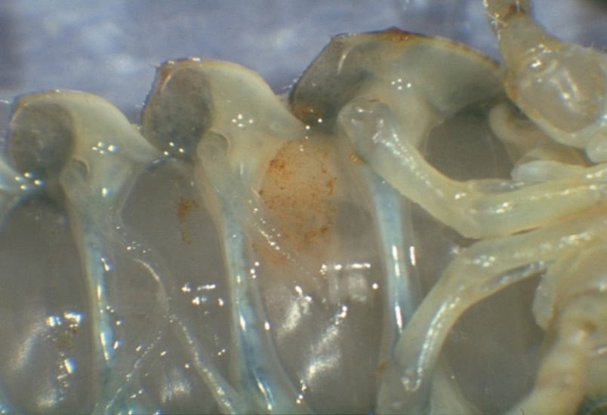
Note: Typical brown markings on an abdominal segment are caused by infection with Aphanomyces astaci. Healthy muscle tissue is present on either side of the affected segment.
Source: D Alderman
Figure 4 Signs of crayfish plague in leg of susceptible stone crayfish (Austropotamobius torrentium)
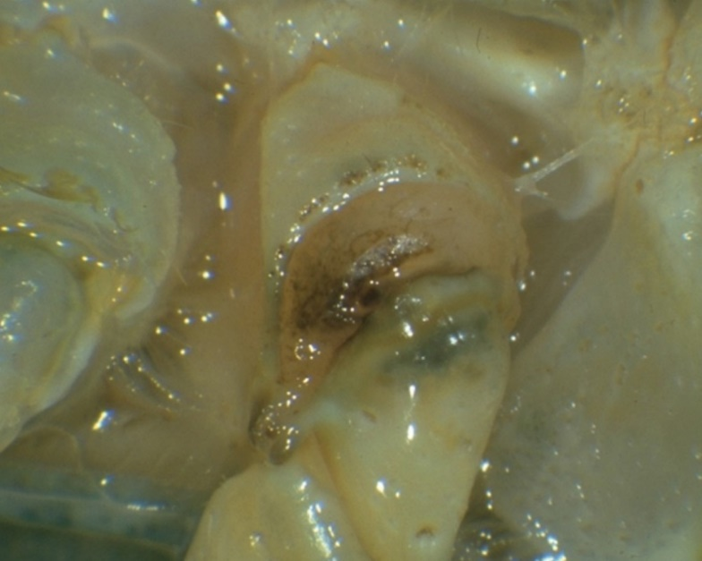
Note: Classic darkening at base of walking legs is caused by infection with Aphanomyces astaci.
Source: D Alderman

Signs of disease
Important: Animals with this disease may show one or more of these signs, but the pathogen may still be present in the absence of any signs.
Disease signs at the farm, tank or pond level are:
- high mortality at the time of the initial outbreak (usually near 100%)
- many dead or weak crayfish floating or lying in watercourses or ponds (mortalities may go unnoticed in the wild)
- crayfish in open water during daylight hours
- unsteady and raised gait ('walking on stilts')
- weakened, rapid tail escape response
- crayfish unable to remain upright (more evident when out of water)
- progressive paralysis
- crayfish trying to scratch or pinch themselves (occasionally seen).
Gross pathological signs are:
- fungal growth on soft, non-calcified parts of the carapace
- brown or black spots on the carapace, where fungal hyphae proliferate
- fine black lines on the soft shell underneath the tail
- melanised (black) shell in chronically infected individuals
- death occurring within days or weeks of the initial infection (particularly in European crayfish, Astacus sp.)
- white and necrotic musculature in the tail.
Microscopic pathological signs are:
- aseptate hyphae on the cuticle.

Disease agent
Crayfish plague is caused by infection with the oomycete Aphanomyces astaci. Although previously regarded as a fungus, the genus Aphanomyces is now classified with diatoms and brown algae in a group called Stramenopiles or Chromista. This pathogen is known to occur in freshwater only.

Host range
Table 1 Species known to be susceptible to crayfish plague
Common name | Scientific name
Asian freshwater shrimpª | Macrobrachium dayanum
Chinese mitten crabª | Eriocheir sinensis
Crayfish (native to Europe)ª | Astacus spp.
Crayfish (native to North America)ª | Orconectes spp.
European river crab | Potamon potamios
Freshwater crayfishª | Cherax spp.
Giant crayfish (native to Australia) | Astacopsis spp.
Giant Tasmanian crayfish | Astacopsis gouldi
Gippsland spiny crayfish | Euastacus kershawi
Japanese crayfishª | Cambaroides japonicus
Louisiana red swamp crayfishª | Procambarus clarkii
Marbled crayfishª | Procambarus fallax. f. virginalis
Noble crayfishª | Astacus astacus
Redclaw crayfishª | Cherax quadricarinatus
Signal crayfishª | Pacifastacus leniusculus
Smooth crayfish (native to Australia) | Geocherax spp.
Spiny crayfish (native to Australia) | Euastacus spp.
Stone crayfishª | Austropotamobius torrentium
Turkish crayfishª | Astacus leptodactylus
White-clawed crayfishª | Austropotamobius pallipes
Yabbies (freshwater, native to Australia)ª | Cherax destructor
a Naturally susceptible.
Table 2 Non-crustacean vectors of crayfish plague
Common name | Scientific name
Piscivorous birds | Various genera and species

Presence in Australia
Exotic disease—not recorded in Australia.
Map 1 Presence of crayfish plague, by jurisdiction
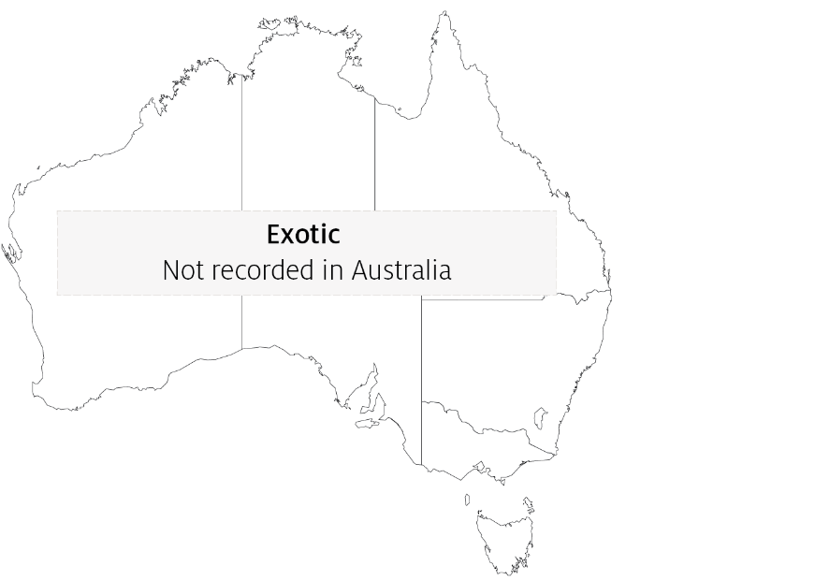

Epidemiology
- Mortalities of up to 100% have occurred in Europe, with local extinction of susceptible populations.
- North American crayfish (signal crayfish, Louisiana red swamp crayfish, Orconectes sp.) can be infected without showing clinical signs or succumbing to the disease. This allows them to become carriers of the disease agent and a source of transmission to less resistant species of crayfish.
- The disease was introduced into Europe by American freshwater crayfish and has decimated European crayfish stocks (wild and cultured). Until recently, there was no evidence of development of resistance to the disease among European species. There is now evidence of latent subclinical Aphanomyces astaci infections in some European crayfish, including noble crayfish (Astacus astacus) and Turkish crayfish (Astacus leptodactylus).
- Crayfish plague can occur at any time of year but is more likely in the summer months.
- Death occurs between 5 and 50 days (or more) from initial infection, depending on water temperature and initial number of zoospores. As little as one zoospore may be sufficient to initiate a lethal infection in susceptible crayfish species.
- Aphanomyces astaci releases motile zoospores directly to the water column when crayfish die. This is the primary transmission mechanism; motile zoospores of A. astaci swim actively in the water column and show positive movement towards other crayfish.
- Zoospores emerging from spores can swim for up to 5 days at 20°C but are capable of encystment and re-emergence up to 3 times, extending the period of their infective viability to several weeks.
- Translocation and migration of fish, birds and other wildlife can allow them to act as vectors, transporting the disease agent into previously unexposed waters.
- Aphanomyces astaci can be introduced to a new susceptible crayfish population on contaminated ropes, traps, fishing gear, boots, nets and other equipment.
- Infection with A. astaci may be suspected when mortalities are observed to be limited to highly susceptible species of freshwater crayfish (where all other flora and fauna, particularly other crustaceans, are normal and healthy).
- The known host range for A. astaci has expanded as more ornamental crayfish species are examined. There have been several instances where Australian crayfish species have been infected with A. astaci after intermingling with North American or European crayfish species within the ornamental trade.

Differential diagnosis
The list of similar diseases in the next section refers only to the diseases covered by this field guide. Gross pathological signs may also be representative of diseases not included in this guide. Do not rely on gross signs to provide a definitive diagnosis. Use them as a tool to help identify the listed diseases that most closely account for the observed signs.

Similar diseases
None of the other diseases in this field guide result in the rapid mortality of crayfish or other gross signs of crayfish plague. In Australia, infection with the microbial parasite Thelohania (or porcelain disease) may cause similar gross signs. Initial misdiagnosis has occurred when pollution has resulted in mortality of aquatic crustaceans where other species have survived. In a few cases, examination by light microscopy can further define a diagnosis. However, further laboratory examination is always required for a definitive diagnosis.

Sample collection
Only trained personnel should collect samples. Using only gross pathological signs to differentiate between diseases is not reliable, and some aquatic animal disease agents pose a risk to humans. If you are not appropriately trained, phone your state or territory hotline number and report your observations. If you have to collect samples, the agency taking your call will advise you on the appropriate course of action. Local or district fisheries or veterinary authorities may also advise on sampling.

Emergency disease hotline
See something you think is this disease? Report it. Even if you’re not sure.
Call the Emergency Animal Disease Watch Hotline on 1800 675 888. They will refer you to the right state or territory agency.

Further reading
CEFAS International Database on Aquatic Animal Diseases Crayfish plague
Department of Agriculture, Water and the Environment AQUAVETPLAN disease strategy manual: Crayfish plague
World Organisation for Animal Health Manual of diagnostic tests for aquatic animals
These hyperlinks were correct at the time of publication.

Contact details
Emergency Animal Disease Watch Hotline 1800 675 888
Email AAH@agriculture.gov.au
Website agriculture.gov.au/pests-diseases-weeds/aquatic
© Commonwealth of Australia 2020
This work is copyright. It may be reproduced in whole or in part subject to the inclusion of an acknowledgement of the source and no commercial usage or sale.

