Infection with Aphanomyces invadans

Also known as epizootic ulcerative syndrome (EUS), red spot disease (RSD), ulcerative mycosis (UM) and mycotic granulomatosis

From Aquatic animal diseases significant to Australia: identification field guide, 5th edition
Figure 1 EUS in golden perch (Macquaria ambigua)
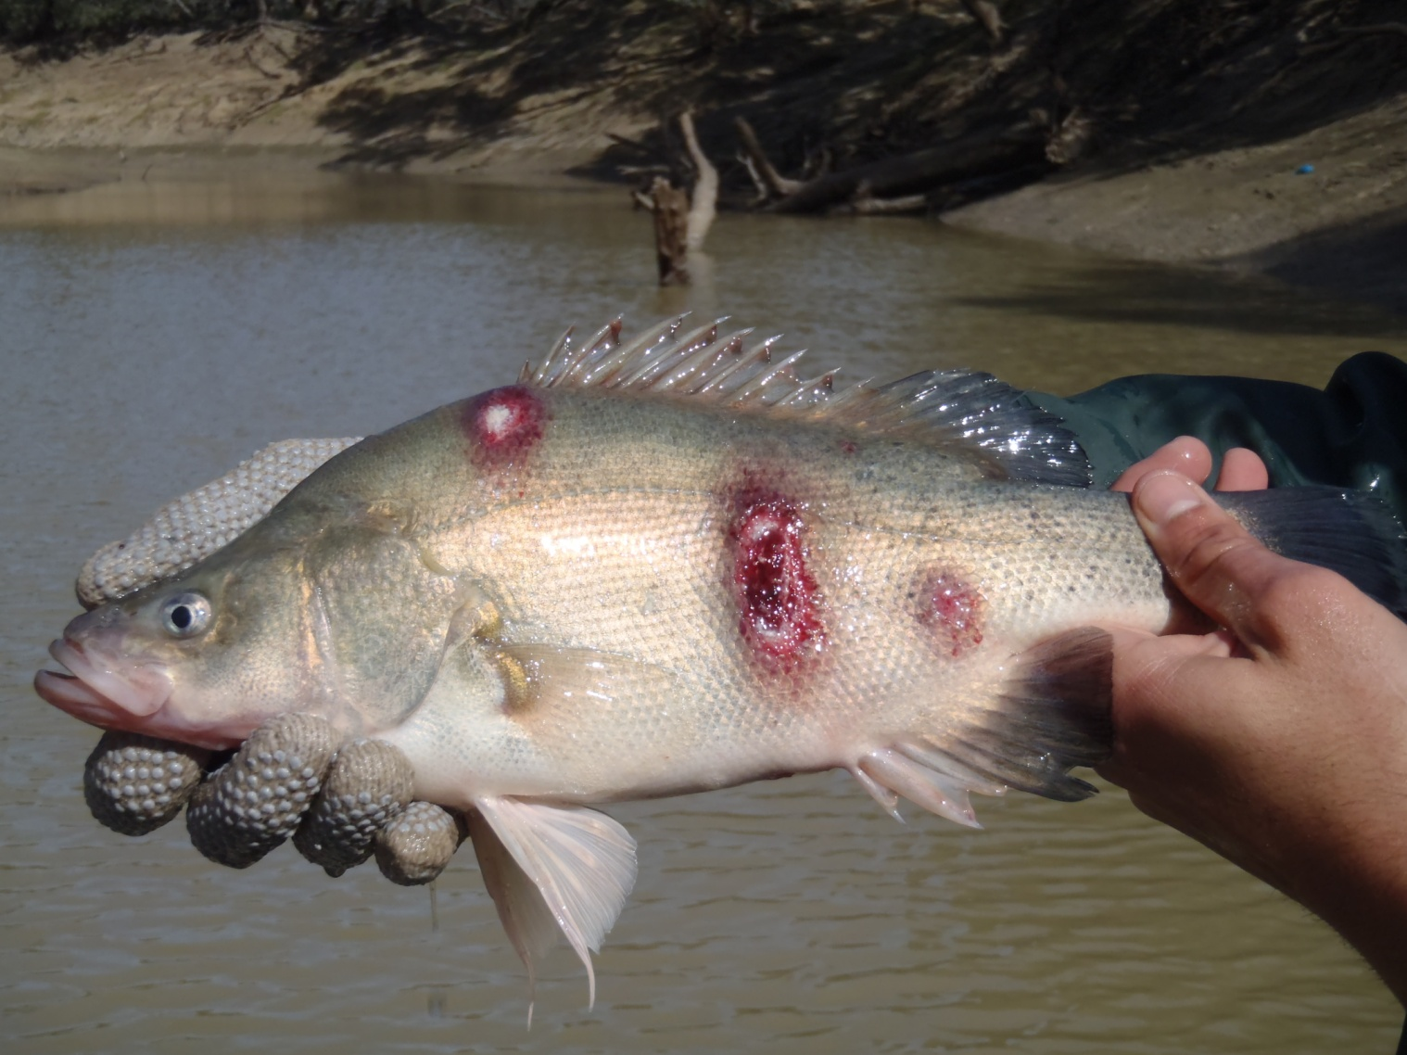
Note: Multiple ulcerative lesions on flanks caused by infection with Aphanomyces invadans.
Source: C Boys
Figure 2 EUS in spangled perch (Leiopotherapon unicolour)
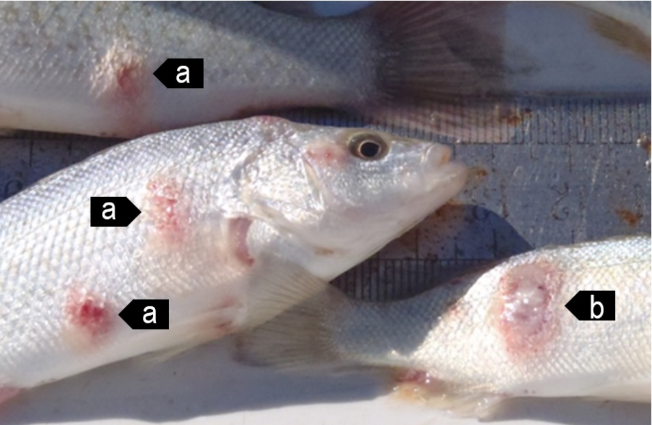
Note Focal haemorrhagic ulcerative lesions (a) will progress to a deep ulcer (b).
Source: C Boys
Figure 3 EUS in sand whiting (Sillago ciliata)
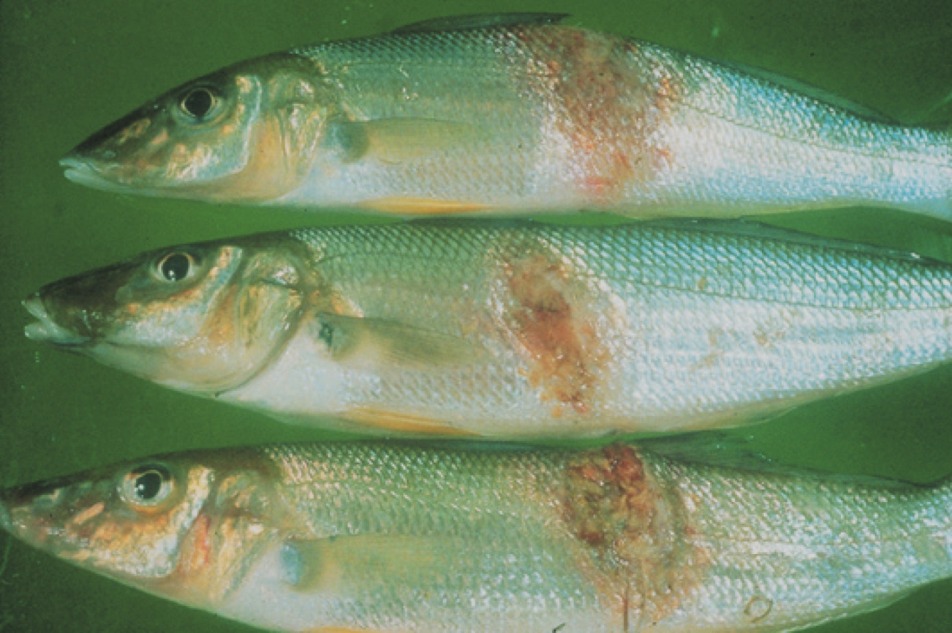
Note: Progression of red lesion (top) to deep ulcer (bottom) of classical red sores on the body.
Source: NSW Department of Primary Industries

Signs of disease
Important: Animals with this disease may show one or more of these signs, but the pathogen may still be present in the absence of any signs.
Disease signs at the farm, tank or pond level are:
- loss of appetite
- dark body colour
- mass mortality
- erratic swimming
- rubbing on the surfaces of tanks
- increased respiratory rate and effort.
Gross pathological signs are:
- lesions on the body showing as red spots, black burn-like marks or deeper ulcers with red centres and white rims
- progressive lesions
  - lesions start as reddening under a single scale but quickly spread to involve adjacent scales
  - lesions continue to widen and deepen, forming ulcers that erode underlying tissues to expose (depending on infection location) skeletal musculature, vertebrae, brain or viscera.
- unilateral or bilateral clouding of the eye (particularly in barramundi).
Microscopic pathological signs are:
- erythematous dermatitis
- hyphae (fungal threads) associated with granulomatous tissue, sometimes extending into visceral organs
- liquefactive necrosis of muscle tissue.

Disease agent
Infection with the oomycete fungus Aphanomyces invadans causes a disease called epizootic ulcerative syndrome (EUS); also known as red spot disease (RSD), ulcerative mycosis (UM) or mycotic granulomatosis. Although previously regarded as a fungus, the genus Aphanomyces is now classified with diatoms and brown algae in a group called Stramenopiles or Chromista.

Host range
More than 100 estuarine and freshwater species of fish are known to be susceptible to infection with A. invadans.
Table 1 Species in Australia known to be susceptible to Aphanomyces invadans
Common name | Scientific name
Australian bassª | Macquaria novemaculeata
Archerfishª | Toxotes chatareus
Banded archerfishª | Toxotes jaculatrix
Barcoo grunterª | Scortum barcoo
Barramundiª | Lates calcarifer
Bony breamª | Nematalosa erebi
Chanda perchª | Ambassis agassizii
Cichlidsª | Cichlidae
Climbing perchª | Anabas testudineus
Cyprinidsª | Cyprinidae
Dusky flatheadª | Platycephalus fuscus
Eastern freshwater cod | Maccullochella ikei
Eels | Anguillidae all species
Estuarine rockcodª | Epinephelus tauvina
Flathead gobyª | Glossogobius giuris
Fork-tailed catfish | Arius spp.
Froggatt’s catfish | Cinetodus froggatti
Giant glassfishª | Parambassis gulliveri
Giant grouper | Epinephelus lanceolatus
Giant gudgeonª | Oxyeleotris selheimi
Goldfish | Carassius auratus auratus
Golden perch | Macquaria ambigua
Grouper and estuary codª | Epinephelus spp.
Long tomª | Strongylura krefftii
Mangrove jackª | Lutjanus argentimaculatus
Mouth almightyª | Glossamia aprion
Sea mulletª | Mugil cephalus
Mulletsª | Mugilidae
Murray cod | Maccullochella peelii
Nurseryfish | Kurtus gulliveri
Primitive archer fishª | Toxotes lorentzi
Rainbow fishª | Melanotaenia splendida
Rainbow trout | Oncorhynchus mykiss
Saratogaª | Scleropages jardini
Scatª | Scatophagus argus
Shortfin eelª | Anguilla australis
Silver perchª | Bidyanus bidyanus
Silver trevallyª | Pseudocaranx dentex
Sleepy codª | Oxyeleotris lineolatus
Striped grunterª | Amniataba percoides
Spangled perchª | Leiopotherapon unicolor
Triangular shield catfishª | Neoarius leptaspis
Tropical two-winged flying fishª | Exocoetus volitans
Whitingª | Sillago ciliata
Yellowfin breamª | Acanthopagrus australis
a Naturally susceptible. Note: Other species have been shown to be experimentally susceptible. A current list of known susceptible species found both within and outside of Australia is included in the World Organisation for Animal Health Manual of Diagnostic Tests for Aquatic Animals.

Presence in Australia
EUS is endemic in many freshwater catchments and estuaries in Australia. The disease has been officially reported from New South Wales, the Northern Territory, Queensland, Victoria, South Australia and Western Australia.
Map 1 Presence of Aphanomyces invadans, by jurisdiction
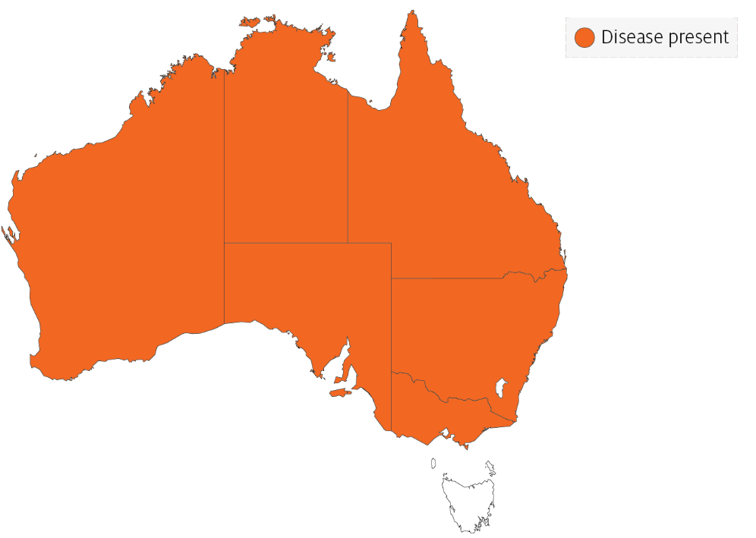

Epidemiology
- The disease is seen in more than 100 freshwater and estuarine species of fish and infection has spread rapidly throughout Asia, associated with the movement of ornamental fish.
- Predisposing factors leading to skin damage (such as parasites, bacterial or viral infection, physical trauma or acidic water) are normally required to allow the Aphanomyces oomycete to initiate clinical signs of EUS. Secondary opportunistic infections are also a common finding.
- Disease is often associated with acid water run-off and can appear after heavy rains (particularly after a long dry period) with water temperatures of 18°C to 22°C favouring sporulation.
- Disease transmission is through zoospore transfer in freshwater, direct contact between fish and skin contamination (penetration assisted by damage to skin).
- Zoospores can encyst if they do not find a host, and can survive for at least 19 days.
- Water salinity above 2 ppt can stop the spread of this obligate freshwater disease agent.

Differential diagnosis
The list of similar diseases in the next section refers only to the diseases covered by this field guide. Gross pathological signs may also be representative of diseases not included in this guide. Do not rely on gross signs to provide a definitive diagnosis. Use them as a tool to help identify the listed diseases that most closely account for the observed signs.

Similar diseases
Enteric septicaemia of catfish, grouper iridoviral disease, infection with Aeromonas salmonicida—atypical strains, koi herpesvirus disease (KHV), viral haemorrhagic septicaemia (VHS) and tilapia lake virus (TiLV) disease.

Sample collection
Only trained personnel should collect samples. Using only gross pathological signs to differentiate between diseases is not reliable, and some aquatic animal disease agents pose a risk to humans. If you are not appropriately trained, phone your state or territory hotline number and report your observations. If you have to collect samples, the agency taking your call will advise you on the appropriate course of action. Local or district fisheries or veterinary authorities may also advise on sampling.

Emergency disease hotline
See something you think is this disease? Report it. Even if you’re not sure.
Call the Emergency Animal Disease Watch Hotline on 1800 675 888. They will refer you to the right state or territory agency.

Further reading
CABI Invasive species compendium Epizootic ulcerative syndrome
Network of Aquaculture Centres in Asia–Pacific Epizootic ulcerative syndrome: disease card
World Organisation for Animal Health Manual of diagnostic tests for aquatic animals
These hyperlinks were correct at the time of publication.

Contact details
Emergency Animal Disease Watch Hotline 1800 675 888
Email AAH@agriculture.gov.au
Website agriculture.gov.au/pests-diseases-weeds/aquatic
© Commonwealth of Australia 2020
This work is copyright. It may be reproduced in whole or in part subject to the inclusion of an acknowledgement of the source and no commercial usage or sale.

