Infection with Batrachochytrium dendrobatidis (Bd)

Also known as chytridiomycosis, cutaneous chytridiomycosis and amphibian chytrid fungus

From Aquatic animal diseases significant to Australia: identification field guide, 5th edition
Figure 1 Great barred frog (Mixophyes fasciolatus) with severe infection with Batrachochytrium dendrobatidis
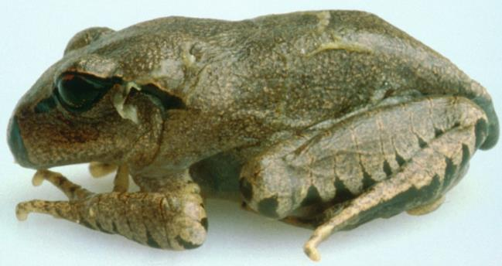
Note: Pieces of shedding skin on the body.
Source: L Berger

Signs of disease
Important: Animals with this disease may show one or more of these signs, but the pathogen may still be present in the absence of any signs.
Disease signs at the farm, tank or pond level are:
- lethargy
- ataxia
- paralysis
- loss of flee response
- loss of righting reflex
- abnormal sitting posture
- tetanic spasms
- nocturnal species emerging during daylight
- burrowing species remaining outside of burrows.
Gross pathological signs are:
- erythema (redness) of the ventral surface
- lesions ranging from no obvious change to sloughing (as small flakes of skin).
Gross changes to the skin may be seen in severe infections. However, these are not specific to the disease.
Microscopic pathological signs are:
- loss of pigmented jaw sheaths and teeth rows in tadpoles' mouthparts
- zoosporangia in the outer epidermal layers that are seen on fresh pieces of shed skin and in histological sections
- hyperkeratosis of the epidermis in areas where zoosporangia occur.

Disease agent
Chytridiomycosis is caused by infection with the parasitic chytrid fungus, Batrachochytrium dendrobatidis (Bd), of the class Chytridiomycota, order Rhizophydiales. Recent evidence suggests that B. dendrobatidis originated in Southeast Asia and was spread worldwide through international trade of amphibians.

Host range
Most, if not all, amphibians appear to be susceptible to infection with B. dendrobatidis. This includes all members of the orders Anura (frogs and toads), Caudata (including salamanders, newts and sirens) and Gymnophiona (caecilians). Amphibian species differ in degree of susceptibility; some are naturally resistant, while others are extremely susceptible with B. dendrobatidis infection, greatly increasing extinction risk in some isolated populations. In Australia, B. dendrobatidis has been directly implicated in the extinction of at least four native frog species and the decline of many others.
Table 1 Species known to be susceptible to Batrachochytrium dendrobatidis
Common name | Scientific name
Caecilians | Order Gymnophiona
Frogs and toads | Order Anura
Bumpy rocket frog | Litoria inermis
Cane toad | Bufo marinus
Great barred frog | Mixophyes fasciolatus
Green tree frog | Litoria caerulea
Magnificent tree frog | Litoria splendida
Ornate burrowing frog | Limnodynastes ornatus
Ornate nursery frog | Cophixalus ornatus
Red tree frog | Litoria rubella
Red-backed toadlet | Pseudophryne coriacea
Sharp-snouted day frog | Taudactylus acutirostris
Short-footed frog | Cyclorana brevipes
Striped burrowing frog | Cyclorana alboguttata
Salamanders newts and sirens | Order Caudata
Alpine newt | Ichthyosaura alpestris
Blue tailed fire belly newt | Cynops cyanurus
Chiang Mai crocodile newt | Tylototriton uyenoi
Chinese firebelly newt | Cynops orientalis
Clouded salamander | Hynobius nebulosus
Eastern newt | Notophthalmus viridescens
European cave salamander | Speleomantes spp.
Fire salamander | Salamandra salamandra
French cave salamander | Hydromantes strinatii
Italian newt | Lissotriton italicus
Japanese clawed salamander | Onychodactylus japonicas
Japanese fire belly newt | Cynops pyrrhogaster
Lesser siren | Siren intermedia
North African fire salamander | Salamandra algira
Northern crested newt | Triturus cristatus
Northern spectacled salamander | Salamandrina perspicillata
Rough skinned newt | Taricha granulosa
Sardinian brook salamander | Euproctus platycephalus
Siberian salamander | Salamandrella keyserlingii
Smooth newt | Lissotriton vulgaris
Spanish ribbed newt | Pleurodeles waltl
Sword tailed newt | Cynops ensicauda
Vietnamese crocodile newt | Tylototriton vietnamensis
Vietnamese salamander | Paramesotriton deloustali
Wenxian knobby newt | Tylototriton wenxianensis
Yellow spotted newt | Neurergus crocatus
Zeiglers crocodile newt | Tylototriton ziegleri

Presence in Australia
Infection with B. dendrobatidis has been officially reported across Australia in Queensland, New South Wales, the Australian Capital Territory, Victoria, South Australia, Tasmania and Western Australia. It does not occur in arid inland areas.
Map 1 Presence of Batrachochytrium dendrobatidis, by jurisdiction
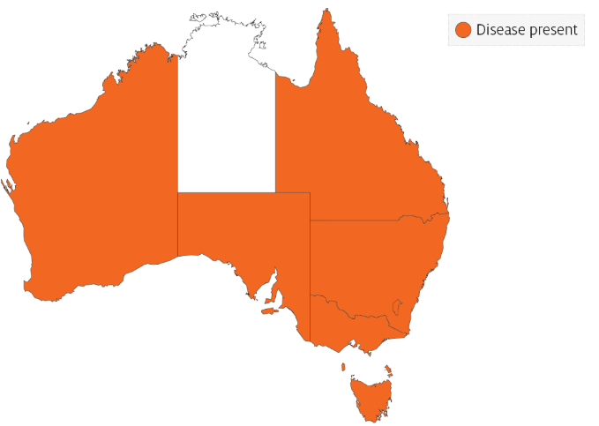

Epidemiology
- All age classes, except eggs, are known to be susceptible to infection. Mortality has only rarely been reported in tadpoles.
- Batrachochytrium dendrobatidis infects only keratinised tissues (skin of metamorphosed amphibians or the mouthparts of tadpoles). In contrast, B. salamandrivorans in salamanders infects only epidermal tissues, causing ulceration.
- Incubation times vary from about 14 to more than 70 days, with mortalities usually occurring within 2 to 3 days of the first clinical signs. Mortalities have approached 100% in some Australian amphibians.
- Horizontal transmission is via waterborne, motile zoospores and is likely to be by direct animal-to-animal contact. Vertical transmission via eggs has not been demonstrated.
- Outbreaks may be associated with seasons (cooler months), altitude (most declines are generally restricted to high-altitude populations) and breeding habitat.
- Temperature affects the survival and growth of B. dendrobatidis, maximum growth occurring between 17°C and 25°C. The sporangia die in temperatures of 32°C or higher. The pathogen can persist in very low host densities.
- Large-scale mortality of newly metamorphosed amphibians may indicate infection, as some species appear to be most susceptible at this time.

Differential diagnosis
The list of similar diseases in the next section refers only to the diseases covered by this field guide. Gross pathological signs may also be representative of diseases not included in this guide. Do not rely on gross signs to provide a definitive diagnosis. Use them as a tool to help identify the listed diseases that most closely account for the observed signs.

Similar diseases
Infection with Batrachochytrium salamandrivorans.

Sample collection
Only trained personnel should collect samples. Using only gross pathological signs to differentiate between diseases is not reliable, and some aquatic animal disease agents pose a risk to humans. If you are not appropriately trained, phone your state or territory hotline number and report your observations. If you have to collect samples, the agency taking your call will advise you on the appropriate course of action. Local or district fisheries or veterinary authorities may also advise on sampling.

Emergency disease hotline
See something you think is this disease? Report it. Even if you’re not sure.
Call the Emergency Animal Disease Watch Hotline on 1800 675 888. They will refer you to the right state or territory agency.

Further reading
Department of the Environment and Energy Infection of amphibians with chytrid fungus resulting in chytridiomycosis (2016)
Imperial College London Global Bd mapping project
World Organisation for Animal Health Manual of Diagnostic Tests for Aquatic Animals
These hyperlinks were correct at the time of publication.

Contact details
Emergency Animal Disease Watch Hotline 1800 675 888
Email AAH@agriculture.gov.au
Website agriculture.gov.au/pests-diseases-weeds/aquatic
© Commonwealth of Australia 2020
This work is copyright. It may be reproduced in whole or in part subject to the inclusion of an acknowledgement of the source and no commercial usage or sale.

