Infection with Batrachochytrium salamandrivorans (Bsal)

Also known as Bsal chytridiomycosis and salamander chytrid disease

From Aquatic animal diseases significant to Australia: identification field guide, 5th edition
Figure 1 Adult fire salamander (Salamandra salamandra) infected by Batrachochytrium salamandrivorans
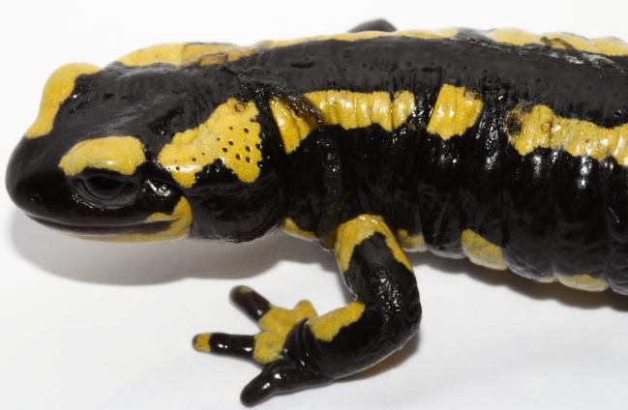
Note: Lesions consist of multifocal erosions with a black margin and dysecdysis.
Source: F Pasmans

Signs of disease
Important: Animals with this disease may show one or more of these signs, but the pathogen may still be present in the absence of any signs.
Disease signs at the farm, tank or pond level are:
- anorexia
- apathy
- ataxia
- high levels of mortality at temperatures below 25°C.
Gross pathological signs are:
- discolouration and/or roughening of the skin, with excessive skin sloughing
- focal or multifocal skin ulcerations with significant degradation of the epidermis, impairment of vital skin functions, and subsequent death.
Microscopic pathological signs are:
- lesions consisting of focal necrotic epidermal ulcerations with high numbers of colonial thalli of B. salamandrivorans, bordered by keratinocytes containing intracellular fungal thalli.

Disease agent
Bsal chytridiomycosis is caused by infection with the parasitic chytrid fungus, Batrachochytrium salamandrivorans (Bsal) of the class Chytridiomycota, order Rhizophydiales. B. salamandrivorans was first detected in wild salamanders in the Netherlands and Belgium in 2013/14, and was subsequently found in captive salamanders and newts in Germany, and the UK. Investigations suggest B. salamandrivorans probably originated in southeast Asia, where it has been found in Japan, Thailand, Vietnam and China.

Host range
A range of salamanders, newts and sirens (order Caudata) appear to be highly susceptible to infection with B. salamandrivorans. Members of the families Salamandridae, Plethodontidae, Hynobiidae and Sirenidae can carry the pathogen, often without showing any clinical signs. Species endemic to Asia appear to be more resistant to disease but may be asymptomatic carriers of the fungus.
Table 1 Species known to be susceptible to Batrachochytrium salamandrivorans
Common name | Scientific name
Alpine newt | Ichthyosaura alpestris
Blue tailed fire belly newt | Cynops cyanurus
Chiang Mai crocodile newt | Tylototriton uyenoi
Clouded salamander | Hynobius nebulosus
Eastern newt | Notophthalmus viridescens
European cave salamanders | Speleomantes spp.
Fire salamander | Salamandra salamandra
French cave salamander | Hydromantes strinatii
Italian newt | Lissotriton italicus
Japanese clawed salamander | Onychodactylus japonicas
Japanese fire belly newt | Cynops pyrrhogaster
Lesser siren | Siren intermedia
North African fire salamander | Salamandra algira
Northern crested newt | Triturus cristatus
Northern spectacled salamander | Salamandrina perspicillata
Rough skinned newt | Taricha granulosa
Sardinian brook salamander | Euproctus platycephalus
Siberian salamander | Salamandrella keyserlingii
Smooth newt | Lissotriton vulgaris
Spanish ribbed newt | Pleurodeles waltl
Sword tailed newt | Cynops ensicauda
Vietnamese crocodile newt | Tylototriton vietnamensis
Vietnamese salamander | Paramesotriton deloustali
Wenxian knobby newt | Tylototriton wenxianensis
Yellow spotted newt | Neurergus crocatus
Zeigler’s crocodile newt | Tylototriton ziegleri

Presence in Australia
Exotic disease—not recorded in Australia.
Map 1 Presence of Batrachochytrium salamandrivorans, by jurisdiction
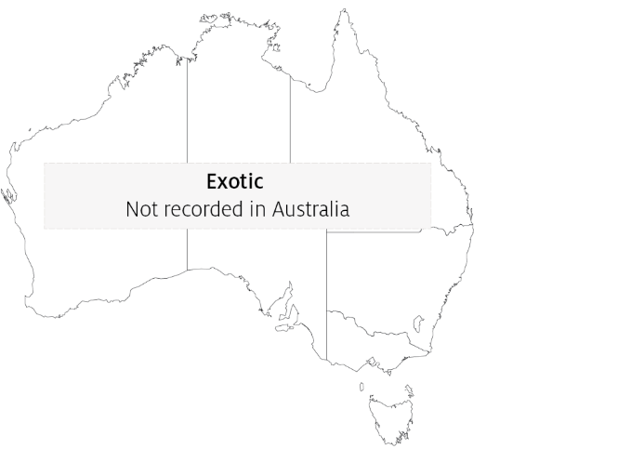

Epidemiology
- Batrachochytrium salamandrivorans infects epidermal tissue causing multifocal ulcerations.
- Optimal temperature for growth of the fungus is 15°C and optimal salinity is 0ppt (freshwater). Desiccation is fatal for all life stages of the fungus.
- Horizontal transmission is via waterborne, motile zoospores and is likely to be by direct animal-to-animal contact. Mortality occurs 12 to 18 days after exposure to infective zoospores at 15°C, and within 22 to 27 days when susceptible animals are placed in contact with infected animals.
- Zoospores can remain viable in water for up to 3 weeks.
- Batrachochytrium salamandrivorans has been eliminated from wild salamanders by exposure to greater than 25°C for at least 10 days or a synergistic treatment with antifungals.
- Disease outbreaks in wild populations may be seasonal (during the cooler months), and can cause significant population declines that may lead to extinction.

Differential diagnosis
The list of similar diseases in the next section refers only to the diseases covered by this field guide. Gross pathological signs may also be representative of diseases not included in this guide. Do not rely on gross signs to provide a definitive diagnosis. Use them as a tool to help identify the listed diseases that most closely account for the observed signs.

Similar diseases
Infection with Batrachochytrium dendrobatidis.

Sample collection
Only trained personnel should collect samples. Using only gross pathological signs to differentiate between diseases is not reliable, and some aquatic animal disease agents pose a risk to humans. If you are not appropriately trained, phone your state or territory hotline number and report your observations. If you have to collect samples, the agency taking your call will advise you on the appropriate course of action. Local or district fisheries or veterinary authorities may also advise on sampling.

Emergency disease hotline
See something you think is this disease? Report it. Even if you’re not sure.
Call the Emergency Animal Disease Watch Hotline on 1800 675 888. They will refer you to the right state or territory agency.

Microscope images
Figure 2 Hematoxylin and eosin stained section of skin of fire salamander (Salamandra salamandra) infected by Batrachochytrium salamandrivorans
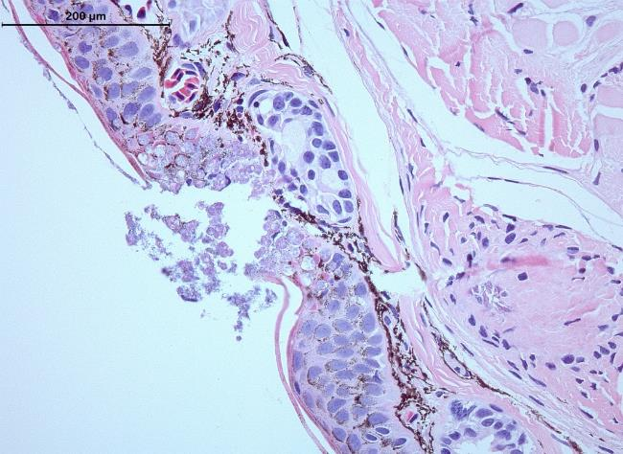
Note: Histopathological lesions consist of multifocal epidermal erosions, with numerous colonial chytrid thalli inside epidermal cells and bacterial overgrowth. Scale bar = 200µm
Source: A Martel

Further reading
European Food Safety Authority Scientific and technical assistance concerning the survival, establishment and spread of ‘Batrachochytrium salamandrivorans’ (Bsal) in the EU
World Organisation for Animal Health, ‘Batrachochytrium salamandrivorans’ disease card
These hyperlinks were correct at the time of publication.

Contact details
Emergency Animal Disease Watch Hotline 1800 675 888
Email AAH@agriculture.gov.au
Website agriculture.gov.au/pests-diseases-weeds/aquatic
© Commonwealth of Australia 2020
This work is copyright. It may be reproduced in whole or in part subject to the inclusion of an acknowledgement of the source and no commercial usage or sale.

