Infection with Bonamia exitiosa

Also known as bonamiosis

From Aquatic animal diseases significant to Australia: identification field guide, 5th edition
Figure 1 Australian flat oysters (Ostrea angasi) infected with Bonamia exitiosa
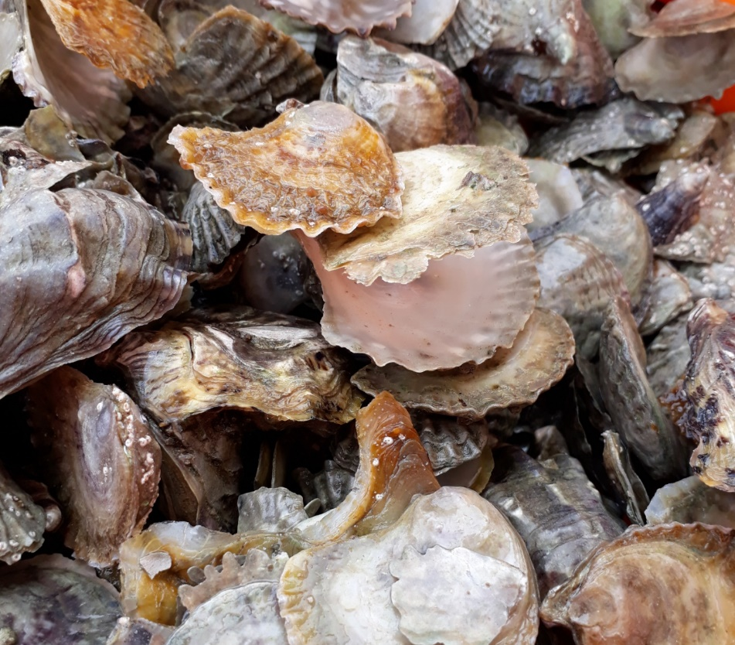
Note: Gaping of oysters and high mortality rate due to infection with Bonamia exitiosa.
Source: B Diggles
Figure 2 New Zealand dredge oysters (Ostrea chilensis) with digestive gland sectioned
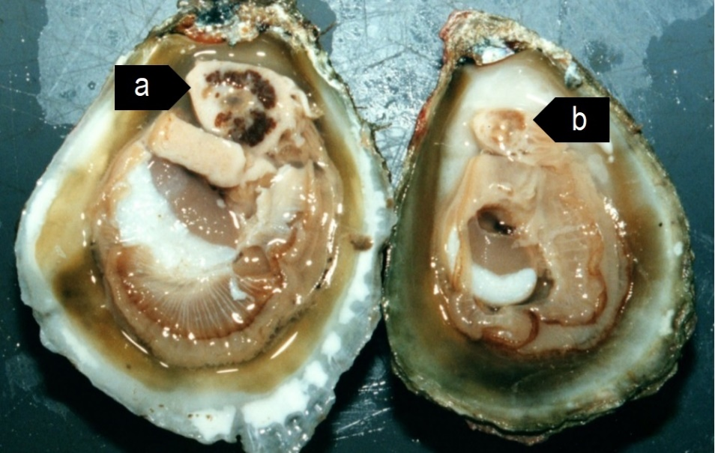
Note: Normal healthy oyster gland (a) compared with pale atrophied digestive gland of oyster with heavy Bonamia exitiosa infection (b).
Source: B Diggles

Signs of disease
Important: Animals with this disease may show one or more of these signs, but the pathogen may still be present in the absence of any signs.
Diseases caused by any of the microcell species are similar. In cases of light infection, few signs or no clinical or gross signs are present. Concurrent infections with more than one species of Bonamia may also occur. Definitive identification of Bonamia or Mikrocytos species requires histological laboratory examination and molecular diagnostic techniques.
Disease signs at the farm, tank or pond level are:
- dead or gaping oysters
- increased mortality.
Gross pathological signs are:
- stunted growth and poor condition
- weakened shell closure, leading to slight gaping
- watery flesh, pale atrophied digestive gland in clinically diseased oysters
- algae-covered shell lips after the mantle shrinks and no longer reaches the edges
- deformities of the gill margins.
Infection with Bonamia exitiosa rarely results in gross pathological signs of disease in oysters under natural conditions—most infections are asymptomatic.
Microscopic pathological signs are:
- microcell parasites within haemocytes and vesicular connective tissues (especially the gill or mantle)
- individual microcells are basophilic, spherical or ovoid parasites, 2 to 3µm in diameter
- microcells of B. exitiosa tend to be larger than those of B. ostreae when both occur in the same host
- In Australian flat oysters (Ostrea angasi), apparently low numbers of parasites cause massive focal haemocyte aggregation with necrotic foci.

Disease agent
Bonamiosis is caused by infection with Bonamia exitiosa. This is an intrahaemocytic protist classified in the order Haplosporidia (class Ascetosporea). It causes lethal infection of flat oysters. Recent evidence confirms that B. exitiosa that infects Australian flat oysters is the same species that infects dredge oysters (O. chilensis) in New Zealand.

Host range
Bonamia exitiosa is mainly a parasite of flat oysters. However, microcells that are occasionally visible in Pacific oysters have been confirmed to be B. exitiosa by PCR analysis. Sydney rock oysters may also occasionally be subclinical carriers of B. exitiosa and appear to harbour very low numbers of these parasites.
Table 1 Species known to be naturally susceptible to infection with Bonamia exitiosa
Common name | Scientific name
American eastern oyster | Crassostrea virginica
Argentinian flat oyster | Ostrea puelchana
Dwarf oyster | Ostrea stentina
European flat oyster | Ostrea edulis
New Zealand dredge oyster | Ostrea chilensis
Olympia oyster | Ostrea lurida
Pacific oyster | Crassostrea gigas
Southern mud oyster or Australian flat oyster | Ostrea angasi
Sydney rock oyster | Saccostrea glomerata

Presence in Australia
Bonamia exitiosa has been recorded in flat oysters in Victoria and New South Wales as well as in a very low percentage of Sydney rock oysters in New South Wales. It is likely that Bonamia spp. previously recorded in flat oysters in Tasmania, South Australia and Western Australia are also B. exitiosa.
Bonamia ostreae and other Bonamia spp. are exotic to Australia, so any differential diagnosis of Bonamia spp. infection in Australian oysters requires specific confirmation using molecular diagnostic techniques to differentiate between the endemic B. exitiosa and exotic B. ostreae and Bonamia spp.
Map 1 Presence of Bonamia exitiosa, by jurisdiction
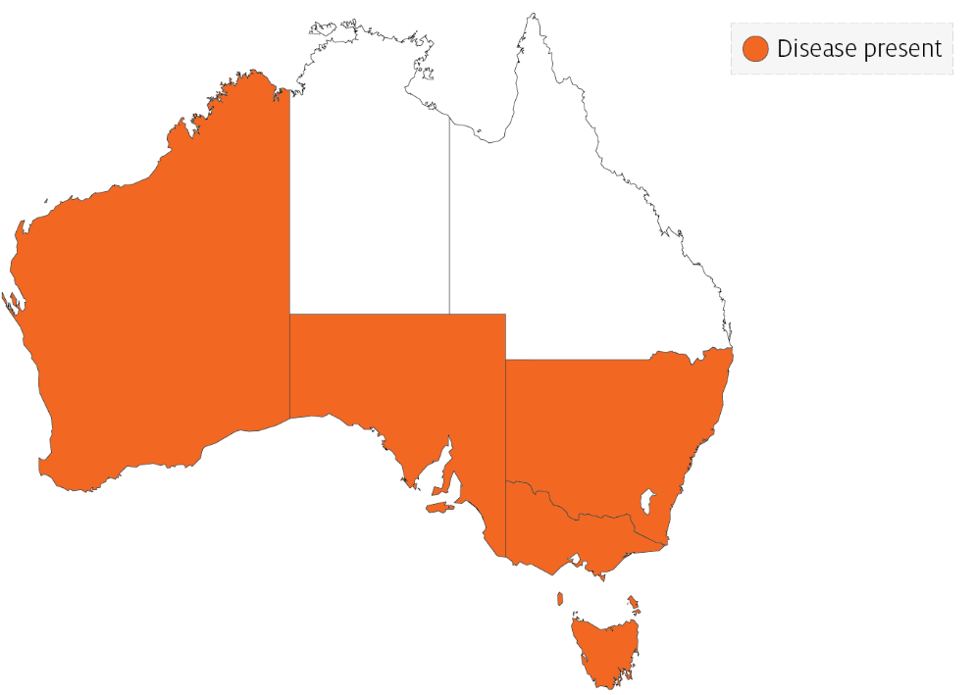

Epidemiology
- Mortalities can occur all year, but the highest prevalence is in mid to late summer after the host spawns.
- The disease dynamics of B. exitiosa in the New Zealand dredge oyster can be affected by exposure to temperature extremes (below 7°C or above 26°C), high salinity (40ppt), starvation (prolonged holding in filtered seawater), handling (vigorous stirring 4 times per day) or heavy coinfection with apicomplexan protists.
- Cohabitation of infected and uninfected oysters in holding tanks facilitates horizontal transmission of infection to the uninfected oysters.
- A seasonal pattern of disease has been observed in New Zealand since 1964. Separate epizootics in 1985 to 1991 and 1998 to 2003 resulted in cumulative mortality of more than 90% in wild populations of New Zealand dredge oysters.
- Transmission is thought to occur from host to host via infective stages that are carried from one oyster bed to another by water currents.
- The introduction of B. exitiosa into New Zealand and Australia is thought to be due to introduction of infected hosts carried in biofouling on shipping, followed by human movements of subclinically infected oysters.

Differential diagnosis
The list of similar diseases in the next section refers only to the diseases covered by this field guide. Gross pathological signs may also be representative of diseases not included in this guide. Do not rely on gross signs to provide a definitive diagnosis. Use them as a tool to help identify the listed diseases that most closely account for the observed signs.

Similar diseases
Infection with Bonamia ostreae, infection with Bonamia spp. and infection with Mikrocytos mackini.
There are few or no visual cues to the presence of these diseases other than poor condition, shell gaping and increased mortality. Consequently, it is impossible to use gross signs alone to differentiate between infecion by Bonamia species and Mikrocytos. Concurrent infections with more than one species of Bonamia may also occur. Any presumptive diagnosis requires further laboratory examination.
Light microscopy can contribute diagnostic information, but further laboratory examination and molecular diagnostic techniques are required for a definitive diagnosis.

Sample collection
Only trained personnel should collect samples. Using only gross pathological signs to differentiate between diseases is not reliable, and some aquatic animal disease agents pose a risk to humans. If you are not appropriately trained, phone your state or territory hotline number and report your observations. If you have to collect samples, the agency taking your call will advise you on the appropriate course of action. Local or district fisheries or veterinary authorities may also advise on sampling.

Emergency disease hotline
See something you think is this disease? Report it. Even if you’re not sure.
Call the Emergency Animal Disease Watch Hotline on 1800 675 888. They will refer you to the right state or territory agency.

Microscope images
Figure 3 Stained heart imprint from New Zealand dredge oyster (Ostrea chilensis)
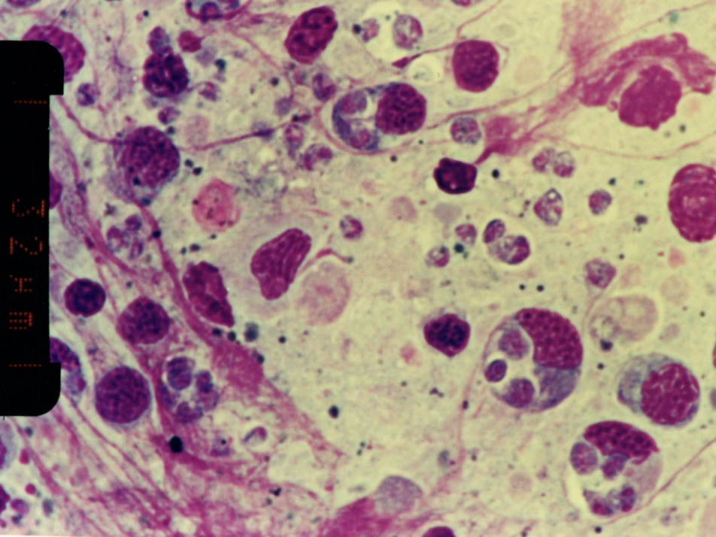
Note: Several microcells of Bonamia exitiosa within and outside haemocytes. Scale bar = 32µm.
Source: B Diggles
Figure 4 Histological section of heavy Bonamia exitiosa infection in vesicular connective (leydig) tissue of gonad of New Zealand dredge oyster (Ostrea chilensis)
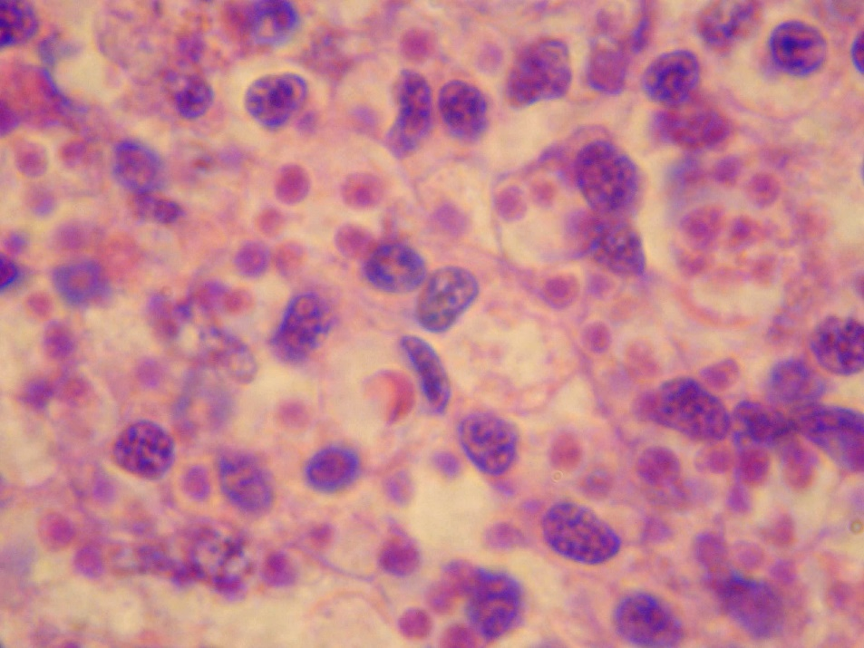
Note: The pink spherical microcells of B. exitiosa are smaller than the basophilic host cell nuclei.
Source: B Diggles
Figure 5 Histological section through vesicular connective (leydig) tissue of New Zealand dredge oyster (Ostrea chilensis)
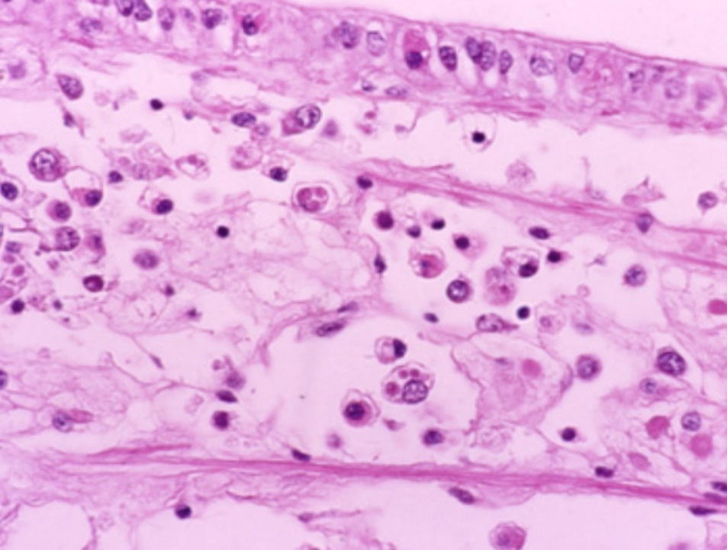
Note: Numerous circulating haemocytes, many containing Bonamia exitiosa (the small pink spheres in the haemocyte cytoplasm, smaller than a nucleus).
Source: B Jones

Further reading
CABI Invasive Species Compendium Bonamiosis (‘Bonamia exitiosa’)
CEFAS International Database on Aquatic Animal Diseases Infection with ‘Bonamia exitiosa’
World Organisation for Animal Health Manual of diagnostic tests for aquatic animals
These hyperlinks were correct at the time of publication.

Contact details
Emergency Animal Disease Watch Hotline 1800 675 888
Email AAH@agriculture.gov.au
Website agriculture.gov.au/pests-diseases-weeds/aquatic
© Commonwealth of Australia 2020
This work is copyright. It may be reproduced in whole or in part subject to the inclusion of an acknowledgement of the source and no commercial usage or sale.

