Infection with Bonamia ostreae

Also known as bonamiosis

From Aquatic animal diseases significant to Australia: identification field guide, 5th edition
Figure 1 Mortality of European flat oysters (Ostrea edulis) infected with Bonamia ostreae
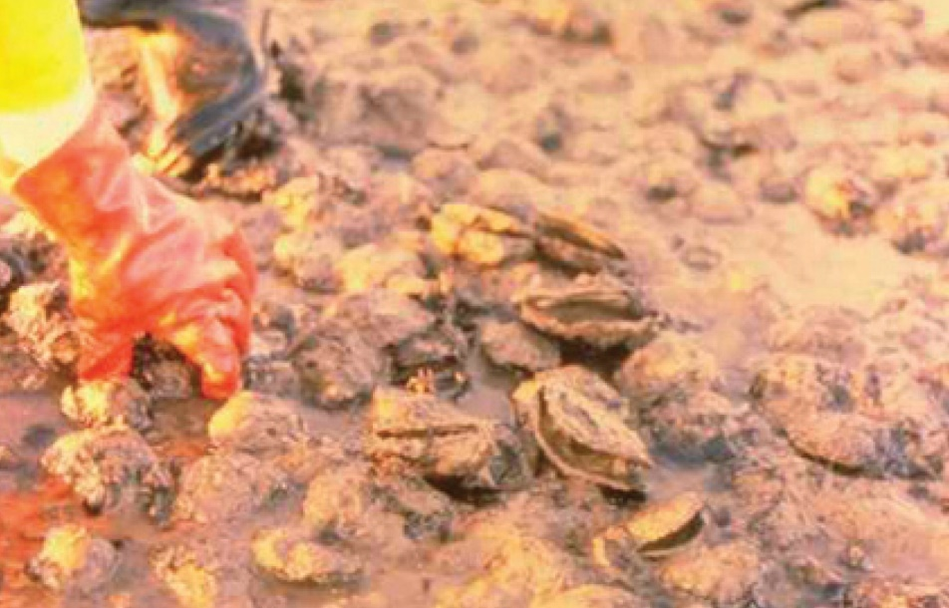
Note: Classic gaping of diseased oysters.
Source: D Alderman

Signs of disease
Important: Animals with this disease may show one or more of these signs, but the pathogen may still be present in the absence of any signs.
Diseases caused by any of the microcell species are similar. In cases of light infection, few or no clinical or gross signs are present. Concurrent infections with more than one species of Bonamia may also occur. Definitive identification of Bonamia or Mikrocytos species requires histological laboratory examination and molecular diagnostic techniques.
Disease signs at the farm, tank or pond level are:
- dead or gaping oysters
- increased mortality.
Gross pathological signs are:
- generally poor condition
- gills appearing eroded
- yellow discolouration of the gills and mantle.
Infection with Bonamia ostreae rarely results in gross pathological signs of disease in oysters. Often the only sign is increased mortality.
Microscopic pathological signs are:
- dense infiltrations of haemocytes, some containing microcell parasites in the connective tissue of the gill and mantle and in the vascular sinuses around the stomach and intestine
- extensive lesions, including perforated ulcers in the connective tissue of the gills, mantle and digestive gland.

Disease agent
Bonamiosis is caused by infection with Bonamia ostreae, an intrahaemocytic protist classified in the order Haplosporidia (class Ascetosporea). B. ostreae causes lethal infection of flat oysters.

Host range
B. ostreae is mainly a parasite of European flat oysters (Ostrea edulis). Australian flat oysters reared in France have been shown to be susceptible to B. ostreae. Microcells of B. ostreae are also occasionally detectable in cupped oysters (Pacific oysters, Portuguese oysters and Suminoe oysters) that co-occur in areas where B. ostreae epizootics occur in O. edulis.
Table 1 Species known to be naturally susceptible to infection with Bonamia ostreae
Common name | Scientific name
Argentinian flat oyster | Ostrea puelchana
Asiatic oyster | Ostrea denselammellosa
European flat oyster | Ostrea edulis
New Zealand dredge oyster | Ostrea chilensis
Pacific oyster | Crassostrea gigas
Portuguese oyster | Crassostrea angulata
Southern mud oyster or Australian flat oyster | Ostrea angasi
Suminoe oyster | Crassostrea ariakensis

Presence in Australia
Exotic disease—not recorded in Australia.
Bonamia ostreae has not been recorded and is considered exotic to Australia. Any differential diagnosis of Bonamia spp. infection in Australian oysters requires specific confirmation using molecular diagnostic techniques to discriminate between the endemic B. exitiosa and exotic B. ostreae and Bonamia spp.
Map 1 Presence of Bonamia ostreae, by jurisdiction
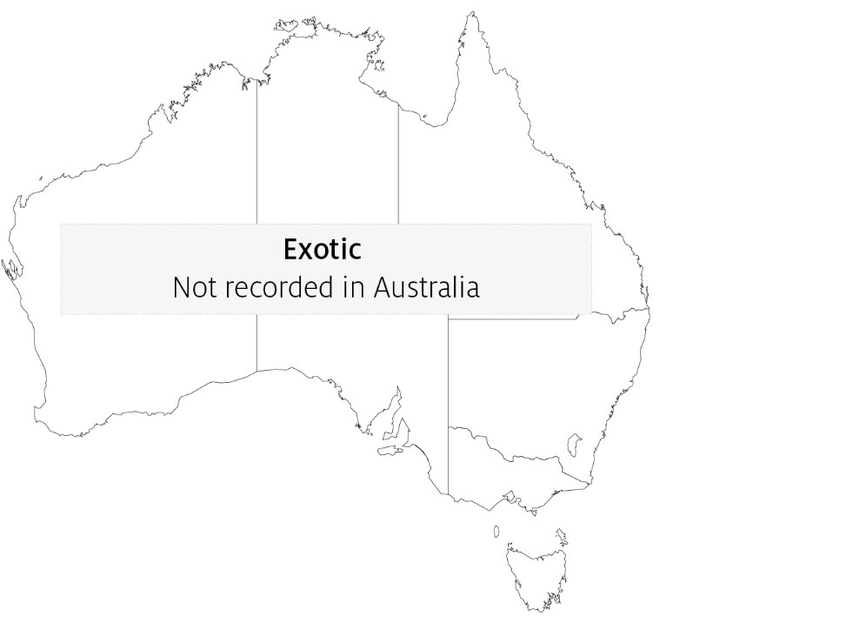

Epidemiology
- The critical host age for development of disease appears to be 2 years. However, other age classes are susceptible to infection.
- Significant mortalities usually occur at water temperatures of 12 to 20°C.
- Systemic infection of haemocytes effectively starves the oyster of energy required for survival. The infected animal eventually dies from exhaustion and starvation.
- Some studies suggest that prevalence and intensity of infection increase during late winter and autumn. However, the disease may occur at any time during the year.
- The pre-patent period is up to 5 months.
- Horizontal transmission of the parasite can occur directly from host to host and indirectly between oyster beds via the water.
- Bonamia ostreae is thought to have spread from California to Europe by human movement of infected oysters. It has also been detected in New Zealand (including in concurrent infections with B. exitiosa) and was possibly introduced by infected hosts carried in biofouling on shipping.

Differential diagnosis
The list of similar diseases in the next section refers only to the diseases covered by this field guide. Gross pathological signs may also be representative of diseases not included in this guide. Do not rely on gross signs to provide a definitive diagnosis. Use them as a tool to help identify the listed diseases that most closely account for the observed signs.

Similar diseases
Infection with Bonamia exitiosa, infection with Bonamia spp. and infection with Mikrocytos mackini.
There are few or no visual cues to the presence of this disease other than poor condition, shell gaping and increased mortality. Consequently, it is impossible to use gross signs alone to differentiate between infection by Bonamia species and Mikrocytos species. Concurrent infections with more than one species of Bonamia may also occur. Any presumptive diagnosis requires further laboratory examination.
Light microscopy can contribute diagnostic information, but further laboratory examination and molecular diagnostic techniques are required for a definitive diagnosis.

Sample collection
Only trained personnel should collect samples. Using only gross pathological signs to differentiate between diseases is not reliable, and some aquatic animal disease agents pose a risk to humans. If you are not appropriately trained, phone your state or territory hotline number and report your observations. If you have to collect samples, the agency taking your call will advise you on the appropriate course of action. Local or district fisheries or veterinary authorities may also advise on sampling.

Emergency disease hotline
See something you think is this disease? Report it. Even if you’re not sure.
Call the Emergency Animal Disease Watch Hotline on 1800 675 888. They will refer you to the right state or territory agency.

Further reading
CABI Invasive Species Compendium ‘Bonamia ostreae’
CEFAS International Database on Aquatic Animal Diseases Infection with ‘Bonamia ostreae’
World Organisation for Animal Health Manual of diagnostic tests for aquatic animals
These hyperlinks were correct at the time of publication.

Contact details
Emergency Animal Disease Watch Hotline 1800 675 888
Email AAH@agriculture.gov.au
Website agriculture.gov.au/pests-diseases-weeds/aquatic
© Commonwealth of Australia 2020
This work is copyright. It may be reproduced in whole or in part subject to the inclusion of an acknowledgement of the source and no commercial usage or sale.

