Infection with Bonamia species

Also known as bonamiosis

From Aquatic animal diseases significant to Australia: identification field guide, 5th edition

Signs of disease
Important: Animals with this disease may show one or more of these signs, but the pathogen may still be present in the absence of any signs.
Diseases caused by any of the microcell species are similar. In cases of light infection, few signs or no clinical or gross signs may be present. Concurrent infections with more than one species of Bonamia may also occur. Definitive identification of infection with Bonamia or Mikrocytos species requires histological laboratory examination and molecular diagnostic techniques.
Disease signs at the farm, tank or pond level are:
- dead or gaping oysters
- increased mortality.
Gross pathological signs are:
- stunted growth and poor condition
- weakened shell closure, leading to slight gaping
- watery flesh, pale atrophied digestive gland in clinically diseased oysters
- algae-covered shell lips after the mantle shrinks and no longer reaches the edges
- deformities to the gill margins.
Infection with Bonamia spp. rarely results in gross pathological signs of disease in oysters under natural conditions.—Most infections are asymptomatic.
Microscopic pathological signs are:
- microcell parasites in or near epithelia-may be in very low numbers
- microcells may also occur within haemocytes and vesicular connective tissues (especially the gill or mantle)
- individual microcells are basophilic, spherical or ovoid parasites, 2 to 3µm in diameter
- some species of exotic Bonamia spp. produce spores (such as B. perspora).

Disease agent
Bonamiosis is caused by infection with Bonamia spp., intrahaemocytic protists classified in the order Haplosporidia (class Ascetosporea). Both flat and cupped oysters may become infected.
This disease listing includes B. perspora and unidentified Bonamia spp., but excludes B. exitiosa and B. ostreae, which are addressed in separate disease listings.

Host range
Table 1 Species known to be naturally susceptible to infection with Bonamia spp.
Common name | Scientific name
Crested oyster | Ostrea equestris
Dwarf oyster | Ostrea stentina
European flat oyster | Ostrea edulis
Hawaiian oyster | Dendostrea sandvicensis
New Zealand dredge oyster | Ostrea chilensis
Pacific oyster | Crassostrea gigas
Southern mud oyster or Australian flat oyster | Ostrea angasi

Presence in Australia
Exotic disease—not recorded in Australia.
Bonamia exitiosa has been recorded from flat oysters in Victoria and New South Wales, and in a very low percentage of Sydney rock oysters in New South Wales. It is likely that Bonamia spp. previously recorded in flat oysters in Tasmania, South Australia and Western Australia are also B. exitiosa.
Bonamia ostreae and other Bonamia spp. are exotic to Australia, so any differential diagnosis of Bonamia spp. infection in Australian oysters requires specific confirmation using molecular diagnostic techniques to differentiate between the endemic B. exitiosa and exotic B. ostreae and Bonamia spp.
Map 1 Presence of Bonamia spp. (excluding B. exitiosa), by jurisdiction
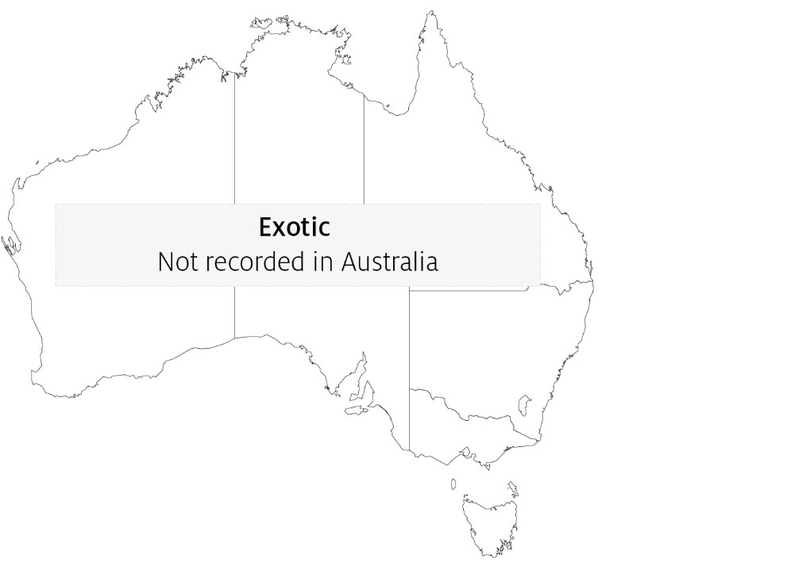

Epidemiology
- Mortalities may occur all year, but usually happen in spring and summer.
- In most cases, oysters are lightly infected without mortalities. Factors that contribute to disease outbreaks are often unclear.
- Bonamia spp. are thought to be spread by human movements of subclinically infected oysters, and via infected hosts carried in biofouling on shipping.

Differential diagnosis
The list of similar diseases in the next section refers only to the diseases covered by this field guide. Gross pathological signs may also be representative of diseases not included in this guide. Do not rely on gross signs to provide a definitive diagnosis. Use them as a tool to help identify the listed diseases that most closely account for the observed signs.

Similar diseases
Infection with Bonamia exitiosa, infection with Bonamia ostreae and infection with Mikrocytos mackini.
There are few or no visual cues to the presence of this disease other than poor condition, shell gaping and increased mortality. Consequently, it is impossible to use gross signs alone to differentiate between infection by Bonamia species and Mikrocytos species. Concurrent infections with more than one species of Bonamia may also occur. Any presumptive diagnosis requires further laboratory examination.
Light microscopy can contribute diagnostic information (such as in the case of B. perspora infection when spores are present), but further laboratory examination and molecular diagnostic techniques are required for a definitive diagnosis.

Sample collection
Only trained personnel should collect samples. Using only gross pathological signs to differentiate between diseases is not reliable, and some aquatic animal disease agents pose a risk to humans. If you are not appropriately trained, phone your state or territory hotline number and report your observations. If you have to collect samples, the agency taking your call will advise you on the appropriate course of action. Local or district fisheries or veterinary authorities may also advise on sampling.

Emergency disease hotline
See something you think is this disease? Report it. Even if you’re not sure.
Call the Emergency Animal Disease Watch Hotline on 1800 675 888. They will refer you to the right state or territory agency.

Microscope images
Figure 1 Histological section of digestive gland of crested oyster (Ostrea equestris) with Bonamia perspora sporocysts
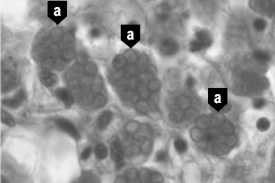
Note: Sporocysts of B. perspora (a).
Source: R Carnegie
Figure 2 Histological section of digestive gland of crested oyster (Ostrea equestris) with Bonamia perspora spores
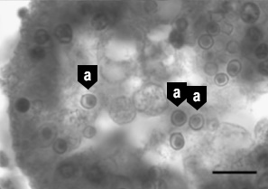
Note: Individual spores of B. perspora (a) released into the lumen of the digestive gland tubule. Scale bar = 10µm.
Source: R Carnegie

Further reading
Australia and New Zealand standard diagnostic procedure Bonamiosis in Australian ‘Ostrea angasi’
CEFAS International Database on Aquatic Animal Diseases Bonamiosis
These hyperlinks were correct at the time of publication.

Contact details
Emergency Animal Disease Watch Hotline 1800 675 888
Email AAH@agriculture.gov.au
Website agriculture.gov.au/pests-diseases-weeds/aquatic
© Commonwealth of Australia 2020
This work is copyright. It may be reproduced in whole or in part subject to the inclusion of an acknowledgement of the source and no commercial usage or sale.

