Infection with Enterocytozoon hepatopenaei (EHP)

Also known as hepatopancreatic microsporidosis

From Aquatic animal diseases significant to Australia: identification field guide, 5th edition

Signs of disease
Important: Animals with this disease may show one or more of these signs, but the pathogen may still be present in the absence of any signs.
Disease signs at the farm, tank or pond level are:
- unusually retarded growth in the absence of other gross signs of disease.
There are no specifically distinctive gross signs of infection by EHP.
Microscopic pathological signs are:
- the presence of basophilic, cytoplasmic inclusions (microsporidian sporocysts) containing clusters of elliptical to somewhat ovoid spores of 1.1 ± 0.21µm by 0.6–0.7 ± 0.1µ min haematoxylin and eosin stained tissue sections of hepatopancreas tubule epithelial cells
- free spores released from lysed cells occasionally observable in the tubule lumens.

Disease agent
Hepatopancreatic microsporidosis is caused by infection with Enterocytozoon hepatopenaei (EHP), a microsporidian parasite classified within the family Enterocytozoonidae. It was first discovered in Penaeus monodon in Thailand in 2004.

Host range
Species known to be susceptible to E. hepatopenaei are listed in Table 1 and Table 2. A similar microsporidian has been reported to infect kuruma prawns in Queensland, but the taxonomic affinities of that parasite are unclear. E. hepatopenaei has also been detected in frozen Artemia biomass and live polychaetes.
Table 1 Species known to be susceptible to EHP
Common name | Scientific name
Black tiger prawnª | Penaeus monodon
Pacific white shrimpª | Penaeus (Litopenaeus) vannamei
Pacific blue shrimp | Penaeus (Litopenaeus) stylirostris
a Naturally susceptible.
Table 2 Non-crustacean carriers
Common name | Scientific name
Brine shrimpª | Artemia salina
Polychaetesª | Various genera and species
a Naturally susceptible.

Presence in Australia
Exotic disease—not recorded in Australia.
EHP is considered exotic to Australia. However, other microsporidians have been reported to infect kuruma prawns (Penaeus (Marsupenaeus) japonicus) in Queensland.
Map 1 Presence of Enterocytozoon hepatopenaei, by jurisdiction
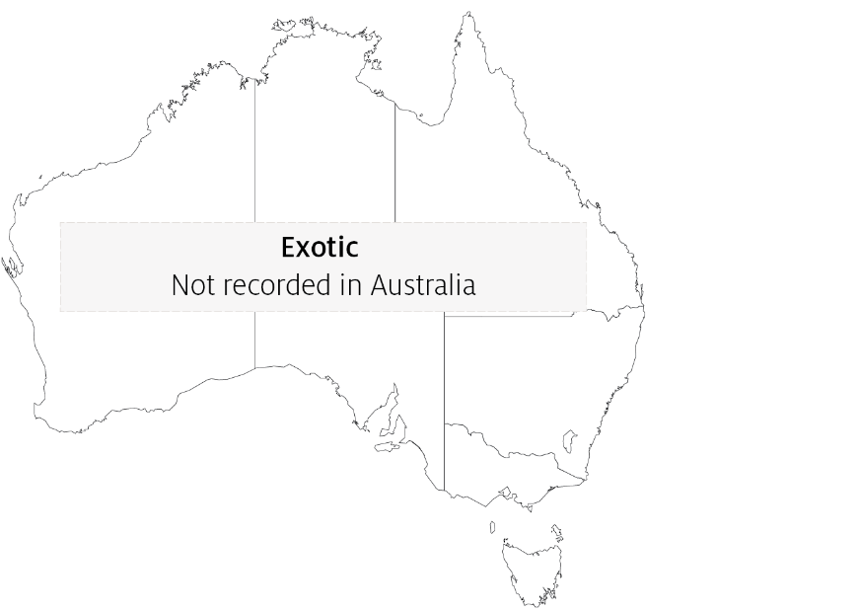

Epidemiology
- EHP is known to infect only the tubule epithelial cells of the hepatopancreas of prawns.
- EHP should therefore not be confused with other microsporidians with different tissue trophism, such as Agmasoma penaei that infects muscle tissue and connective tissue leading to the gross signs of 'cotton shrimp disease' or 'white back' disease.
- EHP can be transmitted horizontally among prawns cohabiting in rearing ponds.
- Heavily infected prawns may display white faeces that are packed with microsporidian spores.
- Infection with EHP may be a significant risk factor in the development of acute hepatopancreatic necrosis disease (AHPND).

Differential diagnosis
The list of similar diseases in the next section refers only to the diseases covered by this field guide. Gross pathological signs may also be representative of diseases not included in this guide. Do not rely on gross signs to provide a definitive diagnosis. Use them as a tool to help identify the listed diseases that most closely account for the observed signs.

Similar diseases
Acute hepatopancreatic necrosis disease (AHPND) and infection with Hepatobacter penaei (NHP).

Sample collection
Only trained personnel should collect samples. Using only gross pathological signs to differentiate between diseases is not reliable, and some aquatic animal disease agents pose a risk to humans. If you are not appropriately trained, phone your state or territory hotline number and report your observations. If you have to collect samples, the agency taking your call will advise you on the appropriate course of action. Local or district fisheries or veterinary authorities may also advise on sampling.

Emergency disease hotline
See something you think is this disease? Report it. Even if you’re not sure.
Call the Emergency Animal Disease Watch Hotline on 1800 675 888. They will refer you to the right state or territory agency.

Microscope images
Figure 1 Histopathology of hepatopancreas of Pacific white shrimp (Penaeus (Litopenaeus) vannamei) infected with Enterocytozoon hepatopenaei
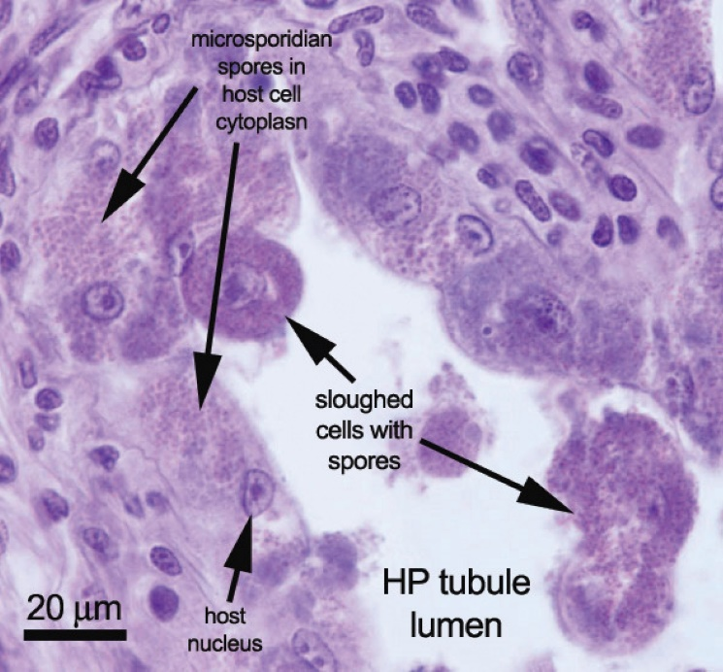
Note: Sloughed tubule epithelial cells containing many microsporidian spores in the cytoplasm. Scale bar = 20µm.
Source: T Flegel
Figure 2 Histopathology of hepatopancreas of Pacific white shrimp (Penaeus (Litopenaeus) vannamei) infected with Enterocytozoon hepatopenaei
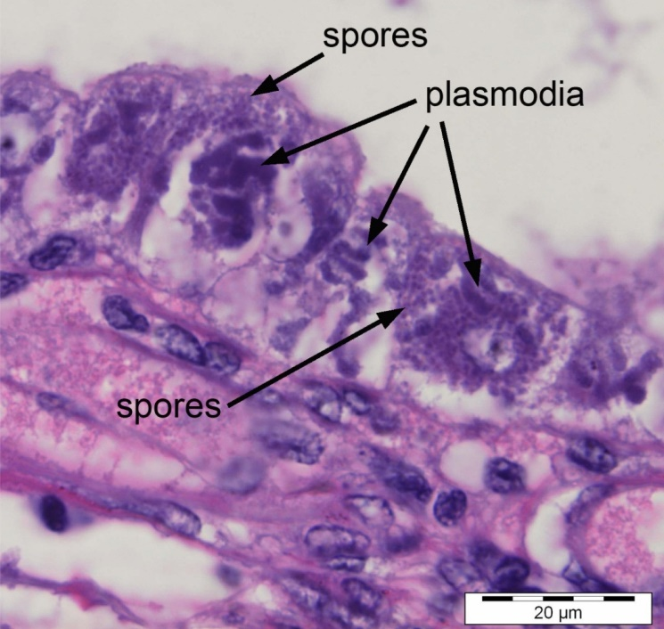
Note: Numerous spores inside sporocysts (plasmodia). Scale bar = 20µm.
Source: T Flegel
Figure 3 Electron micrograph of spore of Enterocytozoon hepatopenaei
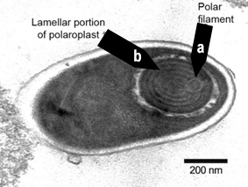
Note: Polar filament (a) with 5 or 6 coils, in lamellar portion of polarplast (b). Scale bar = 200nm
Source: T Flegel
Figure 4 Electron micrograph cross-section of polar filament in Enterocytozoon hepatopenaei spore
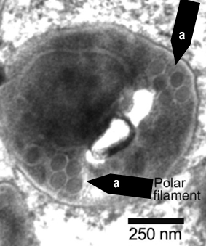
Note: Cross-sections of coils (a) of the polar filament. Scale bar = 250nm
Source: T Flegel

Further reading
Network of Aquaculture Centres in Asia-Pacific Hepatopancreatic microsporidosis caused by infection with ‘Enterocytooon hepatopenaei’: disease card
This hyperlink was correct at the time of publication.

Contact details
Emergency Animal Disease Watch Hotline 1800 675 888
Email AAH@agriculture.gov.au
Website agriculture.gov.au/pests-diseases-weeds/aquatic
© Commonwealth of Australia 2020
This work is copyright. It may be reproduced in whole or in part subject to the inclusion of an acknowledgement of the source and no commercial usage or sale.

