Infection with Gyrodactylus salaris

Also known as gyrodactylosis

From Aquatic animal diseases significant to Australia: identification field guide, 5th edition
Figure 1 Juvenile Atlantic salmon (Salmo salar) infected with Gyrodactylus salaris
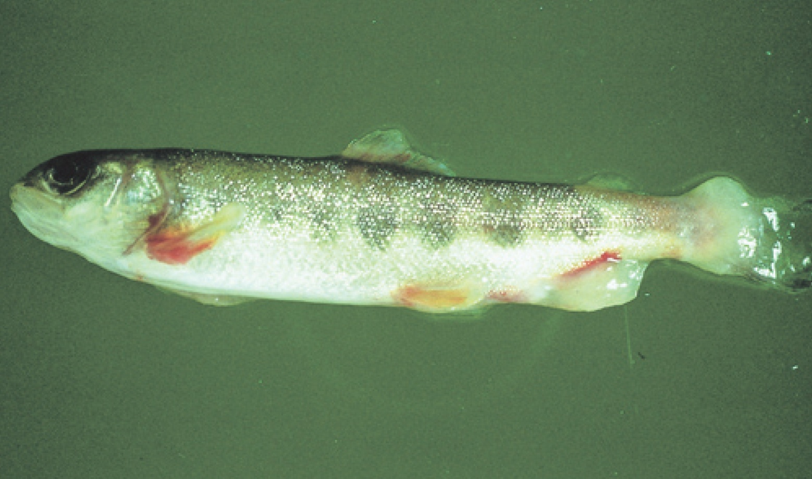
Note: Excessive mucous and peeling of skin, especially around the tail.
Source: T Håstein

Signs of disease
Important: Animals with this disease may show one or more of these signs, but the pathogen may still be present in the absence of any signs.
Disease signs at the farm, tank or pond level are:
- lethargy
- high mortality in Atlantic salmon (Salmo salar)
- scrubbing (rubbing against objects in response to skin irritation) and flashing (darting and twisting of fish and erratic swimming)
- gathering in low-current waters when heavily infected.
Gross pathological signs are:
- ulcers
- sloughing of the skin
- greyish appearance; as disease progresses, dorsal and pectoral fins may have a whitish appearance due to thickening of the epidermis
- excess mucus on skin
- frayed fins.
There are no definitive microscopic pathological signs. Most waters have many types of monogenean flukes that are parasitic on fish gills and skin. Any evidence of infestation with these parasites beyond what is visible to the naked eye requires identification by a parasitologist experienced in identifying Gyrodactylus species.

Disease agent
Gyrodactylosis is caused by infection with Gyrodactylus salaris, an obligate freshwater ectoparasitic flatworm (Platyhelminthes) belonging to the family Gyrodactylidae (class Monogenea). G. salaris occurs in Europe, mainly around the Baltic Sea and Norway.

Host range
All species of salmonids should be considered potentially susceptible to infection by G. salaris, unless future testing suggests otherwise.
Table 1 Species known to be naturally susceptible to Gyrodactylus salaris
Common name | Scientific name
Arctic char | Salvelinus alpinus
Atlantic salmon | Salmo salar
Brook trout | Salvelinus fontinalis
Brown troutª | Salmo trutta
Grayling | Thymallus thymallus
Lake trout | Salvelinus namaycush
Rainbow trout | Oncorhynchus mykiss
Salmonids (all presumed susceptible) | Salmonidae, all species
a Susceptibility of brown trout is very low; G. salaris will usually only establish in a brown trout population co-existing with infected salmonids. Note: Other species not listed have been shown to be experimentally susceptible.

Presence in Australia
Exotic disease—not recorded in Australia.
Map 1 Presence of Gyrodactylus salaris, by jurisdiction
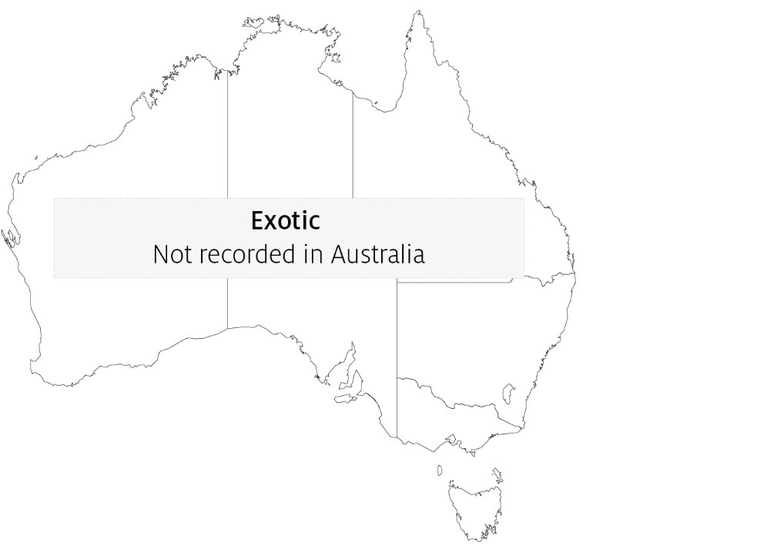

Epidemiology
- Gyrodactylus salaris may be present for years in farmed salmonids, especially rainbow trout, without the fish showing any clinical signs of disease.
- Gyrodactylus salaris is a freshwater parasite that cannot survive in seawater. However, it can survive a few days at salinity of up to 20 ppt.
- The parasite can survive 5 to 6 days detached from the host but cannot survive drying out.
- Transmission is horizontal (directly via the water column) by contact between infected and uninfected fish, or by contact between host fish and detached parasites on the substrate.
- Mortality in susceptible farmed Atlantic salmon can reach 100%.
- The parasite is readily spread between farms and countries through the transport of infected fish.

Differential diagnosis
The list of similar diseases in the next section refers only to the diseases covered by this field guide. Gross pathological signs may also be representative of diseases not included in this guide. Do not rely on gross signs to provide a definitive diagnosis. Use them as a tool to help identify the listed diseases that most closely account for the observed signs.

Similar diseases
Many diseases listed in this field guide appear similar to infection with G. salaris. Further laboratory diagnosis is required for any presumptive diagnosis.

Sample collection
Only trained personnel should collect samples. Using only gross pathological signs to differentiate between diseases is not reliable, and some aquatic animal disease agents pose a risk to humans. If you are not appropriately trained, phone your state or territory hotline number and report your observations. If you have to collect samples, the agency taking your call will advise you on the appropriate course of action. Local or district fisheries or veterinary authorities may also advise on sampling.

Emergency disease hotline
See something you think is this disease? Report it. Even if you’re not sure.
Call the Emergency Animal Disease Watch Hotline on 1800 675 888. They will refer you to the right state or territory agency.

Microscope images
Figure 2 Scanning electron micrograph of Gyrodactylus salaris attached to skin of juvenile Atlantic salmon (Salmo salar)
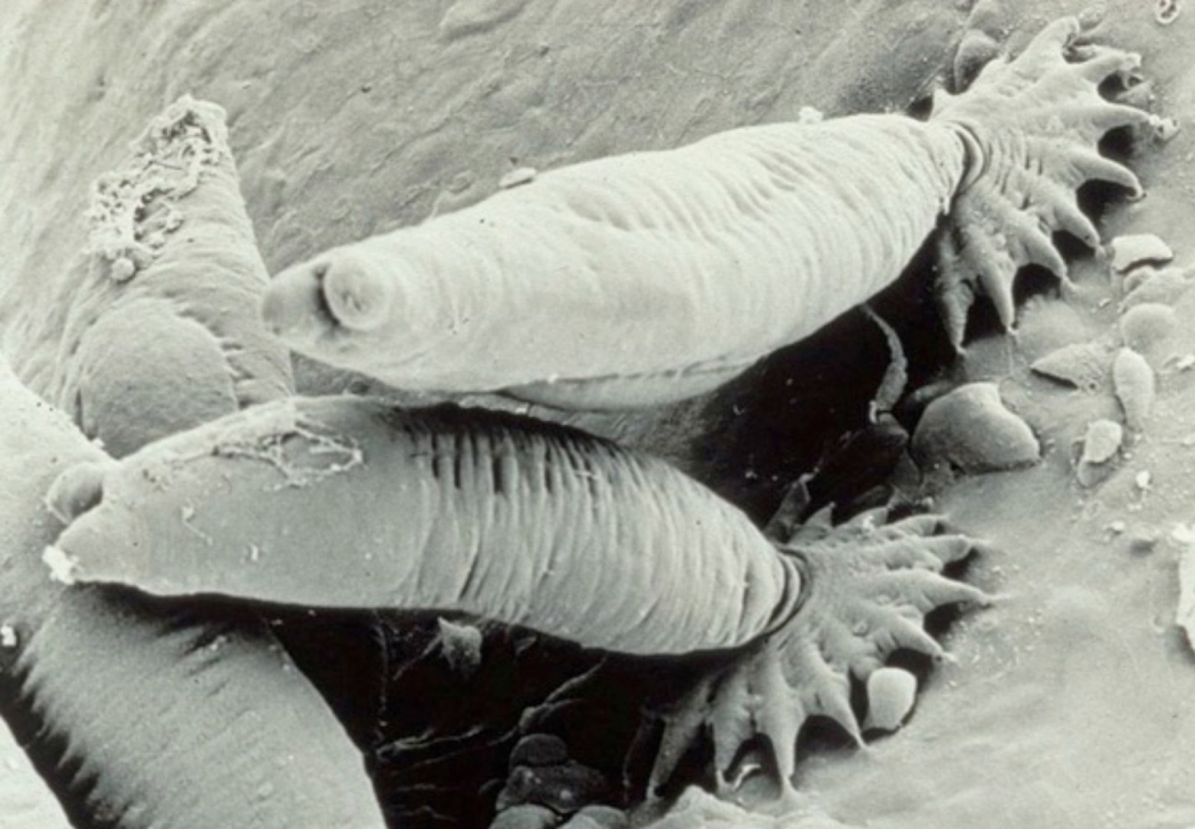
Note: Several parasites attached to the fish skin with their posterior attachment organ (opisthaptor).
Source: TA Mo

Further reading
CABI Invasive Species Compendium ‘Gyrodactylus salaris’
World Organisation for Animal Health Manual of diagnostic tests for aquatic animals
These hyperlinks were correct at the time of publication.

Contact details
Emergency Animal Disease Watch Hotline 1800 675 888
Email AAH@agriculture.gov.au
Website agriculture.gov.au/pests-diseases-weeds/aquatic
© Commonwealth of Australia 2020
This work is copyright. It may be reproduced in whole or in part subject to the inclusion of an acknowledgement of the source and no commercial usage or sale.

