Infection with Hepatobacter penaei

Also known as necrotising hepatopancreatitis (NHP)

From Aquatic animal diseases significant to Australia: identification field guide, 5th edition
Figure 1 Pacific white shrimp (Penaeus (Litopenaeus) vannamei) infected with Hepatobacter penaei
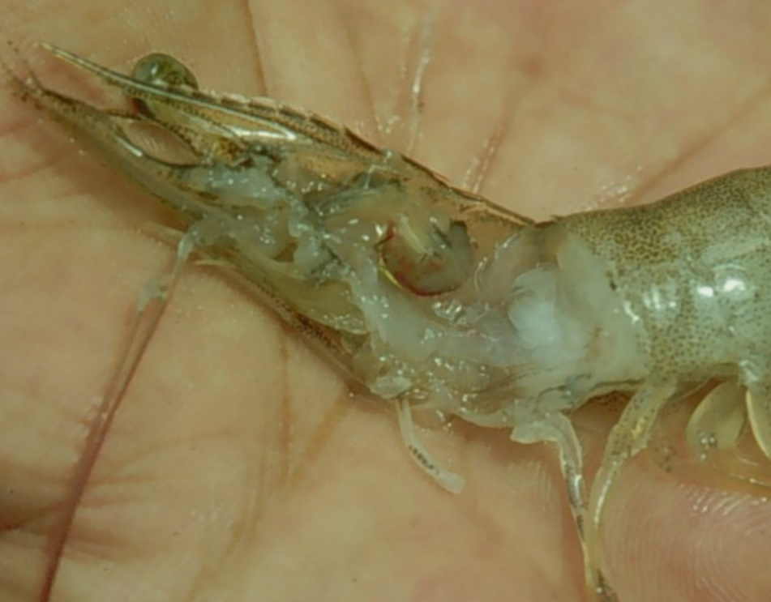
Note: Marked reduction in size and pale colour of the hepatopancreas.
Source: DV Lightner
Figure 2 Swimmerets of a Pacific white shrimp (Penaeus (Litopenaeus) vannamei) infected with Hepatobacter penaei
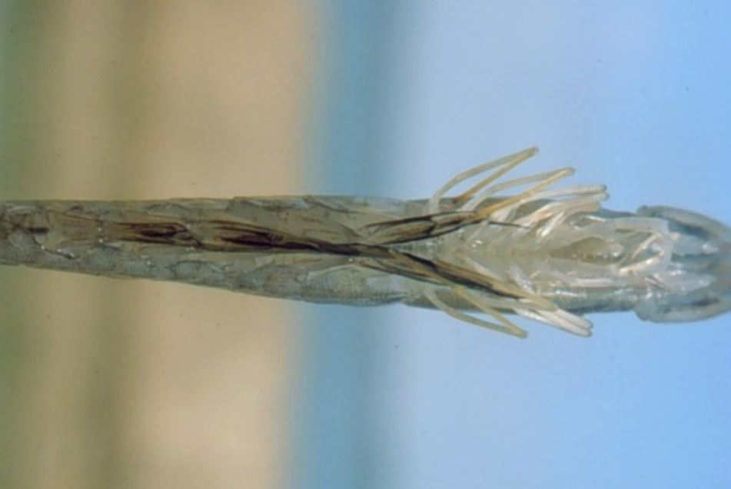
Note: Darkening at base of swimmerets, giving a fouled, ‘dirty’ appearance.
Source: DV Lightner

Signs of disease
Important: Animals with this disease may show one or more of these signs, but the pathogen may still be present in the absence of any signs.
Disease signs at the farm, tank or pond level are:
- lethargy
- emaciation
- heavy protozoan or bacterial fouling
- reduced growth rate.
Gross pathological signs are:
- soft shell
- flaccid body
- black gills
- empty intestinal tract
- degenerated or atrophied digestive gland (hepatopancreas), which appears pale to white
- black (melanised) streaks in the hepatopancreas.
Microscopic pathological signs are:
- multifocal granulomatous lesions in hepatopancreatic tubules, with atrophy of adjacent hepatopancreatic tubule epithelial cells
- tubular cells within the granulomatous lesions that can be hypertrophied and contain basophilic organisms within the cytoplasm
- sloughing of tubule epithelial cells
- severe haemocytic inflammation of the intratubular spaces.

Disease agent
NHP is caused by infection with Hepatobacter penaei, a Gram-negative, intracytoplasmic species of alphaproteobacterium that infects the hepatopancreas of prawns. H. penaei is also referred to as the NHP bacterium.
H. penaei exists in two morphological forms:
- rod-shaped, nonflagellated rickettsia-like organism
- helical flagellated form.

Host range
Table 1 Species known to be susceptible to Hepatobacter penaei
Common name | Scientific name
Aloha prawn | Penaeus marginatus
American lobster | Homarus americanus
Black tiger prawn | Penaeus monodon
Gulf banana prawn | Penaeus (Fenneropenaeus) merguiensis
Northern brown shrimpª | Penaeus (Farfantepenaeus) aztecus
Northern pink shrimpª | Penaeus (Farfantepenaeus) duorarum
Northern white shrimpª | Penaeus (Litopenaeus) setiferus
Pacific blue shrimpª | Penaeus (Litopenaeus) stylirostris
Pacific white shrimpª | Penaeus (Litopenaeus) vannamei
Yellow-leg shrimpª | Penaeus (Farfantepenaeus) californiensis
a Naturally susceptible.

Presence in Australia
Exotic disease—not recorded in Australia.
Map 1 Presence of Hepatobacter penaei, by jurisdiction
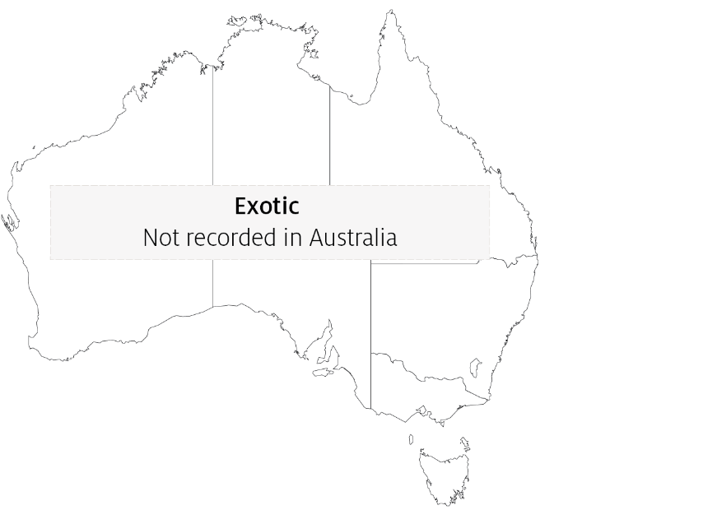

Epidemiology
- NHP outbreaks are often preceded by lengthy periods of high water temperatures (29°C to 31°C) and elevated salinity (up to 40ppt).
- Mortalities usually occur midway through the grow-out phase and can reach 90% to 95% within 30 days.
- NHP appears to be transmitted by direct ingestion of carrier prawns (survivors of H. penaei infections may carry the bacteria for life) and through contaminated water.
- Hepatobacter penaei may also be shed in faeces and contribute to disease transmission.

Differential diagnosis
The list of similar diseases in the next section refers only to the diseases covered by this field guide. Gross pathological signs may also be representative of diseases not included in this guide. Do not rely on gross signs to provide a definitive diagnosis. Use them as a tool to help identify the listed diseases that most closely account for the observed signs.

Similar diseases
Acute hepatopancreatic necrosis disease (AHPND) and infection with Enterocytozoon hepatopenaei (EHP).

Sample collection
Only trained personnel should collect samples. Using only gross pathological signs to differentiate between diseases is not reliable, and some aquatic animal disease agents pose a risk to humans. If you are not appropriately trained, phone your state or territory hotline number and report your observations. If you have to collect samples, the agency taking your call will advise you on the appropriate course of action. Local or district fisheries or veterinary authorities may also advise on sampling.

Emergency disease hotline
See something you think is this disease? Report it. Even if you’re not sure.
Call the Emergency Animal Disease Watch Hotline on 1800 675 888. They will refer you to the right state or territory agency.

Microscope images
Figure 3 Photomicrograph of hepatopancreas of juvenile Pacific white shrimp (Penaeus (Litopenaeus) vannamei) with severe subacute (grade 3–4) NHP
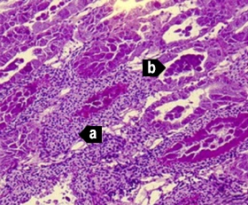
Note: Principal histopathological changes due to the disease include severe haemocytic inflammation (with some melanised foci) of the intratubular spaces (a) in response to necrosis, cytolysis and sloughing of hepatopancreas tubule epithelial cells (b). 150x magnification.
Source: DV Lightner
Figure 4 Photomicrograph of hepatopancreas of juvenile Pacific white shrimp (Penaeus (Litopenaeus) vannamei) with severe subacute (grade 3–4) NHP
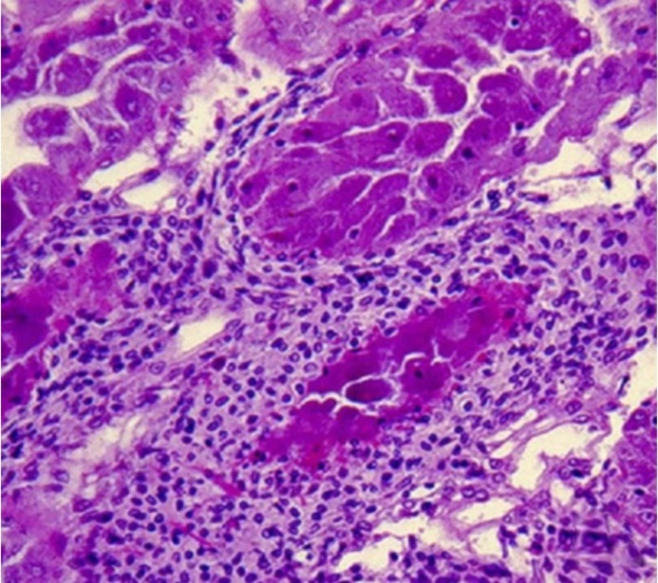
Note: Higher magnification of upper left of Figure 3. 300x magnification.
Source: DV Lightner
Figure 5 Photomicrograph of hepatopancreas of juvenile Pacific white shrimp (Penaeus (Litopenaeus) vannamei) with severe subacute (grade 3–4) NHP
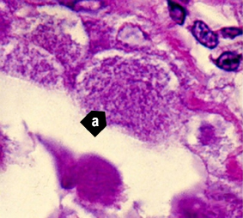
Note: Higher magnification view of Figure 3 and Figure 4. Tubule epithelial cells have no cytoplasmic lipid droplets. Instead, they contain masses of the tiny, non-membrane bound intracytoplasmic H. penaei (a). 1700x magnification.
Source: DV Lightner
Figure 6 Photomicrograph of hepatopancreas of juvenile Pacific white shrimp (Penaeus (Litopenaeus) vannamei) with severe chronic NHP
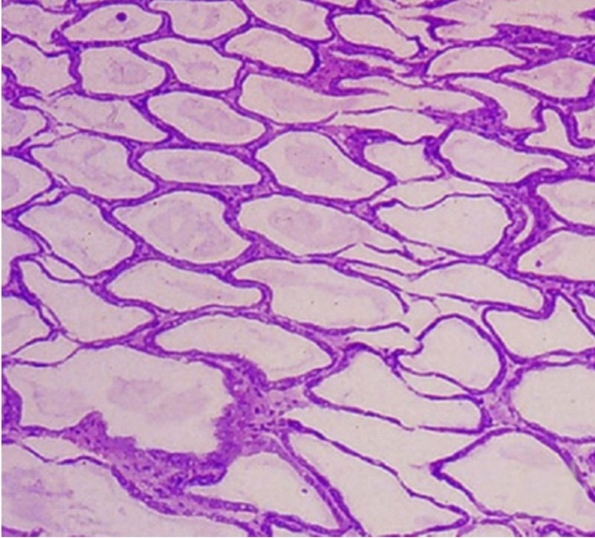
Note: Hepatopancreas tubule epithelium is markedly atrophied, resulting in the formation of large oedematous (fluid-filled or ‘watery’) areas. 100x magnification
Source: DV Lightner
Figure 7 Photomicrograph of atrophied hepatopancreas from juvenile Pacific white shrimp (Penaeus (Litopenaeus) vannamei) with chronic NHP
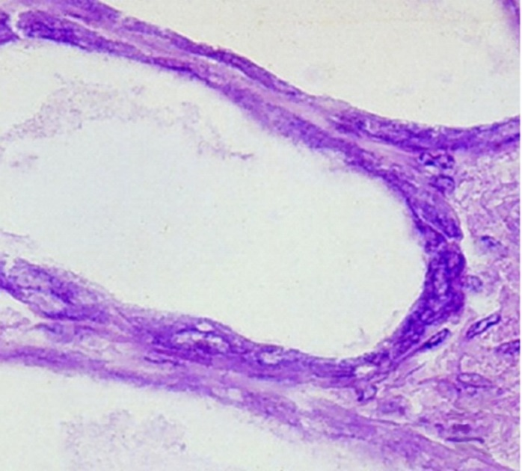
Note: In contrast to the subacute phase of NHP, chronic-phase NHP shows no, or only occasional, foci of haemocytic inflammation of the necrotic or degenerating hepatopancreatic tubules. NHP bacteria may be found in the cytoplasm of an occasional hepatopancreocyte. 900x magnification.
Source: DV Lightner
Figure 8 Hepatopancreocyte containing cytoplasmic masses of the NHP bacterium
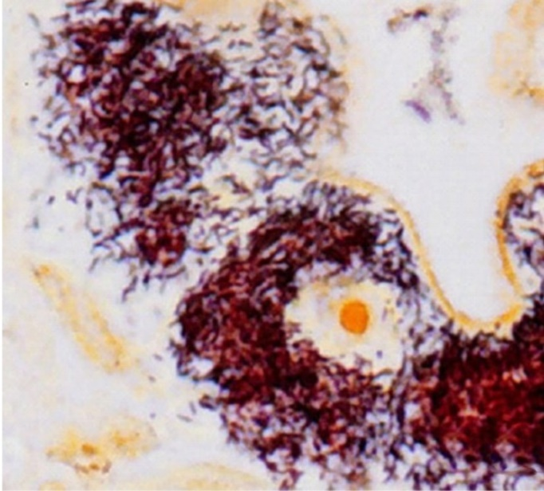
Note: Silver stain has been used to show individual bacteria as brown or black. Unaffected cells and nuclei are pale brown. 1600x magnification.
Source: DV Lightner
Figure 9 Transmission electron microscope micrograph of a hepatopancreocyte of a juvenile Pacific white shrimp (Penaeus (Litopenaeus) vannamei) with NHP
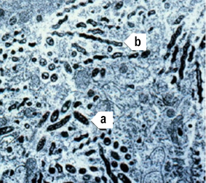
Note: The micrograph shows many intracellular rod-shaped forms (a) and helical forms (b) of the NHP bacterium in the cytoplasm. 10,000× magnification
Source: DV Lightner
Figure 10 Hepatopancreas of juvenile Pacific white shrimp (Penaeus (Litopenaeus) vannamei) with NHP
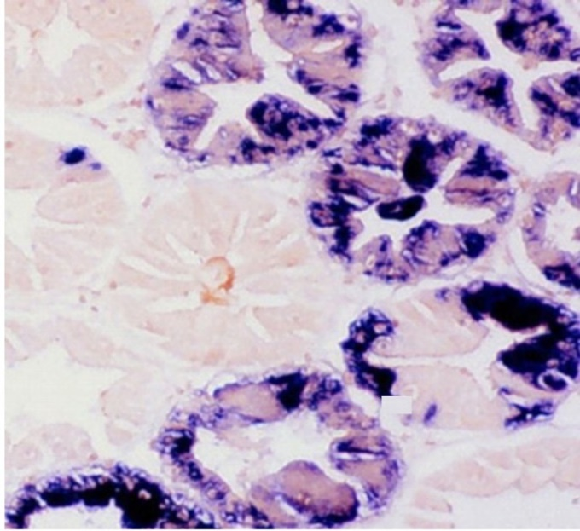
Note: The digoxigenin-labelled DNA probe marks cytoplasmic masses of Hepatobacter penaei blue-black. 250x magnification.
Source: DV Lightner
Figure 11 Hepatopancreas of juvenile Pacific white shrimp (Penaeus (Litopenaeus) vannamei) with NHP
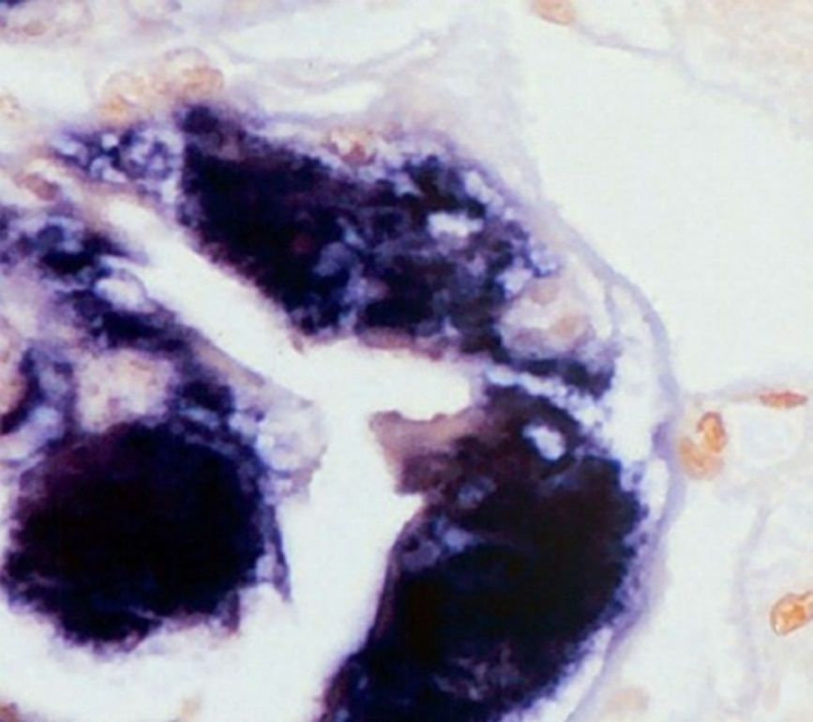
Note: The digoxigenin-labelled DNA probe marks cytoplasmic masses of H. penaei blue-black. 1000x magnification.
Source: DV Lightner

Further reading
CABI Invasive Species Compendium Necrotising hepatopancreatitis
CEFAS International Database on Aquatic Animal Diseases ‘Hepatobacter penaei’ (Necrotising hepatopancreatitis)
World Organisation for Animal Health Manual of diagnostic tests for aquatic animals
These hyperlinks were correct at the time of publication.

Contact details
Emergency Animal Disease Watch Hotline 1800 675 888
Email AAH@agriculture.gov.au
Website agriculture.gov.au/pests-diseases-weeds/aquatic
© Commonwealth of Australia 2020
This work is copyright. It may be reproduced in whole or in part subject to the inclusion of an acknowledgement of the source and no commercial usage or sale.

