Infection with HPR-deleted or HPR0 infectious salmon anaemia virus (ISAV)

Also known as infectious salmon anaemia (ISA)

From Aquatic animal diseases significant to Australia: identification field guide, 5th edition
Figure 1 Atlantic salmon (Salmo salar) with ISA
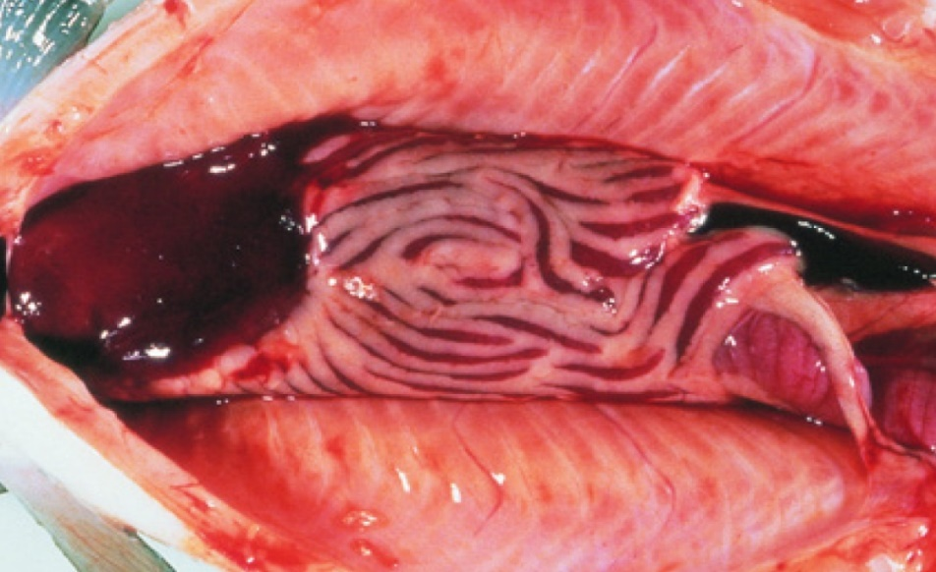
Note: Gross internal signs of ISA include dark liver, ascites and enlarged spleen.
Source: T Poppe

Signs of disease
Important: Animals with this disease may show one or more of these signs, but the pathogen may still be present in the absence of any signs.
Disease signs at the farm, tank or pond level are:
- mortality rate up to 100%
- fish congregating near the surface
- fish gasping at the surface
- lethargy
- loss of appetite.
Gross pathological signs are:
- pale gills and heart
- swollen abdomen
- exophthalmos (popeye), bleeding eyes
- fin rot
- ecchymotic (bruise-like) skin haemorrhages
- scale-pocket oedema
- swollen and dark liver, kidney and spleen (early sign); liver may be almost black
- petechial (pinpoint) haemorrhages in internal fat, peritoneum and skeletal muscle
- dark red intestinal wall mucosa
- ascites (fluid in the abdominal cavity)
- surface haemorrhages on liver.
Microscopic pathological signs are:
- renal interstitial haemorrhage and tubular necrosis
- branchial lamellar and filamental congestion
- congestion of the intestine and pyloric caecae
- perivascular inflammation and focal necrosis in liver.

Disease agent
ISA is caused by infection with the pathogenic highly polymorphic region (HPR)-deleted infectious salmon anaemia virus (ISAV), or the non-pathogenic HPR0 (non-deleted HPR) ISAV, a single stranded RNA virus classified within the genus Isavirus within the family Orthomyxoviridae. Infection with HPR-deleted ISAV may cause severe disease in Atlantic salmon (Salmo salar). However, Detection of HPR0 ISAV has never been associated with clinical signs of disease in Atlantic salmon.

Host range
The only species known to display clinical signs of ISA is the Atlantic salmon (Salmo salar). Several other fish species have been confirmed to be asymptomatic carriers of the virus.
Table 1 Species known to display clinical signs of ISA
Common name | Scientific name
Atlantic salmon | Salmo salar
Table 2 Species known to be asymptomatic carriers or vectors of ISAV
Common name | Scientific name
Arctic char | Salvelinus alpinus
Atlantic cod | Gadus morhua
Atlantic herring | Clupea harengus
Brown troutª | Salmo trutta
Coalfish or pollock | Pollachius virens
Coho salmonª | Oncorhynchus kisutch
Masu salmonª | Oncorhynchus masou
Rainbow troutª | Oncorhynchus mykiss
Salmon louse | Lepeophtheirus salmonis and Caligus coryphaenae
a Naturally susceptible. Note: Other species have been shown to be experimentally susceptible.

Presence in Australia
Exotic disease—not recorded in Australia.
The distantly related pilchard orthomyxo-like virus (POMV) has been reported from wild caught pilchards and cultured Atlantic salmon in Tasmania, but infectious salmon anaemia caused by infection with HPR-deleted or HPR0 ISAV has not been recorded in Australia and is considered exotic.
Map 1 Presence of ISAV, by jurisdiction
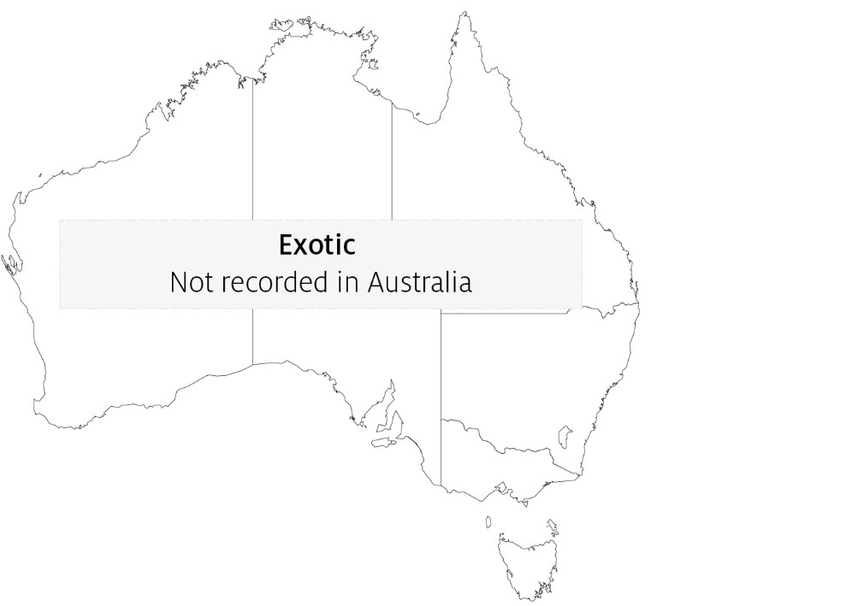

Epidemiology
- ISA occurs mainly in the northern hemisphere in spring and early winter (water temperatures from 3°C to above 15°C).
- The disease has caused major epizootics and severely impacted Atlantic salmon aquaculture production in Norway, Scotland, Canada and Chile.
- Mortality rates vary from 15% to 100%; mortality may occur over a prolonged period, not necessarily as acute outbreaks.
- ISA is mainly transmitted horizontally through the water column, but also by vectors (sea lice and populations of asymptomatic wild fish carriers).
- Experimental infection demonstrated mortalities within 15 days of exposure to ISAV.
- Spread of the disease has occurred with the movement of live juvenile salmonids between fish farms, with the discharge of organic waste from fish processing plants into the marine environment and via water movement.
- The majority of natural outbreaks seem to occur in salmonid post-smolts.
- ISA has been the subject of extensive eradication campaigns in several countries. These can be successful, but require vigilance to maintain 'free' status.
- It appears that stressors such as husbandry practices (including treatment against salmon lice or infectious diseases), rising or falling temperatures, and poor water quality can predispose salmon to outbreaks of ISA.

Differential diagnosis
The list of similar diseases in the next section refers only to the diseases covered by this field guide. Gross pathological signs may also be representative of diseases not included in this guide. Do not rely on gross signs to provide a definitive diagnosis. Use them as a tool to help identify the listed diseases that most closely account for the observed signs.

Similar diseases
Bacterial kidney disease (BKD), enteric red mouth disease (ERMD), infection with Aeromonas salmonicida atypical strains, infection with salmonid alphavirus (SAV), infectious haematopoietic necrosis (IHN), infectious pancreatic necrosis (IPN) and piscirickettsiosis.

Sample collection
Only trained personnel should collect samples. Using only gross pathological signs to differentiate between diseases is not reliable, and some aquatic animal disease agents pose a risk to humans. If you are not appropriately trained, phone your state or territory hotline number and report your observations. If you have to collect samples, the agency taking your call will advise you on the appropriate course of action. Local or district fisheries or veterinary authorities may also advise on sampling.

Emergency disease hotline
See something you think is this disease? Report it. Even if you’re not sure.
Call the Emergency Animal Disease Watch Hotline on 1800 675 888. They will refer you to the right state or territory agency.

Microscope images
Figure 2 Histopathology of liver of Atlantic salmon (Salmo salar) with ISA
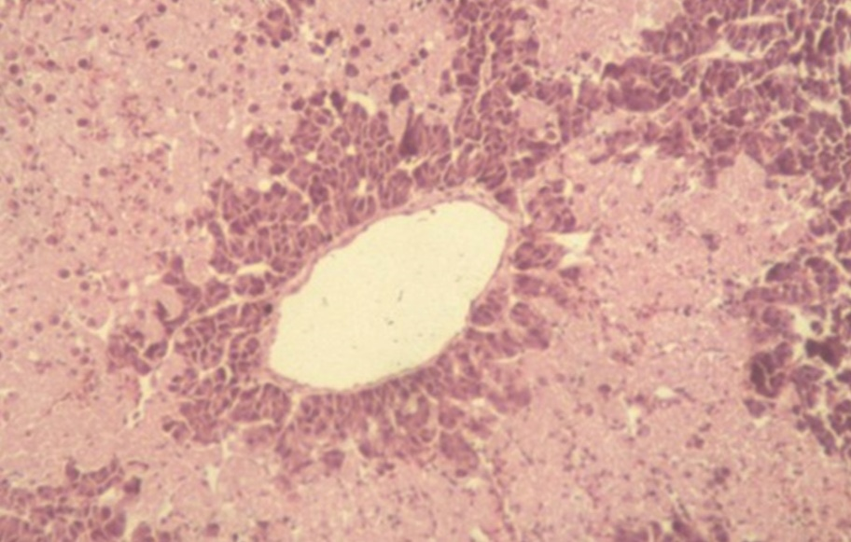
Note: Multifocal bridging necrosis, leaving viable tissue around smaller veins.
Source: T Poppe.
Figure 3 Histopathology of kidney of Atlantic salmon (Salmo salar) with ISA
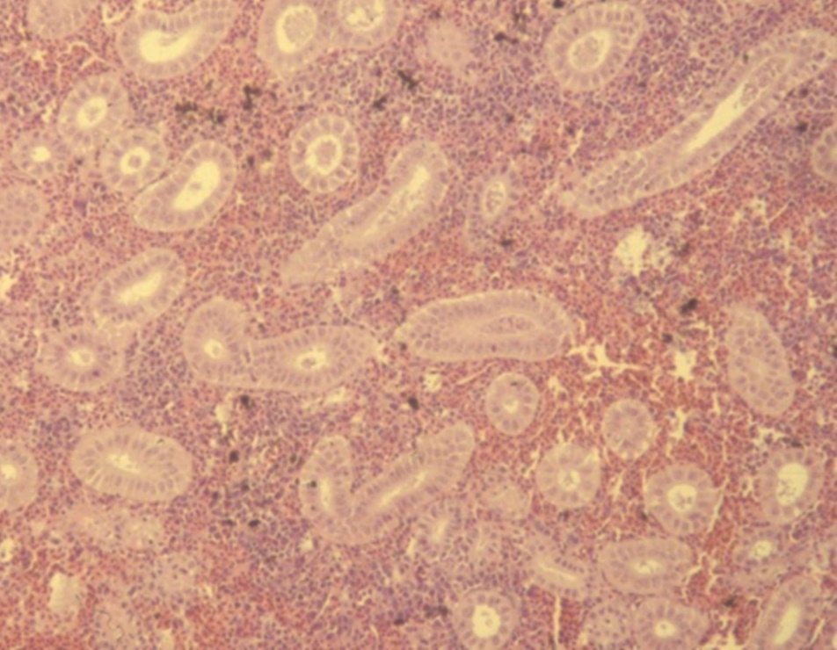
Note: Renal interstitial haemorrhage.
Source: T Poppe

Further reading
Department of Agriculture, Water and the Environment AQUAVETPLAN disease strategy manual: Infectious salmon anaemia
World Organisation for Animal Health Manual of diagnostic tests for aquatic animals
These hyperlinks were correct at the time of publication.

Contact details
Emergency Animal Disease Watch Hotline 1800 675 888
Email AAH@agriculture.gov.au
Website agriculture.gov.au/pests-diseases-weeds/aquatic
© Commonwealth of Australia 2020
This work is copyright. It may be reproduced in whole or in part subject to the inclusion of an acknowledgement of the source and no commercial usage or sale.

