Infection with infectious hypodermal and haematopoietic necrosis virus (IHHNV)

Also known as infectious hypodermal and haematopoietic necrosis (IHHN), infection with Penaeus stylirostris densovirus (PstDNV) and runt deformity syndrome (RDS)

From Aquatic animal diseases significant to Australia: identification field guide, 5th edition
Figure 1 Infection with IHHNV in juvenile Pacific blue shrimp (Penaeus (Litopenaeus) stylirostris)
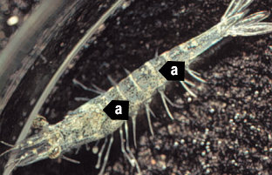
Note: White to buff lesions under carapace (a).
Source: DV Lightner
Figure 2 Runt deformity syndrome due to infection with IHHNV in juvenile black tiger prawn (Penaeus monodon)
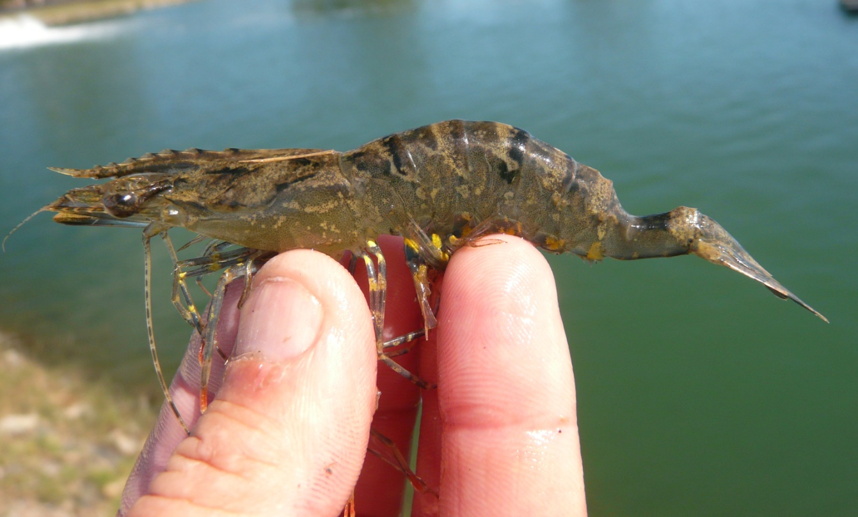
Note: Deformity of the sixth abdominal segment.
Source: B Diggles
Figure 3 Runt deformity syndrome in juvenile Pacific blue shrimp (Penaeus (Litopenaeus) stylirostris) infected with IHHNV
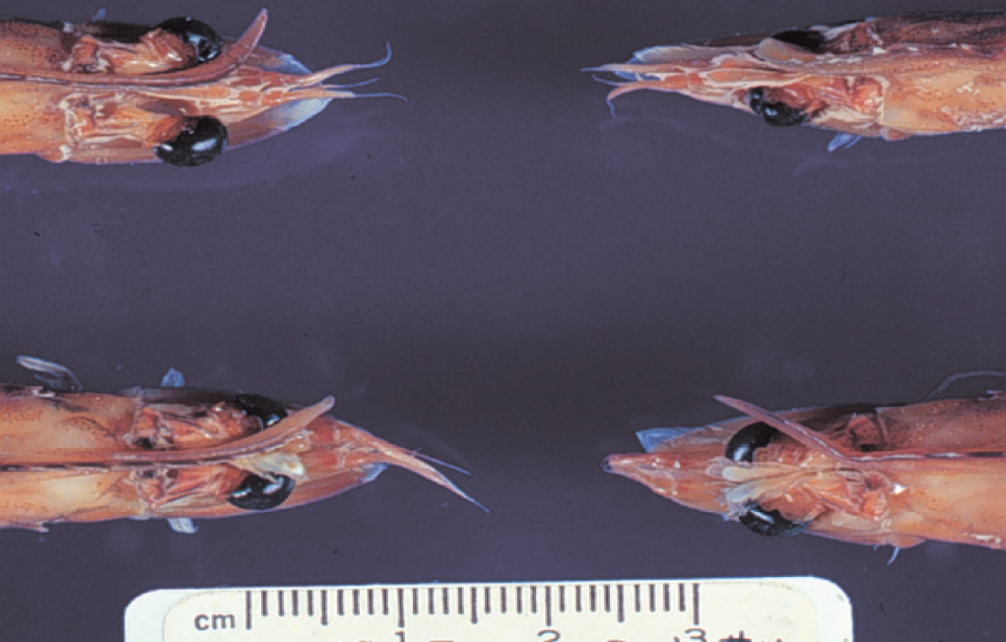
Note: Classic rostrum deformation.
Source: DV Lightner

Signs of disease
Important: Animals with this disease may show one or more of these signs, but the pathogen may still be present in the absence of any signs.
Disease signs at the farm, tank or pond level are:
- reduced food consumption
- cannibalism
- repeatedly floating slowly to the water surface, rolling over and then sinking to the bottom
- morbidity or mortality
- poor hatching success of eggs
- poor survival of larvae and postlarvae.
Gross pathological signs are:
- opaque abdominal musculature
- white to buff lesions under the carapace.
In Pacific blue shrimp, Pacific white shrimp and black tiger prawns, additional gross pathological signs are:
- blue appearance of moribund prawns
- runt deformity syndrome, the effects of which include
  - reduced and irregular growth in juveniles and subadults
  - deformed rostrums growing to one side
  - deformed sixth abdominal segment.
In Pacific blue shrimp, further gross pathological signs are:
- cuticular roughness
- cuticular deformities
- white to buff mottling of the shell, especially at the junction of abdominal shell plates.
Microscopic pathological signs are:
- eosinophilic to pale basophilic intranuclear inclusion bodies (Cowdry type A inclusions) within tissues of ectodermal and mesodermal origin. These inclusion bodies may be easily confused with developing intranuclear inclusion bodies caused by white spot disease.

Disease agent
IHHNV causes runt deformity syndrome (RDS). IHHNV is a densovirus belonging to the family Parvoviridae (subfamily Densovirinae, genus Brevidensovirus). At least 3 distinct genotypes of IHHNV have been identified, but only 2 are known to be infectious to either Pacific white shrimp (Penaeus (Litopenaeus) vannamei) or black tiger prawns (Penaeus monodon). Homologues of portions of the IHHNV genome have been reported from the genomes of host prawns.

Host range
Table 1 Species known to be susceptible to IHHNV
Common name | Scientific name
Argentine stiletto shrimp | Artemesia longinaris
Black tiger prawnª | Penaeus monodon
Brush clawed shore crab | Hemigrapsus penicillatus
Chinese white shrimpª | Penaeus (Fenneropenaeus) chinensis
Cuata swimcrab | Callinectes arcuatus
Giant freshwater prawnª | Macrobrachium rosenbergii
Green tiger prawn or grooved tiger prawnª | Penaeus semisulcatus
Gulf banana prawn | Penaeus (Fenneropenaeus) merguiensis
Indian banana prawn | Penaeus (Fenneropenaeus) indicus
Kuruma prawnª | Penaeus (Marsupenaeus) japonicus
Louisiana swamp crayfishª | Procambarus clarkii
Northern brown shrimp | Penaeus (Farfantepenaeus) aztecus
Northern pink shrimp | Penaeus (Farfantepenaeus) duorarum
Northern white shrimp | Penaeus (Litopenaeus) setiferus
Pacific blue shrimpª | Penaeus (Litopenaeus) stylirostris
Pacific white shrimpª | Penaeus (Litopenaeus) vannamei
Southern white shrimpª | Penaeus (Litopenaeus) schmitti
Western white shrimpª | Penaeus (Litopenaeus) occidentalis
Yellow-leg shrimpª | Penaeus (Farfantepenaeus) californiensis
a Naturally susceptible.

Presence in Australia
IHHNV has been officially reported in black tiger prawns from the Northern Territory and Queensland.
Map 1 Presence of IHHNV, by jurisdiction
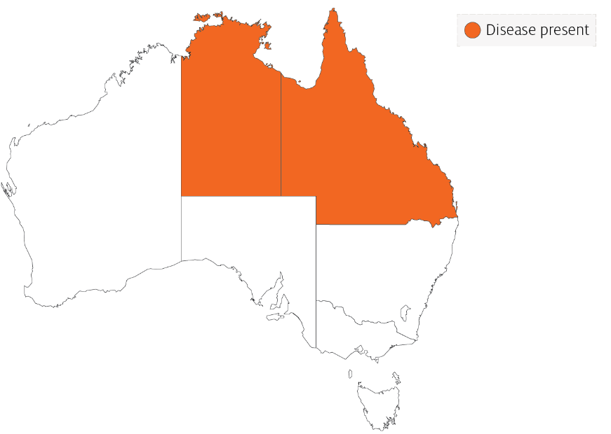

Epidemiology
- Gross signs of disease in an infected animal become evident from about 35 days into postlarval development.
- IHHNV-resistant prawns and early life stages are carriers, and may transfer the virus to more susceptible species and life stages.
- The typical gross signs of runt deformity syndrome may be observed in juveniles and subadults.
- Mortality events seldom occur in infected adult prawns.
- IHHNV suppresses the prawn’s immune system, allowing infection by other disease agents.
- Infected tissue remains infectious after 5 years of storage at –20°C, after 10 years at –80°C, and after storage in 50% glycerine.
- IHHNV infection can result in cumulative mortalities as high as 90% in postlarvae and juveniles.
- Transmission of IHHNV can be via horizontal or vertical routes. Horizontal transmission has been demonstrated by cannibalism or through contaminated water. Vertical transmission has been demonstrated via infected eggs.

Differential diagnosis
The list of similar diseases in the next section refers only to the diseases covered by this field guide. Gross pathological signs may also be representative of diseases not included in this guide. Do not rely on gross signs to provide a definitive diagnosis. Use them as a tool to help identify the listed diseases that most closely account for the observed signs.

Similar diseases
Infection with white spot syndrome virus (WSSV).

Sample collection
Only trained personnel should collect samples. Using only gross pathological signs to differentiate between diseases is not reliable, and some aquatic animal disease agents pose a risk to humans. If you are not appropriately trained, phone your state or territory hotline number and report your observations. If you have to collect samples, the agency taking your call will advise you on the appropriate course of action. Local or district fisheries or veterinary authorities may also advise on sampling.

Emergency disease hotline
See something you think is this disease? Report it. Even if you’re not sure.
Call the Emergency Animal Disease Watch Hotline on 1800 675 888. They will refer you to the right state or territory agency.

Microscope images
Figure 4 Cuticular epithelium and subcuticular connective tissue near heart of juvenile Pacific blue shrimp (Penaeus (Litopenaeus) stylirostris) with severe acute IHHN
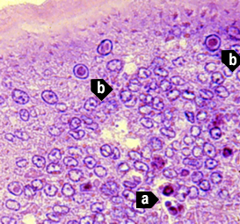
Note: Section stained with haematoxylin and eosin. Numerous necrotic cells with pyknotic nuclei (a) or with pathognomonic eosinophilic intranuclear inclusion bodies (Cowdry type A) (b). 830x magnification.
Source: DV Lightner
Figure 5 Gills of juvenile Pacific blue shrimp (Penaeus (Litopenaeus) stylirostris) with severe acute IHHN
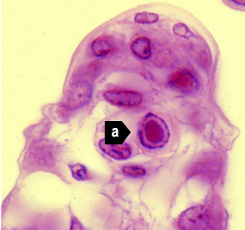
Note: Numerous necrotic cells (a) with pathognomonic eosinophilic intranuclear inclusion bodies (Cowdry type A) that are pathognomonic for IHHNV infection. 1800x magnification.
Source: DV Lightner
Figure 6 Gill lamella with diagnostic IHHNV Cowdry type A inclusions
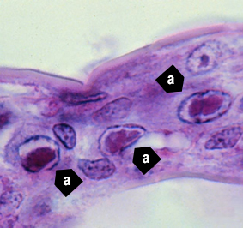
Note: Light micrograph shows 3 adjacent cells with diagnostic IHHNV Cowdry type A inclusions (a) in their hypertrophied nuclei. 1800x magnification.
Source: DV Lightner
Figure 7 IHHNV Cowdry type A inclusion in nucleus of gill epithelial cell
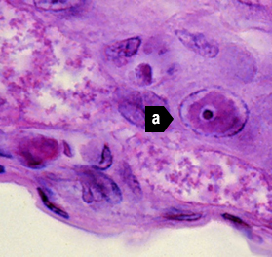
Note: Light micrograph shows a chromatin process within the inclusion body (a). 1800x magnification.
Source: DV Lightner
Figure 8 Midsagittal section of ventral nerve cord of juvenile Pacific white shrimp (Penaeus (Litopenaeus) vannamei) with IHHN
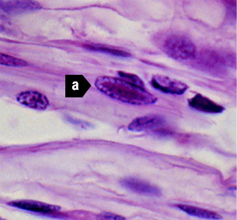
Note: Cowdry type A inclusions take the shape of the host cell nucleus (a). In the nerve cord, they are often elliptical and appear slightly different from Cowdry type A inclusions in other tissue. 1800x magnification.
Source: DV Lightner
Figure 9 Photomicrograph of vas deferens of adult Pacific white shrimp (Penaeus (Litopenaeus) vannamei) with IHHN
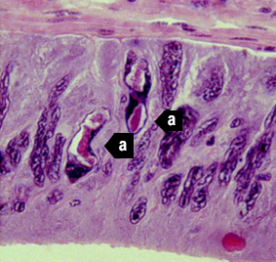
Note: Cowdry type A inclusions in the vas deferens may be unusually shaped (a) because they take on the shape of the nuclei of the tissue. 700x magnification.
Source: DV Lightner
Figure 10 Gills of juvenile Pacific blue shrimp (Penaeus (Litopenaeus) stylirostris) with IHHN
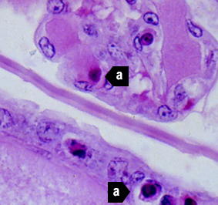
Note Section stained with haemotoxylin and eosin. Although necrotic cells with pyknotic nuclei are numerous (a), no diagnostic Cowdry type A inclusions are apparent 700x magnification.
Source: DV Lightner
Figure 11 Gills of juvenile Pacific blue shrimp (Penaeus (Litopenaeus) stylirostris) with IHHN
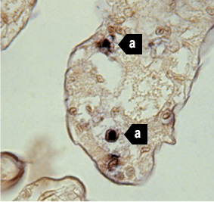
Note: In situ hybridisation section. Several IHHNV-infected cell nuclei have reacted with the digoxigenin labelled probe (a), although no diagnostic Cowdry type A inclusions are apparent. 700x magnification.
Source: DV Lightner
Figure 12 Haematopoietic tissue from juvenile Pacific blue shrimp (Penaeus (Litopenaeus) stylirostris) with IHHN
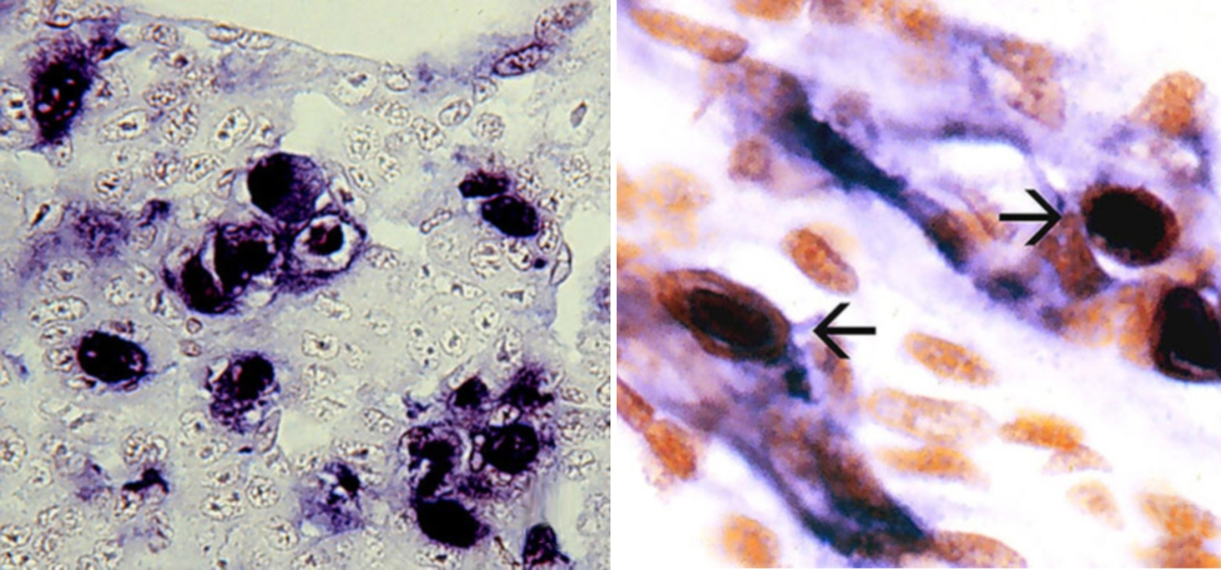
Note: In situ hybridisation section. Digoxigenin (DIG)-labelled probe shows abundant DIG-positive cells where cellular debris or haemolymph have a high content of IHHNV. 700x magnification.
Source: DV Lightner
Figure 13 Midsagittal section of juvenile white shrimp (Penaeus (Litopenaeus) vannamei) with IHHN
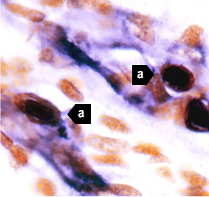
Note: The digoxigenin-labelled probe has reacted with several Cowdry type A inclusions (a) and with cellular debris or haemolymph with a high content of IHHNV. 600x magnification.
Source: DV Lightner

Further reading
CABI Invasive Species Compendium Infectious hypodermal and haematopoietic necrosis
CEFAS International Database on Aquatic Animal Diseases Infectious hypodermal and haematopoietic necrosis
World Organisation for Animal Health Manual of diagnostic tests for aquatic animals
These hyperlinks were correct at the time of publication.

Contact details
Emergency Animal Disease Watch Hotline 1800 675 888
Email AAH@agriculture.gov.au
Website agriculture.gov.au/pests-diseases-weeds/aquatic
© Commonwealth of Australia 2020
This work is copyright. It may be reproduced in whole or in part subject to the inclusion of an acknowledgement of the source and no commercial usage or sale.

