Infection with infectious myonecrosis virus (IMNV)

Also known as infectious myonecrosis

From Aquatic animal diseases significant to Australia: identification field guide, 5th edition
Figure 1 Gross signs of infectious myonecrosis in naturally infected farmed Pacific white shrimp (Penaeus (Litopenaeus) vannamei)
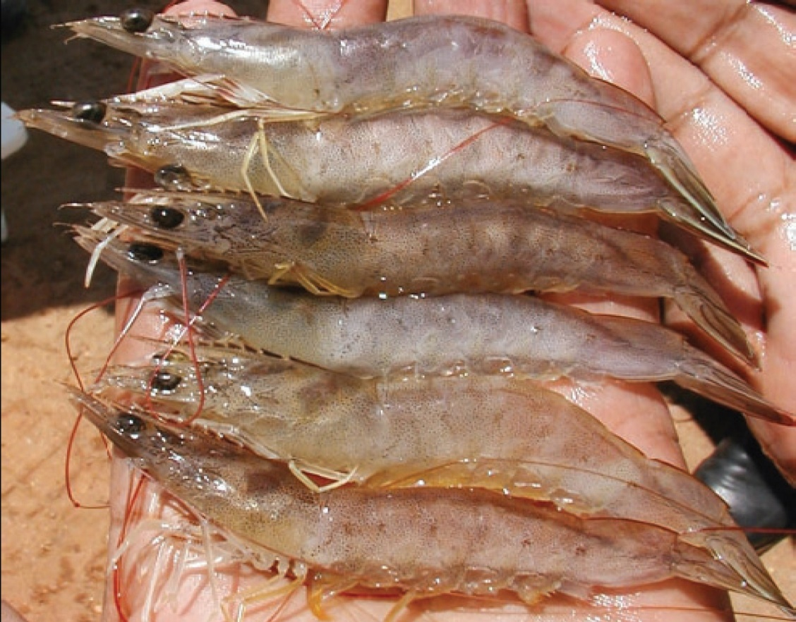
Note: Various degrees of skeletal muscle necrosis, visible as an opaque, whitish discolouration of the abdomen.
Source: DV Lightner
Figure 2 Gross signs of infectious myonecrosis in naturally infected farmed Pacific white shrimp (Penaeus (Litopenaeus) vannamei)
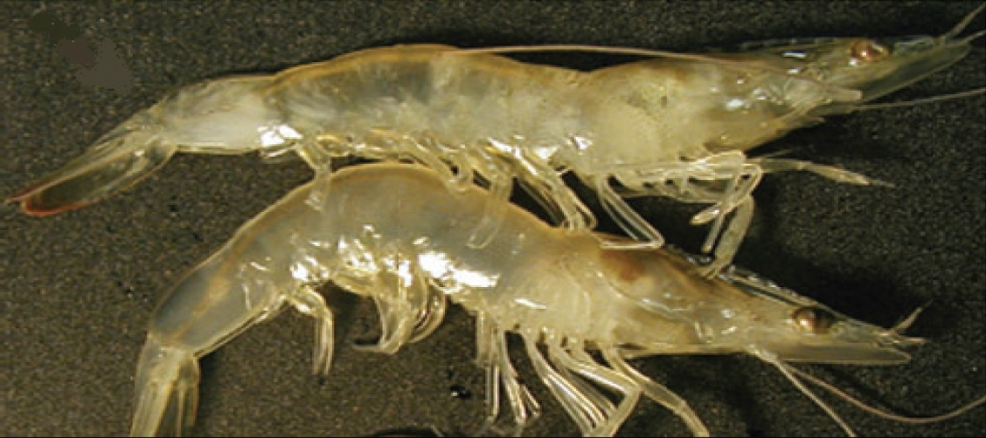
Note: Reddened tail, and skeletal muscle necrosis visible as an opaque, whitish discolouration of the abdominal segments.
Source: DV Lightner

Signs of disease
Important: Animals with this disease may show one or more of these signs, but the pathogen may still be present in the absence of any signs.
Disease signs at the farm, tank or pond level are:
- lethargy
- large numbers of moribund animals and significant mortalities (up to 70%), during or following stressful events
- The acute form of the disease produces gross signs and elevated mortalities, but disease progresses to a chronic phase with persistent low-level mortalities.
Gross pathological signs are:
- focal to extensive white necrotic areas in the striated muscle commonly observed in distal abdominal segments
- necrotic and reddened tail fan
- lymphoid organs increased to 3 to 4 times normal size
- moribund prawns with a full stomach because affected individuals may continue to feed until death.
Microscopic pathological signs are:
- coagulative necrosis of skeletal muscle by haemocytic infiltration and fibrosis.

Disease agent
Infectious myonecrosis is caused by infection with infectious myonecrosis virus (IMNV), a putative totivirus. Phylogenetic analysis based on its RNA-dependent RNA polymerase gene coding sequence groups IMNV most closely with Giardia lamblia virus, a member of the family Totiviridae.

Host range
Table 1 Species known to be susceptible to IMNV
Common name | Scientific name
Black tiger prawn | Penaeus monodon
Brown tiger prawn | Penaeus esculentus
Gulf banana prawn | Penaeus (Fenneropenaeus) merguiensis
Pacific blue shrimp | Penaeus (Litopenaeus) stylirostris
Pacific white shrimpª | Penaeus (Litopenaeus) vannamei
Southern brown shrimp | Penaeus (Farfantepenaeus) subtilis
a Naturally susceptible.

Presence in Australia
Exotic disease—not recorded in Australia.
Map 1 Presence of IMNV, by jurisdiction
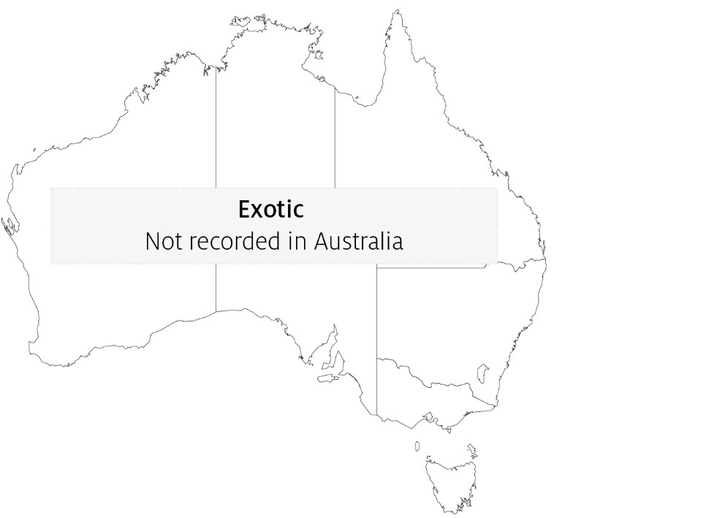

Epidemiology
- IMNV was originally identified in northeastern Brazil in cultured Penaeus (Litopenaeus) vannamei. The virus has since been reported in South-East Asia, including Indonesia, India and Sri Lanka.
- Clinical signs may have sudden onset following stressful events (such as capture by net, reduced feeding or sudden changes in temperature or salinity).
- Affected life stages include juveniles and subadults. Significant mortalities occur in juvenile and subadult pond-reared populations.
- Horizontal transmission has been demonstrated via cannibalism. Vertical transmission (direct passage from parents to offspring via eggs or sperm) is likely but not confirmed.

Differential diagnosis
The list of similar diseases in the next section refers only to the diseases covered by this field guide. Gross pathological signs may also be representative of diseases not included in this guide. Do not rely on gross signs to provide a definitive diagnosis. Use them as a tool to help identify the listed diseases that most closely account for the observed signs.
The clinical signs described and shown here may also be symptomatic of other bacterial or viral infections or poor water quality. Further laboratory examination is needed for a definitive diagnosis.

Similar diseases
Infection with Macrobrachium rosenbergii nodavirus (MrNV) and infection with shrimp haemocyte iridescent virus (SHIV).

Sample collection
Only trained personnel should collect samples. Using only gross pathological signs to differentiate between diseases is not reliable, and some aquatic animal disease agents pose a risk to humans. If you are not appropriately trained, phone your state or territory hotline number and report your observations. If you have to collect samples, the agency taking your call will advise you on the appropriate course of action. Local or district fisheries or veterinary authorities may also advise on sampling.

Emergency disease hotline
See something you think is this disease? Report it. Even if you’re not sure.
Call the Emergency Animal Disease Watch Hotline on 1800 675 888. They will refer you to the right state or territory agency.

Microscope images
Figure 3 Skeletal muscle of Pacific white shrimp (Penaeus (Litopenaeus) vannamei) infected with IMNV
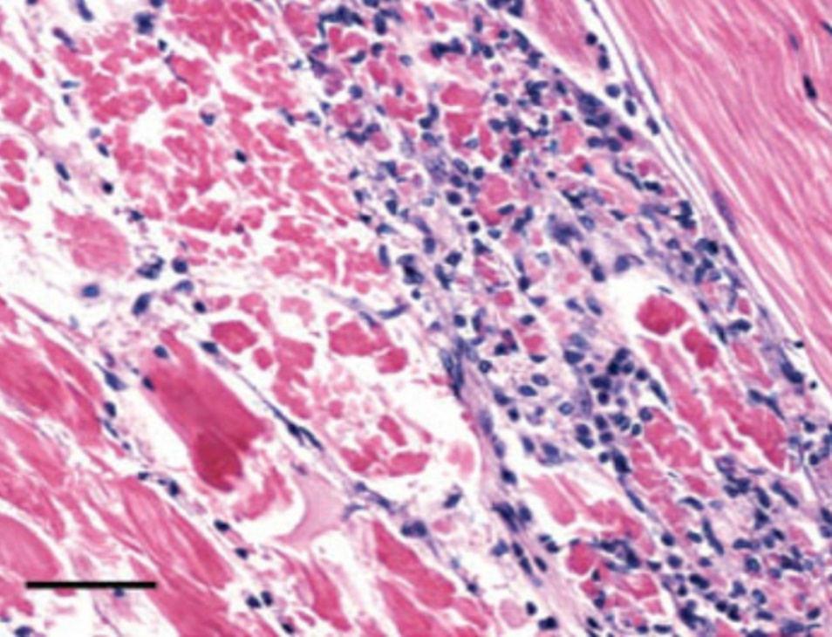
Note: Coagulative necrosis of skeletal muscle accompanied by haemocytic infiltration and fibrosis. Normal skeletal muscle can be observed in the upper right corner. Haematoxylin and eosin stain Scale bar = 50μm.
Source: DV Lightner
Figure 4 Muscle cells of Pacific white shrimp (Penaeus (Litopenaeus) vannamei) infected with IMNV
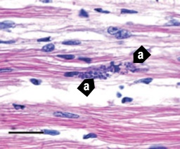
Note: Perinuclear pale basophilic to dark basophilic inclusion bodies in a group of muscle cells (a).Haematoxylin and eosin stain. Scale bar = 20μm.
Source: DV Lightner
Figure 5 In situ hybridisation of skeletal muscle tissue using a digoxigenin-labelled IMNV probe
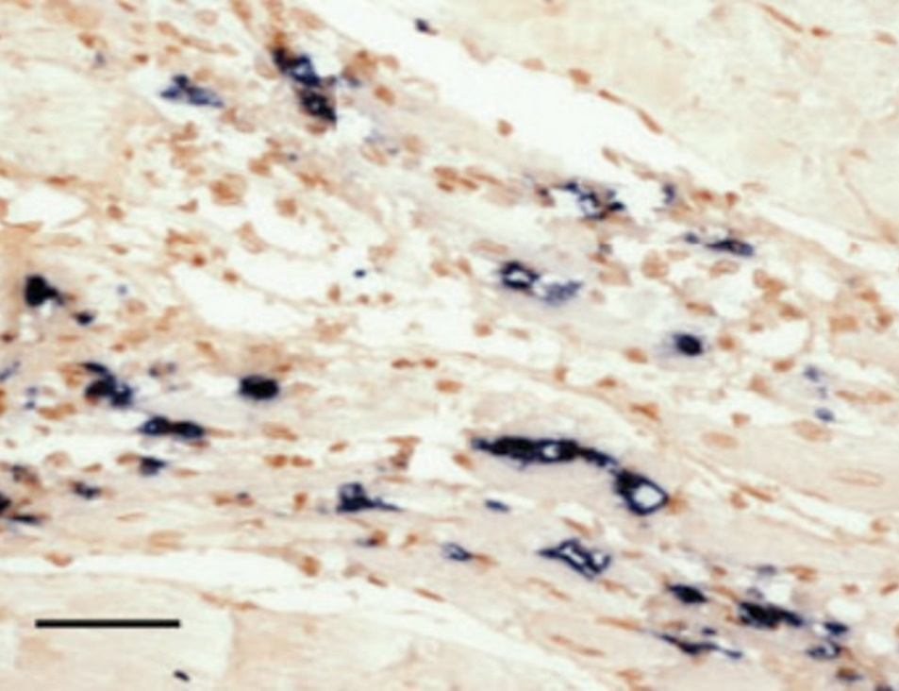
Note: Black precipitate is present in areas where probe has hybridised with target virus. Bismarck brown counterstain. Scale bar = 50μm.
Source: DV Lightner

Further reading
CABI Invasive Species Compendium Infectious myonecrosis
CEFAS International Database on Aquatic Animal Diseases Infectious myonecrosis
World Organisation for Animal Health Manual of diagnostic tests for aquatic animals
These hyperlinks were correct at the time of publication.

Contact details
Emergency Animal Disease Watch Hotline 1800 675 888
Email AAH@agriculture.gov.au
Website agriculture.gov.au/pests-diseases-weeds/aquatic
© Commonwealth of Australia 2020
This work is copyright. It may be reproduced in whole or in part subject to the inclusion of an acknowledgement of the source and no commercial usage or sale.

