Infection with infectious spleen and kidney necrosis virus (ISKNV)-like viruses

From Aquatic animal diseases significant to Australia: identification field guide, 5th edition
Figure 1 Dwarf gourami (Colisa lalia) infected with an ISKNV-like iridovirus
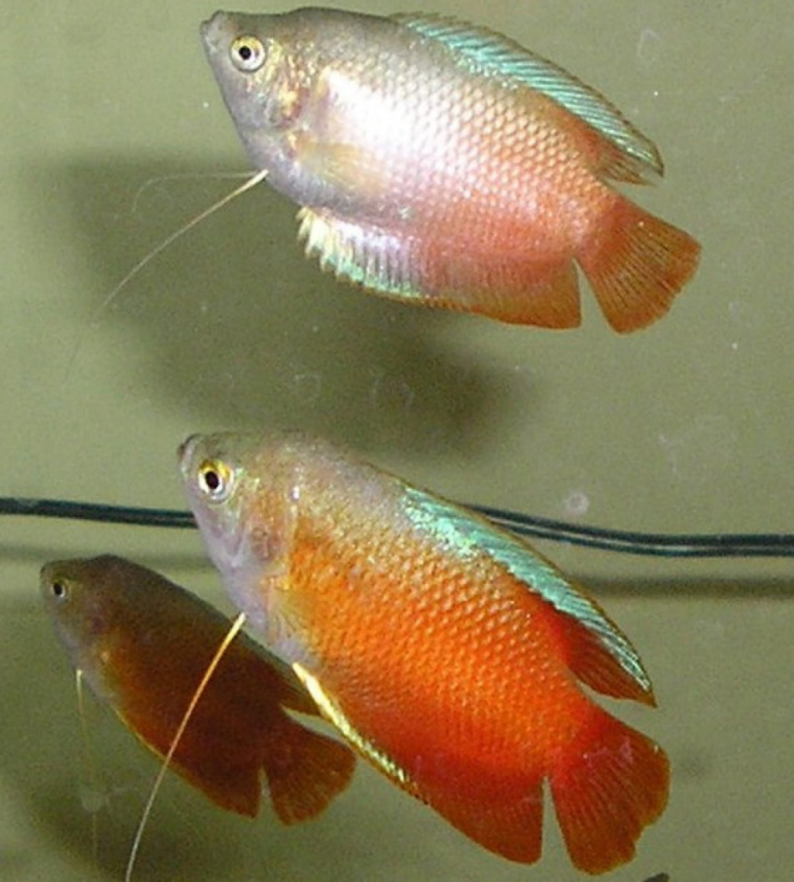
Note: Pale colouration of diseased fish (top) compared with normal colours of unaffected fish (bottom).
Source: J Go
Figure 2 Murray cod (Maccullochella peelii) fingerling experimentally infected with an ISKNV-like iridovirus
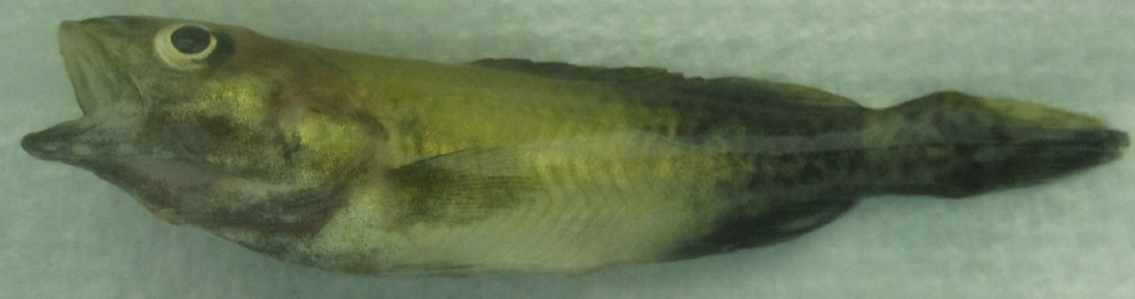
Note: Discolouration around the front of the body (normal colouration evident near the tail) and signs of respiratory distress at time of death (flared opercula).

Signs of disease
Important: Animals with this disease may show one or more of these signs, but the pathogen may still be present in the absence of any signs.
Disease signs at the farm, tank or pond level are:
- mortalities between 50% and 100%
- fish remaining on bottom of tank and not feeding well
- lethargy
- respiratory distress (rapid movement of opercula).
Gross pathological signs are:
- changes in body colour (darkening or lightening)
- exophthalmos (popeye)
- abdominal distension (due to fluid or enlargement of organs).
Microscopic pathological signs are:
- basophilic hypertrophied cells throughout numerous body tissues, but especially the haematopoietic tissues of the kidney and spleen
- some virus affected cells may resemble amoebae in appearance.

Disease agent
ISKNV-like viruses are classified in the genus Megalocytivirus, family Iridoviridae. Viruses of this group are related to ranaviruses and predominantly cause disease in freshwater fish (particularly cichlids, gouramis and poeciliids). ISKNV-like megalocytiviruses that are genetically distinct from red seabream iridovirus (listed separately in this guide) (RSIV) are also being increasingly isolated from various species of euryhaline and/or estuarine fish, particularly within the orders Perciformes and Pleuronectiformes.

ISKNV-like megalocytiviruses
ISKNV-like viruses from cichlids (all fish belonging to the family Cichlidae):
- Angelfish iridovirus
- Cichlid iridovirus (includes ram cichlid and chromide cichlid. Although currently uncharacterised, based on histopathology, cichlid iridoviruses are considered to be megalocytiviruses)
- Iridovirus in Apistogramma spp.
- Iridovirus in oscars
- Iridovirus in rainbow krib
- Iridovirus in curviceps.
ISKNV-like viruses from gouramis (fish of the subfamilies Luciocephalinae and Macropodinae, family Osphronemidae):
- Dwarf gourami iridovirus (DGIV)
- Pearl gourami iridovirus
- Iridovirus in thick-lipped gourami, three-spot gourami and silver gourami
- Iridovirus in paradise fish.
ISKNV-like viruses from poeciliids (all fish belonging to the family Poeciliidae):
- African lampeye iridovirus (all fish belonging to the subfamily Aplocheilichthyinae, family Poeciliidae)
- Swordtail iridovirus (based on histopathology, swordtail iridovirus and other iridoviruses identified in the family Poeciliidae are considered to be megalocytiviruses)
- Iridovirus in mollies and platys
- Iridovirus in guppies.
ISKNV-like viruses from euryhaline or estuarine fish:
- Iridovirus in Chinese mandarin fish
- Iridovirus in tiger grouper hybrids
- Flatfish infected with turbot reddish body iridovirus (TRBIV)
- Iridovirus in barramundi with scale drop disease syndrome.

Host range
Table 1 Species known to be susceptible to ISKNV-like viruses
Common name | Scientific name
African lampeye killifishª | Aplocheilichthys normani
Amberjack | Seriola dumerili
Angelfishª | Pterophyllum scalare
Banggai cardinalfishª | Pterapogon kauderni
Barramundiª | Lates calcarifer
Blue tilapia | Oreochromis aureus
Chinese perch or mandarin fishª | Siniperca chuatsi
Curvicepsª | Laetacara curviceps
Dwarf cichlidsª | Apistogramma spp.
Dwarf gouramiª | Trichogaster lalius
Floundersª | Paralichthyidae, all species
Giant grouper | Epinephelus lanceolatus
Golden perch | Macquaria ambigua
Grass carp | Ctenopharyngodon idella
Grouper and estuary codª | Epinephelus spp.
Guppyª | Poecilia reticulata
Japanese parrotfish | Oplegnathus fasciatus
Japanese yellowtailª | Seriola quinqueradiata
Largemouth bass | Micropterus salmoides
Large yellow croaker | Larimichthys crocea
Macquarie perch | Macquaria australasica
Malabar grouperª | Epinephelus malabaricus
Mango tilapia | Sarotherodon galilaeus
Marble gobyª | Oxyeleotris marmorata
Mollyª | Poecilia sphenops
Murray codª | Maccullochella peelii
Nile tilapiaª | Oreochromis niloticus
Orange chromideª | Etroplus maculatus
Orange spotted grouperª | Epinephelus coioides
Orbiculate batfishª | Platax orbicularis
Oscarª | Astronotus ocellatus
Paradise fishª | Macropodus opercularis
Pearl gouramiª | Trichogaster leerii
Rainbow kribª | Pelvicachromis pulcher
Ram cichlidª | Mikrogeophagus ramirezi
Red drumª | Sciaenops ocellatus
Redbelly tilapia | Coptodon zilli
Red sea breamª | Pagrus major
Sailfin molliesª | Poecilia latipinna
Sea bassª | Plectranthias yamakawai
Sea mulletª | Mugil cephalus
Silver gouramiª | Trichogaster microlepis
Snapper | Pagrus auratus
Southern platyfish or red wagtail platyª | Xiphophorus maculatus
Southern pygmy perch | Nannoperca australis
Spangled emperor | Lethrinus nebulosus
Striped beakfishª | Oplegnathus fasciatus
Swordtail or green swordtailª | Xiphophorus helleri
Thick-lipped gouramiª | Colisa labiosa
Three-spot gouramiª | Trichogaster trichopterus
Tiger grouper hybridª | Epinephelus fuscoguttatus × E. lanceolatus
Tilapias | Cichlidae, various genera and species
Tilapia hybrids | Oreochromis niloticus × O. aureus
Turbotª | Scophthalmus maximus
Zebrafish | Danio rerio
a Naturally susceptible. Note: Other species have been shown to be experimentally susceptible. Some native Australian fish species included (such as Murray cod, Maccullochella peelii) are known to be highly susceptible to ISKNV-like viruses.

Presence in Australia
Exotic disease—not recorded in Australia.
ISKNV-like viruses have not been recorded from wild fish in Australia. However, these viruses are regularly detected in ornamental fish in quarantine at the international border, and in retail pet shops.
Map 1 Presence of ISKNV-like viruses, by jurisdiction
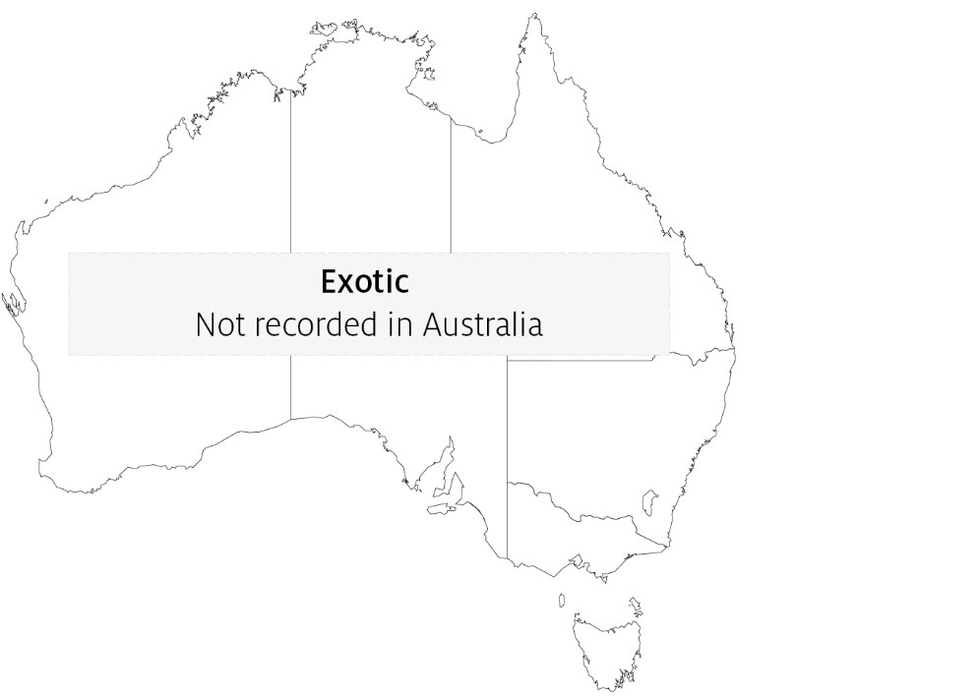

Epidemiology
- ISKNV-like viruses are prone to inactivation by desiccation or heat at temperatures above 50°C, but are stable in water at 4°C for extended periods.
- ISKNV-like viruses have been found to cause disease in a wide variety of species (may lack strict host specificity).
- Horizontal transmission via cohabitation, water, ingestion of excreta or cannibalism is likely (based on experimental transmission studies).
- There is evidence that some species may be long-term asymptomatic carriers of ISKNV-like viruses and that prevalence in infected populations may be high.

Differential diagnosis
The list of similar diseases in the next section refers only to the diseases covered by this field guide. Gross pathological signs may also be representative of diseases not included in this guide. Do not rely on gross signs to provide a definitive diagnosis. Use them as a tool to help identify the listed diseases that most closely account for the observed signs.

Similar diseases
Epizootic haematopoietic necrosis (EHN), grouper iridoviral disease and red sea bream iridoviral disease (RSIVD).

Sample collection
Only trained personnel should collect samples. Using only gross pathological signs to differentiate between diseases is not reliable, and some aquatic animal disease agents pose a risk to humans. If you are not appropriately trained, phone your state or territory hotline number and report your observations. If you have to collect samples, the agency taking your call will advise you on the appropriate course of action. Local or district fisheries or veterinary authorities may also advise on sampling.

Emergency disease hotline
See something you think is this disease? Report it. Even if you’re not sure.
Call the Emergency Animal Disease Watch Hotline on 1800 675 888. They will refer you to the right state or territory agency.

Further reading
Biosecurity Australia 2014, Importation of freshwater ornamental fish: review of biosecurity risks associated with gourami iridovirus and related viruses—provisional final import risk analysis report
Fu X, Li N, Liu L, Lin Q, Wang F, Lai Y, Jiang H, Pan H, Shi C, Wu S 2011, ‘Genotype and host range analysis of infectious spleen and kidney necrosis virus (ISKNV)’, Virus Gene

Contact details
Emergency Animal Disease Watch Hotline 1800 675 888
Email AAH@agriculture.gov.au
Website agriculture.gov.au/pests-diseases-weeds/aquatic
© Commonwealth of Australia 2020
This work is copyright. It may be reproduced in whole or in part subject to the inclusion of an acknowledgement of the source and no commercial usage or sale.

