Infection with Macrobrachium rosenbergii nodavirus (MrNV)

Also known as white tail disease and white muscle disease

From Aquatic animal diseases significant to Australia: identification field guide, 5th Department of Agriculture, Water and the Environment
Figure 1 White tail disease in giant freshwater prawn (Macrobrachium rosenbergii) postlarvae infected with MrNV
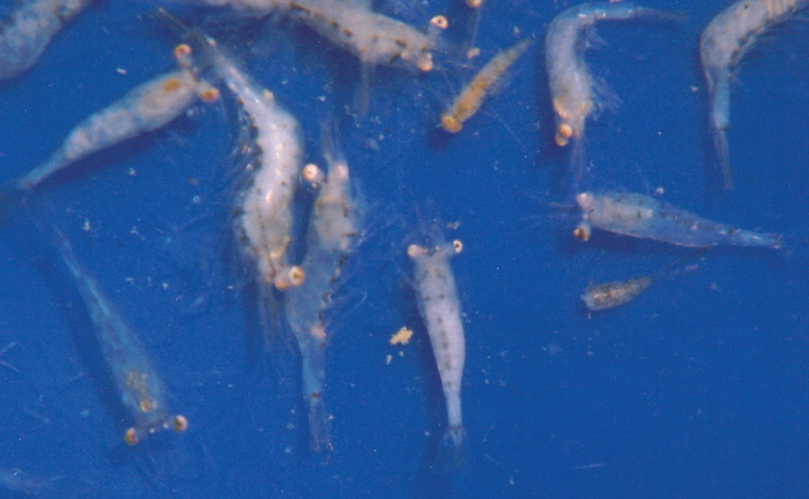
Note: Compare opaque musculature of affected prawns with the more transparent healthy prawns.
Source: AS Sahul Hameed

Signs of disease
Important: Animals with this disease may show one or more of these signs, but the pathogen may still be present in the absence of any signs.
Disease signs at the farm, tank or pond level are:
- whitish postlarvae
- lethargy
- mortality occurring 2 to 3 days after infection of the first postlarva in larval rearing tanks
- mortality of up to 95% within 5 days after the appearance of the first gross signs.
Gross pathological signs are:
- particularly milky and opaque abdomen (tail), starting at the tail extremity (telson region) and gradually progressing towards the head
- appearance in the tanks of abnormal floating moults that resemble mica flakes
- degeneration of telson and uropods (in severe cases)
- white colouration of abdominal muscle.
Microscopic pathological signs are:
- acute Zenker's necrosis of striated muscles, characterised by severe hyaline degeneration, necrosis and muscular lysis
- pathognomonic basophilic intracytoplasmic inclusion bodies in infected muscle tissues.

Disease agent
Also known as white tail disease or white muscle disease, this disease is caused by infection with Macrobrachium rosenbergii nodavirus (MrNV) and extra small virus (XSV). MrNV is a member of the family Nodaviridae. MrNV and XSV are both associated with the disease, but their respective roles are uncertain. These viruses are known to occur in fresh and brackish water.

Host range
MrNV causes disease mainly in giant freshwater prawns (Macrobrachium rosenbergii). However, several species of penaeids and red claw crayfish may be asymptomatic carriers of the virus, and Artemia and various species of aquatic insects are known vectors that can carry MrNV.
Table 1 Species known to be susceptible to infection with MrNV
Common name | Scientific name
Black tiger prawn | Penaeus monodon
Giant freshwater prawnª | Macrobrachium rosenbergii
Indian banana prawn | Penaeus (Fenneropenaeus) indicus
Kuruma prawn | Penaeus (Marsupenaeus) japonicus
Pacific white shrimp | Penaeus (Litopenaeus) vannamei
Penaeids | Various genera and species
Red claw crayfish | Cherax quadricarinatus
a Naturally susceptible. Note: Other species are known carriers or potential carriers of the virus.
Table 2 Non-decapod crustacean carriers
Common name | Scientific name
Aquatic insectsª | Various genera and species
Brine shrimp | Artemia salina
a Naturally susceptible. Note: Other species have been shown to be experimentally susceptible.

Presence in Australia
White tail disease has been officially reported in giant freshwater prawns in north Queensland.
Map 1 Presence of MrNV, by jurisdiction
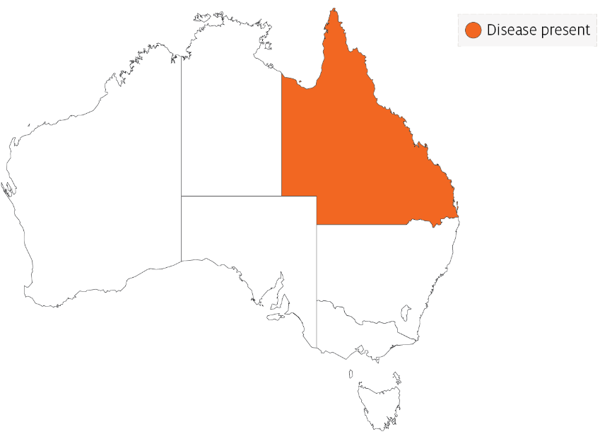

Epidemiology
- Very few postlarvae showing the clinical signs of white tail disease survive. Those that survive seem to grow normally in grow-out ponds.
- Outbreaks most commonly occur in larvae, postlarvae and early juveniles. Adult life stages are resistant and act as carriers.
- Transmission is both vertical (direct passage from parents to offspring via eggs) and horizontal (from virus present in the water surrounding susceptible prawns or direct contact with an infected prawn).
- Mortality rates are variable and reach up to 95%.
- Some penaeid shrimp, crayfish, Artemia and aquatic insects are vectors of white tail disease.

Differential diagnosis
The list of similar diseases in the next section refers only to the diseases covered by this field guide. Gross pathological signs may also be representative of diseases not included in this guide. Do not rely on gross signs to provide a definitive diagnosis. Use them as a tool to help identify the listed diseases that most closely account for the observed signs.
The clinical signs described and shown here may also be symptomatic of other bacterial or viral infections, or poor water quality. Further laboratory examination is needed for a definitive diagnosis.

Similar diseases
Infection with infectious myonecrosis virus (IMNV) and infection with shrimp haemocyte iridescent virus (SHIV).

Sample collection
Only trained personnel should collect samples. Using only gross pathological signs to differentiate between diseases is not reliable, and some aquatic animal disease agents pose a risk to humans. If you are not appropriately trained, phone your state or territory hotline number and report your observations. If you have to collect samples, the agency taking your call will advise you on the appropriate course of action. Local or district fisheries or veterinary authorities may also advise on sampling.

Emergency disease hotline
See something you think is this disease? Report it. Even if you’re not sure.
Call the Emergency Animal Disease Watch Hotline on 1800 675 888. They will refer you to the right state or territory agency.

Further reading
CABI Invasive Species Compendium White tail disease
CEFAS International Database on Aquatic Animal Diseases White tail disease
World Organisation for Animal Health Manual of diagnostic tests for aquatic animals
These hyperlinks were correct at the time of publication.

Contact details
Emergency Animal Disease Watch Hotline 1800 675 888
Email AAH@agriculture.gov.au
Website agriculture.gov.au/pests-diseases-weeds/aquatic
© Commonwealth of Australia 2020
This work is copyright. It may be reproduced in whole or in part subject to the inclusion of an acknowledgement of the source and no commercial usage or sale.

