Infection with Marteilia sydneyi

Also known as Marteiliosis and QX disease

From Aquatic animal diseases significant to Australia: identification field guide, 5th edition
Figure 1 Sydney rock oysters (Saccostrea glomerata) infected with Marteilia sydneyi
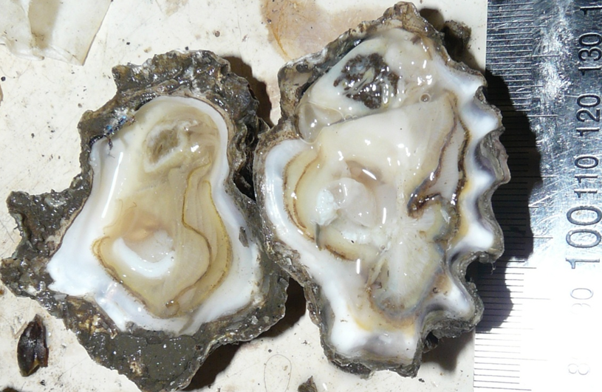
Note: Shrunken, pale yellowish, watery digestive gland typical of oyster infected with QX disease (left). Normal digestive gland of oyster is darker (right).
Source: B Diggles

Signs of disease
Important: Animals with this disease may show one or more of these signs, but the pathogen may still be present in the absence of any signs.
Disease signs at the farm, tank or pond level are:
- reduced growth rate
- gaping shells
- high cumulative mortalities of up to 100%.
Gross pathological signs are:
- shrunken, watery body
- generally poor condition
- death often within 60 days of infection
- colourless and translucent tissue because the gonad is completely resorbed
- digestive gland (usually a deep green or brown colour) becomes pale yellow or brown.
Microscopic pathological signs are:
- focal haemocytic inflammation of the gills
- hyperplasia of the connective tissue and gill epithelium, with fusion of gill filaments
- massive infection of the digestive gland tubule epithelium with sporogenic stages.

Disease agent
Marteiliosis (also known as QX disease) is caused by infection with Marteilia sydneyi. This protozoan parasite (order Paramyxida, class Ascetosporea) infects the digestive system of Sydney rock oysters and mud dwelling polychaete worms. Other closely related species of Marteilia may cause similar diseases, including M. pararefringens in oysters and mussels, M. cochillia in cockles, M. octospora in razor shells, and M. refringens in oysters, mussels, cockles and clams.

Host range
Marteilia sydneyi has an indirect life cycle. Mud-dwelling polychaetes are one known intermediate host, but there may be others.
Table 1 Species known to be naturally susceptible to infection with Marteilia sydneyi
Common name | Scientific name
Rock oyster | Saccostrea cucullata
Sydney rock oyster | Saccostrea glomerata
Polychaete | Nephtys australiensis

Presence in Australia
Infection with M. sydneyi is responsible for losses in the Sydney rock oyster industry on the east coast of Australia. The parasite and disease are present in Queensland and New South Wales. A related species of Marteilia has been detected in apparently healthy Australian flat oysters (Ostrea angasi) in New South Wales. A Marteilia sp. (probably M. sydneyi) was officially reported in 1994, associated with disease in the coral rock oyster (Saccostrea cucullata) in Western Australia.
Map 1 Presence of Marteilia sydneyi, by jurisdiction
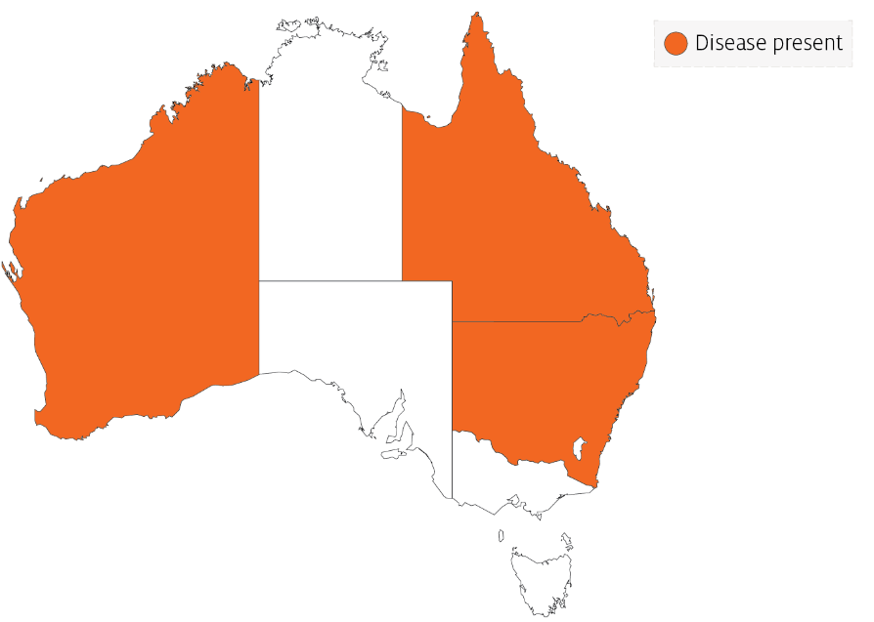

Epidemiology
- The presence of the Marteilia sydneyi in eastern Australian estuaries is not always accompanied by QX disease. Most of the estuaries that are free of QX disease have less anthropogenic disturbance in the catchment.
- Oysters may be subjected to infection for a period of as little as 2 weeks per year.
- Outbreaks of disease occur in summer and autumn. Warm temperatures favour parasite development, leading to greatest mortality at the end of summer.
- Onset of the disease is often associated with immunosuppression of oysters due to stressors such as flooding or low salinity, high water temperature and excessive sedimentation.
- Transmission is horizontal. The pathogen passes from the environment into the epithelium of the palps and gills, where it proliferates without forming spores. In advanced infections, spores are formed in the digestive gland epithelium.
- Oysters that carry low levels of M. sydneyi infections can shed the parasite and make a full recovery.
- The life cycle of M. sydneyi is indirect but not fully understood. Intermediate hosts are required to complete the life cycle. Benthic mud-dwelling polychaetes such as Nephtys australiensis are one of possibly several intermediate hosts.
- Increased virulence of M. sydneyi in degraded estuaries compared to historical times may be due to a combination of several factors. These include increased immunosuppression of the host due to declining water quality together with increased abundance of polychaete intermediate hosts that are favoured by sedimentation, eutrophication and other anthropogenic changes derived from catchment development.

Differential diagnosis
The list of similar diseases in the next section refers only to the diseases covered by this field guide. Gross pathological signs may also be representative of diseases not included in this guide. Do not rely on gross signs to provide a definitive diagnosis. Use them as a tool to help identify the listed diseases that most closely account for the observed signs.

Similar diseases
Infection with Marteilia refringens.
The clinical signs of infection with M. sydneyi are almost identical to those of infection with other Ascetosporea. These include high mortalities associated with colourless and translucent tissue, poor condition, pale digestive gland and a shrunken body. Any presumptive diagnosis requires further laboratory examination. Light microscopy can contribute diagnostic information, but further laboratory examination and molecular diagnostic techniques are required for a definitive diagnosis.

Sample collection
Only trained personnel should collect samples. Using only gross pathological signs to differentiate between diseases is not reliable, and some aquatic animal disease agents pose a risk to humans. If you are not appropriately trained, phone your state or territory hotline number and report your observations. If you have to collect samples, the agency taking your call will advise you on the appropriate course of action. Local or district fisheries or veterinary authorities may also advise on sampling.

Emergency disease hotline
See something you think is this disease? Report it. Even if you’re not sure.
Call the Emergency Animal Disease Watch Hotline on 1800 675 888. They will refer you to the right state or territory agency.

Microscope images
Figure 2 Hypothetical development of Marteilia sydneyi in Sydney rock oyster (Saccostrea glomerata)
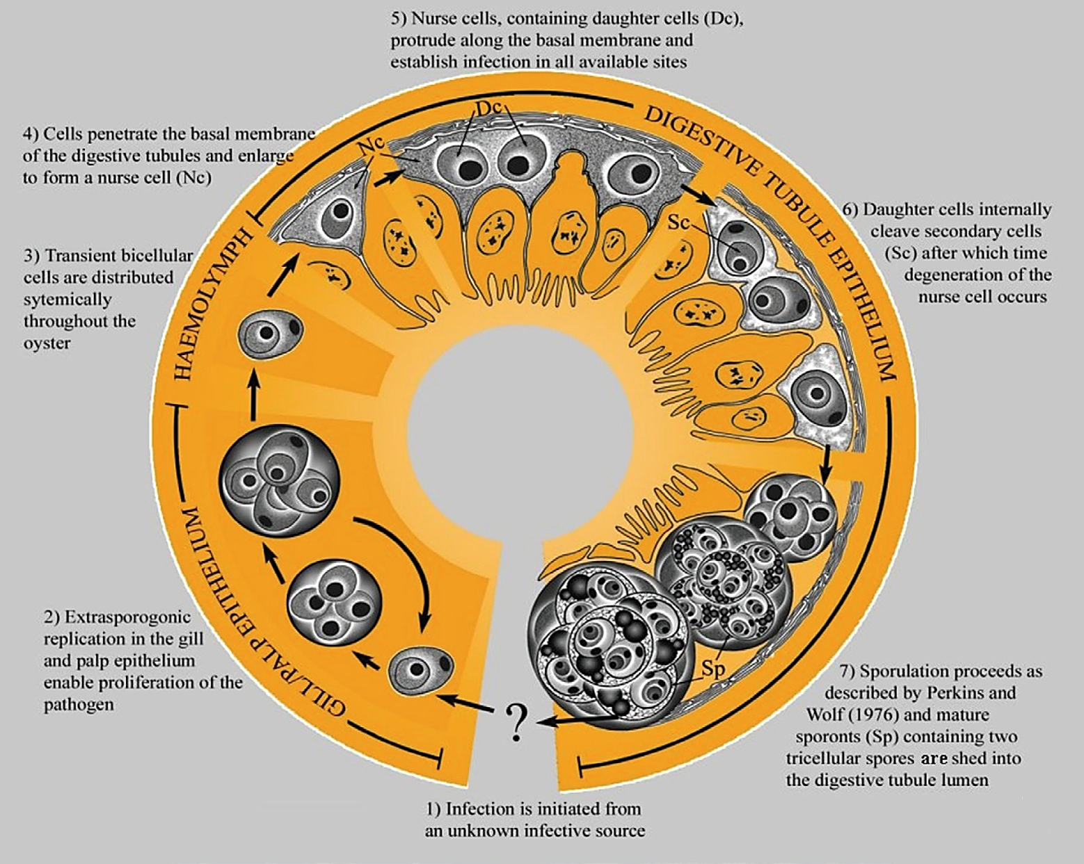
Note: Migration of M. sydneyi infective stages, from gills and palps to digestive gland tubule epithelium where sporulation occurs.
Source: S Ridgeway
Figure 3 Unstained wet smear of digestive gland of Sydney rock oyster (Saccostrea glomerata) with QX disease
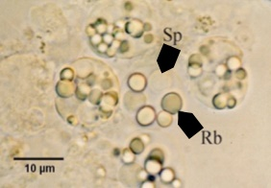
Note: M. sydneyi sporonts with refractile bodies (Rb) and spores (Sp). Scale bar = 10µm.
Source: S Ridgeway
Figure 4 Unstained wet smear of digestive gland of Sydney rock oyster (Saccostrea glomerata) showing Marteilia sydneyi sporonts viewed under interference contrast optics
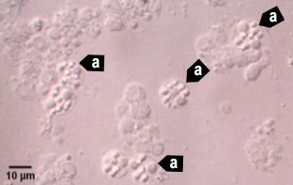
Note: Many M. sydneyi sporonts (a) visible. Scale bar = 10µm.
Source: S Ridgeway
Figure 5 Hemacolor (Merck)-stained tissue imprint of digestive gland of Sydney rock oyster (Saccostrea glomerata) infected with Marteilia sydneyi in multiple life stages
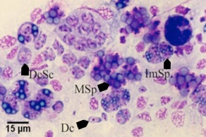
Note: Various life cycle stages, including daughter cells (Dc), daughter cells containing secondary cells (DcSc), immature sporonts (ImSp) and mature sporonts (MSp). The various stages observed are often ruptured from their enclosing cells (the nurse cells or sporangiosori).Scale bar = 15µm.
Source: S Ridgeway
Figure 6 Histopathology of gills of Sydney rock oyster (Saccostrea glomerata) infected with Marteilia sydneyi
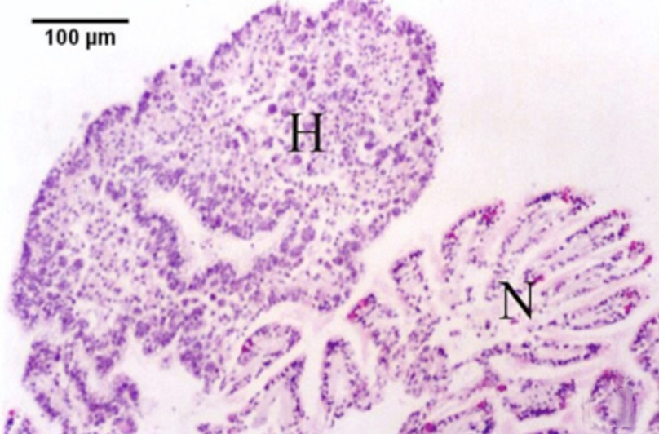
Note: Reaction of S. glomerata to the presence of numerous M. sydneyi extrasporogonic stages in the epithelium of the gills. Consisting of epithelial and connective tissue haemocytosis (H) and fusion of filaments. Contrasted with relatively normal-looking gill tissue (N). Scale bar = 100µm.
Source: S Ridgeway
Figure 7 Histopathology of palp epithelium of Sydney rock oyster (Saccostrea. glomerata) infected with Marteilia sydneyi
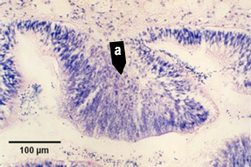
Note: Replicating stages of M. sydneyi in the palp epithelium causing hypertrophy of epithelial cells in the presence of proliferating parasites (a). Scale bar = 100µm.
Source: S Ridgeway
Figure 8 High power magnification of the epithelium of gills of Sydney rock oyster (Saccostrea glomerata)
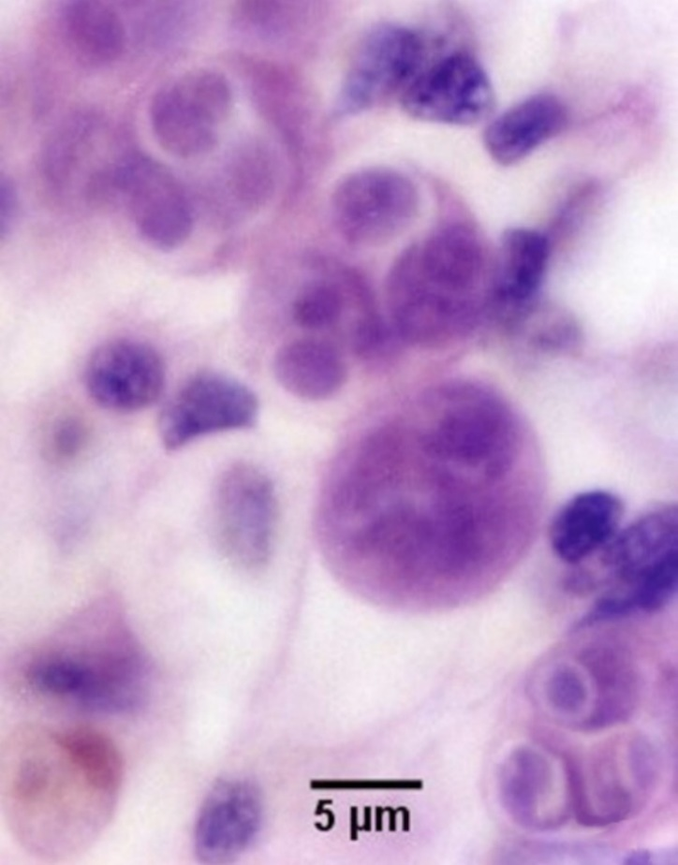
Note: Extrasporogonic stages (see phase 2 in Figure 2). Scale bar = 5µm
Source: S Ridgeway
Figure 9 Serial sections of haemocytic infiltration of connective tissue surrounding infected digestive gland tubules
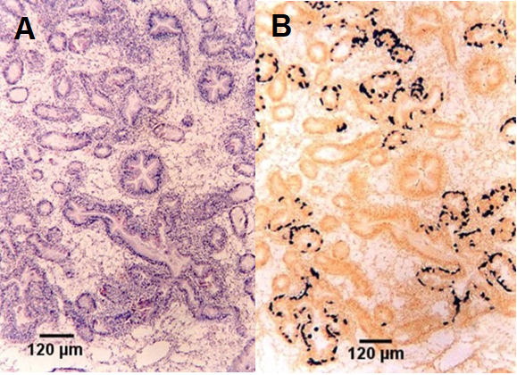
Note: Comparison of histopathological section (A) and in situ hybridisation section (B). Location of presporulating nurse cell stages in digestive gland tubule epithelia show stained black in B. Scale bar = 120µm
Source: S Ridgeway
Figure 10 Nurse cell stained black by in situ hybridisation
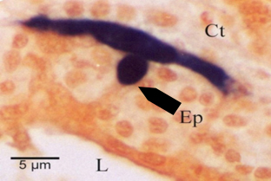
Note: Stain shows extent of the pseudopodial extensions along basal membrane of digestive tubule epithelium (Ep). This feature is not evident with haematoxylin and eosin staining. Other labelled features are connective tissue (Ct) surrounding the tubule and lumen (L) of the tubule. Scale bar = 5µm.
Source: S Ridgeway
Figure 11 Histological section of digestive gland of Sydney rock oyster (Saccostrea glomerata) with Marteilia sydneyi nurse cell
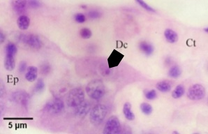
Note: Nurse cell containing one daughter cell (Dc) along basal membrane of tubule between connective tissue (Ct) surrounding the tubules and tubule epithelium (Ep). Scale bar = 5µm.
Source: S Ridgeway
Figure 12 Two photos of same tissue section at different focal planes, demonstrating budding of daughter cell
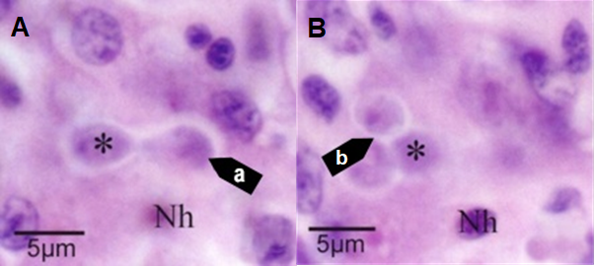
Note: The new daughter cell (a) budding within the nurse cell is visible only in one focal plane (A). Another daughter cell (asterisk), and the host cell nucleus (Nh) are visible in each figure. Two additional daughter cells (b) within the nurse cell visible only in the second focal plane (B). Scale bar = 5µm.
Source: S Ridgeway

Figure 13 Histological section of digestive gland of Sydney rock oyster (Saccostrea glomerata) with daughter cells of Marteilia sydneyi
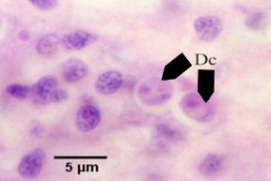
Note: Nurse cell of M. sydneyi containing 2 daughter cells (Dc) (see phase 5 in Figure 2). Scale bar = 5µm.
Source: S Ridgeway
Figure 14 Histological section of digestive gland of Sydney rock oyster (Saccostrea glomerata) with bicellular daughter cells of Marteilia sydneyi
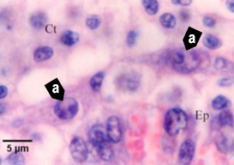
Note: Nurse cells of M. sydneyi containing bicellular daughter cells (a) along the basal membrane between tubule epithelium (Ep) and connective tissue (Ct) that contains numerous infiltrating haemocytes (see phase 6 in Figure 2). Scale bar = 5µm
Source: S Ridgeway
Figure 15 Histological section of digestive gland of Sydney rock oyster (Saccostrea glomerata) with primary and secondary cells of Marteilia sydneyi
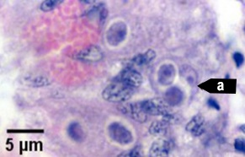
Note: Primary cell (a) containing 2 secondary cells (sporont primordia) just before sporulation (see initiation of phase 7 in Figure 2). Scale bar = 5µm.
Source: S Ridgeway
Figure 16 Histological section of digestive gland of Sydney rock oyster (Saccostrea glomerata) with Marteilia sydneyi sporulating stages
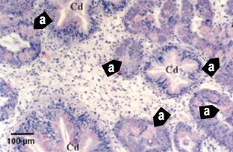
Note: Numerous sporulating stages (a) in the digestive gland tubules. Sporulation does not occur in the ciliated ducts (Cd) of the digestive gland. Scale bar = 100µm
Source: S Ridgeway
Figure 17 Histological section of digestive gland of Sydney rock oyster (Saccostrea glomerata) with Marteilia sydneyi sporonts
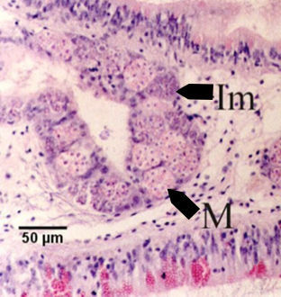
Note: Immature sporonts (Im) and mature sporonts (M) within sporangiosori in a digestive gland tubule. The epithelium of the tubule is almost completely replaced by M. sydneyi. Scale bar = 50µm.
Source: S Ridgeway

Further reading
CABI Invasive Species Compendium Infection with ‘Marteilia sydneyi’
CEFAS International Database on Aquatic Animal Diseases Marteiliosis
These hyperlinks were correct at the time of publication.

Contact details
Emergency Animal Disease Watch Hotline 1800 675 888
Email AAH@agriculture.gov.au
Website agriculture.gov.au/pests-diseases-weeds/aquatic
© Commonwealth of Australia 2020
This work is copyright. It may be reproduced in whole or in part subject to the inclusion of an acknowledgement of the source and no commercial usage or sale.

