Infection with Marteilioides chungmuensis

Also known as marteilioidosis

From Aquatic animal diseases significant to Australia: identification field guide, 5th edition
Figure 1 Pacific oyster (Crassostrea gigas) infected with Marteilioides chungmuensis
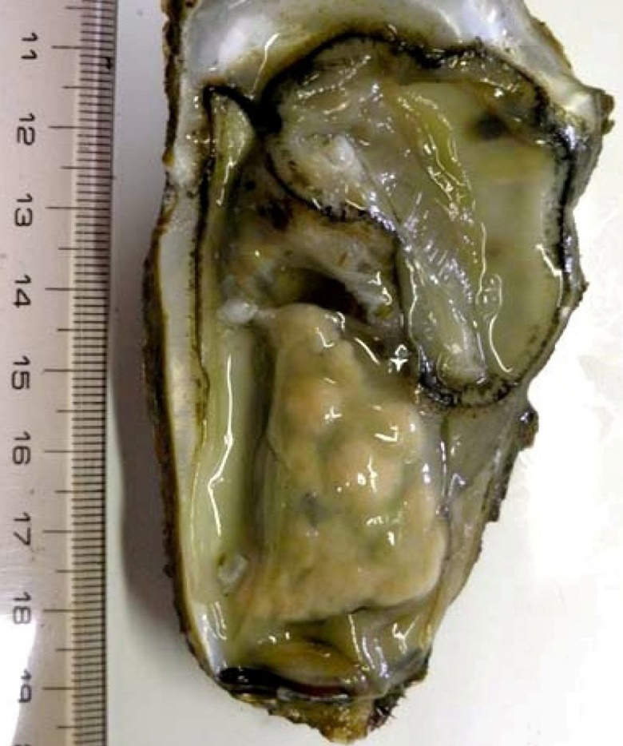
Note: Nodular yellowish lesions visible in the gonad.
Source: N Itoh

Signs of disease
Important: Animals with this disease may show one or more of these signs, but the pathogen may still be present in the absence of any signs.
Disease signs at the farm, tank or pond level are:
- spawning failure
- high mortalities.
Gross pathological signs are:
- visible distension of the mantle surface due to infected eggs retained within the follicle
- nodule-like structures on the gonad surface.
Microscopic pathological signs are:
- paramyxean parasites within oocytes.

Disease agent
Marteilioidosis is caused by infection with Marteilioides chungmuensis, a protozoan parasite (order Paramyxida, class Ascetosporea) that infects the oocytes of oysters.

Host range
Table 1 Species known to be susceptible to infection with Marteilioides chungmuensis
Common name | Scientific name
Iwagaki oyster | Crassostrea nippona
Pacific oysterª | Crassostrea gigas
a Naturally susceptible. Note: Other species have been shown to be experimentally susceptible.

Presence in Australia
Exotic disease—not recorded in Australia.
Marteilioides chungmuensis has not been recorded in Australia and is considered exotic. Other species of Marteilioides have been reported in the ovary of Saccostrea echinata from the Northern Territory and Western Australia. The related M. branchialis causes focal lesions in the gill lamellae of Sydney rock oysters in northern New South Wales.
Map 1 Presence of Marteilioides chungmuensis, by jurisdiction
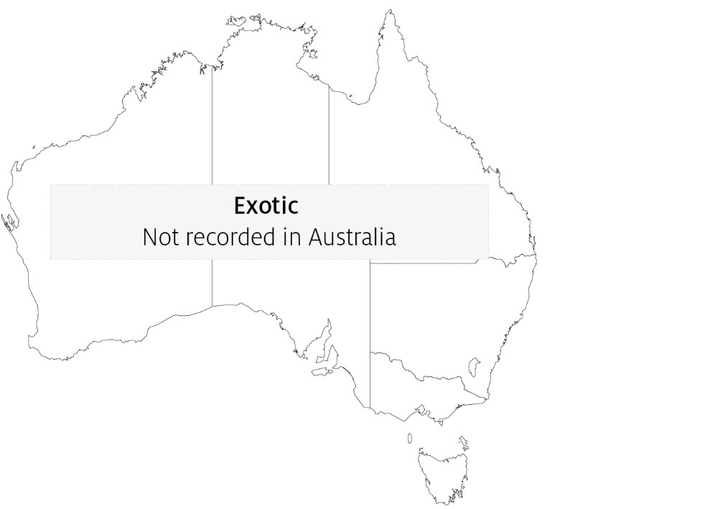

Epidemiology
- Marteilioides chungmuensis infects the cytoplasm of mature oocytes and can affect a substantial proportion of eggs.
- Prolonged spawning activity of infected oysters has been observed, resulting in nutritional wasting and mortality.
- Prevalence of infection increases during spawning in summer and decreases after spawning in winter.
- Infected oysters lose their marketability, due to their abnormal appearance.
- Mode of transmission is unknown. However, as for other paramyxeans, intermediate hosts may be involved in the life cycle of the parasite.

Differential diagnosis
The list of similar diseases in the next section refers only to the diseases covered by this field guide. Gross pathological signs may also be representative of diseases not included in this guide. Do not rely on gross signs to provide a definitive diagnosis. Use them as a tool to help identify the listed diseases that most closely account for the observed signs.

Similar diseases
No diseases listed in this field guide are similar to infection with Marteilioides chungmuensis.

Sample collection
Only trained personnel should collect samples. Using only gross pathological signs to differentiate between diseases is not reliable, and some aquatic animal disease agents pose a risk to humans. If you are not appropriately trained, phone your state or territory hotline number and report your observations. If you have to collect samples, the agency taking your call will advise you on the appropriate course of action. Local or district fisheries or veterinary authorities may also advise on sampling.

Emergency disease hotline
See something you think is this disease? Report it. Even if you’re not sure.
Call the Emergency Animal Disease Watch Hotline on 1800 675 888. They will refer you to the right state or territory agency.

Microscope images
Figure 2 Histological section of ovary of Pacific oyster (Crassostrea gigas)
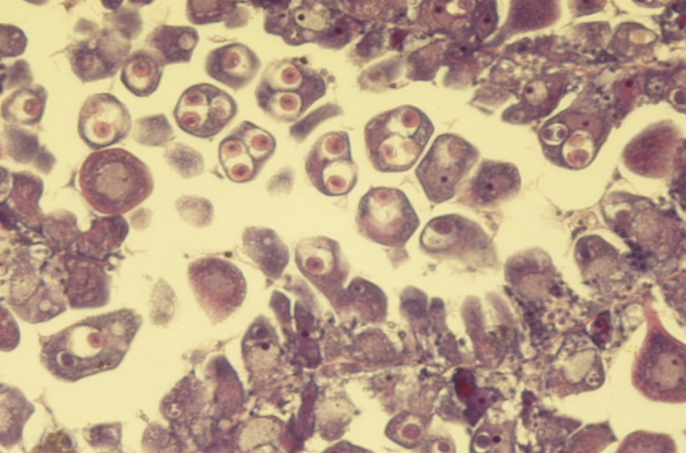
Note: Intracellular (within oocytes) Marteilioides chungmuensis parasites.
Source: N Itoh

Further reading
European Union Reference Laboratory for Molluscs Diseases ‘Marteilioides chungmuensis’
Fisheries and Oceans Canada ‘Marteilioides chungmuensis’ of oysters
These hyperlinks were correct at the time of publication.

Contact details
Emergency Animal Disease Watch Hotline 1800 675 888
Email AAH@agriculture.gov.au
Website agriculture.gov.au/pests-diseases-weeds/aquatic
© Commonwealth of Australia 2020
This work is copyright. It may be reproduced in whole or in part subject to the inclusion of an acknowledgement of the source and no commercial usage or sale.

