Infection with Mikrocytos mackini

Also known as Denman Island disease

From Aquatic animal diseases significant to Australia: identification field guide, 5th edition
Figure 1 Pacific oysters (Crassostrea gigas) removed from shell showing focal lesions characteristic of infection with Mikrocytos mackini
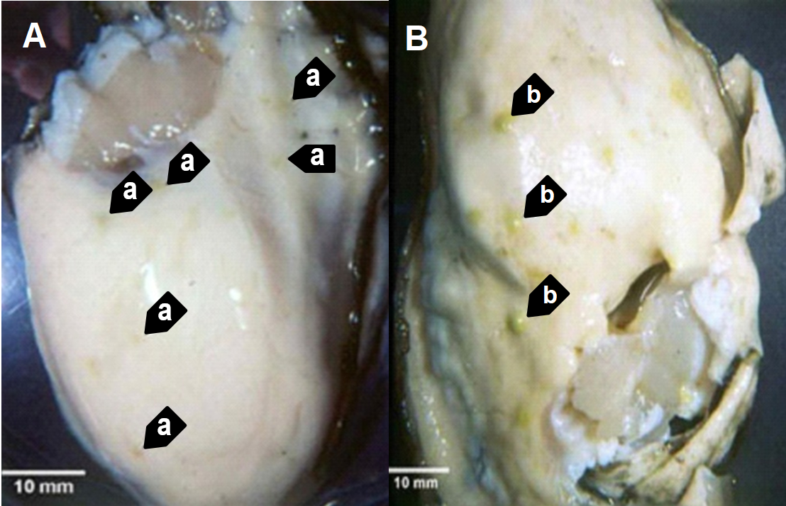
Note: Oyster (left) shows lesions (a) typical of early infections. Oyster (right) shows lesions (b) typical of advanced stages of the disease, when M. mackini typically can no longer be found in the lesions.
Source: S Bower
Figure 2 European flat oyster (Ostrea edulis) with lesions caused by infection with Mikrocytos mackini
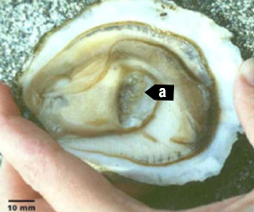
Note: Numerous lesions in the adductor muscle (a) caused by M. mackini (experimental infection).
Source: S Bower

Signs of disease
Important: Animals with this disease may show one or more of these signs, but the pathogen may still be present in the absence of any signs.
Diseases caused by any of the microcell species are similar. In cases of light infection, few or no clinical or gross signs are present. Concurrent infections with more than one species of Bonamia may also occur. Definitive identification of Bonamia or Mikrocytos species requires histological laboratory examination and molecular diagnostic techniques.
Disease signs at the farm, tank or pond level are:
- dead or gaping oysters
- increased mortality.
Gross pathological signs are:
- focal yellow or green lesions up to 5mm in diameter within the body wall or on surfaces of the gonad, labial palps, gills or mantle
- brown scars on the shell adjacent to lesions on the mantle surface
- gaping oysters due to impaired adductor muscle contraction.
Microscopic pathological signs are:
- focal intracellular infection, mainly of vesicular connective tissue (leydig) cells, resulting in haemocyte infiltration and tissue necrosis
- intracellular and extracellular microcell protozoa, 2 to 3µm in diameter, in vesicular connective tissue cells immediately adjacent to lesions.

Disease agent
Denman Island disease is caused by infection with Mikrocytos mackini, an intracellular protozoan parasite that causes lethal infection of certain species of oysters. M. mackini is classified in the order Mikrocytida within the class Ascetosporea, and is not closely related to Bonamia spp.
Mikrocytids are a highly divergent group of protists that infect a range of aquatic invertebrates including bivalve molluscs, decapod crustaceans and annelids.

Host range
Table 1 Species known to be susceptible to infection with Mikrocytos mackini
Common name | Scientific name
American eastern oysterª | Crassostrea virginica
European flat oyster | Ostrea edulis
Olympia oysterª | Ostrea lurida
Pacific oysterª | Crassostrea gigas
a Naturally susceptible. Note: Other species have been shown to be experimentally susceptible.

Presence in Australia
Exotic disease—not recorded in Australia.
Map 1 Presence of Mikrocytos mackini, by jurisdiction
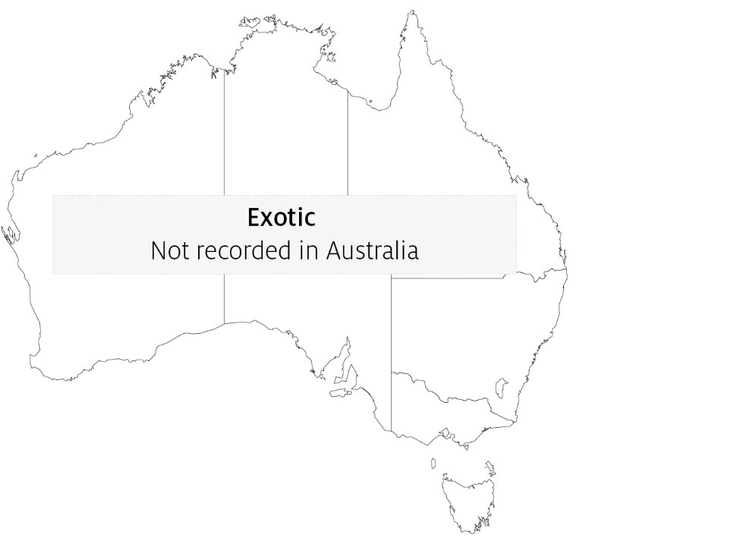

Epidemiology
- Severe infections appear to be restricted to oysters over 2 years old.
- The disease is associated with low temperature and high salinity. Most mortalities occur during April to May (spring in the Northern Hemisphere). There is a 3 to 4 month pre-patent period when temperatures are less than 10°C.
- The Pacific oyster appears to be more resistant to the disease than other species challenged experimentally under laboratory and field conditions.

Differential diagnosis
The list of similar diseases in the next section refers only to the diseases covered by this field guide. Gross pathological signs may also be representative of diseases not included in this guide. Do not rely on gross signs to provide a definitive diagnosis. Use them as a tool to help identify the listed diseases that most closely account for the observed signs.

Similar diseases
Infection with Bonamia ostreae, infection with Bonamia exitiosa and infection with Bonamia spp.
There are few or no visual cues to the presence of this disease other than poor condition, shell gaping and increased mortality. Consequently, it is impossible to use gross signs alone to differentiate between infection by M. mackini and Bonamia species. Any presumptive diagnosis requires further laboratory examination.
Light microscopy can contribute diagnostic information, but further laboratory examination and molecular diagnostic techniques are required for a definitive diagnosis.

Sample collection
Only trained personnel should collect samples. Using only gross pathological signs to differentiate between diseases is not reliable, and some aquatic animal disease agents pose a risk to humans. If you are not appropriately trained, phone your state or territory hotline number and report your observations. If you have to collect samples, the agency taking your call will advise you on the appropriate course of action. Local or district fisheries or veterinary authorities may also advise on sampling.

Emergency disease hotline
See something you think is this disease? Report it. Even if you’re not sure.
Call the Emergency Animal Disease Watch Hotline on 1800 675 888. They will refer you to the right state or territory agency.

Microscope images
Figure 3 Proposed developmental cycle of Mikrocytos mackini
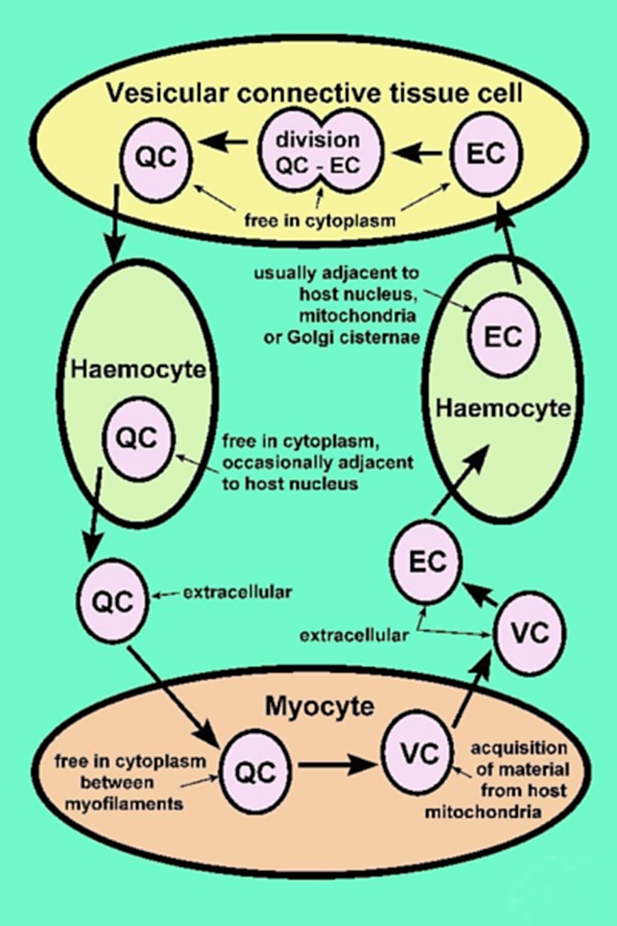
Note: Host cell type and host organelle affiliation for the three recognised morphological forms: quiescent cell (QC), vesicular cell (VC) and endosomal cell (EC).
Source: S Bower
Figure 4 Section through lesion caused by Mikrocytos mackini in the mantle of Pacific oyster (Crassostrea gigas)
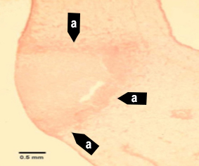
Note: The intracellular protozoan (not visible at this magnification) usually occurs in the intact vesicular connective tissue cells immediately surrounding the periphery of the lesion (a). Haematoxylin and eosin stain. Scale bar = 500µm.
Source: S Bower
Figure 5 Section through lesion in the vesicular connective tissue of Pacific oyster (Crassostrea gigas)
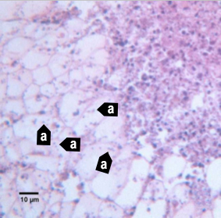
Note: Many Mikrocytos mackini (a) within vesicular connective tissue (leydig) cells next to a lesion characterised by an accumulation of haemocytes and necrotic cells. Haematoxylin and eosin stain. Scale bar = 10µm.
Source: S Bower
Figure 6 Oil immersion magnification of Mikrocytos mackini within the cytoplasm of vesicular connective tissue cells of Pacific oyster (Crassostrea gigas)
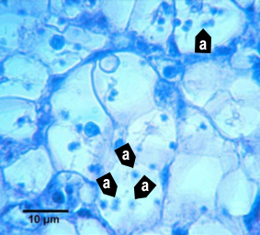
Note: Because of the small size of this parasite, it is very difficult to visualise and photograph in histological preparations. Haematoxylin and eosin stain. Scale bar = 10µm.
Source: S Bower
Figure 7 Mikrocytos mackini within fibres of adductor muscle of Pacific oyster (Crassostrea gigas)
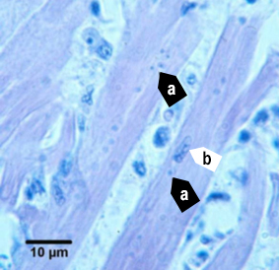
Note: Several M. mackini microcells (a) are located close to the nucleus (b) of a muscle cell. Haematoxylin and eosin stain. Scale bar = 10µm.
Source: S Bower
Figure 8 Electron micrograph of vesicular connective tissue cell from Pacific oyster (Crassostrea gigas)
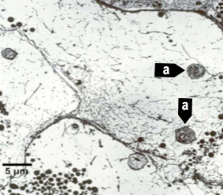
Note: Two M. mackini (a) in the cytoplasm of the cell. Uranyl acetate and lead citrate stain. Scale bar = 5µm.
Source: S Bower
Figure 9 Electron micrograph of two Mikrocytos mackini microcells
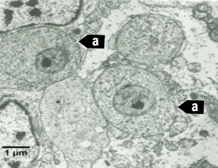
Note: Two M. mackini microcells (a) each containing a nucleus with a pronounced nucleolus and lacking mitochondria. Uranyl acetate and lead citrate stain. Scale bar = 1µm.
Source: S Bower

Further reading
CABI Invasive Species Compendium ‘Mikrocytos mackini’
CEFAS International Database on Aquatic Animal Diseases Infection with ‘Mikrocytos mackini’
European Union Reference Laboratory for Molluscs Diseases ‘Mikrocytos mackini’
World Organisation for Animal Health Manual of diagnostic tests for aquatic animals
These hyperlinks were correct at the time of publication.

Contact details
Emergency Animal Disease Watch Hotline 1800 675 888
Email AAH@agriculture.gov.au
Website agriculture.gov.au/pests-diseases-weeds/aquatic
© Commonwealth of Australia 2020
This work is copyright. It may be reproduced in whole or in part subject to the inclusion of an acknowledgement of the source and no commercial usage or sale.

