Infection with ostreid herpesvirus-1 microvariant (OsHV-1 µvar)

Also known as Pacific oyster mortality syndrome (POMS)

From Aquatic animal diseases significant to Australia: identification field guide, 5th edition
Figure 1 Juvenile Pacific oysters (Crassostrea gigas) infected with OsHV-1 μvar
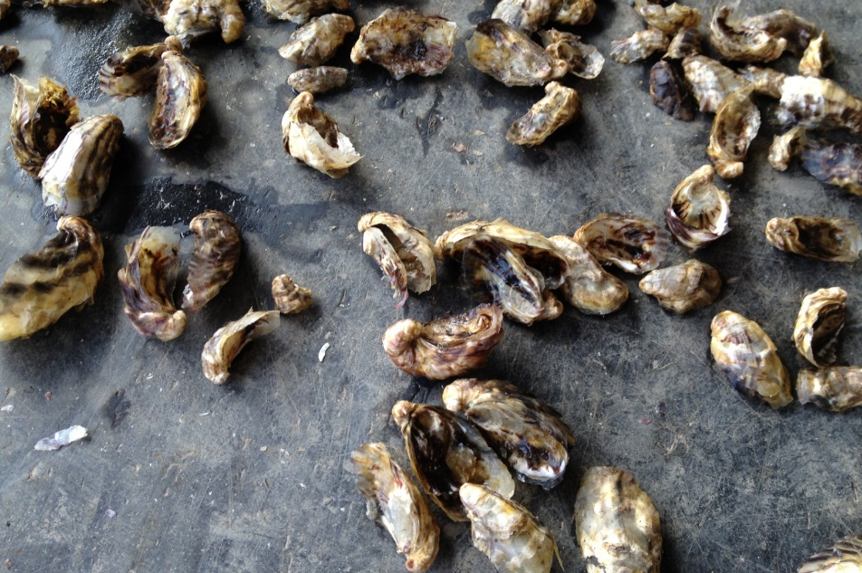
Note: Large number of dead juvenile oysters resulting from mass mortality due to infection with OsHV-1 μvar.
Source: The University of Sydney

Signs of disease
Important: Animals with this disease may show one or more of these signs, but the pathogen may still be present in the absence of any signs.
Disease signs at the farm, tank or pond level are:
- rapid and high cumulative mortalities in Pacific oysters, approaching 100% within 8 to 10 days of infection.
Gross pathological signs are:
- cessation of feeding and swimming by larvae, which exhibit velar lesions
- gaping in adults
- pale digestive gland in spat and older oysters.
Microscopic pathological signs are:
- ulcerative and erosive lesions in the connective tissue of mantle, gills, labial palps and digestive tissue
- nuclear hypertrophy, nuclear chromatin margination and pyknosis
- inflammatory changes ranging from mild and localised, to severe and extensive.

Disease agent
POMS is caused by infection with a microvariant genotype of ostreid herpesvirus-1 (OsHV-1 µvar).The virus is the only member of the genus Ostreavirus (family Malacoherpesviridae, order Herpesvirales).

Host range
Pacific oysters and Portuguese oysters are known to be susceptible to infection with OsHV-1 µvar. Multiple bivalve species (cupped oysters, flat oysters, clams, scallops) are known to be susceptible to other genotypes of OsHV-1. Several of these may also act as carriers and reservoirs for the microvariant strains.
Table 1 Species known to be susceptible to infection with OsHV-1 µvar
Common name | Scientific name
Blue mussel | Mytilus edulis
Hairy mussels | Trichomya hirsuta
Mediterranean mussel | Mytilus galloprovincialis
Pacific oysterª | Crassostrea gigas
Portuguese oysterª | Crassostrea angulata
Sydney cockle or mud arc | Anadara trapezia
Sydney rock oyster | Saccostrea glomerata
a Naturally susceptible. Note: Other species have been shown to be potential reservoir hosts.
Table 2 Non-bivalve carriers
Common name | Scientific name
Barnacles | Balanus spp.
Mud whelks | Pyrazus spp., Batillaria spp.

Presence in Australia
Outbreaks of POMS due to infection with OsHV-1 μvar have been officially reported from oyster growing areas in several regions of New South Wales and Tasmania. Pacific oysters infected with OsHV-1 μvar have also been reported from wild Pacific oysters in Port Adelaide in South Australia.
Map 1 Presence of OsHV-1 μvar, by jurisdiction
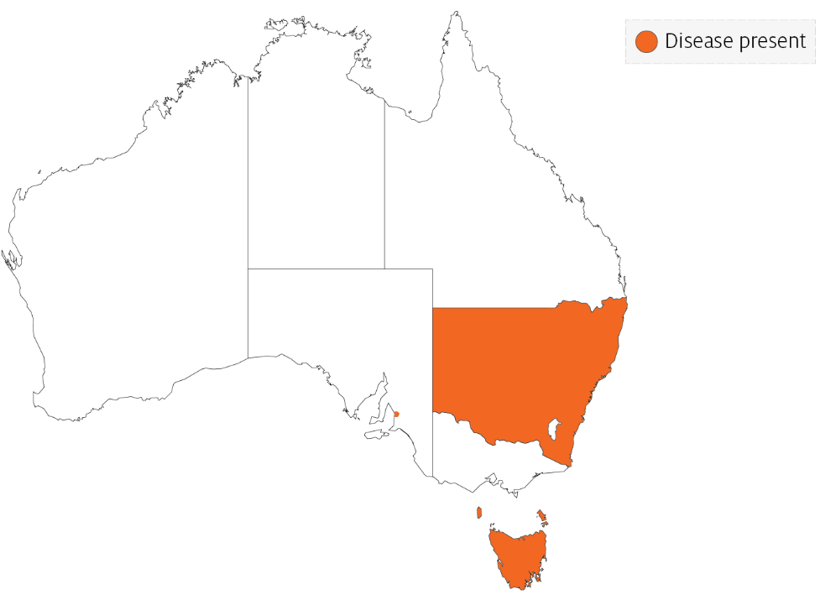

Epidemiology
- The disease can affect all age groups of susceptible oysters. There may be higher mortality in the younger life stages.
- Higher mortality appears to be associated with higher water temperature and crowding.
- Infected adult oysters may be a source of infection for larvae or spat. However, it is not certain if true vertical transmission occurs. Horizontal transmission has been demonstrated.
- Some adult Crassostrea gigas may survive with subclinical OsHV-1 infections, and act as carriers of the virus.
- The introduction of OsHV-1 µvar into new areas is thought to be due to introduction of infected hosts or carriers in biofouling on shipping, often followed by human movements of subclinically infected oysters.
- Water filtration reduces risk of disease entry into hatcheries, suggesting spread of the disease within a water body may be due to movements of infected oyster larvae or free virus adhered to plankton or other particles.

Differential diagnosis
The list of similar diseases in the next section refers only to the diseases covered by this field guide. Gross pathological signs may also be representative of diseases not included in this guide. Do not rely on gross signs to provide a definitive diagnosis. Use them as a tool to help identify the listed diseases that most closely account for the observed signs.

Similar diseases
Iridoviroses.

Sample collection
Only trained personnel should collect samples. Using only gross pathological signs to differentiate between diseases is not reliable, and some aquatic animal disease agents pose a risk to humans. If you are not appropriately trained, phone your state or territory hotline number and report your observations. If you have to collect samples, the agency taking your call will advise you on the appropriate course of action. Local or district fisheries or veterinary authorities may also advise on sampling.

Emergency disease hotline
See something you think is this disease? Report it. Even if you’re not sure.
Call the Emergency Animal Disease Watch Hotline on 1800 675 888. They will refer you to the right state or territory agency.

Microscope images
Figure 2 Histological section of a Pacific oyster (Crassostrea gigas) infected with OsHV-1 μvar
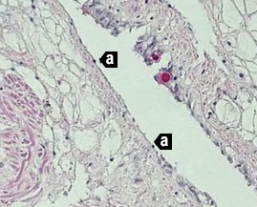
Note: High viral load causing multifocal to coalescing ulceration with attenuation of epithelium and pyknotic nuclei (a). 20x magnification.
Source: M Gabor
Figure 3 In-situ hybridisation of gill of Pacific oyster (Crassostrea gigas) infected with OsHV-1 µvar
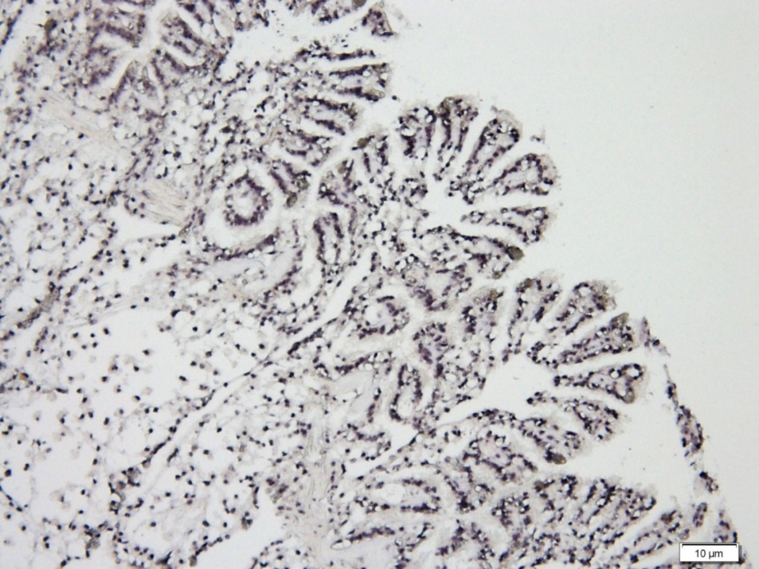
Note: Massive infection of epithelia and connective tissues (black staining). Scale bar 10µm.
Source: C Jenkins
Figure 4 In-situ hybridisation of gonad of Pacific oyster (Crassostrea gigas) infected with OsHV-1 µvar
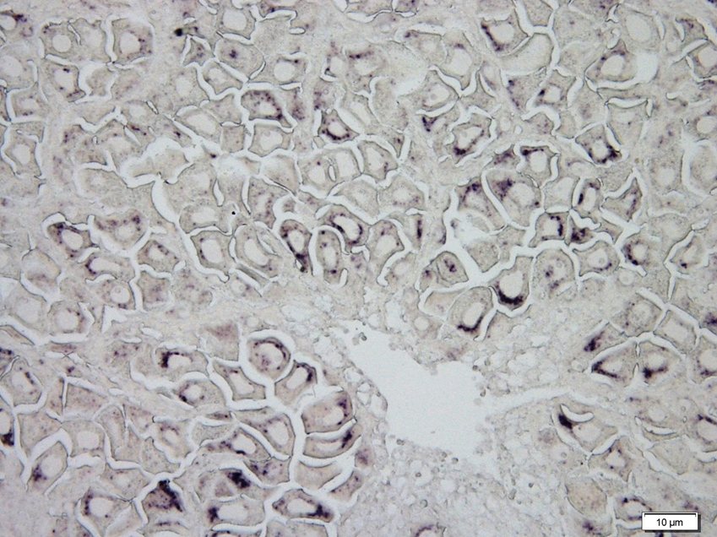
Note: Viral infection (black staining) in many eggs. Scale bar 10µm.
Source: C Jenkins

Further reading
CEFAS International Database on Aquatic Animal Diseases Infection with ostreid herpesvirus 1 microvariant
Department of Agriculture, Water and the Environment AQUAVETPLAN disease strategy manual: Ostreid herpesvirus 1 microvariant
World Organisation for Animal Health Manual of diagnostic tests for aquatic animals
These hyperlinks were correct at the time of publication.

Contact details
Emergency Animal Disease Watch Hotline 1800 675 888
Email AAH@agriculture.gov.au
Website agriculture.gov.au/pests-diseases-weeds/aquatic
© Commonwealth of Australia 2020
This work is copyright. It may be reproduced in whole or in part subject to the inclusion of an acknowledgement of the source and no commercial usage or sale.

