Infection with Perkinsus marinus

Also known as perkinsosis and dermo disease

From Aquatic animal diseases significant to Australia: identification field guide, 5th edition
Figure 1 American oyster (Crassostrea virginica) showing gross signs of infection with Perkinsus marinus
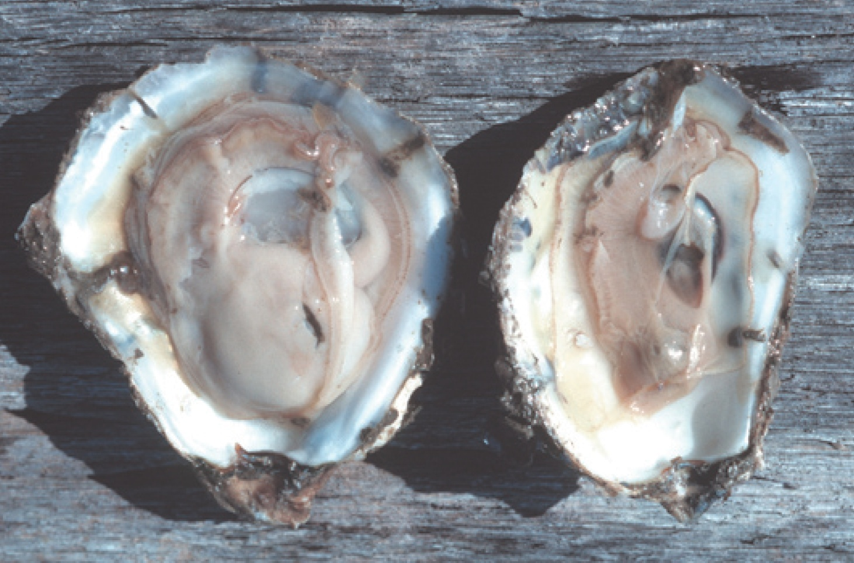
Note: A healthy oyster (left). The infected oyster (right) is thin and watery, typical gross signs of infection with P. marinus.
Source: E Burreson

Signs of disease
Important: Animals with this disease may show one or more of these signs, but the pathogen may still be present in the absence of any signs.
Disease signs at the farm, tank or pond level are:
- gaping
- retarded growth
- poor condition or emaciation
- increased mortality.
Gross pathological signs are:
- shrinkage of mantle away from the outer edge of the shell
- occasional lesions in soft tissue
- pale digestive gland
- thin, watery tissue.
Microscopic pathological signs are:
- large, multifocal lesions in the gut epithelium or connective tissue of organs containing P. marinus cells
- haemocyte infiltration and phagocytosis of P. marinus cells
- destruction of the gut epithelium.

Disease agent
Perkinsosis (or dermo disease) is caused by infection with Perkinsus marinus, an alveolate protest in the family Perkinsidae. P. marinus has been placed nominally in the order Dinoflagellida, but its higher taxonomy is subject to scientific debate. Several other species of the genus Perkinsus infect molluscs such as oysters, mussels, clams and abalone worldwide.

Host range
Table 1 Species known to be susceptible to infection with Perkinsus marinus
Common name | Scientific name
American eastern oysterª | Crassostrea virginica
Baltic macoma | Macoma balthica
Blue mussel | Mytilus edulis
Cortez oysterª | Crassostrea corteziensis
Mangrove oysterª | Crassostrea rhizophorae
Pacific oysterª | Crassostrea gigas
Soft shelled clam | Mya arenaria
Suminoe oysterª | Crassostrea ariakensis
a Naturally susceptible. Note: Other species have been shown to be experimentally susceptible.

Presence in Australia
Exotic disease—not recorded in Australia.
Map 1 Presence of Perkinsus marinus, by jurisdiction
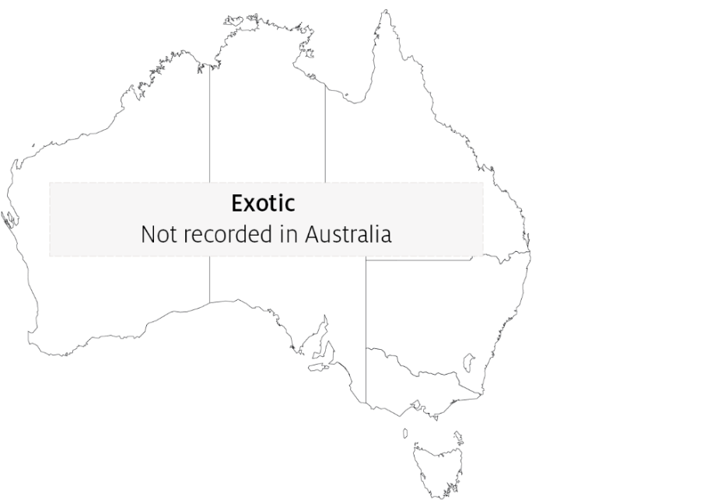

Epidemiology
- Water temperatures above 20°C encourage proliferation of the parasite. This results in systemic disruption of connective tissue and epithelial cells and leads to high mortalities.
- Reduced salinity levels (below 9ppt) can prevent clinical disease resulting from P. marinus infection, even in warm water (above 20°C).
- Cumulative American oyster mortalities of up to 95% have been observed in the first summer following transfer of naïve stock to an area where the disease is known to be present.
- Transmission is horizontal.
- Infection levels increase during spawning and under the stress of oxygen depletion.
- Prevalence and intensity of infection are greatest in oysters more than 1 year old and at depths greater than 90cm.
- Exposure to pollutants will increase the prevalence of infection.

Differential diagnosis
The list of similar diseases in the next section refers only to the diseases covered by this field guide. Gross pathological signs may also be representative of diseases not included in this guide. Do not rely on gross signs to provide a definitive diagnosis. Use them as a tool to help identify the listed diseases that most closely account for the observed signs.

Similar diseases
Infection with Perkinsus olseni.
The clinical signs of infection with P. marinus are similar to those of infection with other species of Perkinsus. These include occasional pustules in soft tissue, pale digestive gland, poor condition, emaciation, shrinkage of mantle and retarded growth. It is therefore difficult to make a presumptive diagnosis based on gross signs alone. Any presumptive diagnosis requires further laboratory examination.

Sample collection
Only trained personnel should collect samples. Using only gross pathological signs to differentiate between diseases is not reliable, and some aquatic animal disease agents pose a risk to humans. If you are not appropriately trained, phone your state or territory hotline number and report your observations. If you have to collect samples, the agency taking your call will advise you on the appropriate course of action. Local or district fisheries or veterinary authorities may also advise on sampling.

Emergency disease hotline
See something you think is this disease? Report it. Even if you’re not sure.
Call the Emergency Animal Disease Watch Hotline on 1800 675 888. They will refer you to the right state or territory agency.

Microscope images
Figure 2 Histopathology of American oyster (Crassostrea virginica) infected with Perkinsus marinus
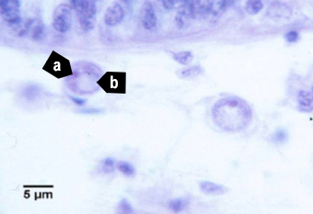
Note: Trophozoite of P. marinus with nucleus (a) and distinctive eccentric vacuole (b). Scale bar = 5µm.
Source: E Burreson
Figure 3 Histopathology of American oyster (Crassostrea virginica) infected with Perkinsus marinus
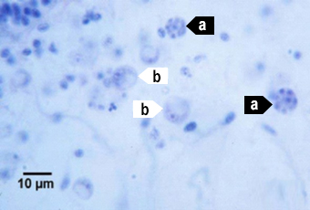
Note: P. marinus 16-cell tomont (a) stages containing immature trophozoites. Maturing trophozoites (b) are also visible. Scale bar = 10µm.
Source: E Burreson
Figure 4 Histopathology of American oyster (Crassostrea virginica) infected with Perkinsus marinus
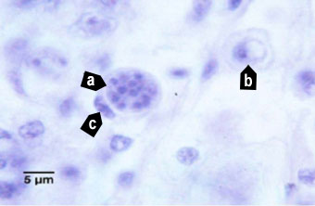
Note: A 16-cell tomont (a) of P. marinus containing developing trophozoites. This tomont is contained within a haemocyte (c indicates the nucleus of the phagocytic cell). A maturing trophozoite (b) is nearby. Scale bar = 5µm.
Source: E Burreson

Further reading
CABI Invasive Species Compendium Infection with ‘Perkinsus marinus’
CEFAS International Database on Aquatic Animal Diseases Infection with ‘Perkinsus marinus’
World Organisation for Animal Health Manual of diagnostic tests for aquatic animals
These hyperlinks were correct at the time of publication.

Contact details
Emergency Animal Disease Watch Hotline 1800 675 888
Email AAH@agriculture.gov.au
Website agriculture.gov.au/pests-diseases-weeds/aquatic
© Commonwealth of Australia 2020
This work is copyright. It may be reproduced in whole or in part subject to the inclusion of an acknowledgement of the source and no commercial usage or sale.

