Infection with Perkinsus olseni

Also known as perkinsosis and Perkinsus disease

From Aquatic animal diseases significant to Australia: identification field guide, 5th edition
Figure 1 Cross-section of foot of greenlip abalone (Haliotis laevigata) infected with Perkinsus olseni
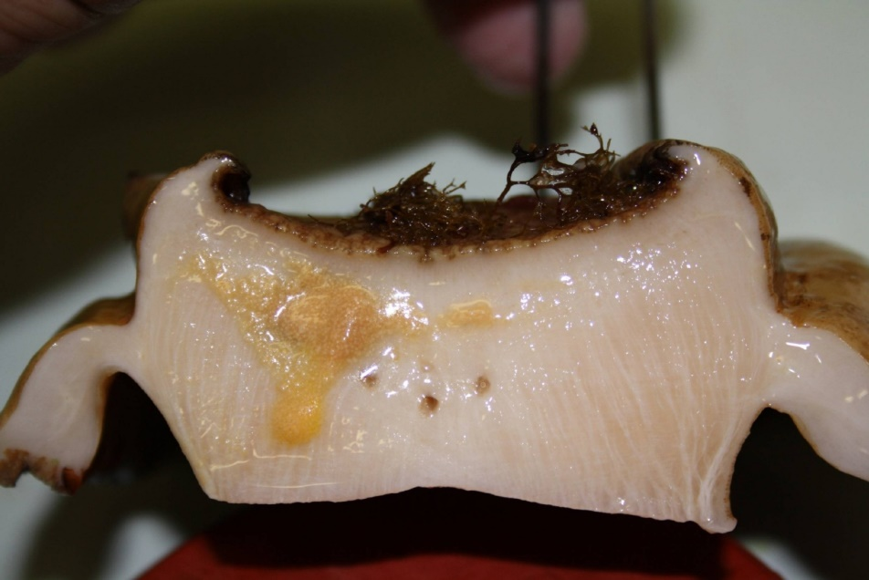
Note: Yellow and smaller brown pustular lesions within the body tissue infected with P. olseni.
Source: N Moody, CSIRO Australian Animal Health Laboratory

Signs of disease
Important: Animals with this disease may show one or more of these signs, but the pathogen may still be present in the absence of any signs.
Disease signs at the farm, tank or pond level are:
- morbidity observed in cultured greenlip (Haliotis laevigata) and blacklip (H. rubra) abalone
- gaping in bivalve species
- increased mortality.
Gross pathological signs are:
- spherical brown abscesses up to 8mm in diameter containing a caseous creamy-brown or yellow deposit in the foot and mantle of blacklip and greenlip abalone (affecting marketability)
- thin, watery tissue with a pale digestive gland
- nodules in the mantle or gills.
Microscopic pathological signs are:
- large focal or multifocal necrotic lesions in connective tissue. These contain haemocyte aggregations around individuals or groups of crescent- or signet-ring-shaped Perkinsus cells with eccentric vacuoles.

Disease agent
Perkinsosis is caused by infection with Perkinsus spp., alveolate protists in the family Perkinsidae. P. olseni has been placed nominally in the order Dinoflagellida, but its higher taxonomy is subject to scientific debate. Several species of the genus Perkinsus infect molluscs such as oysters, mussels, clams and abalone worldwide.
Perkinsus olseni is the main species known to cause this disease in the Asia–Pacific region and is responsible for perkinsosis in abalone, clams and pearl oysters in Australia. P. atlanticus is a junior synonym of P. olseni. Another species, P. chesapeaki, has been detected in wild mud arks (Anadara trapezia) in Moreton Bay, Queensland.

Host range
P. olseni appears to have low host specificity and can infect a wide range of bivalve and gastropod molluscs.
Table 1 Species known to be susceptible to infection with Perkinsus olseni
Common name | Scientific name
Akoya pearl oysterª | Pinctada martensii
Asian littleneck clamª | Venerupis philippinarum
Blacklip abaloneª | Haliotis rubra
Blacklip pearl oysterª | Pinctada margaritifera
Crocus clamª | Tridacna crocea
Elongated giant clam or rugose giant clamª | Tridacna maxima
European aurora venus clamª | Venerupis aurea
Giant clamª | Tridacna gigas
Greenlip abaloneª | Haliotis laevigata
Green-lipped musselª | Perna canaliculus
Grooved carpet shell or venerid clamª | Ruditapes decussatus
Japanese pearl oysterª | Pinctada fucata
Kumamoto oyster | Crassostrea sikamea
Manila clamª | Ruditapes (Venerupis) philippinarum
New Zealand ark shellª | Barbatia novaezelandiae
New Zealand cockleª | Austrovenus stutchburyi
New Zealand pauaª | Haliotis iris
New Zealand pipiª | Paphies australis
New Zealand scallopª | Pecten novaezelandiae
Pacific oysterª | Crassostrea gigas
Pearl oysterª | Pinctada sugillata
Pullet carpet shellª | Venerupis corrugata
Sand cockle | Katelysia rhytiphora
Silverlip pearl oysterª | Pinctada maxima
Southern mud oyster or Australian flat oysterª | Ostrea angasi
Staircase abaloneª | Haliotis scalaris
Suminoe oysterª | Crassostrea ariakensis
Sydney cockle or mud arkª | Anadara trapezia
Venerid clamª | Ruditapes semidecussatus
Venerid commercial clamª | Pitar prostrata
Venus clam | Protothaca jedoensis
Wedge shell | Macomona liliana
Whirling abaloneª | Haliotis cyclobates
a Naturally susceptible. Note: Other species have been shown to be experimentally susceptible.

Presence in Australia
Perkinsus olseni has been reported in Queensland, New South Wales, South Australia and Western Australia; and in Australian flat oysters from Victoria. P. olseni was originally described from wild abalone in South Australia, but has since been detected in a wide variety of molluscs, including clams and pearl oysters.
Map 1 Presence of Perkinsus olseni, by jurisdiction
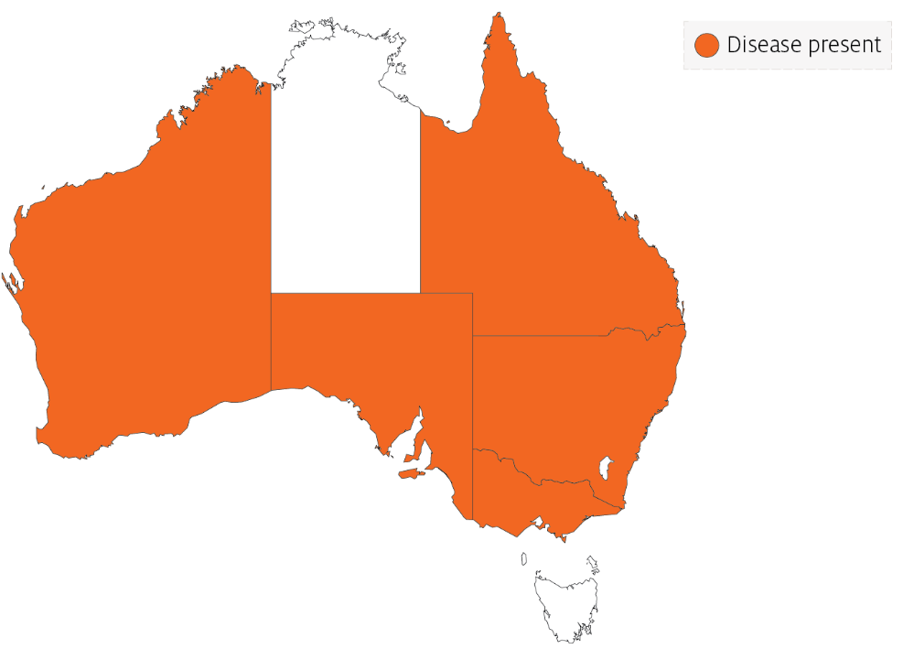

Epidemiology
- Perkinsus olseni has been associated with mass mortality of Haliotis spp. (blacklip and greenlip abalone) in the Gulf of St Vincent, South Australia, and coastal New South Wales (mostly blacklip abalone).
- Horizontal transmission occurs directly from host to host. Some environmental conditions (temperature and salinity) can promote a lifelong carrier state. Higher water temperatures (greater than 20°C) can cause disease and mortalities in temperate species such as abalone.
- Infection intensity increases with the age of the host.
- Prezoosporangia that escape from necrotic pustules or decaying dead abalone undergo further development to zoosporangia in seawater.
- Within 9 days at 20°C and 3 days at 28°C, hundreds of motile, biflagellated zoospores (about 3µm by 5µm) exit from the zoosporangium. The zoospores are infective to abalone and other molluscs.
- P. olseni can survive in salt water for several weeks at –20°C. However, the parasite cannot survive below 15ppt salinity.

Differential diagnosis
The list of similar diseases in the next section refers only to the diseases covered by this field guide. Gross pathological signs may also be representative of diseases not included in this guide. Do not rely on gross signs to provide a definitive diagnosis. Use them as a tool to help identify the listed diseases that most closely account for the observed signs.

Similar diseases
Infection with Perkinsus marinus.
The clinical signs of infection with P. olseni are similar to those of infection with other species of Perkinsus. These include occasional pustules in soft tissue, pale digestive gland, poor condition, emaciation, shrinkage of mantle and retarded growth. It is therefore difficult to make a presumptive diagnosis based on gross signs alone. Any presumptive diagnosis requires further laboratory examination.

Sample collection
Only trained personnel should collect samples. Using only gross pathological signs to differentiate between diseases is not reliable, and some aquatic animal disease agents pose a risk to humans. If you are not appropriately trained, phone your state or territory hotline number and report your observations. If you have to collect samples, the agency taking your call will advise you on the appropriate course of action. Local or district fisheries or veterinary authorities may also advise on sampling.

Emergency disease hotline
See something you think is this disease? Report it. Even if you’re not sure.
Call the Emergency Animal Disease Watch Hotline on 1800 675 888. They will refer you to the right state or territory agency.

Microscope images
Figure 2 Tissue of New Zealand cockle (Austrovenus stutchburyi) infected with Perkinsus olseni
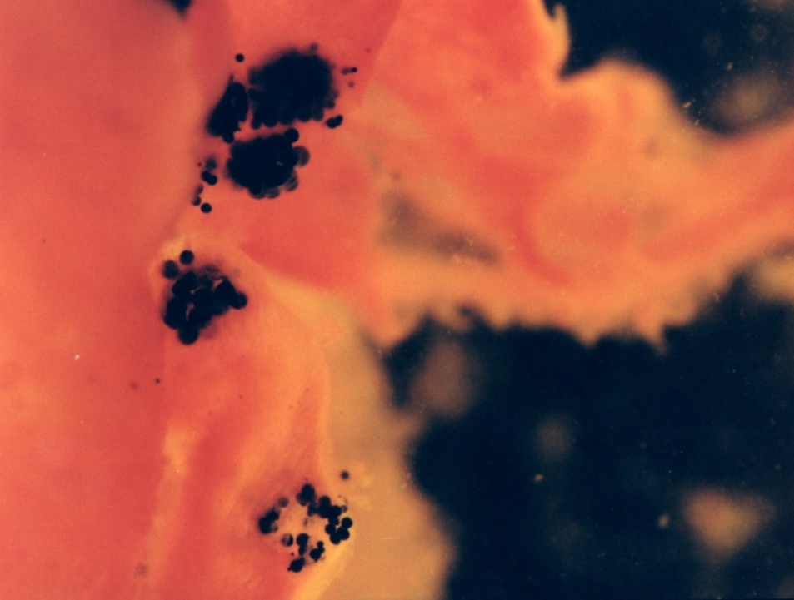
Note: Greatly enlarged individual trophozoites (also called hypnospores) of P. olseni. Sample was stained black by Lugol’s iodine after infected tissue was incubated in Ray’s fluid thioglycollate medium. Stained tissue is visible with the naked eye.
Source: B Diggles
Figure 3 Histopathology of New Zealand cockle (Austrovenus stutchburyi) infected with Perkinsus olseni
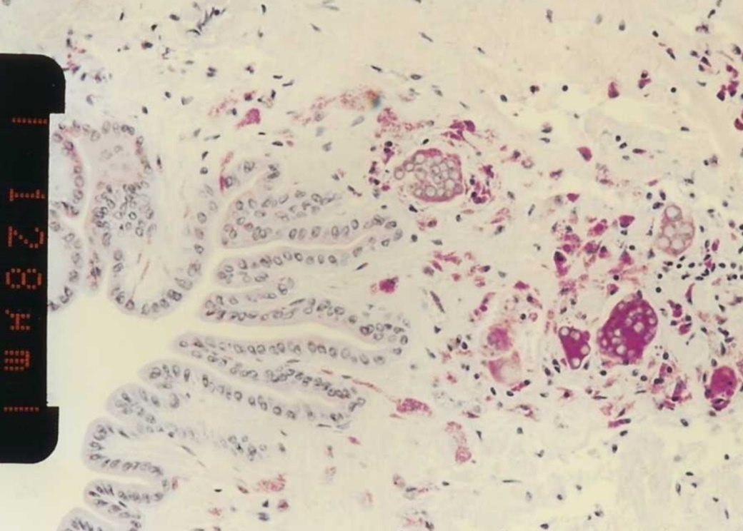
Note: Clusters of developing P. olseni trophozoites surrounded by a strongly eosinophilic periodic acid-Shiff positive amorphous matrix and a host response. Scale bar = 128µm.
Source: B Diggles
Figure 4 Histopathology of clam (Ruditapes sp.) infected with Perkinsus olseni
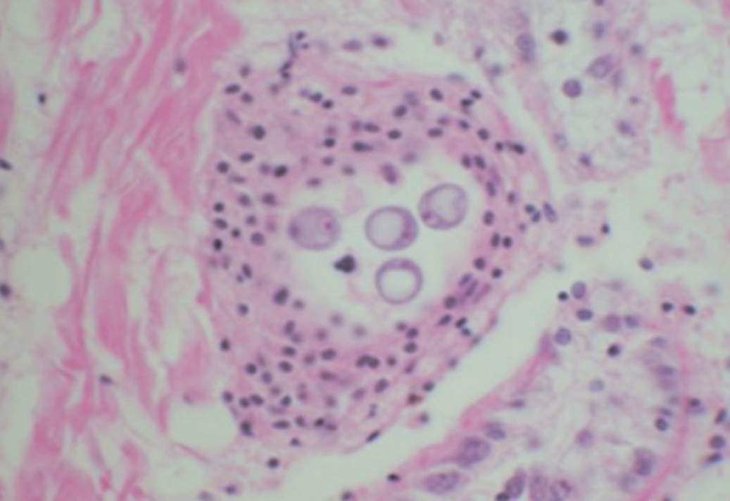
Note: A cluster of signet-ring-shaped P. olseni trophozoites surrounded by an encapsulating host response.
Source: E Burreson
Figure 5 Pedal tissue of greenlip abalone (Haliotis laevigata) infected with Perkinsus olseni
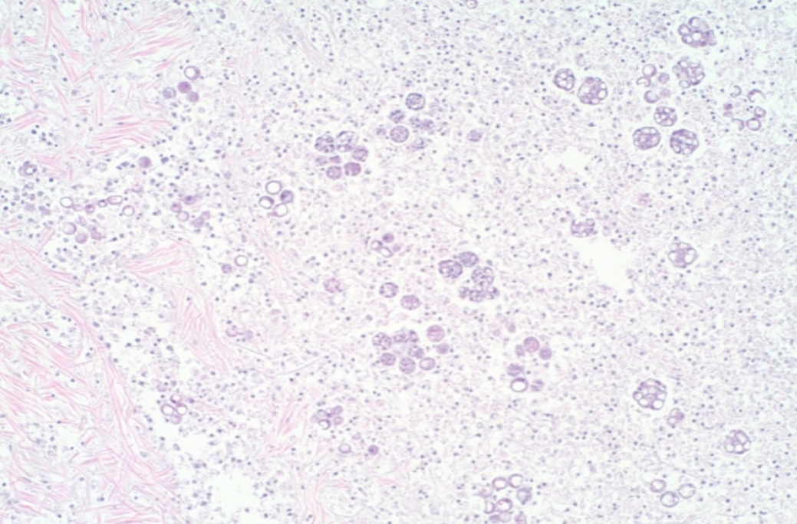
Note: The lesion contains multilocular P. olseni clusters among haemocytes and floccular debris. Haematoxylin and eosin stain. 100x magnification.
Source: S Bastianello
Figure 6 Pedal tissue of greenlip abalone (Haliotis laevigata) infected with Perkinsus olseni
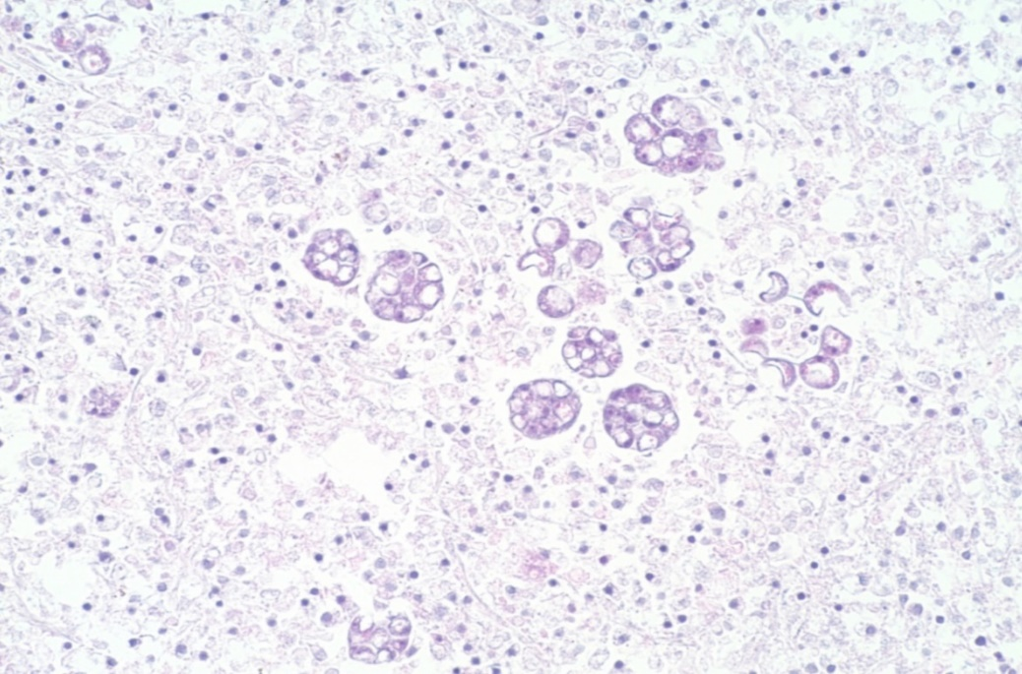
Note: Higher magnification view of Figure 5. Multilocular P. olseni clusters, and more mature signet-ring-shaped organisms among haemocytes and floccular debris. Haematoxylin and eosin stain. 200x magnification.
Source: S Bastianello

Further reading
CABI Invasive Species Compendium Infection with ‘Perkinsus olseni’
CEFAS International Database on Aquatic Animal Diseases Infection with ‘Perkinsus olseni’
World Organisation for Animal Health Manual of diagnostic tests for aquatic animals
These hyperlinks were correct at the time of publication.

Contact details
Emergency Animal Disease Watch Hotline 1800 675 888
Email AAH@agriculture.gov.au
Website agriculture.gov.au/pests-diseases-weeds/aquatic
© Commonwealth of Australia 2020
This work is copyright. It may be reproduced in whole or in part subject to the inclusion of an acknowledgement of the source and no commercial usage or sale.

