Infection with ranavirus

Also known as frog virus 3 (FV-3), Bohle iridovirus (BIV), Ambystoma tigrinum virus (ATV), and Mahaffey Road virus (MHRV)

From Aquatic animal diseases significant to Australia: identification field guide, 5th edition
Figure 1 Hindlimb of magnificent tree frog (Litoria splendida) infected with Mahaffey Road virus
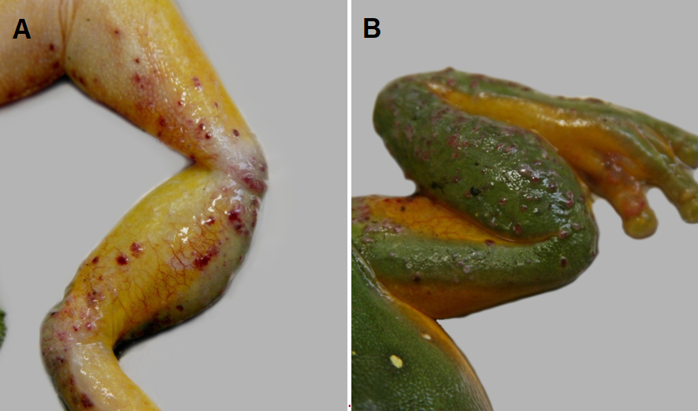
Note: Haemorrhagic skin papules and subcutaneous oedema of the ventral surface (A). Skin papules and erosions on the dorsal surface (B).
Source: Ian Jerrett
Figure 2 Ornate burrowing frog (Platyplectrum ornatus) metamorphs infected with Bohle iridovirus
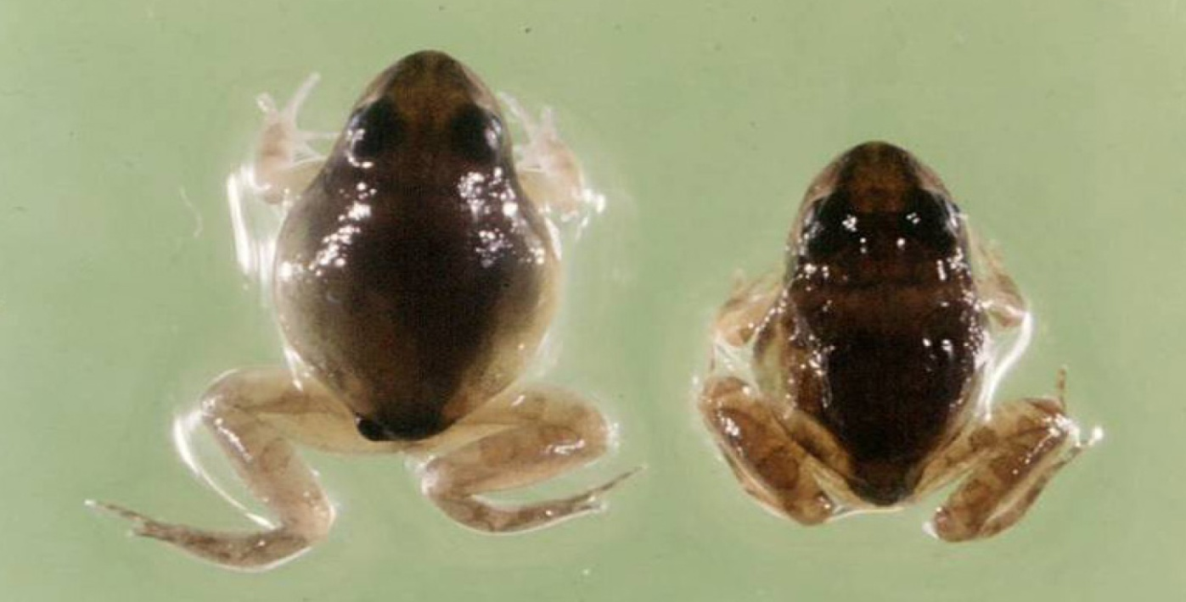
Note: Varying levels of ascites.
Source: R Speare
Figure 3 Green tree frog (Litoria caerulea) infected with Mahaffey Road virus
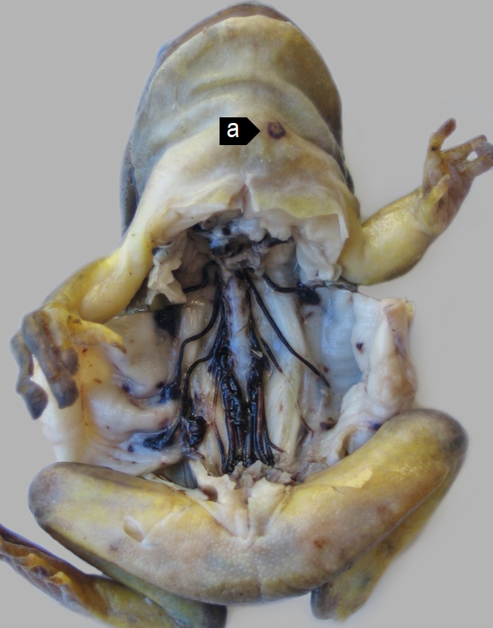
Note: Haemorrhagic perineural tissue and spinal nerves together with petechiation of the parietal coelomic serosa. A skin ulcer (a) is evident on the ventral neck.

Signs of disease
Important: Animals with this disease may show one or more of these signs, but the pathogen may still be present in the absence of any signs.
Disease signs at the farm, tank or pond level are:
- erratic swimming
- lethargy
- loss of equilibrium
- buoyancy problems
- morbidity
- rapid severe mortality events.
Gross pathological signs are:
- poor body condition
- lordosis (abnormal forward curvature of the spine).
In tadpoles and metamorphs, additional gross pathological signs are:
- ascites (free fluid in the abdominal cavity)
- generalised oedema (fluid swelling) of tissues
- focal haemorrhages.
In adults, additional gross pathological signs are:
- skin ulcers, papules and/or erosions
- focal and systematic haemorrhages
- enlargement of the spleen or liver
- oedema of subcutaneous tissue (particularly around the jaw and head, with the tongue protruding).
Microscopic pathological signs are:
- severe renal, pulmonary, hepatic, splenic and haematopoietic necroses and haemorrhages
- basophilic intracytoplasmic inclusion bodies
- erosion, ulceration and hyperplasia of epithelial epidermal cells.

Disease agent
This disease is caused by infection with members of the genus Ranavirus (family Iridoviridae). Viruses infecting amphibians include frog virus 3 (FV-3), Bohle iridovirus (BIV), Ambystoma tigrinum virus (ATV), and Mahaffey Road virus (MHRV). There are many other tentative species in this genus. Bohle iridovirus and Mahaffey Road virus are known from northern Australia in native frogs and cane toads.

Host range
Amphibians (all members of the class Amphibia) are considered to be susceptible to infection with ranavirus. Natural infections are known from most of the major families of the orders Anura (frogs and toads) and Caudata (salamanders, newts and sirens).
Infection with ranaviruses in fish and reptiles can result in asymptomatic infections through to epizootics, depending on species, stress and environmental factors. In challenge experiments, species acutely susceptible to Bohle iridovirus were juvenile green tree frogs (Litoria caerulea), striped burrowing frogs (Cyclorana alboguttata), short-footed frogs (C. brevipes) and red-backed toadlets (Pseudophryne coriacea). Species less susceptible in trials were adult red tree frogs (Litoria rubella), bumpy rocketfrog (L. inermis), green tree frogs, ornate nursery frogs (Cophixalus ornatus), sharp- snouted day frogs (Taudactylus acutirostris) and cane toads (Bufo marinus).
Table 1 Species known to be susceptible to ranavirus
Common name | Scientific name
Frogs and toads | Order Anura
Bumpy rocket frogª | Litoria inermis
Cane toadª | Rhinella marina
Great barred frog | Mixophyes fasciolatus
Green tree frogª | Litoria caerulea
Magnificent tree frogª | Litoria splendida
Ornate burrowing frogª | Platyplectrum ornatus
Ornate nursery frogª | Cophixalus ornatus
Red tree frog | Litoria rubella
Red-backed toadletª | Pseudophryne coriacea
Sharp-snouted day frogª | Taudactylus acutirostris
Short-footed frog | Cyclorana brevipes
Striped burrowing frogª | Cyclorana alboguttata
Salamanders newts and sirens | Order Caudata
Alpine newt | Ichthyosaura alpestris
Blue tailed fire belly newt | Cynops cyanurus
Chiang Mai crocodile newt | Tylototriton uyenoi
Chinese firebelly newt | Cynops orientalis
Clouded salamander | Hynobius nebulosus
Eastern newt | Notophthalmus viridescens
European cave salamander | Speleomantes spp.
Fire salamander | Salamandra salamandra
French cave salamander | Hydromantes strinatii
Italian newt | Lissotriton italicus
Japanese clawed salamander | Onychodactylus japonicas
Japanese fire belly newt | Cynops pyrrhogaster
Lesser siren | Siren intermedia
North African fire salamander | Salamandra algira
Northern crested newt | Triturus cristatus
Northern spectacled salamander | Salamandrina perspicillata
Rough skinned newt | Taricha granulosa
Sardinian brook salamander | Euproctus platycephalus
Siberian salamander | Salamandrella keyserlingii
Smooth newt | Lissotriton vulgaris
Spanish ribbed newt | Pleurodeles waltl
Sword tailed newt | Cynops ensicauda
Vietnamese crocodile newt | Tylototriton vietnamensis
Vietnamese salamander | Paramesotriton deloustali
Wenxian knobby newt | Tylototriton wenxianensis
Yellow spotted newt | Neurergus crocatus
Zeigler’s crocodile newt | Tylototriton ziegleri
a Naturally susceptible. Note: other species likely to be susceptible or shown to be experimentally susceptible.

Presence in Australia
Infection with ranavirus has been officially reported in Australia. Bohle iridovirus was originally isolated from tadpoles of ornate burrowing frogs (Platyplectrum ornatus) in far north Queensland. It has since been isolated from moribund green tree frogs and captive juvenile red-backed toadlets. Another ranavirus, Mahaffey Road virus, was reported from moribund tree frogs in Darwin, Northern Territory. There is serological evidence of ranavirus infection in cane toads across northern Australia.
Map 1 Presence of ranavirus, by jurisdiction
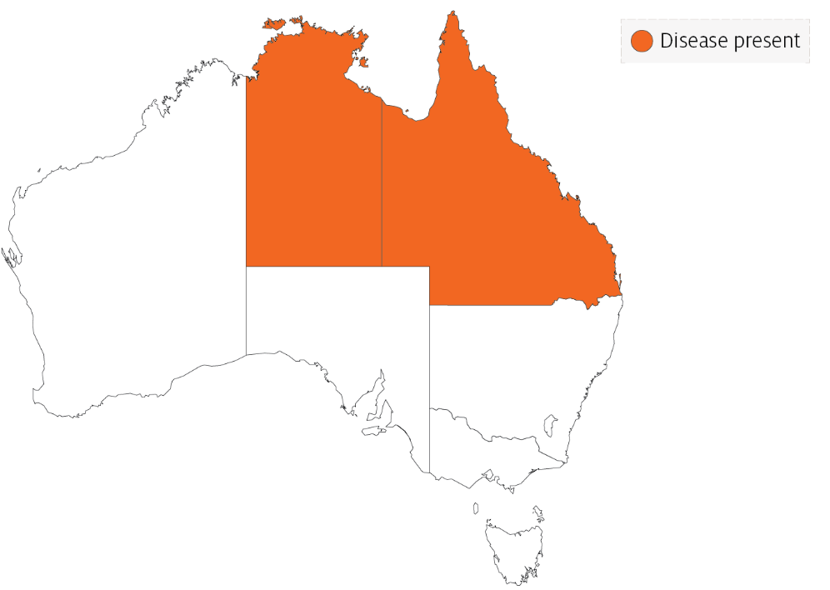

Epidemiology
- Two syndromes in frogs are associated with ranavirus infection: ulcerative syndrome and haemorrhagic syndrome.
- The most common presentation is a rapid, severe mortality event with death due to peracute systemic haemorrhagic disease. However, in Australia, morbidity is more common.
- Mortality and morbidity vary from species to species (0-100%), and may be variable depending on virus type, and age and health status of the host.
- Horizontal transmission occurs via contaminated water, animal-to-animal contact and predation or cannibalism.
- These viruses can be spread between widely separated river systems and impoundments, which suggests viral persistence and the existence of transmission mechanisms other than direct horizontal transmission.
- Vertical transmission is considered likely, but has not been experimentally documented.
- Possible vectors include nets, boats and other equipment, or amphibians used for bait by recreational fishers. Birds are potential mechanical vectors.
- Temperature is considered a likely factor influencing disease outbreaks, with the prevalence or severity of outbreaks greater during warmer months.

Differential diagnosis
The list of similar diseases in the next section refers only to the diseases covered by this field guide. Gross pathological signs may also be representative of diseases not included in this guide. Do not rely on gross signs to provide a definitive diagnosis. Use them as a tool to help identify the listed diseases that most closely account for the observed signs.

Similar diseases
No diseases in this field guide are similar to infection with ranavirus.

Sample collection
Only trained personnel should collect samples. Using only gross pathological signs to differentiate between diseases is not reliable, and some aquatic animal disease agents pose a risk to humans. If you are not appropriately trained, phone your state or territory hotline number and report your observations. If you have to collect samples, the agency taking your call will advise you on the appropriate course of action. Local or district fisheries or veterinary authorities may also advise on sampling.

Emergency disease hotline
See something you think is this disease? Report it. Even if you’re not sure.
Call the Emergency Animal Disease Watch Hotline on 1800 675 888. They will refer you to the right state or territory agency.

Further reading
Wildlife Health Australia Ranaviral disease in wild Australian amphibians
World Organisation for Animal Health Manual of Diagnostic Tests for Aquatic Animals
These hyperlinks were correct at the time of publication.

Contact details
Emergency Animal Disease Watch Hotline 1800 675 888
Email AAH@agriculture.gov.au
Website agriculture.gov.au/pests-diseases-weeds/aquatic
© Commonwealth of Australia 2020
This work is copyright. It may be reproduced in whole or in part subject to the inclusion of an acknowledgement of the source and no commercial usage or sale.

