Infection with salmonid alphavirus (SAV)

Also known as infection with salmon pancreas disease virus (SPDV), salmon pancreas disease (SPD), pancreas disease (PD) and sleeping disease (SD)

From Aquatic animal diseases significant to Australia: identification field guide, 5th edition
Figure 1 Atlantic salmon (Salmo salar) chronically infected with SAV
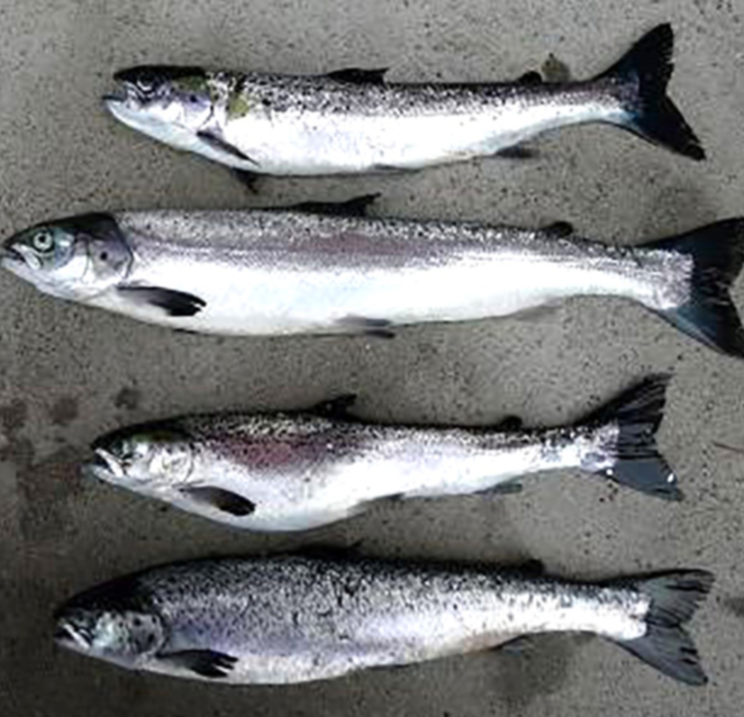
Note: Very thin carrier fish in poor condition a few months after infection.
Source: T Poppe

Signs of disease
Important: Animals with this disease may show one or more of these signs, but the pathogen may still be present in the absence of any signs.
Disease signs at the farm, tank or pond level are:
- Lack of appetite a week or two before a disease outbreak
- clinically diseased fish may swim against the current close to the surface or corners of the cage, or be found resting at the bottom of the tank or cage (sleeping)
- one to several months after the onset of mortality, a portion of the survivors usually fail to grow and become thin and slender (runts).
Gross pathological signs are:
- yellow mucoid gut contents
- petechiae in pyloric fat, pale hearts and/or haemopericardium due to heart rupture
- scale pocket oedema
- exophthalmos
- ascites
- atrophy of red skeletal muscle in chronic cases.
Microscopic pathological signs are:
- necrosis of exocrine pancreas develops shortly before cardiomyocytic necrosis
- severe or total loss of exocrine pancreas, myocarditis and skeletal muscle necrosis, degeneration and myositis
- damage, primarily of the pancreas, and severe cardiac and skeletal.

Disease agent
SPD is caused by infection with salmonid alphavirus (SAV), a member of the family Togaviridae in the genus Alphavirus. Various genetic subtypes of the virus have been detected. SPD first emerged in Scotland and subsequently recognised in France, Ireland, England, Norway, Germany, Italy and Spain.

Host range
Clinical signs of salmon pancreas disease have been reported in Atlantic salmon, sea-reared rainbow trout, brown trout and Arctic char. Wild fish (such as flatfish and wrasses) can be subclinically infected and may act as potential vectors or reservoirs of infection.
Table 1 Species known to be susceptible to SAV
Common name | Scientific name
American plaiceª | Hippoglossoides platessoides
Arctic charª | Salvelinus alpinus
Atlantic salmonª | Salmo salar
Brown trout | Salmo trutta
Dabª | Limanda limanda
Plaiceª | Pleuronectes platessa
Rainbow troutª | Oncorhynchus mykiss
Wrasseª | Labrus bergylta
a Naturally susceptible. Note: Other species have been shown to be experimentally susceptible.

Presence in Australia
Exotic disease—not recorded in Australia.
Map 1 Presence of SAV, by jurisdiction
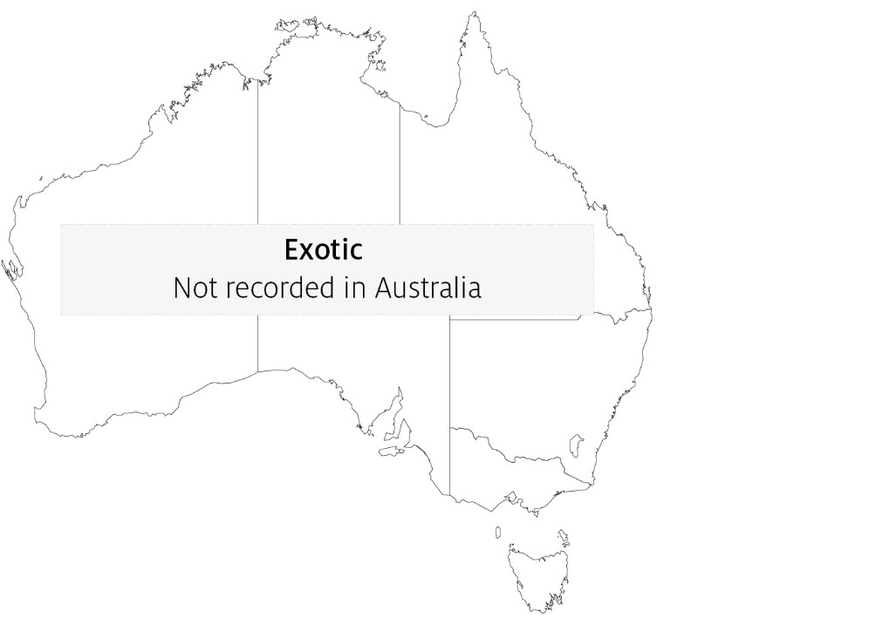

Epidemiology
- SAV is horizontally transmitted, via water and water currents, transport of infected fish, contaminated equipment, well boats and other vehicles. The virus can survive for extended periods in seawater.
- Vertical transmission is considered unlikely but has not been ruled out.
- Water temperature may affect the duration and level of mortality.
- Subtypes 1, 2, 3, 4, 5 and 6 may have different virulence in different hosts.
- All marine life stages of Atlantic salmon are susceptible to disease, from smolts to adult fish. Different strains of Atlantic salmon may have different susceptibility to SAV.
- Farmed rainbow trout in fresh water and salt water are susceptible to disease at all stages of production.
- Mortality varies significantly, from negligible to over 50% in severe cases. Up to 15% of surviving fish will develop into long, slender fish (runts).
- Management and environmental factors that induce stress in fish probably increase mortality significantly.
- Natural reservoirs of SAV may include wild fish. SAV has been detected in some wild flatfish species in Scotland and in wrasses used for sealice management in Ireland.

Differential diagnosis
The list of similar diseases in the next section refers only to the diseases covered by this field guide. Gross pathological signs may also be representative of diseases not included in this guide. Do not rely on gross signs to provide a definitive diagnosis. Use them as a tool to help identify the listed diseases that most closely account for the observed signs.

Similar diseases
Infection with HPR-deleted or HPR0 infectious salmon anaemia virus and infectious pancreatic necrosis (IPN).

Sample collection
Only trained personnel should collect samples. Using only gross pathological signs to differentiate between diseases is not reliable, and some aquatic animal disease agents pose a risk to humans. If you are not appropriately trained, phone your state or territory hotline number and report your observations. If you have to collect samples, the agency taking your call will advise you on the appropriate course of action. Local or district fisheries or veterinary authorities may also advise on sampling.

Emergency disease hotline
See something you think is this disease? Report it. Even if you’re not sure.
Call the Emergency Animal Disease Watch Hotline on 1800 675 888. They will refer you to the right state or territory agency.

Further reading
World Organisation for Animal Health Manual of diagnostic tests for aquatic animals
This hyperlink was correct at the time of publication.

Contact details
Emergency Animal Disease Watch Hotline 1800 675 888
Email AAH@agriculture.gov.au
Website agriculture.gov.au/pests-diseases-weeds/aquatic
© Commonwealth of Australia 2020
This work is copyright. It may be reproduced in whole or in part subject to the inclusion of an acknowledgement of the source and no commercial usage or sale.

