Infection with shrimp haemocyte iridescent virus (SHIV)

Also known as white head disease (WHD), Decapod iridescent virus 1 (DIV1) and Cherax quadricarinatus iridovirus (CQIV)

From Aquatic animal diseases significant to Australia: identification field guide, 5th edition
Figure 1 Gross signs of Pacific white shrimp (Penaeus (Litopenaeus) vannamei) infected with SHIV
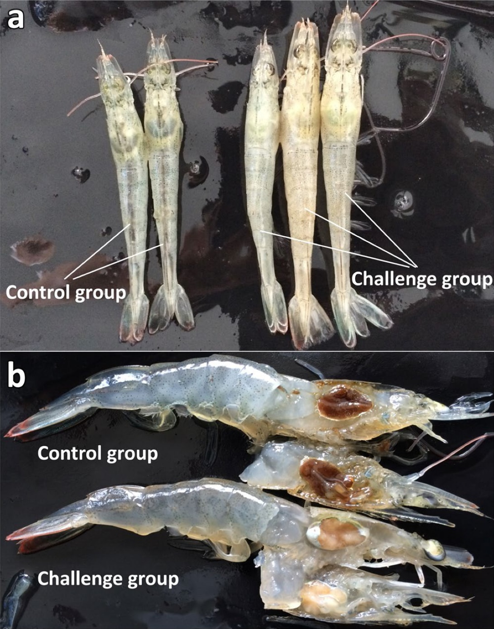
Note: When compared with healthy shrimp (control group), shrimp infected with SHIV (challenge group) have a whitish to yellowish head (a) caused by the pale necrotic hepatopancreas (b) and a slightly iridescent appearance of the carapace.
Source: Qiu et al. 2017

Signs of disease
Important: Animals with this disease may show one or more of these signs, but the pathogen may still be present in the absence of any signs.
Disease signs at the farm, tank or pond level are:
- lethargy
- cessation of feeding
- diseased shrimp sinking to the bottom of the pond
- sudden onset of high mortalities in late-postlarvae, juvenile or subadult prawns.
Gross pathological signs are:
- empty stomach and gut
- soft shell
- damaged antennae
- whitish to yellowish coloured head caused by a pale atrophied hepatopancreas
- white triangle under the carapace at the base of the rostrum in Macrobrachium rosenbergii
- slightly reddish body colour in approximately one third of affected shrimp.
Microscopic pathological signs are:
- many necrotic cells with pyknotic nuclei in the haematopoietic tissue and circulating haemocytes in the gills, hepatopancreas and haemolymph sinuses
- dark eosinophilic inclusions and pyknosis in haematopoietic tissue
- basophilic intracytoplasmic inclusions in haemocytes and other affected cells
- TEM shows many icosahedral non-enveloped virions in arrays within the cytoplasm of haemocytes found in the haemal sinuses, haematopoietic tissue, hepatopancreas and muscle.

Disease agent
SHIV, also known as Decapod iridescent virus 1 (DIV1), is an iridescent virus with a double stranded DNA genome, classified within the proposed genus Decapodiridovirus within the family Iridoviridae. SHIV emerged in China around 2014, causing high mortalities and significant economic losses in cultured Penaeus (Litopenaeus) vannamei and Macrobrachium rosenbergii. Genome sequencing has revealed that SHIV and Cherax quadricarinatus iridovirus (CQIV), identified from freshwater red claw crayfish Cherax quadricarinatus, are likely to be different strains of the same virus species.

Host range
Table 1 Species known to be susceptible to SHIV
Common name | Scientific name
Pacific white shrimp | Penaeus (Litopenaeus) vannamei
Table 2 Non-penaeids known to be susceptible to SHIV
Common name | Scientific name
Giant freshwater prawnª | Macrobrachium rosenbergii
Louisiana swamp crayfishª | Procambarus clarkii
Oriental freshwater shrimpª | Macrobrachium nipponense
Oriental prawn | Exopalaemon carinicauda
Redclaw crayfishª | Cherax quadricarinatus
a Naturally susceptible.
Table 3 Potential carriers of SHIV
Common name | Scientific name
Chinese white shrimp | Penaeus (Fenneropenaeus) chinensis
Superb freshwater shrimp | Macrobrachium superbum
Cladocerans (water fleas) | Order Cladocera

Presence in Australia
Exotic disease—not recorded in Australia.
Map 1 Presence of SHIV, by jurisdiction
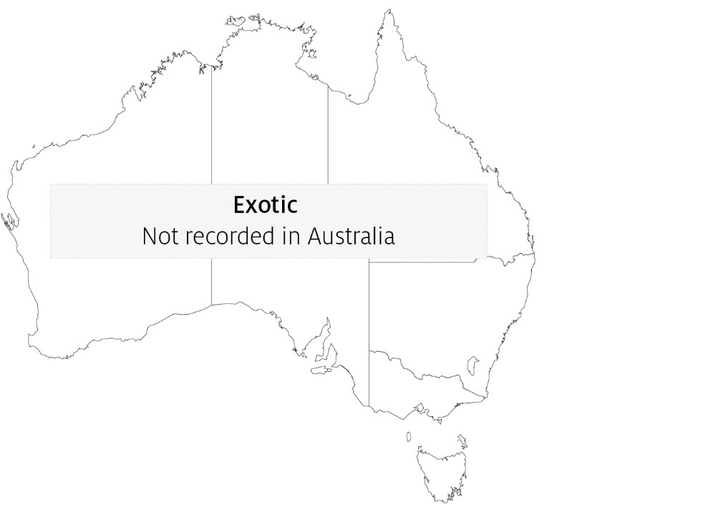

Epidemiology
- Infection with SHIV has been responsible for high mortalities (over 80%) in farmed P. vannamei and M. rosenbergii populations in China since 2014.
- Infection is horizontal via cannibalism of infected shrimp or through contact with infected faeces. Per os and reverse gavage infection experiments in P. vannamei resulted in 100% cumulative mortality within 2 weeks.
- Injection challenges exposing P. vannamei, C. quadricarinatus, and Procambarus clarkii to SHIV also resulted in 100% cumulative mortalities.
- Infected M. rosenbergii exhibit distinctive clinical signs called white head disease, characterised by a distinct white triangle area under the carapace at the base of the rostrum. This effect is a result of the pale colouration of diseased haematopoietic tissue.
- The virus is found mainly in haematopoietic tissue located above the stomach and at the base of antennae, pereiopods and other appendages. However, SHIV infection is systemic and the virus is also found in the haemocytes, gills, hepatopancreas, pereiopods, and muscle.
- qPCR tests show that the highest levels of virus in infected crustaceans are found in the haematopoietic tissue and haemocytes. The lowest viral levels are in the muscle.

Differential diagnosis
The list of similar diseases in the next section refers only to the diseases covered by this field guide. Gross pathological signs may also be representative of diseases not included in this guide. Do not rely on gross signs to provide a definitive diagnosis. Use them as a tool to help identify the listed diseases that most closely account for the observed signs.

Similar diseases
Acute hepatopancreatic necrosis disease (AHPND), gill associated virus disease (GAV), infection with infectious myonecrosis virus (MrNV), infection with Macrobrachium rosenbergii nodavirus, infection with white spot syndrome virus (WSSV) and infection with yellowhead virus genotype 1 (YHV1).

Sample collection
Perinuclear pale basophilic to dark basophilic inclusion bodies are evident in this group of muscle cells (arrows point at some examples).

Emergency disease hotline
See something you think is this disease? Report it. Even if you’re not sure.
Call the Emergency Animal Disease Watch Hotline on 1800 675 888. They will refer you to the right state or territory agency.

Microscope images
Figure 2 Haematopoietic tissue of Pacific white shrimp (Penaeus (Litopenaeus) vannamei) infected with SHIV
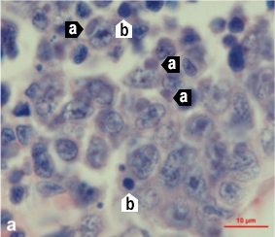
Note: Haemocytes and hepatopancreas cells with dark basophilic cytoplasmic inclusions (a) and numerous necrotic cells with pyknotic nuclei (b). Histological section with haematoxylin and eosin stain. Scale bar = 10 µm.
Source: Qiu et al. 2017
Figure 3 Gills of Pacific white shrimp (Penaeus (Litopenaeus) vannamei) infected with SHIV
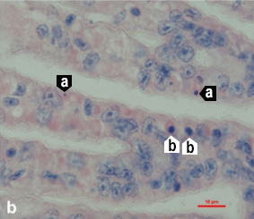
Note: Haemocytes and hepatopancreas cells with dark basophilic cytoplasmic inclusions (a) and numerous necrotic cells with pyknotic nuclei (b). Histological section with haematoxylin and eosin stain. Scale bar = 10 µm.
Source: Qiu et al. 2017
Figure 4 Hepatopancreas of Pacific white shrimp (Penaeus (Litopenaeus) vannamei) infected with SHIV
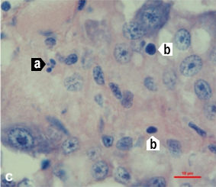
Note: Haemocytes and hepatopancreas cells with dark basophilic cytoplasmic inclusions (a) and numerous necrotic cells with pyknotic nuclei (b). Histological section with haematoxylin and eosin stain. Scale bar = 10 µm.
Source: Qiu et al. 2017
Figure 5 Periopods of Pacific white shrimp (Penaeus (Litopenaeus) vannamei) infected with SHIV
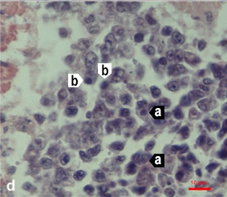
Note: Haemocytes and hepatopancreas cells with dark basophilic cytoplasmic inclusions (a) and numerous necrotic cells with pyknotic nuclei (b). Histological section with haematoxylin and eosin stain. Scale bar = 10 µm.
Source: Qiu et al. 2017

Further reading
Qiu L, Chen MM, Wan XY, Li C, Zhang QL, Wang RY, Cheng DY, Dong X, Yang B, Wang XH, Xiang JH, and Huang J 2017, ‘Characterization of a new member of Iridoviridae, Shrimp haemocyte iridescent virus (SHIV), found in white leg shrimp (Litopenaeus vannamei)’, Scientific Reports.
Qiu L, Chen X, Zhao RH, Li C, Gao W, Zhang QL, Huang J 2019, ‘Description of a natural infection with Decapod iridescent virus 1 in farmed giant freshwater prawn, Macrobrachium rosenbergii’, Viruses.
Xu L, Wang T, Li F, Yang F 2016, ‘Isolation and preliminary characterization of a new pathogenic iridovirus from redclaw crayfish Cherax quadricarinatus’, Diseases of Aquatic Organisms.

Contact details
Emergency Animal Disease Watch Hotline 1800 675 888
Email AAH@agriculture.gov.au
Website agriculture.gov.au/pests-diseases-weeds/aquatic
© Commonwealth of Australia 2020
This work is copyright. It may be reproduced in whole or in part subject to the inclusion of an acknowledgement of the source and no commercial usage or sale.

