Infection with Taura syndrome virus (TSV)

Also known as Taura syndrome and red tail disease

From Aquatic animal diseases significant to Australia: identification field guide, 5th edition
Figure 1 Acute Taura syndrome in Pacific white shrimp (Penaeus (Litopenaeus) vannamei)
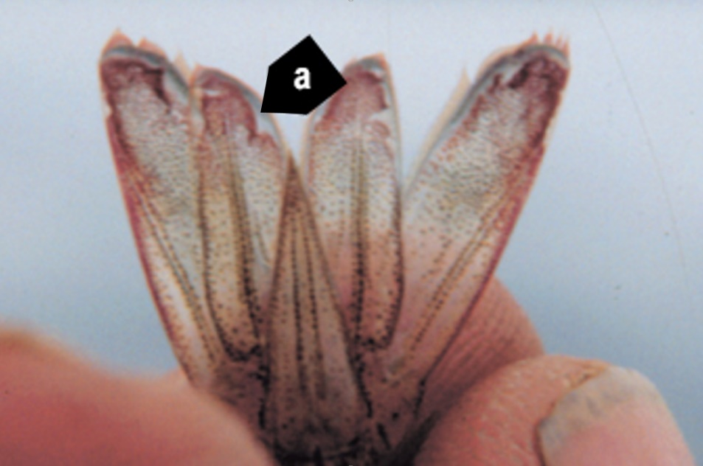
Note: Distinctive red tail fan. Rough edges around cuticular epithelium in the uropods (tail fin) are common signs of infection and suggest focal necrosis of the epithelium at those sites (a).
Source: DV Lightner
Figure 2 Taura syndrome in surviving Pacific white shrimp (Penaeus (Litopenaeus) vannamei)
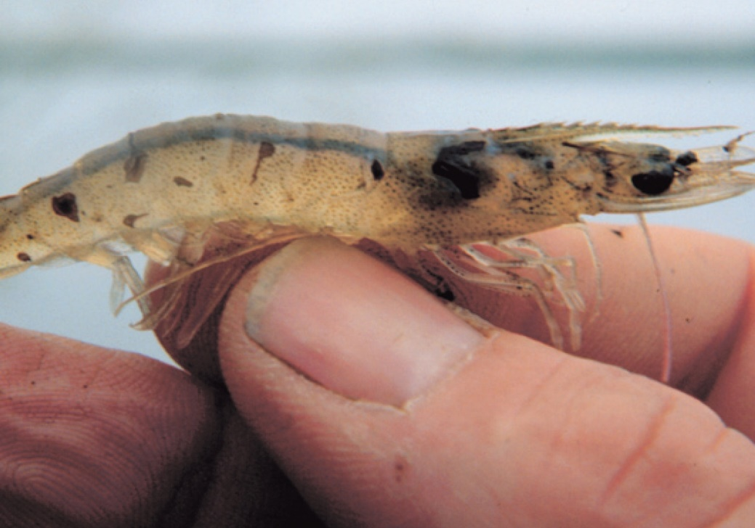
Note: Dark melanised lesions on carapace from a transitional phase infection.
Source: DV Lightner
Figure 3 Moribund, juvenile pond-reared Pacific white shrimp (Penaeus (Litopenaeus) vannamei) in peracute phase of Taura syndrome
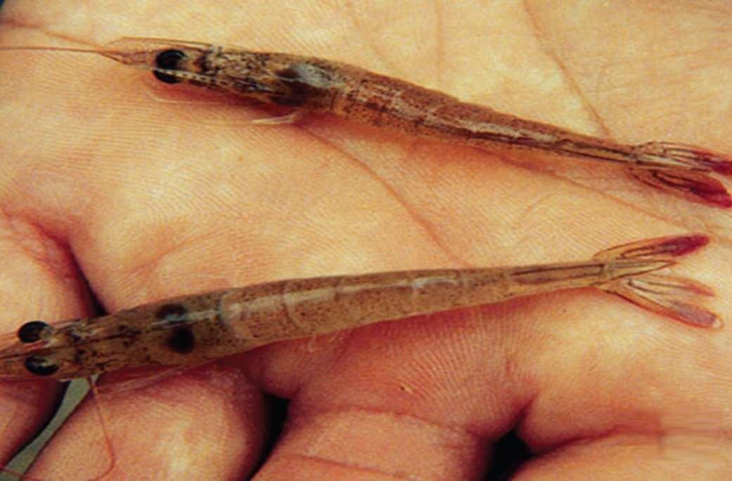
Note: Infected shrimp are lethargic and have soft shells and distinctive red tail fans.
Source: DV Lightner
Figure 4 Juvenile pond-reared Pacific white shrimp (Penaeus (Litopenaeus) vannamei) in chronic or recovery phase of Taura syndrome
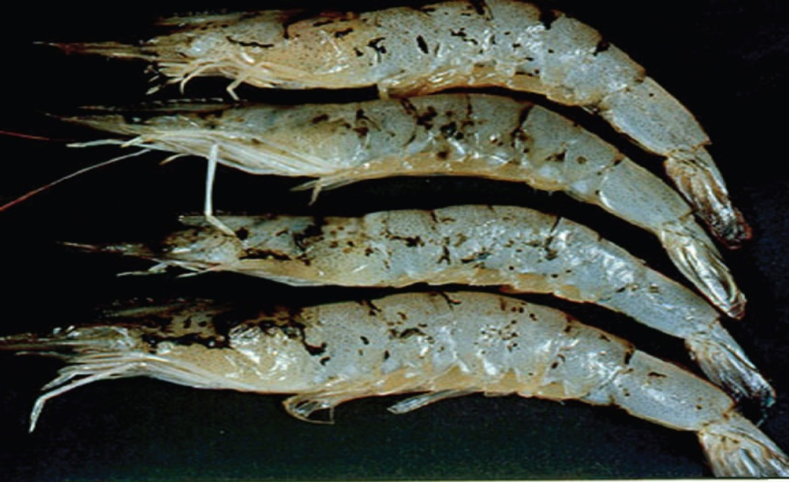
Note: Multiple melanised (dark) foci mark sites of resolving cuticular epithelium necrosis caused by TSV infection .
Source: DV Lightner

Signs of disease
Important: Animals with this disease may show one or more of these signs, but the pathogen may still be present in the absence of any signs.
Disease signs at the farm, tank or pond level are:
- lethargy
- cessation of feeding
- animals gathering at the pond edge when moribund
- sudden increase in presence of seabirds fishing in ponds
- sudden onset of high mortalities in late-postlarvae, juvenile or subadult prawns.
Gross pathological signs are:
- acute phase
  - empty stomach and pale red body surface and appendages
  - red tail fan and pleopods due to the expansion of red chromatophores
  - soft shell
- transition phase
  - multiple, irregularly shaped and randomly distributed melanised (dark) cuticular lesions
  - death, usually at moulting.
There are no obvious gross pathological signs of disease in the chronic phase.
Microscopic pathological signs are:
- necrosis of the cuticular epithelium of appendages
- multifocal lesions in the cuticular epithelium (transition phase)
- abundant pyknotic and karyorrhectic nuclei that give Taura syndrome lesions a pathodiagnostic peppered or buckshot-riddled appearance.

Disease agent
Taura syndrome is caused by infection with Taura syndrome virus (TSV), a small picorna-like RNA virus that belongs to the genus Aparavirus in the family Dicistroviridae.

Host range
A wide range of penaeid prawns (Table 1) and non-penaeid carriers (Table 2) are known to be susceptible to this virus.
Table 1 Species known to be susceptible to TSV
Common name | Scientific name
Black tiger prawnª | Penaeus monodon
Chinese white shrimp | Penaeus (Fenneropenaeus) chinensis
Gulf banana prawn | Penaeus (Fenneropenaeus) merguiensis
Indian banana prawn | Penaeus (Fenneropenaeus) indicus
Kuruma prawn | Penaeus (Marsupenaeus) japonicus
Northern brown shrimp | Penaeus (Farfantepenaeus) aztecus
Northern pink shrimp | Penaeus (Farfantepenaeus) duorarum
Northern white shrimpª | Penaeus (Litopenaeus) setiferus
Pacific blue shrimpª | Penaeus (Litopenaeus) stylirostris
Pacific white shrimpª | Penaeus (Litopenaeus) vannamei
Red endeavour (greasyback) prawnª | Metapenaeus ensis
Southern white shrimpª | Penaeus (Litopenaeus) schmitti
a Naturally susceptible. Note: Other species have been shown to be experimentally susceptible.
Table 2 Non-penaeid carriers
Common name | Scientific name
Acorn and gooseneck barnaclesª | Chelonibia spp., Octolasmis spp.
Fiddler crab | Uca vocans
Freshwater prawn | Macrobrachium lanchesteri
Giant freshwater prawn | Macrobrachium rosenbergii
Mud crabª | Scylla serrata
Mysid shrimp | Palaemon styliferus
Parasitic copepods | Ergasilus manicatus
Piscivorous birds | Various genera and species
Red crab | Sesarma mederi
a Naturally susceptible. Note: Other species have been shown to be experimentally susceptible.

Presence in Australia
Exotic disease—not recorded in Australia.
Map 1 Presence of TSV, by jurisdiction
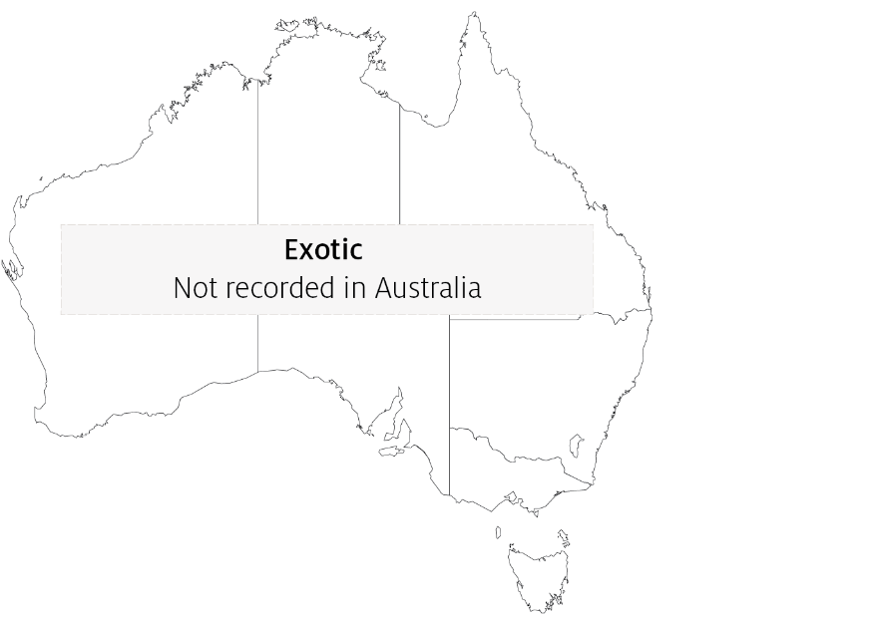

Epidemiology
- Taura syndrome is a disease mainly of the nursery phase of Penaeus (Litopenaeus) vannamei. It usually occurs within 14 to 40 days of stocking postlarvae into grow-out ponds or tanks and results in mortality rates of 40% to more than 90%.
- TSV has been documented in postlarvae, juvenile and adult life stages.
- Survivors of infection with TSV may become lifelong carriers.
- Transmission is horizontal through ingestion. Vertical transmission is suspected, but it has not been experimentally confirmed.
- Migratory birds, aquatic insects and humans are likely mechanical vectors of the virus. Birds may be an important route of transmission. TSV has been demonstrated to remain infectious for up to 48 hours in the faeces of sea gulls that have ingested infected prawn carcasses.
- Resistance of Penaeus monodon and Penaeus (Marsupenaeus) japonicus to TSV is unclear, but they appear to be more resistant than P. vannamei.
- TSV-resistant stocks of P. vannamei and Penaeus (Litopenaeus) stylirostris are commercially available. TSV-resistant stocks have shown survival rates of up to 100% following laboratory challenge.

Differential diagnosis
The list of similar diseases in the next section refers only to the diseases covered by this field guide. Gross pathological signs may also be representative of diseases not included in this guide. Do not rely on gross signs to provide a definitive diagnosis. Use them as a tool to help identify the listed diseases that most closely account for the observed signs.

Similar diseases
Infection with white spot syndrome virus (WSSV) and infection with yellowhead virus genotype 1 (YHV1).

Sample collection
Only trained personnel should collect samples. Using only gross pathological signs to differentiate between diseases is not reliable, and some aquatic animal disease agents pose a risk to humans. If you are not appropriately trained, phone your state or territory hotline number and report your observations. If you have to collect samples, the agency taking your call will advise you on the appropriate course of action. Local or district fisheries or veterinary authorities may also advise on sampling.

Emergency disease hotline
See something you think is this disease? Report it. Even if you’re not sure.
Call the Emergency Animal Disease Watch Hotline on 1800 675 888. They will refer you to the right state or territory agency.

Microscope images
Figure 5 Histological section through stomach of juvenile Pacific white shrimp (Penaeus (Litopenaeus) vannamei) with peracute Taura syndrome
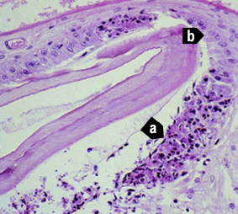
Note: Prominent areas of necrosis in cuticular epithelium (a), which secretes the overlying acellular cuticle. Adjacent to the focal lesions are normal-looking epithelial cells (b). 300x magnification.
Source: DV Lightner
Figure 6 Characteristic lesion in peracute phase of Taura syndrome
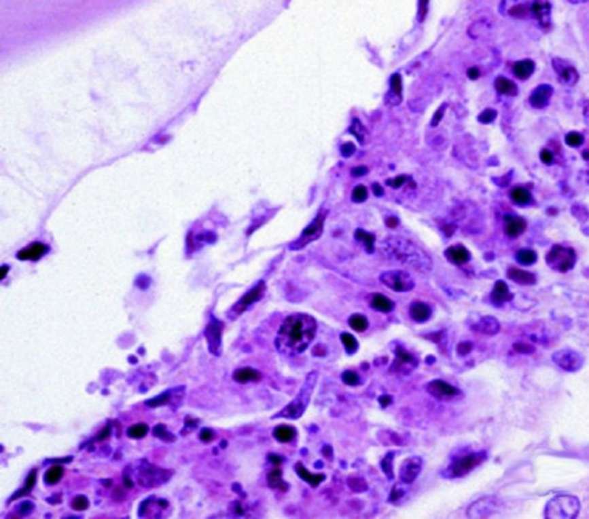
Note: Higher magnification of Figure 5, bottom right (a). Classic Taura syndrome lesions consist of necrotic cuticular epithelial and subcuticular connective tissue cells with pyknotic and karyorrhectic nuclei; a generally increased cytoplasmic eosinophilia; and very numerous, variably staining cytoplasmic inclusions. Cytoplasmic inclusions and pyknotic and karyorrhectic nuclei give the lesion a pathodiagnostic peppered or buckshot-riddled appearance. Absence of haemocytes in or near the lesion suggest lesion is peracute. 900x magnification.
Source: DV Lightner
Figure 7 Pathognomonic focal Taura syndrome virus lesions in cuticular epithelium and subcutis of carapace of juvenile Pacific white shrimp (Penaeus (Litopenaeus) vannamei) with peracute Taura syndrome
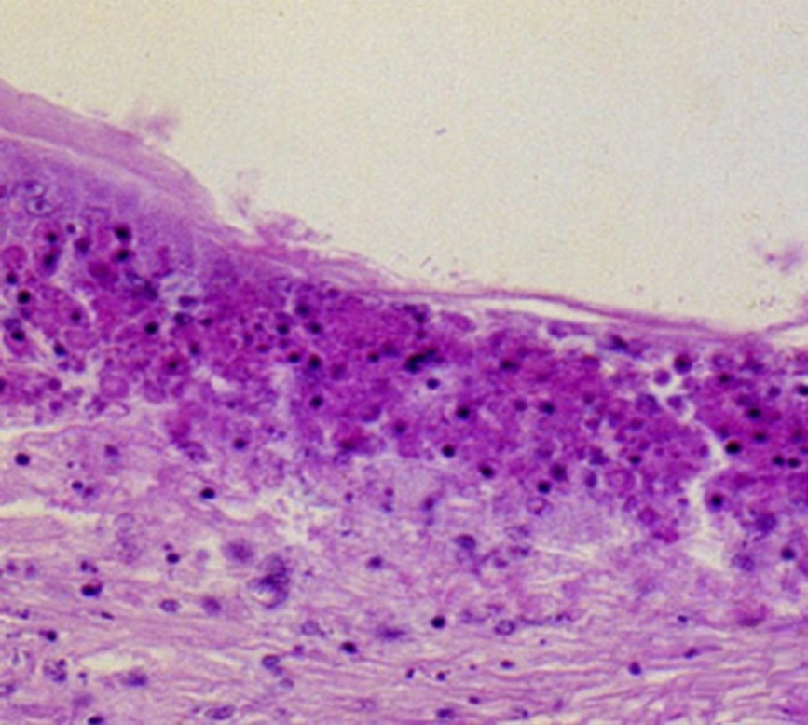
Note: Large numbers of pyknotic and karyorrhectic nuclei. 450x magnification.
Source: DV Lightner
Figure 8 Pathognomonic focal Taura syndrome virus lesions in gills of juvenile Pacific white shrimp (Penaeus (Litopenaeus) vannamei)
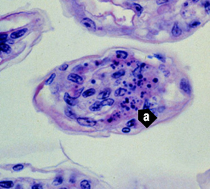
Note: Distinguishing characteristics of the lesions include nuclear pyknosis and karyorrhexis, increased cytoplasmic eosinophilia, and an abundance of variably staining and generally spherical cytoplasmic inclusions (a). 900x magnification.
Source: DV Lightner
Figure 9 Unstained wet mount of uropod of experimentally infected postlarval Pacific white shrimp (Penaeus (Litopenaeus) vannamei) with peracute Taura syndrome
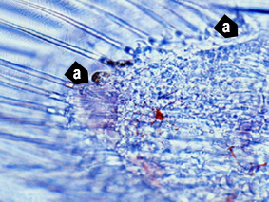
Note: Postlarva in the D4 stage of moult cycle, shown by the old cuticle separated from the new cuticle by a space. Approximate margins (a) of a focal area of necrosis in the cuticular epithelium. Area of necrosis is evidenced by vacant zone under the cuticular epithelium (where cuticular epithelium should be) and by refractile spheres (pyknotic and karyorrhectic nuclei) near periphery of lesion. Expanded red chromatophores are apparent in the subcuticular connective tissues of the uropod. 300x magnification.
Source: DV Lightner
Figure 10 Histological section of resolving cuticular lesion in juvenile Pacific white shrimp (Penaeus (Litopenaeus) vannamei)
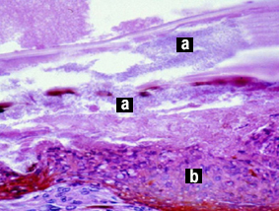
Note: Perforated cuticle is heavily colonised with masses of bacteria (a). Thick, melanised, haemocytic ‘plug’ (b) has formed basal to the cuticular epithelium to temporarily close wound from the outside. Basal to haemocyte plug (b), connective tissue elements and additional infiltrating haemocytes provide basal support for regeneration of cuticular epithelium. Pathognomonic Taura syndrome lesions in recovery or chronic phase of Taura syndrome are usually few, relative to the resolving lesions shown here, and are often entirely absent. 600x magnification.
Source: DV Lightner
Figure 11 Midsagittal section of lymphoid organ of experimentally infected juvenile Pacific white shrimp (Penaeus (Litopenaeus) vannamei) in chronic or recovery phase of Taura syndrome
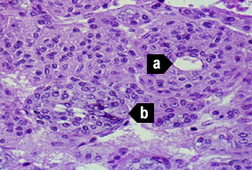
Note: TSV induces some significant lesions in the lymphoid organ (LO), but never pathognomonic Taura syndrome lesions of the type seen in the cuticular epithelium. Normal-looking LO cords or tissue is characterised by multiple layers of sheath cells around a central haemolymph vessel (a). Interspersed are accumulations of disorganised LO cells that form LO ‘spheroids’ (LOS). LOS lack a central vessel and consist of cells that show karyomegaly and large, prominent cytoplasmic vacuoles and other cytoplasmic inclusions (b). 450x magnification.
Source: DV Lightner
Figure 12 In situ hybridisation of appendage from postlarval Pacific white shrimp (Penaeus (Litopenaeus) vannamei) with peracute Taura syndrome
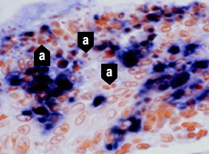
Note: Digoxigenin-labelled cDNA probe reacts with TSV-infected cells, staining cytoplasm of infected cuticular epithelial cells and subcuticular connective tissue. Probe does not react with pyknotic and karyorrhectic nuclei (a) because TSV is only cytoplasmic. These nuclear remnants contribute to ‘peppered’ or ‘buckshot-riddled’ appearance of TSV lesions. 900x magnification.
Source: DV Lightner

Further reading
CABI Invasive Species Compendium Taura syndrome
CEFAS International Database on Aquatic Animal Diseases Taura syndrome
World Organisation for Animal Health Manual of diagnostic tests for aquatic animals
These hyperlinks were correct at the time of publication.

Contact details
Emergency Animal Disease Watch Hotline 1800 675 888
Email AAH@agriculture.gov.au
Website agriculture.gov.au/pests-diseases-weeds/aquatic
© Commonwealth of Australia 2020
This work is copyright. It may be reproduced in whole or in part subject to the inclusion of an acknowledgement of the source and no commercial usage or sale.

