Infection with white spot syndrome virus (WSSV)

Also known as white spot disease (WSD)

From Aquatic animal diseases significant to Australia: identification field guide, 5th edition
Figure 1 WSD in giant black tiger prawn (Penaeus monodon)
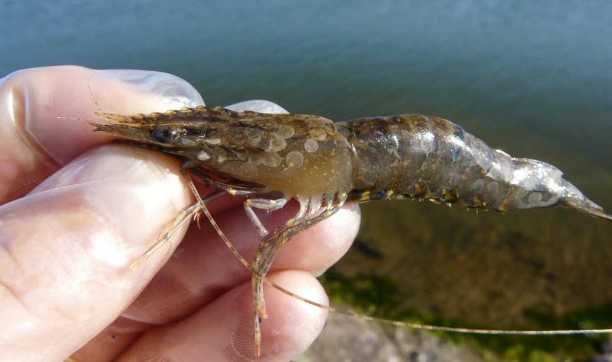
Note: White spots on carapace are typical of infection following acute phase of infection.
Source: B Diggles
Figure 2 WSD in giant black tiger prawn (Penaeus monodon)
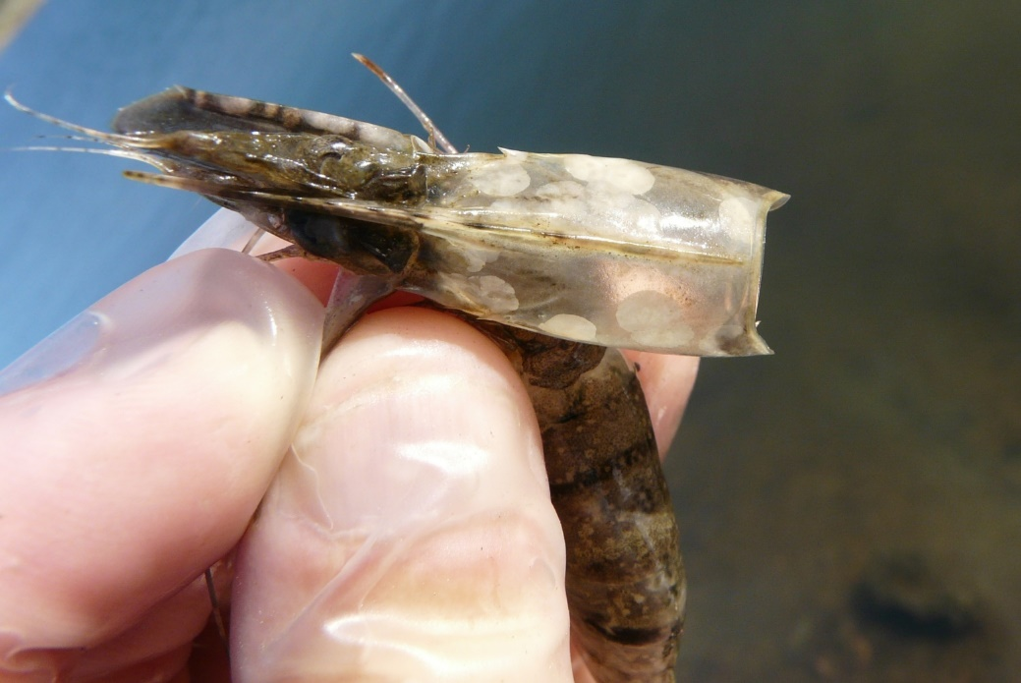
Note: Carapace is loose and when removed, large smooth-edged white spots are evident. Numerous smaller white spots are also evident on the abdominal segments.
Source: B Diggles
Figure 3 Five juvenile black tiger prawns (Penaeus monodon) infected with WSSV lacking classical white spots
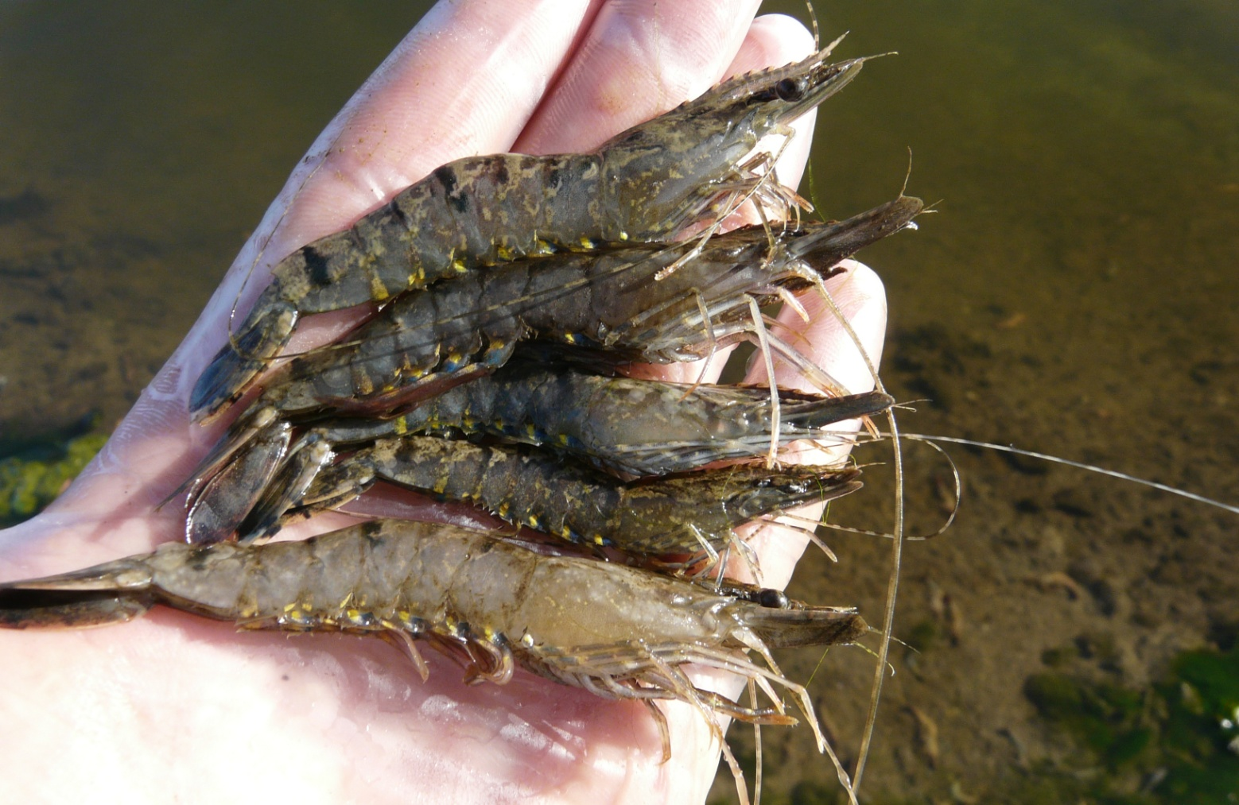
Note: Prawns exhibit few, if any, white spots. Prawns infected with WSSV can present as ‘normal’ prawns.
Source: B Diggles

Signs of disease
Important: Animals with this disease may show one or more of these signs, but the pathogen may still be present in the absence of any signs.
Disease signs at the farm, tank or pond level are:
- rapid onset of mass mortality (80% or more) in farmed penaeid prawns during the grow-out period
- lethargy
- cessation of feeding
- aggregations of moribund prawns near the water surface at the edge of the rearing pond or tank.
Gross pathological signs are:
- loose carapace
- high degree of colour variation, with a predominance of darkened (red, brown or pink) body surface and appendages
- heavy fouling of the surface and gills by external parasites
- white midgut line through the abdomen of severely affected larvae and postlarvae
- delayed (or completely absent) clotting reaction of the haemolymph of infected shrimp
- white calcium deposits embedded in the shell, causing white spots 0.5 to 3.0mm in diameter.
Prawns with WSD may not show distinctive clinical signs. If present, shell lesions can range from minute spots to discs several millimetres in diameter, and may coalesce into larger white plates. Spots are most easily observed by removing the cuticle over the cephalothorax, scraping away any attached tissue with the thumbnail and holding the cuticle up to the light. However, white spots in the cuticle are unreliable for even preliminary diagnosis of WSD. Similar spots can be produced by some bacteria, high alkalinity and other infectious agents or environmental conditions.
Microscopic pathological signs are:
- hypertrophied nuclei in gills and/or cuticular epithelium
- viral aggregates (shown as small reflective spots) in unstained smear preparations of the haemolymph by dark-field microscopy
- pathognomonic inclusion bodies in histological sections in target tissues.

Disease agent
WSD is caused by infection with white spot syndrome virus (WSSV), a large DNA virus assigned as the only member of the genus Whispovirus (family Nimaviridae). The virus only infects crustaceans and appears not to be related to any other known viruses. It is not related to white spot disease of finfish, which is caused by parasitic ciliate protozoans. WSSV is known to occur in fresh, brackish and marine water.

Host range
All decapod crustaceans (order Decapoda) are considered susceptible to infection, including prawns, lobsters and crabs from marine, brackish or freshwater environments (Table 1). The disease has mainly been a problem in farmed penaeid (family Penaeidae) prawns.
Carriers of the virus (Table 2) include rotifers, marine molluscs, polychaete worms and non-decapod crustaceans such as Artemia salina, copepods, non-crustacean arthropods and aquatic insect larvae. Birds can also spread the virus.
Table 1 Species known to be susceptible to infection with WSSV
Common name | Scientific name
All decapod crustaceans | Decapoda—all species
Aloha prawn | Penaeus marginatus
American lobster | Homarus americanus
Argentine stiletto shrimp | Artemesia longinaris
Asian freshwater shrimpª | Macrobrachium dayanum
Barred estuarine shrimpª | Palaemon serrifer
Black tiger prawnª | Penaeus monodon
Brown tiger prawnª | Penaeus esculentus
Brush clawed shore crab | Hemigrapsus penicillatus
Chinese mitten crabª | Eriocheir sinensis
Chinese white shrimpª | Penaeus (Fenneropenaeus) chinensis
Crayfish (native to Europe)ª | Astacus spp.
Crayfish (native to North America)ª | Orconectes spp.
Cuata swimcrab | Callinectes arcuatus
Daggerblade grass shrimp | Palaemon pugio
European river crab | Potamon potamios
European shore crab | Carcinus maenas
Fiddler crab | Uca vocans
Freshwater crayfishª | Cherax spp.
Freshwater prawn | Macrobrachium lanchesteri
Giant crayfish (native to Australia) | Astacopsis spp.
Giant freshwater prawnª | Macrobrachium rosenbergii
Giant Tasmanian crayfish | Astacopsis gouldi
Gippsland spiny crayfish | Euastacus kershawi
Green tiger prawn or grooved tiger prawnª | Penaeus semisulcatus
Greentail prawnª | Metapenaeus bennettae
Gulf banana prawnª | Penaeus (Fenneropenaeus) merguiensis
Indian banana prawnª | Penaeus (Fenneropenaeus) indicus
Japanese crayfish | Cambaroides japonicus
Jelly prawnsª | Acetes spp.
Kuruma prawnª | Penaeus (Marsupenaeus) japonicus
Louisiana swamp crayfishª | Procambarus clarkii
Mangrove swimming crabª | Thalamita crenata
Marbled crayfish | Procambarus fallax. f. virginalis
Mississippi grass shrimp | Palaemonetes kadiakensis
Mud crabª | Scylla serrata
Mysid shrimp | Palaemon styliferus
Noble crayfish | Astacus astacus
Northern brown shrimpª | Penaeus (Farfantepenaeus) aztecus
Northern pink shrimpª | Penaeus (Farfantepenaeus) duorarum
Northern white shrimpª | Penaeus (Litopenaeus) setiferus
Oriental freshwater shrimpª | Macrobrachium nipponense
Oriental prawn | Exopalaemon carinicauda
Pacific blue shrimpª | Penaeus (Litopenaeus) stylirostris
Pacific white shrimpª | Penaeus (Litopenaeus) vannamei
Red claw crayfishª | Cherax quadricarinatus
Red crab | Sesarma mederi
Red endeavour (greasyback) prawnª | Metapenaeus ensis
Sand crabª | Portunus pelagicus
Signal crayfish | Pacifastacus leniusculus
Smooth crayfish | Geocherax spp.
Southern brown shrimp | Penaeus (Farfantepenaeus) subtilis
Southern white shrimp | Penaeus (Litopenaeus) schmitti
Spiny crayfish | Euastacus spp.
Stone crayfish | Austropotamobius torrentium
Sunda river prawn | Macrobrachium sintangene
Superb freshwater shrimp | Macrobrachium superbum
Three spot swimming crabª | Portunus sanguinolentus
Tropical spiny lobster | Panulirus spp.
Turkish crayfish | Astacus leptodactylus
Western white shrimp | Penaeus (Litopenaeus) occidentalis
White-clawed crayfish | Austropotamobius pallipes
Yellow-leg shrimp | Penaeus (Farfantepenaeus) californiensis
Yabbies (freshwater) | Cherax destructor
a Naturally susceptible. Note: Other species are likely to be susceptible or shown to be experimentally susceptible.
Table 2 Non-decapod crustacean carriers
Common name | Scientific name
Annelids | Various genera and species
Aquatic insects | Various genera and species
Brine shrimp | Artemia salina
Molluscs | Various genera and species
Parasitic copepods | Ergasilus manicatus
Piscivorous birds | Various genera and species
Planktonic copepods | Paracartia grani
Polychaetes | Various genera and species
Rotifers | Various genera and species

Presence in Australia
Exotic disease—under official control.
WSD was confirmed in South East Queensland in December 2016. An emergency response to contain and eradicate the disease is ongoing.
Map 1 Presence of WSSV, by jurisdiction
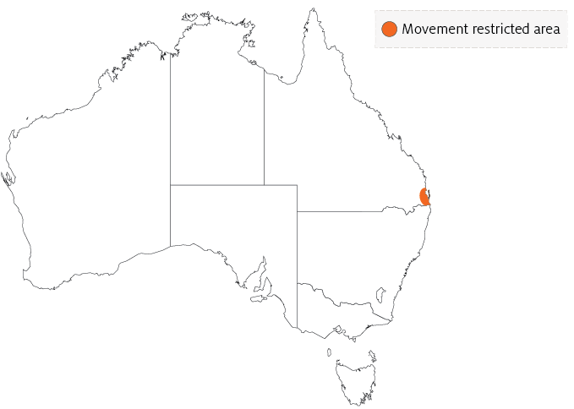

Epidemiology
- WSD is mainly a disease of farmed penaeid prawns, but many species of crustaceans are susceptible to infection with WSSV.
- Rapid mortalities of up to 80% or more within 3 to 10 days have been reported in many countries.
- Prawn farm productivity falls to about 40% of normal rate for 2 years, and then recovers to about 70% over the long term.
- Some of the species listed in the host range section (such as Penaeus monodon) are extremely susceptible to WSSV. Others may be infected but are more resistant to disease.
- Infection may be low level and chronic (lifelong carriers are possible) in healthy crustaceans, or acute infection with disease and mortalities.
- Viral multiplication and disease appears to be induced by environmental and handling stress. Stressors include eye-stalk ablation, spawning, moulting, high stocking densities, changes in salinity, temperature and pH, and plankton blooms. Imposing such stressors on suspect populations can be a useful diagnostic method for detecting the virus.
- All life stages are susceptible, from eggs to broodstock.
- Vertical transmission occurs from infected broodstock.
- Horizontal transmission of disease is usually via cannibalism of sick or dying prawns, or directly through contaminated water.
- Vectors of the virus include rotifers, marine molluscs, polychaete worms and non-decapod crustaceans including Artemia salina, copepods, non-crustacean arthropods and insect larvae.
- Birds can transmit the disease from pond to pond by releasing caught prawns over neighbouring ponds.
- White spot syndrome virus can persist and retain infectivity in seawater at 30°C for at least 30 days (under laboratory conditions) and for at least 4 days in ponds.

Differential diagnosis
The list of similar diseases in the next section refers only to the diseases covered by this field guide. Gross pathological signs may also be representative of diseases not included in this guide. Do not rely on gross signs to provide a definitive diagnosis. Use them as a tool to help identify the listed diseases that most closely account for the observed signs.

Similar diseases
Acute hepatopancreatic necrosis disease (AHPND), infection with Hepatobacter penaei (NHP), infection with infectious hypodermal and haematopoietic necrosis virus (IHHNV), infection with shrimp haemocyte iridescent virus (SHIV), infection with Taura syndrome virus (TSV) and infection with yellowhead virus genotype 1 (YHV1).

Sample collection
Only trained personnel should collect samples. Using only gross pathological signs to differentiate between diseases is not reliable, and some aquatic animal disease agents pose a risk to humans. If you are not appropriately trained, phone your state or territory hotline number and report your observations. If you have to collect samples, the agency taking your call will advise you on the appropriate course of action. Local or district fisheries or veterinary authorities may also advise on sampling.

Emergency disease hotline
See something you think is this disease? Report it. Even if you’re not sure.
Call the Emergency Animal Disease Watch Hotline on 1800 675 888. They will refer you to the right state or territory agency.

Microscope images
Figure 4 Photomicrograph of histological section from stomach of juvenile black tiger prawn (Penaeus monodon) with WSD
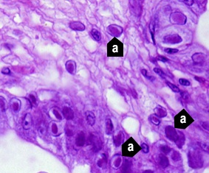
Note: Prominent intranuclear inclusion bodies are abundant in cuticular epithelium and subcuticular connective tissue of the organ (a). Cells in different phases of infection display intranuclear inclusion bodies. Early-phase inclusion bodies in this section are centronuclear and eosinophilic. These are separated from nuclear membrane and marginated chromatin by an artefactual halo. 900x magnification.
Source: DV Lightner
Figure 5 Histological section of stomach of juvenile Chinese white shrimp (Penaeus (Fenneropenaeus) chinensis) with advanced WSD
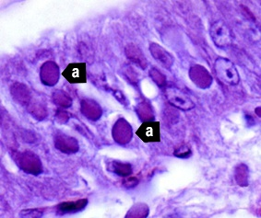
Note: Fully developed WSSV intranuclear inclusion bodies (a) are more basophilic, appear granular in texture and nearly fill affected hypertrophied nucleus. 1300x magnification.
Source: DV Lightner
Figure 6 Histological section of gills from juvenile Chinese white shrimp (Penaeus (Fenneropenaeus) chinensis) with WSD
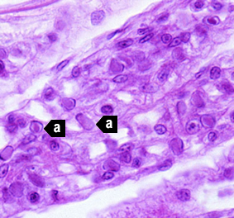
Note: Nearly one-quarter of cells are infected, as indicated by developing and fully developed intranuclear inclusion bodies (a). 900x magnification.
Source: DV Lightner
Figure 7 Histological section of stomach of Pacific blue shrimp (Penaeus (Litopenaeus) stylirostris) experimentally infected with WSSV
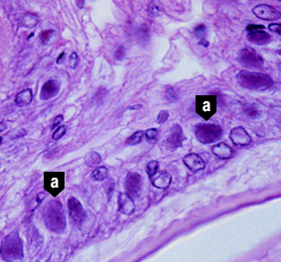
Note: Severe grade 4 infection evidenced by classic WSD intranuclear inclusion bodies (a). 900x magnification.
Source: DV Lightner
Figure 8 Histological section of stomach of Pacific white shrimp (Penaeus (Litopenaeus) vannamei) experimentally infected with WSSV
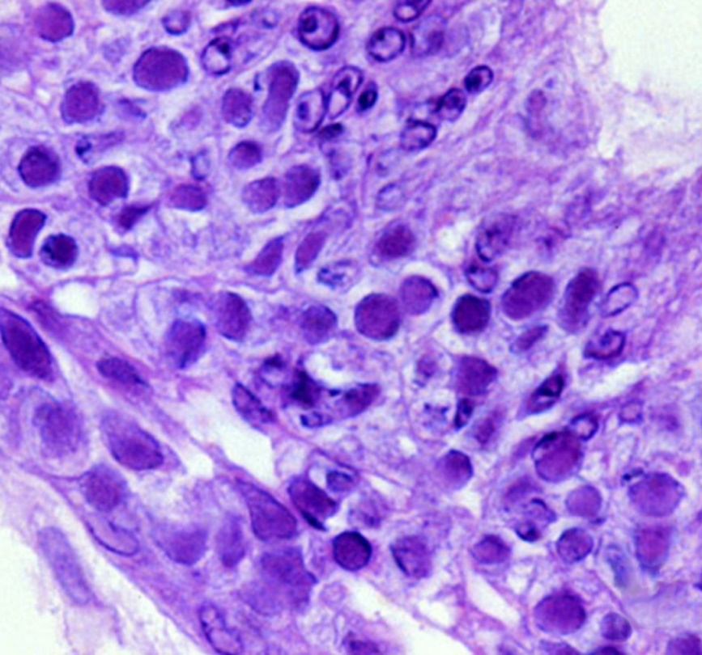
Note: Severe grade 4 infection with many classic WSD intranuclear inclusion bodies. 900x magnification.
Source: DV Lightner
Figure 9 In situ hybridisation of histological section of stomach of juvenile Pacific white shrimp (Penaeus (Litopenaeus) stylirostris) with WSD
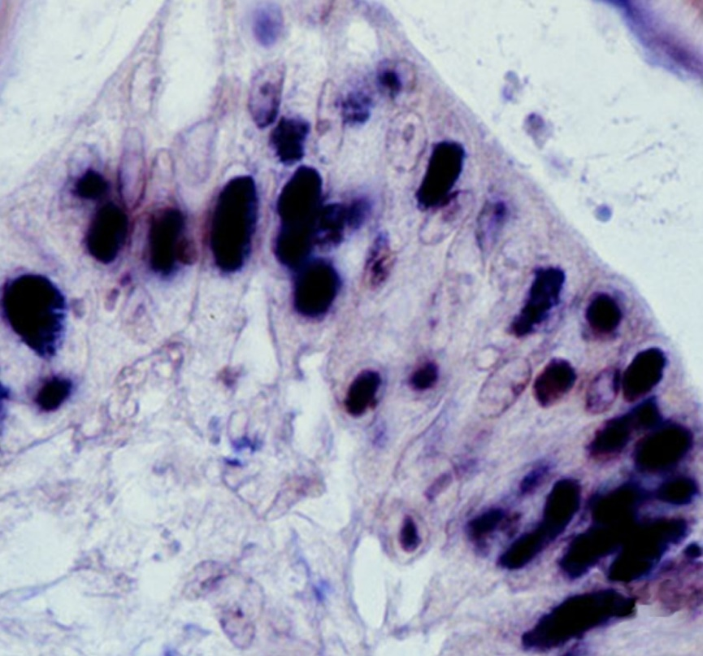
Note: Intranuclear inclusion bodies in the cuticular epithelium of stomach reacting to digoxygenin-labelled DNA probe. 900x magnification.
Source: DV Lightner

Further reading
CABI Invasive Species Compendium White spot disease
CEFAS International Database on Aquatic Animal Diseases White spot disease
Department of Agriculture, Water and the Environment AQUAVETPLAN disease strategy manual: White spot disease of prawns
World Organisation for Animal Health Manual of Diagnostic tests for aquatic animals
These hyperlinks were correct at the time of publication.

Contact details
Emergency Animal Disease Watch Hotline 1800 675 888
Email AAH@agriculture.gov.au
Website agriculture.gov.au/pests-diseases-weeds/aquatic
© Commonwealth of Australia 2020
This work is copyright. It may be reproduced in whole or in part subject to the inclusion of an acknowledgement of the source and no commercial usage or sale.

