Infection with Xenohaliotis californiensis

Also known as withering syndrome of abalone (WS)

From Aquatic animal diseases significant to Australia: identification field guide, 5th edition
Figure 1 Healthy red abalone (Haliotis rufescens), compared with atrophy of specimen with WS
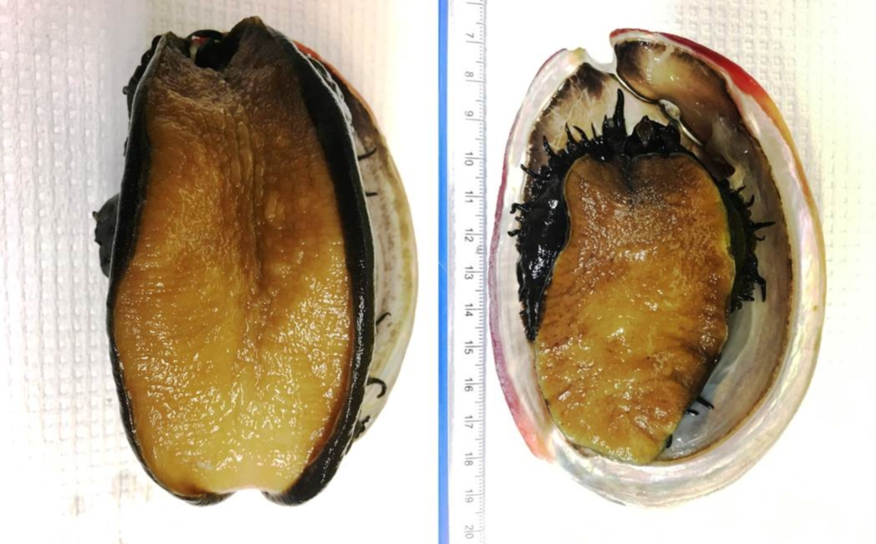
Note: Infected abalone (right) shows severe atrophy or withering of foot muscle and retraction of mantle.
Source: J Moore

Signs of disease
Important: Animals with this disease may show one or more of these signs, but the pathogen may still be present in the absence of any signs.
Disease signs at the farm, tank or pond level are:
- reduced feeding
- inability of individuals to right themselves when upside down
- weakness and lethargy (clinging to horizontal surfaces rather than to vertical or inverted)
- inability to adhere to the substrate
- increased mortality.
Gross pathological signs are:
- wasting of body mass
- retraction of mantle
- atrophy of the foot muscle
- decreased response to tactile stimuli
- diminished reproductive output
- mottling of digestive gland (dark brown with small foci of tan-coloured tissue).
Microscopic pathological signs are:
- presence of intracellular bacteria in the cells of the digestive epithelia
- atrophy of digestive tubules
- increase in connective tissue, inflammation and metaplasia of the digestive gland.

Disease agent
WS is caused by the obligate intracellular bacterium Xenohaliotis californiensis. The bacterium is closely related to the Neorickettsia genus. It is the ancestral form of the family Anaplasmataceae, within the order Rickettsiales.

Host range
Five Haliotis species native to the Californian coast are known to be susceptible to infection with X. californiensis. Disease susceptibility profiles of other Haliotis species (including Australian species) to infection with X. californiensis has not been assessed, but appears likely. Assume that all Australian species of Haliotis are susceptible.
Table 1 Species known to be susceptible to infection with Xenohaliotis californiensis
Common name | Scientific name
Black abaloneª | Haliotis cracherodii
Blacklip abalone | Haliotis rubra
Brownlip abalone | Haliotis conicopora
European abaloneª | Haliotis tuberculata
Flat abalone | Haliotis wallalensis
Green abaloneª | Haliotis fulgens
Greenlip abalone | Haliotis laevigata
Japanese abalone | Haliotis discus hannai
Pink abaloneª | Haliotis corrugata
Red abaloneª | Haliotis rufescens
Small abaloneª | Haliotis diversicolor supertexta
Tiger abalone | Haliotis rubra x laevigata
White abaloneª | Haliotis sorenseni
a Naturally susceptible. Note: Other species likely to be susceptible or shown to be experimentally susceptible.

Presence in Australia
Exotic disease—not recorded in Australia.
Map 1 Presence of Xenohaliotis californiensis, by jurisdiction
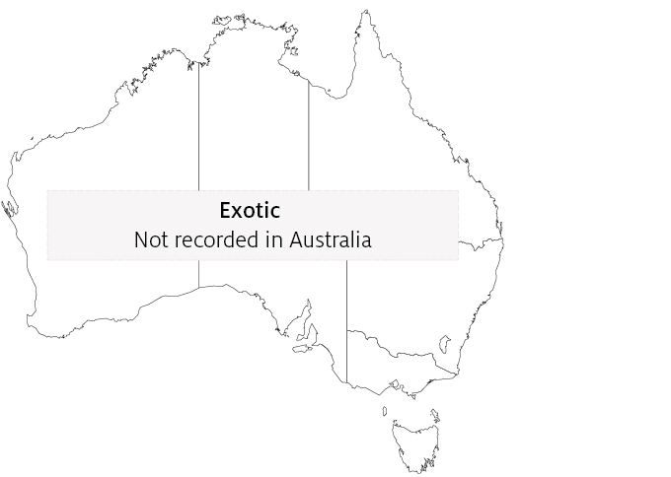

Epidemiology
- The pathogen X. californiensis occurs in marine waters.
- The bacterium attacks the lining of the digestive tract, causing metaplastic cellular changes and apparently obstructing the production of digestive enzymes. As a result, the abalone starve and catabolise their musculature. This causes withering of the foot, which impairs their ability to adhere to substrates and makes them vulnerable to predation.
- Abalone not eaten by predators usually die from starvation.
- Susceptibility varies between species of abalone (99% cumulative decline in black abalone and 30% in red abalone since the disease was first observed in 1986).
- Abalone can be infected with the bacterium without developing the disease.
- Transmission occurs horizontally by cohabitation with infected abalone (via the faecal–oral route).
- Environmental stressors, such as elevated water temperature, may predispose carriers of the bacterium to disease. Survivors can remain carriers of the bacterium.
- The disease can be treated with antibiotics. Severity of the disease may be reduced by infection of X. californiensis with hyperparasitic bacteriophages, which can give the rickettsial inclusions a distinctively altered (pleomorphic) appearance.

Differential diagnosis
The list of similar diseases in the next section refers only to the diseases covered by this field guide. Gross pathological signs may also be representative of diseases not included in this guide. Do not rely on gross signs to provide a definitive diagnosis. Use them as a tool to help identify the listed diseases that most closely account for the observed signs.

Similar diseases
No diseases in this field guide are similar to infection with Xenohaliotis californiensis.

Sample collection
Only trained personnel should collect samples. Using only gross pathological signs to differentiate between diseases is not reliable, and some aquatic animal disease agents pose a risk to humans. If you are not appropriately trained, phone your state or territory hotline number and report your observations. If you have to collect samples, the agency taking your call will advise you on the appropriate course of action. Local or district fisheries or veterinary authorities may also advise on sampling.

Emergency disease hotline
See something you think is this disease? Report it. Even if you’re not sure.
Call the Emergency Animal Disease Watch Hotline on 1800 675 888. They will refer you to the right state or territory agency.

Microscope images
Figure 2 Histological section of postoesophagus tissue from farmed black abalone (Haliotis cracherodii) infected with Xenohaliotis californiensis
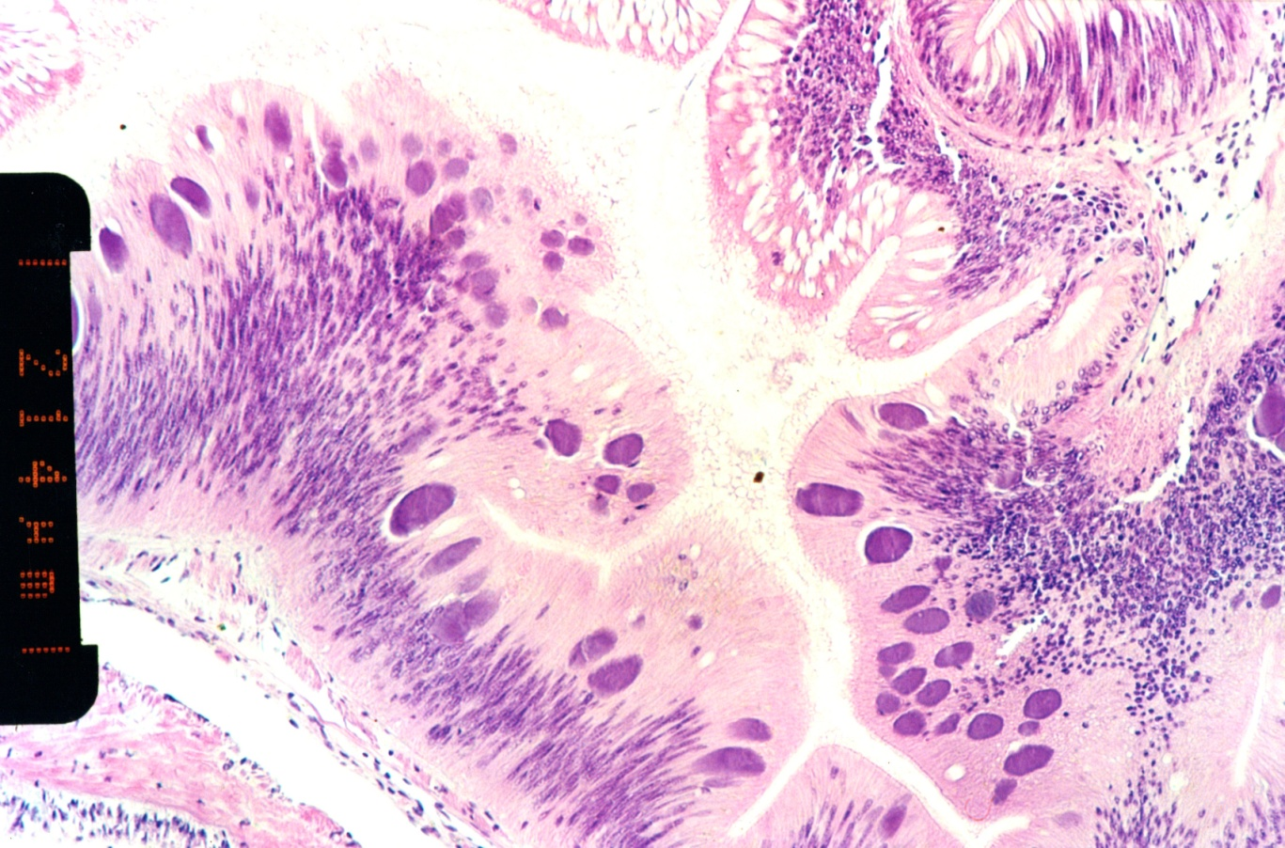
Note: Numerous basophilic inclusions in epithelial cells, each containing thousands of individual bacteria. Scale bar = 214µm.
Source: B Diggles
Figure 3 High power micrograph of epithelium of postoesophagus of red abalone (Haliotis rufescens) infected with Xenohaliotis californiensis
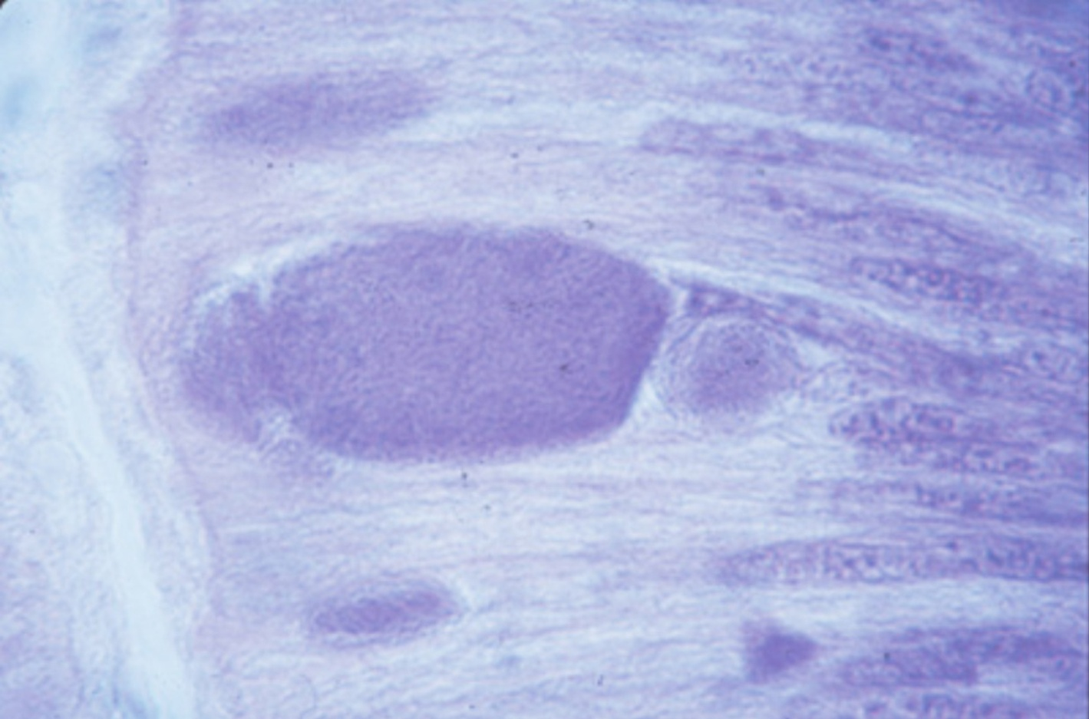
Note: Large basophilic cytoplasmic inclusion filled with X. californiensis.
Source: J Moore
Figure 4 Histological section of postoesophagus tissue of red abalone (Haliotis rufescens)
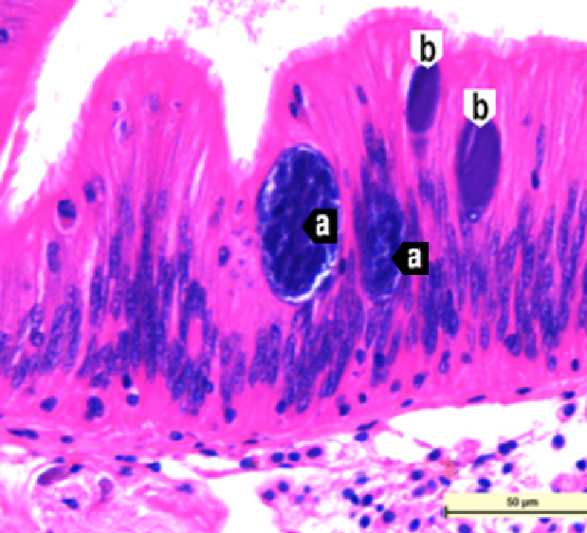
Note: The 2 larger pleomorphic Xenohaliotis californiensis inclusions (a) are infected by a bacteriophage. The 2 smaller inclusions (b) are normal. 40x magnification, scale bar = 50µm.
Source: J Moore

Further reading
CABI Invasive Species Compendium ‘Xenohaliotis californiensis’
CEFAS International Database on Aquatic Animal Diseases Infection with ‘Xenohaliotis californiensis’
World Organisation for Animal Health Manual of diagnostic tests for aquatic animals
These hyperlinks were correct at the time of publication.

Contact details
Emergency Animal Disease Watch Hotline 1800 675 888
Email AAH@agriculture.gov.au
Website agriculture.gov.au/pests-diseases-weeds/aquatic
© Commonwealth of Australia 2020
This work is copyright. It may be reproduced in whole or in part subject to the inclusion of an acknowledgement of the source and no commercial usage or sale.

