Infection with yellowhead virus genotype 1 (YHV1)

Also known as yellowhead disease

From Aquatic animal diseases significant to Australia: identification field guide, 5th edition
Figure 1 Yellowhead disease in giant black tiger prawns (Penaeus monodon)
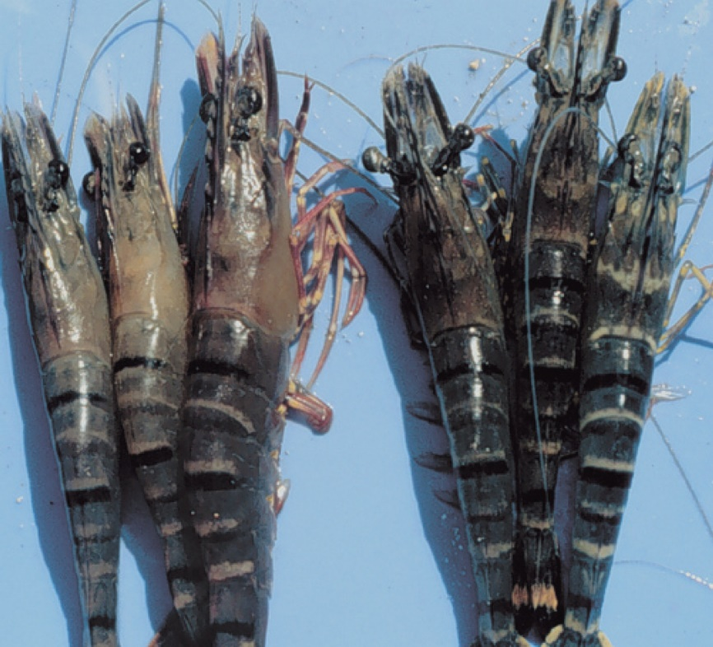
Note: Infected prawns (left) show pale yellow heads.
Source: DV Lightner

Signs of disease
Important: Animals with this disease may show one or more of these signs, but the pathogen may still be present in the absence of any signs.
Disease signs at the farm, tank or pond level are:
- aggregations of moribund prawns near the water surface at the edge of the rearing pond or tank
- abnormally high feeding rate of infected 5g to 15g prawns for several days and then cessation of feeding
- mass mortality (up to 100%) occurring 2 to 4 days after cessation of feeding.
Gross pathological signs are:
- yellowing of the cephalothorax and general bleaching of the body
- white, yellow or brown gills
- exceptionally soft digestive gland compared with normal
- yellow, swollen digestive gland, making the head appear yellow.
Microscopic pathological signs are:
- moderate to large numbers of deeply basophilic, evenly stained, spherical, cytoplasmic inclusions within tissues of ectodermal and mesodermal origin.

Disease agent
Yellowhead disease is caused by infection with yellowhead virus genotype 1 (YHV1), a corona-like RNA virus in the genus Okavirus, family Roniviridae and order Nidovirales. YHV1 is one of at least 10 genotypes in the yellowhead complex of viruses and is the only known agent of yellowhead disease. Gill-associated virus (GAV) is designated as genotype 2 (covered separately within the field guide). Several other known genotypes in the complex (genotypes 3 to 10) occur commonly in black tiger prawns (Penaeus monodon) in East Africa, Asia and Australia. Most of these other genotypes are rarely or never associated with disease.

Host range
YHV1 is highly infectious for most known species of cultivated penaeid prawns. There are variations in the susceptibility of different species to disease. Laboratory trials have shown that YHV1 can cause high mortality in black tiger prawns, Pacific white shrimp, Pacific blue shrimp, northern brown shrimp, northern pink shrimp, Sunda river prawns, mysid shrimp and barred estuarine shrimp. Until proven otherwise, it should be assumed that most penaeid prawns worldwide are susceptible to infection with YHV1.
Table 1 Species known to be susceptible to infection with YHV1
Common name | Scientific name
Barred estuarine shrimp | Palaemon serrifer
Black tiger prawnª | Penaeus monodon
Brown tiger prawn | Penaeus esculentus
Daggerblade grass shrimp | Paleamon pugio
Giant freshwater prawn | Macrobrachium rosenbergii
Greentail prawn | Metapenaeus bennettae
Gulf banana prawnª | Penaeus (Fenneropenaeus) merguiensis
Jelly prawnsª | Acetes spp.
Kuruma prawnª | Penaeus (Marsupenaeus) japonicus
Mississippi grass shrimp | Palaemon kadiakensis
Mysid shrimpª | Palaemon styliferus
Northern brown shrimp | Penaeus (Farfantepenaeus) aztecus
Northern pink shrimp | Penaeus (Farfantepenaeus) duorarum
Northern white shrimpª | Penaeus (Litopenaeus) setiferus
Pacific blue shrimp | Penaeus (Litopenaeus) stylirostris
Pacific white shrimp | Penaeus (Litopenaeus) vannamei
Red endeavour (greasyback) prawnª | Metapenaeus ensis
Sunda river prawn | Macrobrachium sintangene
a Naturally susceptible. Note: Other species shown to be experimentally susceptible.

Presence in Australia
Exotic disease—not recorded in Australia.
YHV1 is the most virulent genotype within the yellowhead complex, and the only known agent to cause yellowhead disease. It has never been recorded in Australia and is considered exotic. Other genotypes are known to occur in Australia, including YHV2 (gill associated virus), YHV6 and YHV7.
Map 1 Presence of YHV1, by jurisdiction
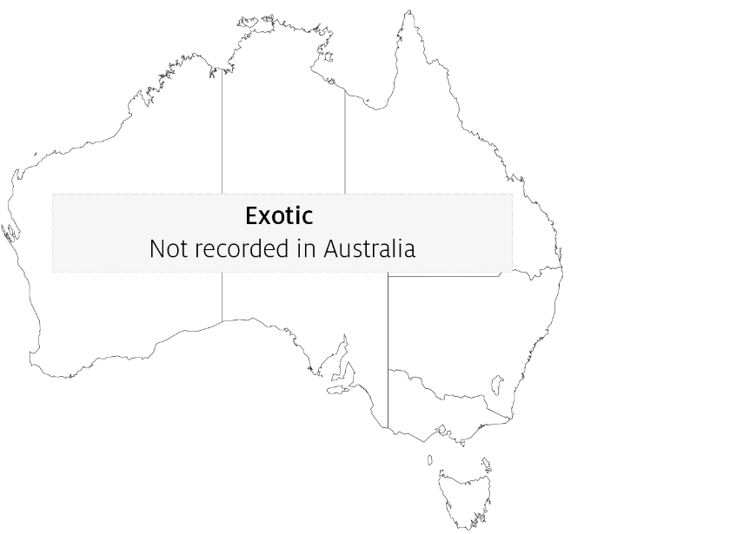

Epidemiology
- Penaeus monodon suffers acute epizootics, with mortality reaching 100% within 3 to 5 days of the first appearance of gross signs of infection.
- YHV1 can be transmitted horizontally by injection, ingestion of infected tissue, immersion in membrane-filtered tissue extracts or cohabitation with infected shrimp. Transmission has also been demonstrated by injection of extracts of jelly prawns (Acetes spp.) collected from infected ponds.
- Vertical transmission occurs from both male and female parents, possibly via surface infection or contamination of tissue surrounding fertilised eggs.
- Penaeus monodon younger than 15 days postlarvae are resistant to YHV1. Those from postlarval days 20 to 25 to subadult are highly susceptible.
- Mortalities usually occur during the early to late juvenile stages in rearing ponds.
- There are at least 10 genotypes of virus in the yellowhead virus group. YHV1 is the only genotype known to cause yellowhead disease.

Differential diagnosis
The list of similar diseases in the next section refers only to the diseases covered by this field guide. Gross pathological signs may also be representative of diseases not included in this guide. Gross signs should not be relied on to provide a definitive diagnosis. They should be used as a tool to help identify the listed diseases that most closely account for the observed signs.

Similar diseases
Gill associated virus disease (GAV), infection with Hepatobacter penaei (NHP), infection with shrimp haemocyte iridescent virus (SHIV) and infection with Taura syndrome virus (TSV).

Sample collection
Only trained personnel should collect samples. Using only gross pathological signs to differentiate between diseases is not reliable, and some aquatic animal disease agents pose a risk to humans. If you are not appropriately trained, phone your state or territory hotline number and report your observations. If you have to collect samples, the agency taking your call will advise you on the appropriate course of action. Local or district fisheries or veterinary authorities may also advise on sampling.

Emergency disease hotline
See something you think is this disease? Report it. Even if you’re not sure.
Call the Emergency Animal Disease Watch Hotline on 1800 675 888. They will refer you to the right state or territory agency.

Microscope images
Figure 2 Histological section of lymphoid organ of juvenile giant black tiger prawn (Penaeus monodon) with severe acute yellowhead disease
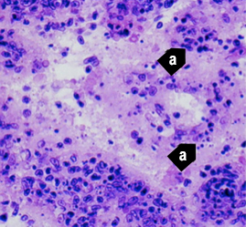
Note: Generalised, diffuse necrosis of lymphoid organ (LO) cells with pyknotic and karyorrhectic nuclei (a). Necrosis in acute yellowhead disease distinguishes it from infection due to Taura syndrome virus, which produces similar cytopathology in other target tissues, but not in the LO. 525x magnification.
Source: DV Lightner
Figure 3 Histological section of lymphoid organ of juvenile giant black tiger prawn (Penaeus monodon) with severe acute yellowhead disease
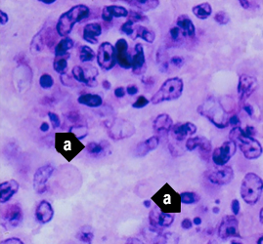
Note: Same sample as Figure 2. Single or multiple perinuclear inclusion bodies, ranging from pale to darkly basophilic, are apparent in some affected cells (a). 1700x magnification.
Source: DV Lightner
Figure 4 Histological section of the gills from a juvenile black tiger prawn (Penaeus monodon) with yellowhead disease
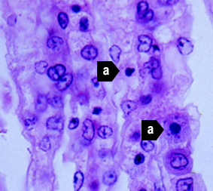
Note: Generalised, diffuse necrosis of cells in the gill lamellae, affected cells displaying pyknotic and karyorrhectic nuclei (a). A few large, conspicuous, generally spherical cells with basophilic cytoplasm are present in the section. These cells may be immature haemocytes, released prematurely in response to a yellowhead virus–induced haemocytopaenia. 1000x magnification.
Source: DV Lightner
Figure 5 Histological section of lymphoid organ of juvenile Pacific white shrimp (Penaeus (Litopenaeus) vannamei) experimentally infected with YHV1
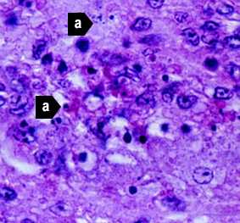
Note: Severe (grade 3–4) diffuse to multifocal necrosis, characterised by cells with increased eosinophilic cytoplasm, pyknotic or karyorrhectic nuclei (a) and pale to densely basophilic perinuclear inclusions. 1000x magnification.
Source: DV Lightner
Figure 6 Histological section of lymphoid organ of northern brown shrimp (Penaeus (Farfantepenaeus) aztecus) experimentally infected with YHV1
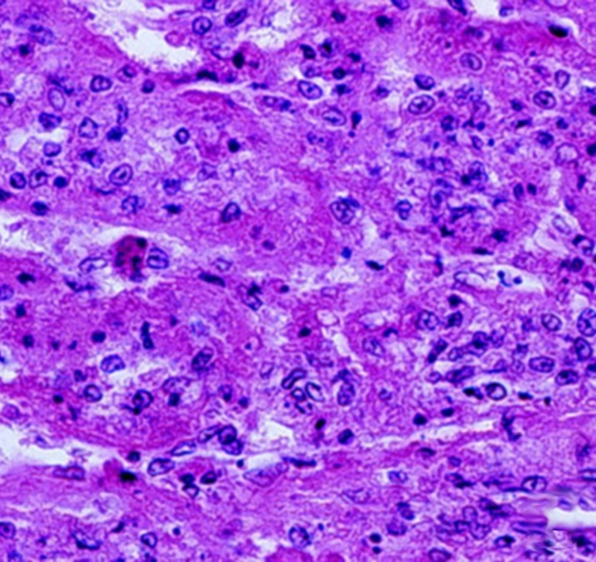
Note: Severe (grade 3–4) diffuse to multifocal necrosis, characterised by cells with increased eosinophilic cytoplasm, pyknotic or karyorrhectic nuclei and pale to densely basophilic perinuclear inclusions. 525x magnification.
Source: DV Lightner
Figure 7 Histological section of gills of juvenile northern pink shrimp (Penaeus (Farfantepenaeus) duorarum) experimentally infected with YHV1
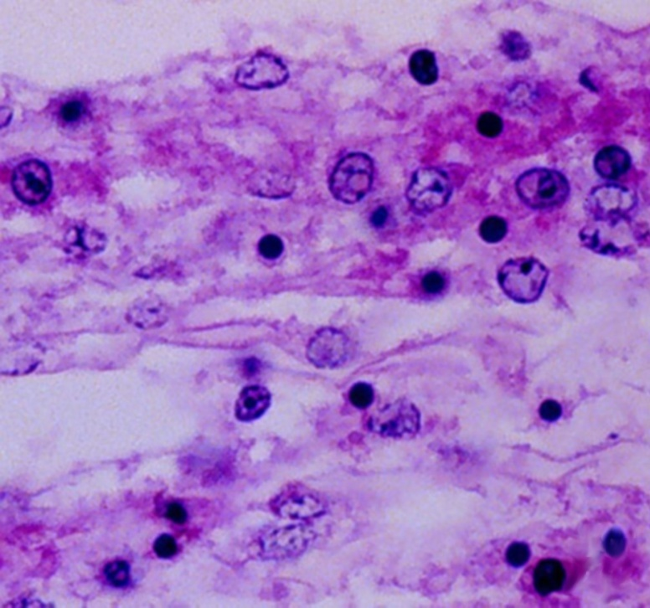
Note: Severe (grade 4) diffuse to multifocal necrosis, characterised by cells with increased eosinophilic cytoplasm, pyknotic or karyorrhectic nuclei, and pale to densely basophilic perinuclear inclusions. 1000× magnification.
Source: DV Lightner
Figure 8 Histological section of oesophagus of Pacific white shrimp (Penaeus (Litopenaeus) vannamei) experimentally infected with YHV1
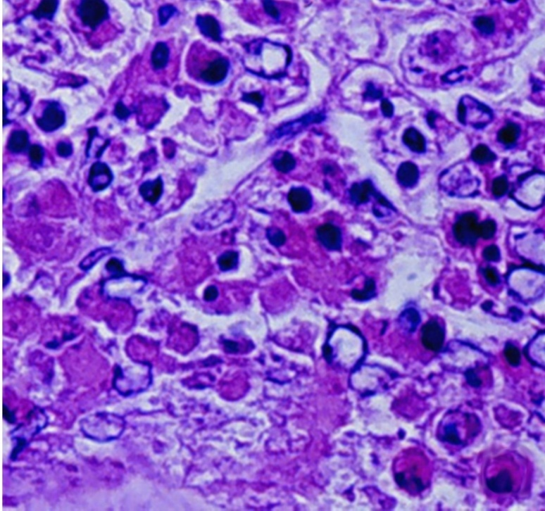
Note: Severe (grade 4) diffuse to multifocal necrosis is present, characterised by cells with increased eosinophilic cytoplasm, pyknotic or karyorrhectic nuclei, and pale to densely basophilic perinuclear inclusions. 1000x magnification.
Source: DV Lightner

Further reading
CABI Invasive Species Compendium Yellow head disease
CEFAS International Database on Aquatic Animal Diseases Yellowhead disease
World Organisation for Animal Health Manual of diagnostic tests for aquatic animals
These hyperlinks were correct at the time of publication.

Contact details
Emergency Animal Disease Watch Hotline 1800 675 888
Email AAH@agriculture.gov.au
Website agriculture.gov.au/pests-diseases-weeds/aquatic
© Commonwealth of Australia 2020
This work is copyright. It may be reproduced in whole or in part subject to the inclusion of an acknowledgement of the source and no commercial usage or sale.

