Infectious haematopoietic necrosis (IHN)

Also known as infection with infectious haematopoietic necrosis virus (IHNV)

From Aquatic animal diseases significant to Australia: identification field guide, 5th edition
Figure 1 Chinook salmon fry (Oncorhynchus tshawytscha) with IHN
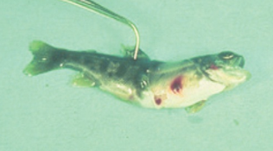
Note: Characteristic darkening from the tail region, swollen abdomen and haemorrhaging at base of the fins.
Source: J Fryer
Figure 2 Rainbow trout fry (Oncorhynchus mykiss) with and without IHN
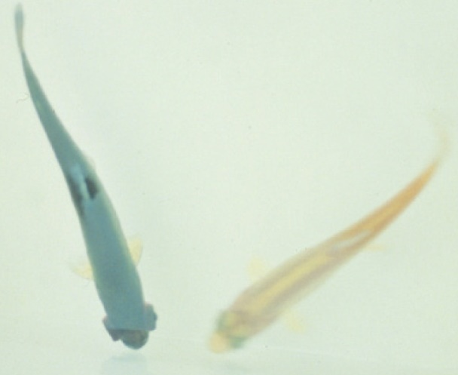
Note: Infected fish (left) shows darker colouring and exopthalmia compared to the uninfected fish (right)
Source: G Kurath

Signs of disease
Important: Animals with this disease may show one or more of these signs, but the pathogen may still be present in the absence of any signs.
Disease signs at the farm, tank or pond level are:
- mass mortality
- lethargic swimming with intermittent bouts of frenzied, abnormal activity (spiral swimming and flashing).
Gross pathological signs are:
- numerous yolk sac haemorrhages in the fry of rainbow trout and salmon
- darkening of the skin and pale gills
- haemorrhages on the abdomen and around the pupil of the eye
- exophthalmos (popeye) and a swollen abdomen
- trailing white faecal cast
- bleeding at the base of the fins
- stomach empty of food but distended with a gelatinous substance
- pale internal organs
- petechial (pinpoint) haemorrhages in the fatty tissue and muscle surrounding the organs and stomach wall
- spinal deformities in surviving fish.
Microscopic pathological signs are:
- necrosis of eosinophilic granular cells in the intestinal wall
- degenerative necrosis in haematopoietic tissues.

Disease agent
IHN is caused by infection with salmonid Novirhabdovirus, also known as infectious haematopoietic necrosis virus (IHNV). This virus is an enveloped single-stranded, negative-sense RNA virus classified within the family Novirhabdoviridae, and is closely related to other important fish rhabdoviruses such as viral haemorrhagic septicaemia virus (VHSV) and spring viraemia of carp virus (SVCV). Molecular analysis suggests that IHNV was originally endemic to the Pacific coast of North America, and was spread to Europe and Asia through translocations of salmonid eggs or fry.

Host range
Table 1 Species known to be susceptible to IHN
Common name | Scientific name
Amago salmonª | Oncorhynchus rhodurus
Arctic char | Salvelinus alpinus
Atlantic codª | Gadus morhua
Atlantic salmonª | Salmo salar
Ayu | Plecoglossus altivelis
Brook troutª | Salvelinus fontinalis
Brown troutª | Salmo trutta
Burbot | Lota lota
Chinook salmonª | Oncorhynchus tshawytscha
Chum salmonª | Oncorhynchus keta
Coho salmonª | Oncorhynchus kisutch
Cutthroat troutª | Oncorhynchus clarkii
Gilt-head sea bream | Sparus aurata
Grayling | Thymallus thymallus
Lake trout | Salvelinus namaycush
Masu salmonª | Oncorhynchus masou
Pacific herring | Clupea pallasii
Pacific salmonª | Oncorhynchus spp.
Pike | Esox lucius
Pile perch | Rhacochilus vacca
Pink salmonª | Oncorhynchus gorbuscha
Rainbow trout | Oncorhynchus mykiss
Shiner perch | Cymatogaster aggregata
Sockeye salmonª | Oncorhynchus nerka
Tubesnout | Aulorhynchus flavidus
Turbot | Scophthalmus maximus
Whitespotted char | Salvelinus leucomaenis
White sturgeon | Acipenser transmontanus
a Naturally susceptible. Note: Other species have been shown to be experimentally susceptible.
Table 2 Non-fish carriers
Common name | Scientific name
Gill lice | Salmincola spp.
Leeches | Piscicola spp.
Mayfly | Callibaetis spp.
Piscivorous birds | Various genera and species

Presence in Australia
Exotic disease—not recorded in Australia.
Map 1 Presence of IHN, by jurisdiction
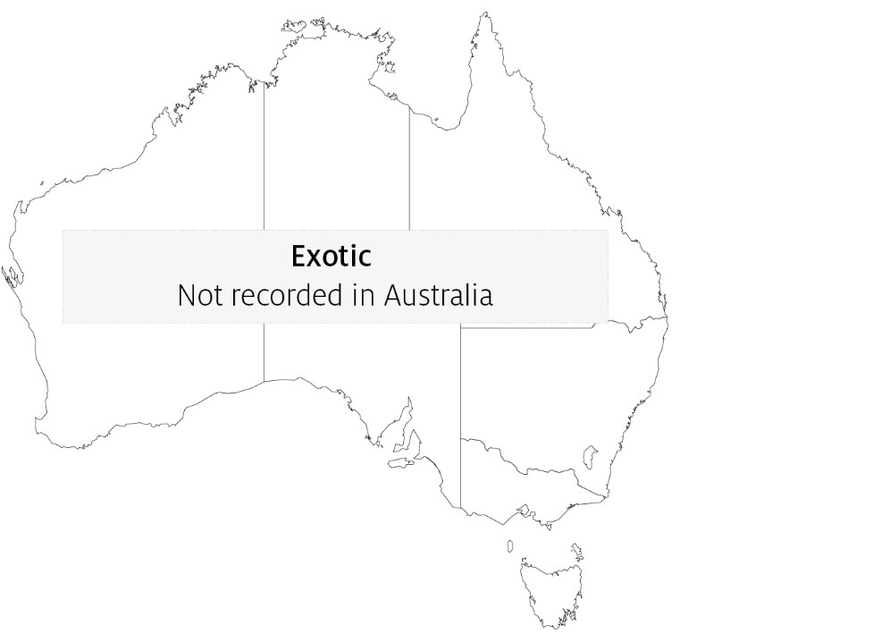

Epidemiology
- IHN is a cold-water disease. Clinical signs typically occur at temperatures between 8°C and 15°C. Outbreaks rarely occur once water temperatures reach more than 15°C.
- IHN is typically found in young, farmed trout and salmon fry or fingerlings, and in adults during or just following spawning.
- Mass mortalities of up to 90% can occur in hatcheries, typically with 100% of the population infected.
- Mortality also occurs in wild populations of Pacific salmon infected with IHNV. Survivors can be the source of infection of farmed stock.
- Susceptibility to infection varies between individuals of the same species and appears to be largely age dependent, with younger individuals being more susceptible.
- Fish that survive IHN are potential carriers of the virus for a period that depends on environmental conditions (such as temperature).
- The virus is shed into the water from infected fish through faeces, urine, spawning fluids and external mucous.
- Transmission is generally horizontal, with the virus entering fish through the gills and skin. Some blood-sucking parasites such as gill lice (Salmincola spp.) and leeches may serve as vectors.
- Virus can be transferred to new areas via the movement of infected fish or eggs, and by other sources such as contaminated equipment, water, birds or insects such as mayflies.
- Outbreaks are most likely to occur around the time of spawning, with increased levels of virus released into the environment with spawning fluids.
- It is believed that the spread of IHNV from the west coast of North America to Asia and Europe has been principally via the shipment of infected fish and eggs, suggesting some degree of vertical transmission. The risk of such egg-associated transmission is significantly reduced by the common practice of egg surface disinfection, but is not eliminated.

Differential diagnosis
The list of similar diseases in the next section refers only to the diseases covered by this field guide. Gross pathological signs may also be representative of diseases not included in this guide. Do not rely on gross signs to provide a definitive diagnosis. Use them as a tool to help identify the listed diseases that most closely account for the observed signs.

Similar diseases
Enteric red mouth disease, epizootic haematopoietic necrosis (EHN), furunculosis, infectious pancreatic necrosis (IPN), infection with HPR-deleted or HPR0 infectious salmon anaemia virus, viral haemorrhagic septicaemia (VHS) and whirling disease.

Sample collection
Only trained personnel should collect samples. Using only gross pathological signs to differentiate between diseases is not reliable, and some aquatic animal disease agents pose a risk to humans. If you are not appropriately trained, phone your state or territory hotline number and report your observations. If you have to collect samples, the agency taking your call will advise you on the appropriate course of action. Local or district fisheries or veterinary authorities may also advise on sampling.

Emergency disease hotline
See something you think is this disease? Report it. Even if you’re not sure.
Call the Emergency Animal Disease Watch Hotline on 1800 675 888. They will refer you to the right state or territory agency.

Further reading
CEFAS International Database on Aquatic Animal Diseases Infectious Haematopoietic Necrosis
World Organisation for Animal Health Manual of diagnostic tests for aquatic animals
These hyperlinks were correct at the time of publication.

Contact details
Emergency Animal Disease Watch Hotline 1800 675 888
Email AAH@agriculture.gov.au
Website agriculture.gov.au/pests-diseases-weeds/aquatic
© Commonwealth of Australia 2020
This work is copyright. It may be reproduced in whole or in part subject to the inclusion of an acknowledgement of the source and no commercial usage or sale.

