Infectious pancreatic necrosis (IPN)

Also known as infection with infectious pancreatic necrosis virus (IPNV)

From Aquatic animal diseases significant to Australia: identification field guide, 5th edition
Figure 1 IPN in rainbow trout (Oncorhynchus mykiss)
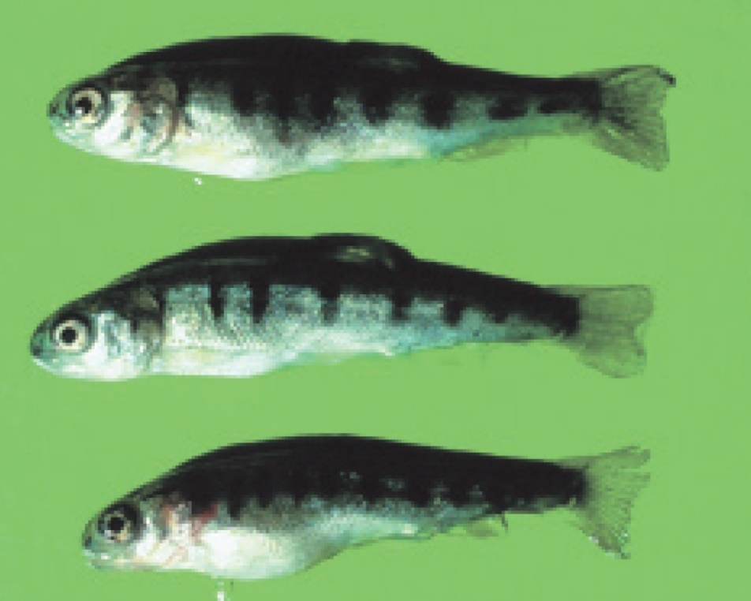
Note: Abdominal distension and darkened body colour.
Source: T Håstein

Signs of disease
Important: Animals with this disease may show one or more of these signs, but the pathogen may still be present in the absence of any signs.
Signs of disease described are representative of IPN in salmonids.
Disease signs at the farm, tank or pond level are:
- sudden and progressive increase in mortality at first feeding of fry, particularly in faster growing individuals
- cumulative mortality rates from 10% to 90%
- low persistent mortality
- fish lying still on the bottom of tanks or ponds
- fish swimming with a spiralling, corkscrew motion.
Gross pathological signs are:
- long, thin, whitish trailing faecal casts
- swollen abdomen
- darkening body colour
- typically pale gills
- exophthalmos (popeye)
- lesions and ulcers in pancreas, oesophagus and stomach
- haemorrhages sometimes present in ventral areas, including the ventral fins
- abnormally pale spleen, kidney, liver and heart of fry
- intestines empty or filled with clear mucus.
Microscopic pathological signs are:
- extensive and/or severe necrosis of acinar pancreatic cells
- focal or generalised necrosis of liver
- sloughing of intestinal mucosa with characteristic McKnight cells in the lumen (eosinophilic and hyaline epithelial cells.

Disease agent
IPN is caused by infection with infectious pancreatic necrosis virus (IPNV), a double stranded RNA virus classified within the genus Aquabirnavirus (family Birnaviridae). Several genogroups have been identified and are described by their different hosts and geographical origins. The most frequently found and highly virulent strain of IPNV is the Sp serotype in genogroup 5.

Host range
A wide range of marine and freshwater fish species are susceptible to IPNV. The disease agent can be spread naturally by mechanical vectors such as piscivorous birds (including passage through the bird digestive system), blood feeding parasites and filter feeding molluscs (such as common European scallop Pecten maximus).
Table 1 Fish species likely to be severely affected by IPNV
Common name | Scientific name
American eelª | Anguilla rostrata
Atlantic cod | Gadus morhua
Atlantic halibut | Hippoglossus hippoglossus
Atlantic salmonª | Salmo salar
Brook troutª | Salvelinus fontinalis
Brown troutª | Salmo trutta
Coho salmon | Oncorhynchus kisutch
Eelsª | Anguillidae, all species
European eel | Anguilla anguilla
Japanese eel | Anguilla japonica
Pacific salmon | Oncorhynchus spp.
Rainbow troutª | Oncorhynchus mykiss
Shortfin eel | Anguilla australis
Turbot | Scophthalmus maximus
Wrasses | Labridae, all species
a Naturally susceptible. Note: Other species likely to be susceptible or have been shown to be experimentally susceptible.
Table 2 Non-fish carriers
Common name | Scientific name
Common European scallop | Pecten maximus
European flat oyster | Ostrea edulis
Fish louse | Argulus foliaceus
Molluscs | Various genera and species
Piscivorous birds | Various genera and species
Salmon louse | Lepeophtheirus salmonis and Caligus coryphaenae

Presence in Australia
Exotic disease—not recorded in Australia.
Other aquabirnaviruses, distinct from IPNV, are present in Australia and New Zealand.
- Tasmanian aquabirnavirus in farmed Atlantic salmon and rainbow trout.
- Victorian trout aquabirnavirus in farmed rainbow trout.
- New Zealand birnavirus in diseased turbot and asymptomatic sea-run chinook salmon.
Map 1 Presence of IHN, by jurisdiction
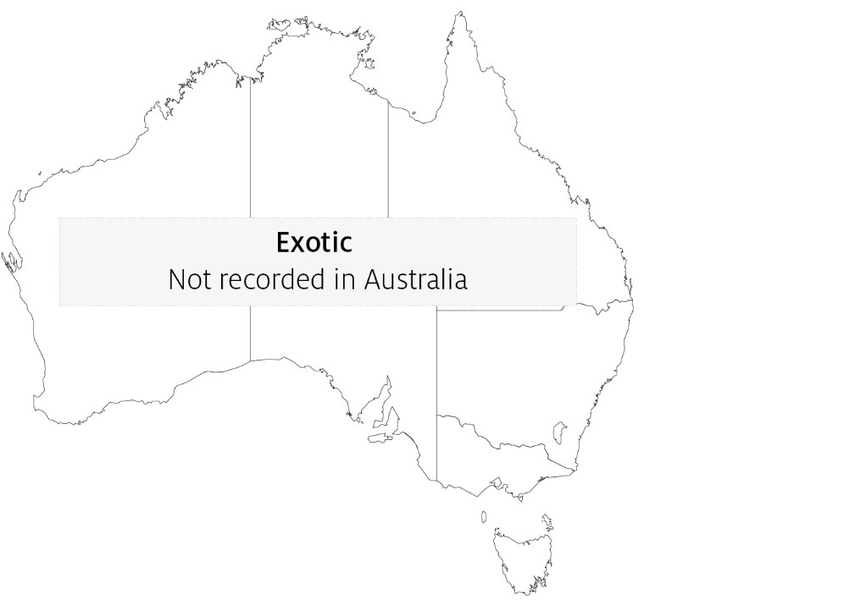

Epidemiology
- IPNV is highly contagious and fish that survive infection are presumed to become carriers. Asymptomatic carrier fish represent a risk for introduction of disease to healthy stocks.
- Viral transmission can occur horizontally (the virus enters fish through the gills or gastrointestinal tract) and vertically (transmitted via eggs of infected carrier broodfish).
- IPNV is shed in faeces, urine, spawning fluids and external mucus. Spawning favours the transmission of IPN virus with increased levels of virus excreted in spawning fluids.
- Outbreaks of disease are most likely to occur when fish are stressed. Factors raising physiological stress levels include first feeding, high stocking densities, fluctuations in water temperature and salinity and management practices requiring handling of fish. Outbreaks are known to occur at water temperatures as low as 4°C and as high as 18°C.
- The disease can cause high mortalities (70%) in young trout, with cumulative mortalities of 10% to 90%.
- The highest mortality rates usually occur in freshwater hatcheries in fry less than 6 months of age. However, IPN is known to affect rainbow trout and post-smolt Atlantic salmon after transfer from freshwater to seawater.
- IPNV can survive in both freshwater and saltwater environments. It is quite stable and resists destruction by disinfection, enabling it to persist in a range of environmental conditions on equipment such as nets and containers.
- Virus may be spread and healthy stocks exposed via contaminated transport water, infected eggs and blood feeding parasites. Piscivorous birds and molluscs are also known vectors of IPNV.

Differential diagnosis
The list of similar diseases in the next section refers only to the diseases covered by this field guide. Gross pathological signs may also be representative of diseases not included in this guide. Do not rely on gross signs to provide a definitive diagnosis. Use them as a tool to help identify the listed diseases that most closely account for the observed signs.

Similar diseases
Infection with HPR-deleted or HPR0 infectious salmon anaemia virus, infection with salmonid alphavirus (SAV), infectious haematopoietic necrosis (IHN) and viral haemorrhagic septicaemia (VHS).

Sample collection
Only trained personnel should collect samples. Using only gross pathological signs to differentiate between diseases is not reliable, and some aquatic animal disease agents pose a risk to humans. If you are not appropriately trained, phone your state or territory hotline number and report your observations. If you have to collect samples, the agency taking your call will advise you on the appropriate course of action. Local or district fisheries or veterinary authorities may also advise on sampling.

Emergency disease hotline
See something you think is this disease? Report it. Even if you’re not sure.
Call the Emergency Animal Disease Watch Hotline on 1800 675 888. They will refer you to the right state or territory agency.

Further reading
CABI Invasive Species Compendium Infectious Pancreatic Necrosis
CEFAS International Database on Aquatic Animal Diseases Infectious Pancreatic Necrosis
These hyperlinks were correct at the time of publication.

Contact details
Emergency Animal Disease Watch Hotline 1800 675 888
Email AAH@agriculture.gov.au
Website agriculture.gov.au/pests-diseases-weeds/aquatic
© Commonwealth of Australia 2020
This work is copyright. It may be reproduced in whole or in part subject to the inclusion of an acknowledgement of the source and no commercial usage or sale.

